MCQ-2
1) Given below are three images (1,2,3). Which of the following option is correct for these images?
A)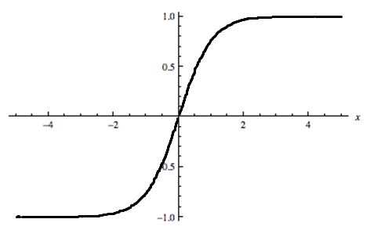
B)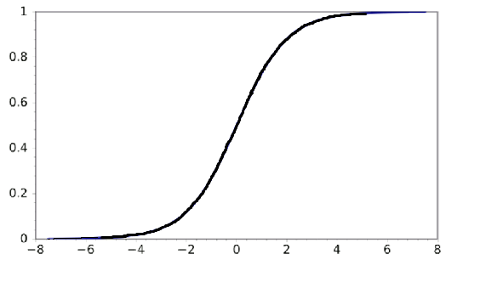
C)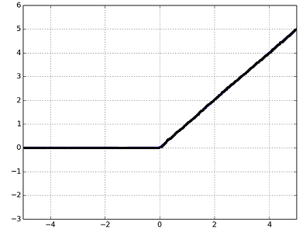
A)1 is tanh, 2 is ReLU and 3 is SIGMOID activation functions.
B)1 is SIGMOID, 2 is ReLU and 3 is tanh activation functions.
C)1 is ReLU, 2 is tanh and 3 is SIGMOID activation functions.
D)1 is tanh, 2 is SIGMOID and 3 is ReLU activation functions.

2) Below are the 8 actual values of target variable in the train file.
[0,0,0,1,1,1,1,1]
What is the entropy of the target variable?
A) -(5/8 log(5/8) + 3/8 log(3/8))
B) 5/8 log(5/8) + 3/8 log(3/8)
C) 3/8 log(5/8) + 5/8 log(3/8)
D) 5/8 log(3/8) – 3/8 log(5/8)

3) Skip gram model is one of the best models used in Word2vec algorithm for words embedding. Which one of the following models depict the skip gram model?
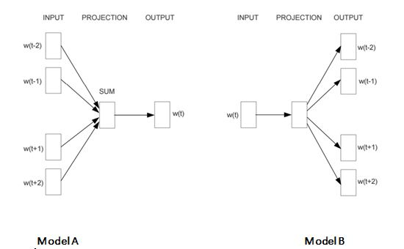
A) A
B)B
C) Both A and B
D) None of these

4) Which of the following statements is/are true about “Type-1” and “Type-2” errors?
- Type1 is known as false positive and Type2 is known as false negative.
- Type1 is known as false negative and Type2 is known as false positive.
- Type1 error occurs when we reject a null hypothesis when it is actually true.
A) Only1
B) Only2
C) Only3
D)1 and 2
E) 1 and 3
F) 2 and 3

5) Which of the following is/are one of the important step(s) to pre-process the text in NLP based projects?
- Stemming
- Stop word removal
- Object Standardization
A)1 and 2
B)1 and 3
C)2 and 3
D)1,2 and 3

6) Suppose you want to project high dimensional data into lower dimensions. The two most famous dimensionality reduction algorithms used here are PCA and t-SNE. Let’s say you have applied both algorithms respectively on data “X” and you got the datasets “X_projected_PCA” , “X_projected_tSNE”.
Which of the following statements is true for “X_projected_PCA” & “X_projected_tSNE” ?
A)X_projected_PCA will have interpretation in the nearest neighbour space.
B)X_projected_tSNE will have interpretation in the nearest neighbour space.
C) Both will have interpretation in the nearest neighbour space.
D) None of them will have interpretation in the nearest neighbour space.

Context: 16-17
Given below are three scatter plots for two features (Image 1, 2 & 3 from left to right).
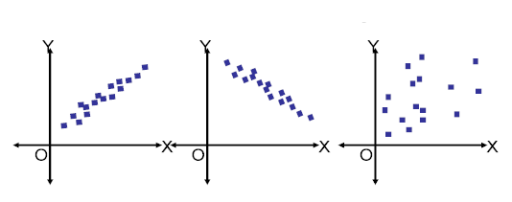
7) In the above images, which of the following is/are example of multi-collinear features?
A) Features in Image 1
B) Features in Image 2
C) Features in Image 3
D) Features in Image 1 & 2
E) Features in Image 2 & 3
F) Features in Image 3 & 1

In Image 1, features have high positive correlation where as in Image 2 has high negative correlation between the features so in both images pair of features are the example of multicollinear features.

8) In previous question, suppose you have identified multi-collinear features. Which of the following action(s) would you perform next?
- Remove both collinear variables.
- Instead of removing both variables, we can remove only one variable.
- Removing correlated variables might lead to loss of information. In order to retain those variables, we can use penalized regression models like ridge or lasso regression.
A)Only 1
B)Only 2
C)Only 3
D)Either 1 or 3
E)Either 2 or 3

9) Adding a non-important feature to a linear regression model may result in.
- Increase in R-square
- Decrease in R-square
A)Only 1 is correct
B) Only 2 is correct
C) Either 1 or 2
D) None of these

10) Suppose, you are given three variables X, Y and Z. The Pearson correlation coefficients for (X, Y), (Y, Z) and (X, Z) are C1, C2 & C3 respectively.
Now, you have added 2 in all values of X (i.enew values become X+2), subtracted 2 from all values of Y (i.e. new values are Y-2) and Z remains the same. The new coefficients for (X,Y), (Y,Z) and (X,Z) are given by D1, D2 & D3 respectively. How do the values of D1, D2 & D3 relate to C1, C2 & C3?
A)D1= C1, D2 < C2, D3 > C3
B) D1 = C1, D2 > C2, D3 > C3
C) D1 = C1, D2 > C2, D3 < C3
D) D1 = C1, D2 < C2, D3 < C3
E) D1 = C1, D2 = C2, D3 = C3
F) Cannot be determined

11) Imagine, you are solving a classification problems with highly imbalanced class. The majority class is observed 99% of times in the training data.
Your model has 99% accuracy after taking the predictions on test data. Which of the following is true in such a case?
- Accuracy metric is not a good idea for imbalanced class problems.
- Accuracy metric is a good idea for imbalanced class problems.
- Precision and recall metrics are good for imbalanced class problems.
- Precision and recall metrics aren’t good for imbalanced class problems.
A)1 and 3
B)1 and 4
C)2 and 3
D)2 and 4
Refer the question number 4 fromin this article.

12) In ensemble learning, you aggregate the predictions for weak learners, so that an ensemble of these models will give a better prediction than prediction of individual models.
Which of the following statements is / are true for weak learners used in ensemble model?
- They don’t usually overfit.
- They have high bias, so they cannot solve complex learning problems
- They usually overfit.
A)1 and 2
B)1 and 3
C)2 and 3
D)Only 1
E)Only 2
F)None of the above

13) Which of the following options is/are true for K-fold cross-validation?
- Increase in K will result in higher time required to cross validate the result.
- Higher values of K will result in higher confidence on the cross-validation result as compared to lower value of K.
- If K=N, then it is called Leave one out cross validation, where N is the number of observations.

A) 1 and 2
B) 2 and 3
C)1 and 3
D)1,2 and 3

Question Context 23-24
Cross-validation is an important step in machine learning for hyper parameter tuning. Let’s say you are tuning a hyper-parameter “max_depth” for GBM by selecting it from 10 different depth values (values are greater than 2) for tree based model using 5-fold cross validation.
Time taken by an algorithm for training (on a model with max_depth 2) 4-fold is 10 seconds and for the prediction on remaining 1-fold is 2 seconds.
Note: Ignore hardware dependencies from the equation.
14) Which of the following option is true for overall execution time for 5-fold cross validation with 10 different values of “max_depth”?
A) Less than 100 seconds
B) 100 – 300 seconds
C) 300 – 600 seconds
D) More than or equal to 600 seconds
C) None of the above
D) Can’t estimate

15) In previous question, if you train the same algorithm for tuning 2 hyper parameters say “max_depth” and “learning_rate”.
You want to select the right value against “max_depth” (from given 10 depth values) and learning rate (from given 5 different learning rates). In such cases, which of the following will represent the overall time?
A)1000-1500 second
B)1500-3000 Second
C) More than or equal to 3000 Second
D) None of these

