Start MySQL server directly from the ZIP install, without using MSI

Create a data directory
mkdir C:\Users\ChandranSrinivasan\Documents\mysql-8.0.45-winx64\data
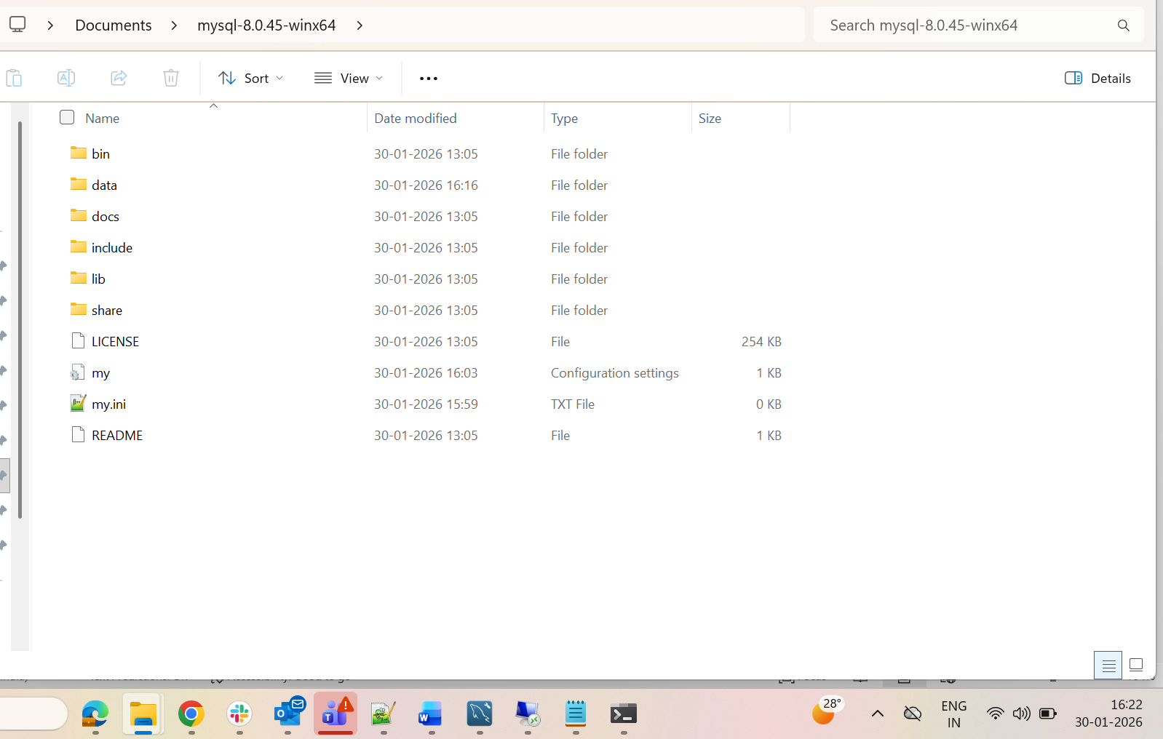
Create my.ini in the ZIP root
C:\Users\ChandranSrinivasan\Documents\mysql-8.0.45-winx64\my.ini
Paste inside ini file
[mysqld]
basedir=C:/Users/ChandranSrinivasan/Documents/mysql-8.0.45-winx64
datadir=C:/Users/ChandranSrinivasan/Documents/mysql-8.0.45-winx64/data
port=3306
server-id=1
sql_mode=NO_ENGINE_SUBSTITUTION
default_authentication_plugin=mysql_native_password
[client]
port=3306

Initialize the database (first time only) to generate temporary password
cd C:\Users\ChandranSrinivasan\Documents\mysql-8.0.45-winx64\bin\mysqld --initialize –console
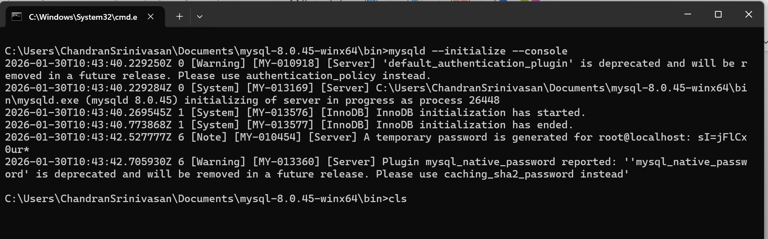

Start MySQL server manually from ZIP
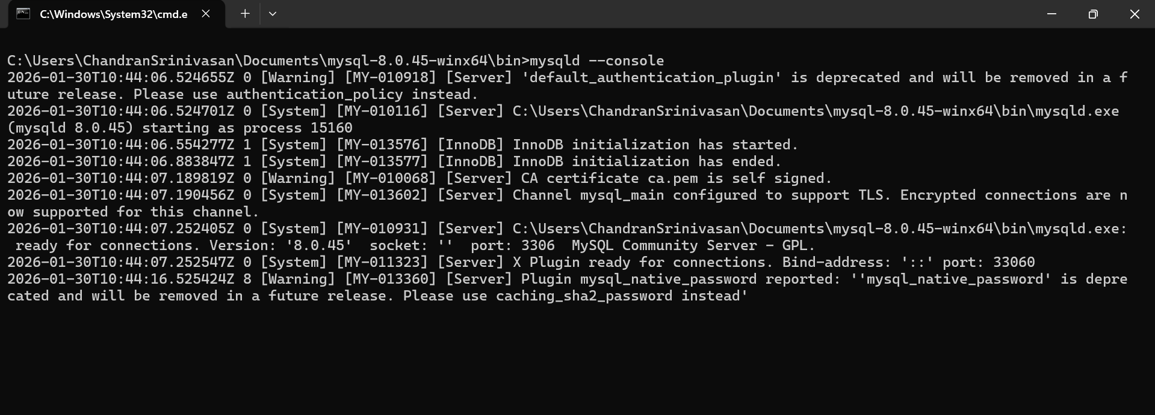

Connect while running
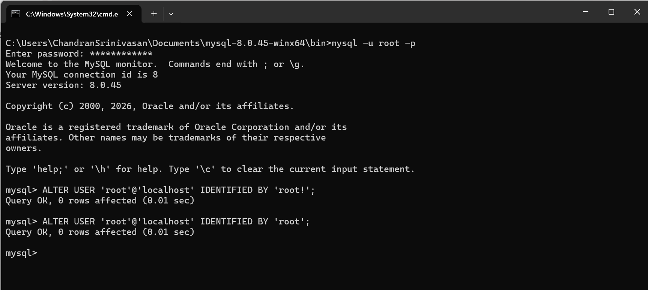
ALTER USER 'root'@'localhost' IDENTIFIED BY 'root';
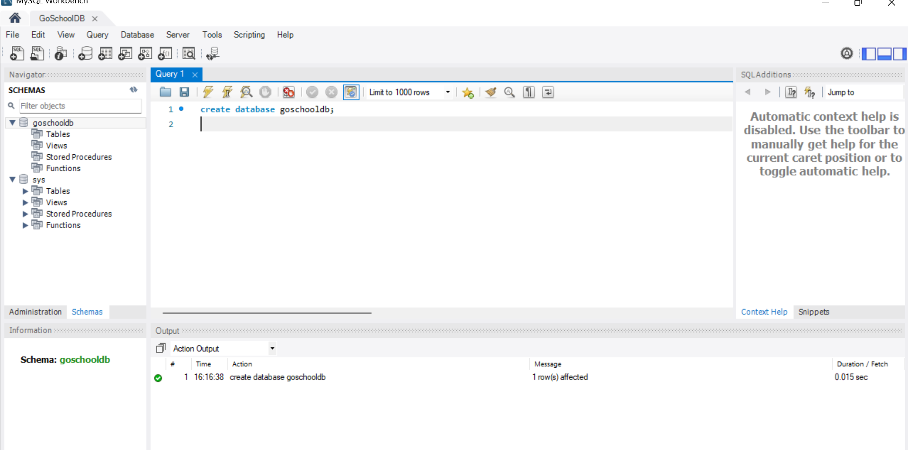

Data model for GoSchool
create database goschooldb;
use goschooldb;
drop table enrollment;
drop table student;
drop table subject;
drop table teacher;

CREATE TABLE teacher (
teacher_id INT PRIMARY KEY AUTO_INCREMENT,
first_name VARCHAR(50) NOT NULL,
last_name VARCHAR(50) NOT NULL,
email VARCHAR(100) UNIQUE,
mobile VARCHAR(50) NOT NULL,
created_at TIMESTAMP DEFAULT CURRENT_TIMESTAMP
);
CREATE TABLE subject (
subject_id INT PRIMARY KEY AUTO_INCREMENT,
subject_name VARCHAR(100) NOT NULL,
teacher_id INT,
FOREIGN KEY (teacher_id) REFERENCES teacher(teacher_id)
);
CREATE TABLE student (
student_id INT PRIMARY KEY AUTO_INCREMENT,
first_name VARCHAR(50) NOT NULL,
last_name VARCHAR(50) NOT NULL,
dob DATE,
email VARCHAR(100) NOT NULL,
mobile VARCHAR(50) NOT NULL,
created_at TIMESTAMP DEFAULT CURRENT_TIMESTAMP
);

CREATE TABLE enrollment (
enrollment_id INT PRIMARY KEY AUTO_INCREMENT,
student_id INT,
subject_id INT,
grade CHAR(2),
FOREIGN KEY (student_id) REFERENCES student(student_id),
FOREIGN KEY (subject_id) REFERENCES subject(subject_id)
);

select * from student;

