PORTFOLIO PROJECT REPORT
RadioML Modulation
Classifier
An interpretable RF signal intelligence pipeline using classical machine learning
Project | Dataset | Approach
RadioML modulation recognition | RadioML 2016.10a | Handcrafted features + classical ML

Prepared by Chandranshu Verma
August 2026

Executive summary
This project implements an end-to-end modulation-recognition workflow for short complex baseband captures. It begins with raw in-phase and quadrature samples, converts each capture into a compact set of interpretable RF measurements, trains two classical classifiers, evaluates performance across signal-to-noise ratio, adds unsupervised anomaly detection, and exposes the pipeline through a small Streamlit application.
The goal is explainability rather than state-of-the-art accuracy. Logistic Regression provides a linear baseline, while Random Forest captures nonlinear relationships among amplitude, phase, and spectral features. On the fixed held-out test set, Logistic Regression achieved 44.45% accuracy and Random Forest achieved 50.44%. Random Forest performance rose from approximately chance level at -20 dB to 79.1% at 18 dB, demonstrating that aggregate accuracy alone is not an adequate RF performance measure.
Measure | Verified result | Interpretation
Dataset size | 220,000 signals | Balanced across modulation and SNR
Signal shape | 2 × 128 | I and Q channels, 128 samples each
Modulation classes | 11 | Analog and digital modulation families
SNR range | -20 to 18 dB | 20 levels in 2 dB steps
Random Forest accuracy | 50.44% | All SNR levels combined
Random Forest at 18 dB | 79.14% | Clear-signal operating point

Project objectives

1. Dataset and signal representation
RadioML 2016.10a is stored as a dictionary keyed by (modulation, SNR). Each key maps to 1,000 examples with shape (1000, 2, 128). A single example therefore contains 128 I samples and 128 Q samples. The inspected file contains 220 dictionary blocks and 220,000 signals in total.

I/Q samples
A complex baseband sample is represented as x[n] = I[n] + jQ[n]. The I component lies on the horizontal axis and the Q component lies on an orthogonal axis. Together they retain both signal magnitude and phase. Magnitude is calculated as |x[n]| = sqrt(I[n]^2 + Q[n]^2), while phase is calculated with atan2(Q[n], I[n]).

Modulation classes
Family | Classes in the dataset
Phase/amplitude digital | BPSK, QPSK, 8PSK, QAM16, QAM64, PAM4
Frequency digital | CPFSK, GFSK
Analog | AM-DSB, AM-SSB, WBFM

Signal-to-noise ratio
SNR compares signal power with noise power: SNR(dB) = 10 log10(Psignal / Pnoise). At negative SNR, noise power exceeds signal power. In that regime, constellation structure, phase transitions, amplitude patterns, and spectral shape become difficult to distinguish. This is why modulation-recognition performance must be reported as a function of SNR.
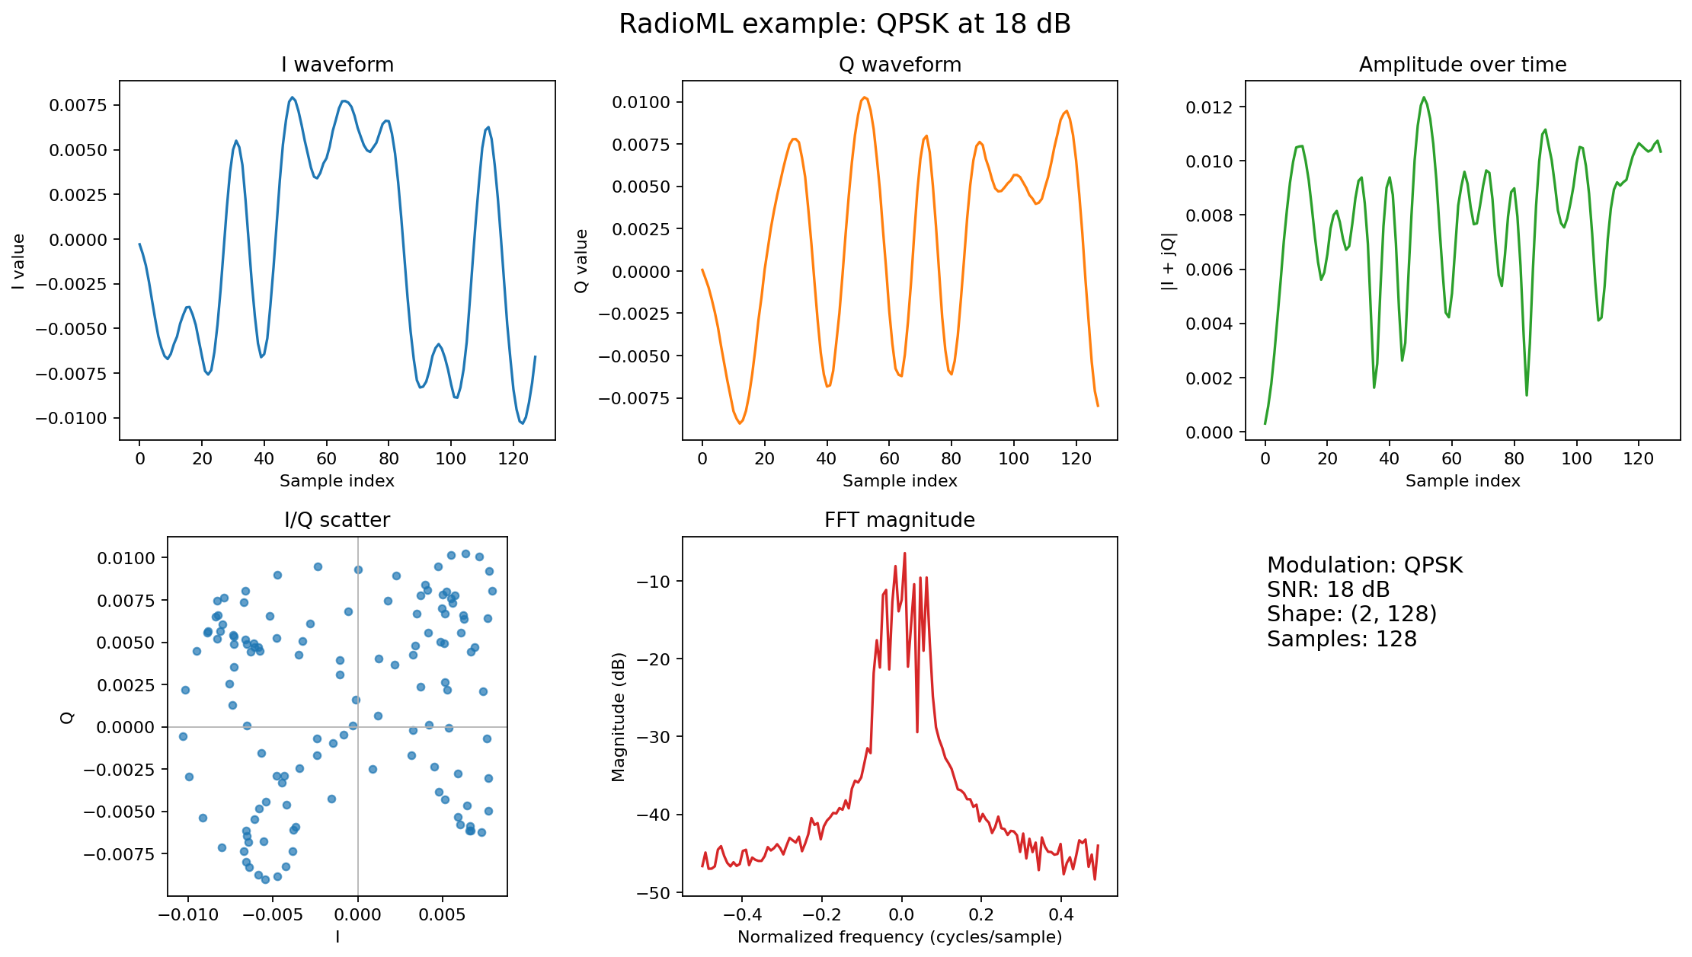
Figure 1. QPSK example at 18 dB: time-domain channels, amplitude, I/Q scatter, and FFT.

2. Feature engineering
Each raw capture contains 256 scalar values. Instead of passing these values directly to a model, the project compresses each capture into 15 measurements that can be explained in RF and statistical terms. This loses fine time-order information, but produces a structured table suitable for classical machine learning.
Feature group | Measurements | Purpose
Amplitude | mean, standard deviation, RMS, maximum, variance | Signal strength and variation
Power | mean power | Average I² + Q²
Phase | phase standard deviation | Angular spread
I/Q | I std, Q std, I/Q correlation | Variation and channel relationship
Spectrum | centroid, bandwidth, entropy, FFT peak | Frequency location and energy distribution
Distribution | amplitude kurtosis | Peakedness and heavy tails

Spectral entropy
The FFT power spectrum is normalized into a probability distribution across frequency bins. Entropy is then divided by log2(N), producing a value between zero and one. Low entropy means energy is concentrated in relatively few bins; high entropy means energy is broadly distributed and more noise-like.

Feature-table checks

3. Classification methodology
The data was divided into 176,000 training signals and 44,000 test signals. Stratification used the combined modulation and SNR label, preserving every operating condition in both partitions. SNR was excluded from the feature matrix and retained only for analysis.

Models
Model | Role | Configuration
Logistic Regression | Linear baseline | StandardScaler + LogisticRegression; 1,000 max iterations
Random Forest | Main classifier | 100 trees; maximum depth 18; minimum leaf size 2

Standardization is performed inside the Logistic Regression pipeline, so scaling parameters are learned from training data only. Random Forest does not require feature scaling because its trees use threshold splits. Limiting tree depth reduced the serialized classifier from roughly 1.4 GB to 178 MB while slightly improving measured accuracy.

Evaluation measures

Overall test results
Model | Accuracy | Gain over chance
Logistic Regression | 44.45% | +35.36 percentage points
Random Forest | 50.44% | +41.35 percentage points

With 11 balanced classes, random guessing corresponds to approximately 9.09%. The nonlinear forest improves on the linear baseline, indicating that useful relationships among the handcrafted features are not purely linear.

4. Results and interpretation
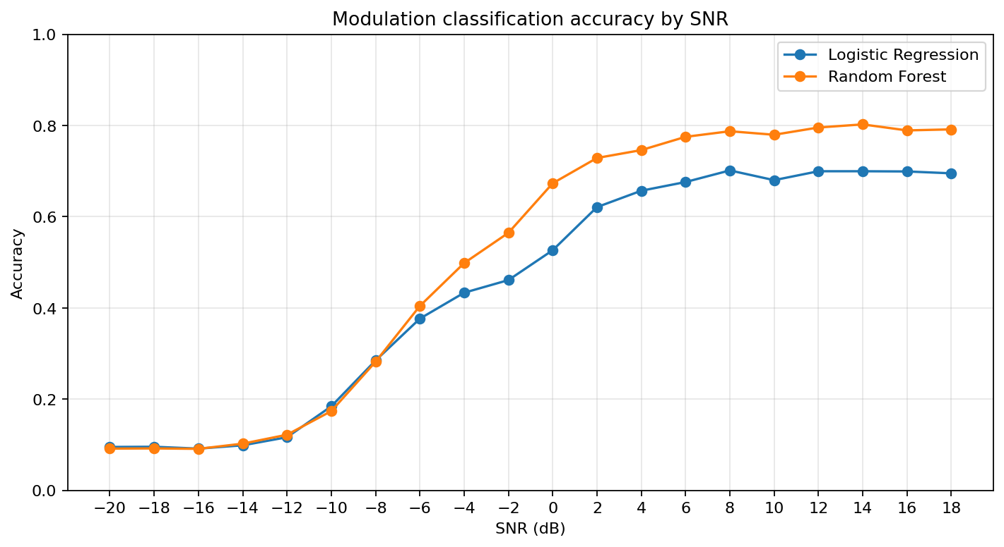
Figure 2. Test accuracy by SNR for both classifiers.
SNR | Random Forest accuracy | Operating interpretation
-20 dB | 9.1% | Near chance
-10 dB | 17.4% | Near chance
-6 dB | 40.4% | Transition region
0 dB | 67.3% | Transition region
6 dB | 77.5% | High-SNR plateau
12 dB | 79.5% | High-SNR plateau
18 dB | 79.1% | High-SNR plateau

The curve has three clear regions. Below approximately -14 dB, the extracted features contain little usable class information. Between -10 dB and 2 dB, accuracy rises rapidly as modulation structure emerges from the noise. Above approximately 6 dB, the forest plateaus near 78–80%. This plateau suggests that the remaining errors are caused primarily by representational limits rather than insufficient SNR.

Confusion analysis
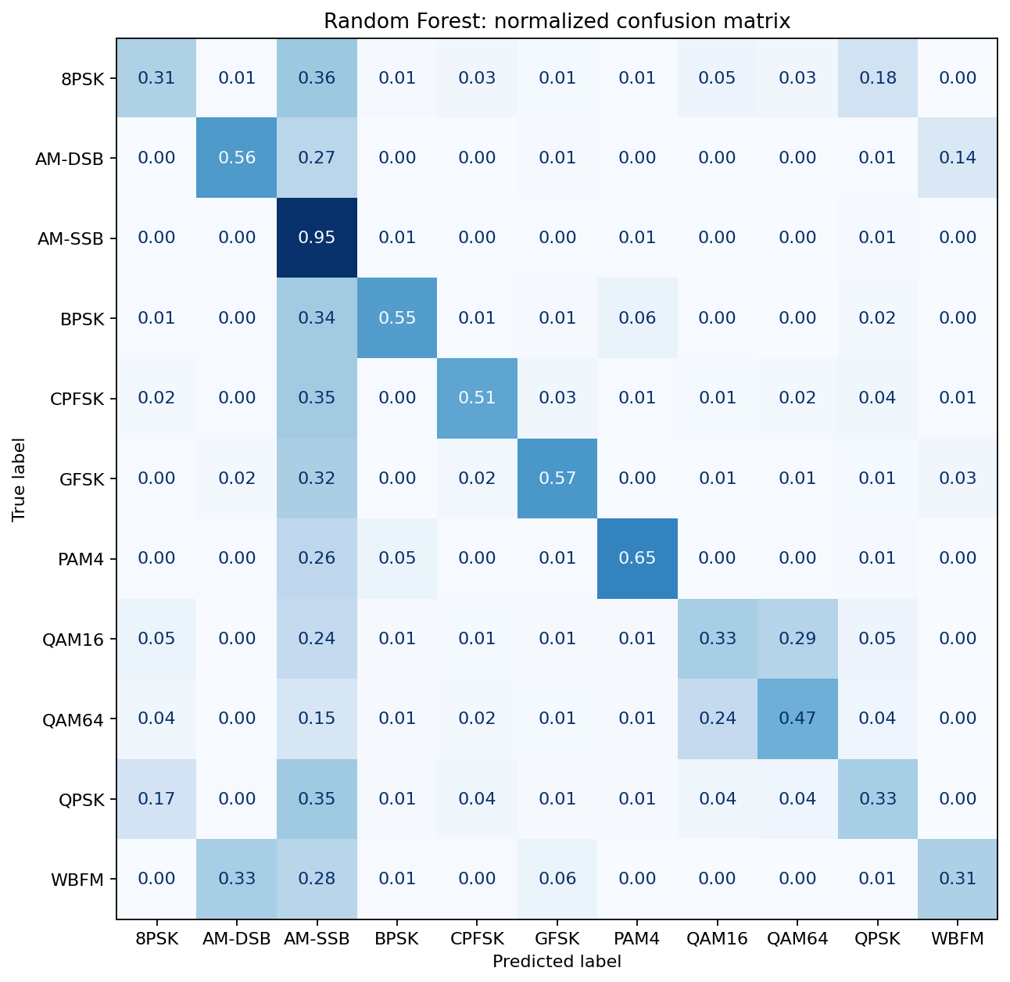
Figure 3. Random Forest confusion matrix, normalized by true class.

Feature importance
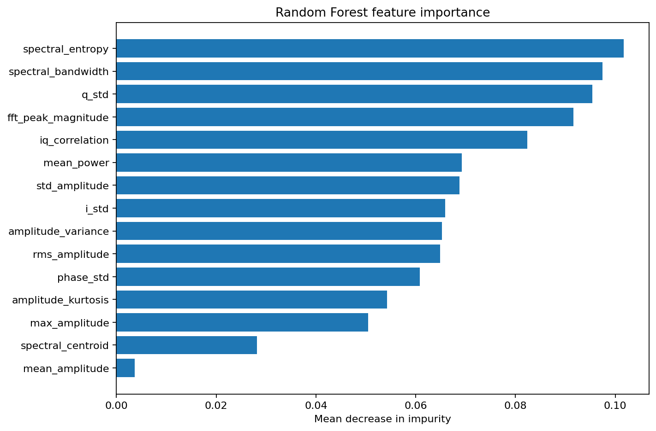
Figure 4. Random Forest mean-decrease-in-impurity feature importance.
Spectral entropy and spectral bandwidth are the leading features, followed by Q variation, FFT peak magnitude, and I/Q correlation. Mean amplitude contributes very little, matching the earlier observation that RadioML normalizes average magnitude. Importance values are diagnostic rather than causal: correlated measurements such as RMS amplitude and mean power can divide importance between themselves.

5. Anomaly detection
Isolation Forest was trained on a reproducible sample of 50,000 ordinary training examples using the same 15 features. It was not given modulation labels or anomaly labels. The detector returns a decision score: positive values are treated as normal and negative values as anomalous. A contamination setting of 2% establishes the operating threshold.
Test group | Mean score | Flagged anomalous | Result
Normal high-SNR signals | +0.087 | 3.3% | Low false-positive rate
Strong added noise | -0.094 | 100.0% | Detected
Threefold amplitude | -0.105 | 100.0% | Detected
Frequency offset | +0.076 | 2.7% | Mostly missed

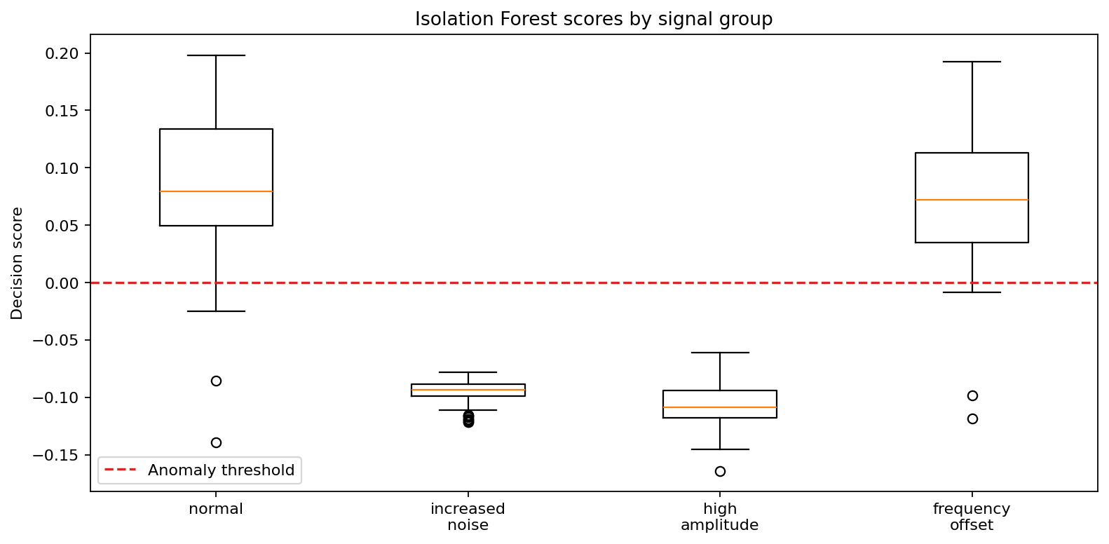
Figure 5. Isolation Forest score distributions. The dashed line marks the decision threshold.

Interpretation
Added noise and amplitude scaling move several features outside the training distribution, so they are isolated reliably. A pure frequency shift mainly changes spectral centroid while preserving amplitude, power, entropy, and bandwidth. The detector therefore accepts most shifted signals. In a practical spectrum-monitoring system, this unsupervised detector should be paired with explicit allowed-channel or carrier-frequency rules.

6. Inference and application
The reusable predict_signal(iq_signal, snr) function validates a (2, 128) input, extracts features, invokes the Random Forest classifier, obtains its maximum class probability, calculates an Isolation Forest decision score, and returns one dictionary. SNR is returned as context but is not provided to either model.
Output field | Meaning
predicted_modulation | Winning Random Forest class
confidence | Largest predicted class probability; not formally calibrated
anomaly_score | Isolation Forest decision score
is_anomaly | True when the anomaly prediction is -1
snr_db | Measurement context returned to the caller

Example behavior
Input | Prediction | Confidence | Anomaly result
QPSK at 18 dB | QPSK | 59.7% | Normal, score +0.137
QAM16 at -20 dB | AM-SSB | 26.8% | Normal, but uncertain class
Noisy QPSK variant | QAM64 | 16.4% | Anomaly, score -0.086

The noisy example illustrates why classification and anomaly detection are complementary. The classifier must select one of its 11 known classes, even when none is a good match. The anomaly detector supplies an additional warning that the feature vector lies outside the normal training distribution.

Streamlit dashboard
The local dashboard allows selection of modulation, SNR, and example index. It displays I/Q waveforms, amplitude, I/Q scatter, FFT magnitude, predicted class, confidence, anomaly score, the SNR accuracy curve, and the Random Forest confusion matrix. It calls the same inference function used by command-line tests, avoiding duplicate model logic.

7. Limitations and next steps

Reasonable extensions

8. Interview summary
I built a classical RF machine-learning pipeline on RadioML 2016.10a. Each input is a short complex baseband capture with 128 I/Q samples. I converted it into 15 interpretable amplitude, phase, correlation, and spectral features, then compared Logistic Regression with Random Forest using a split stratified by modulation and SNR. Random Forest reached 50.44% overall accuracy, but the key result was the SNR curve: performance was near chance at very low SNR and approximately 79% at 18 dB. Spectral entropy and bandwidth were the most useful features. I also added Isolation Forest to flag unusual feature combinations, and I documented that it detected strong noise and amplitude anomalies but usually missed pure frequency shifts. Finally, I wrapped classification and anomaly scoring in one inference function and a small Streamlit interface.

9. Reproduction
From the repository root, create the environment, set RADIOML_DATASET to the trusted pickle location, and run the following commands in order:
python scripts/explore.py "$RADIOML_DATASET"
python scripts/build_features.py "$RADIOML_DATASET"
python src/train.py
MPLBACKEND=Agg python src/evaluate.py
MPLBACKEND=Agg python src/anomaly.py "$RADIOML_DATASET"
streamlit run app.py

Artifact map
Location | Contents
data/ | Feature table and local dataset link
models/ | Classifier, split IDs, and anomaly detector
results/ | Metrics, reports, and figures
scripts/ | Exploration and feature-building commands
src/ | Feature extraction, training, evaluation, anomaly, and inference code

