

Windows Enforcer Policy enforcement using WFP

High Level Design Document : 1st Draft

09.27.2019

Overview
The current implementation of enforcing the policies using Firewall engine has the major issues:
- High CPU Usage by svchost.exe (Windows Advanced Firewall) while configuring the policies
- Time taken to configure the policies
This document describes the solution to solve the above mentioned issues using WFP filters.

Scope
The scope of this project is limited to Windows Tetration enforcer. Other components and communication between the components will remain the same. This project focuses on using WFP APIsI to enforce network policies but guarantees the same solution as the current one.

Current Implementation using Firewall API
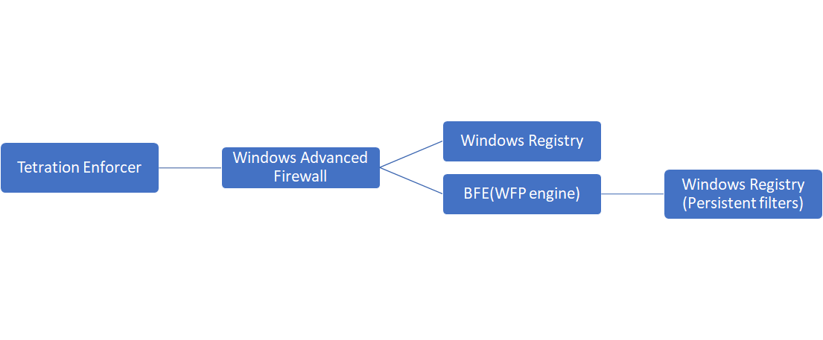

Problems with current policy enforcement

Scalability
- It is observed that CPU Utilization is very high while configuring firewall rules.svchost.exe (LocalServiceNoNetwork) consumes high CPU. Windows Firewall Service (mssvc) and BFE run under the same service. Both the services consume high CPU.
- Time taken to configure the rules increases with the number of firewall rules and complexity of the rules to be configured increase. Time is not linear with number of rules. Windows Firewall service validates the rule , checks the current profile settings against the rule , and creates a number of WFP filters.
- Firewall UI is unresponsive when too many rules are configured
This behavior is observed while configuring 1000 Firewall policies with multiple ip addresses defined for source or destination IP filtering
It takes 1.5 hr. to configure the rules with CPU usage more than 50%.

Please refer Windows Advanced Firewall Performance statistics:
https://drive.google.com/file/d/1nXMZ8ntZX-P3iFkoJF9FzRiOnZbcMHMR/view?ths=true

Number of WFP filters created by Firewall Rules
- Firewall Engine generates multiple WFP filters for a single firewall rule
Consider this rule :
src ip 172.10.1.5 and (dest port 80 or 443) and dest ip [10.0.0.1-10.0.05]
Firewall engine generates 2 filters:
Src IP 172.10.1.5 and Dest Port 80 and Dest IP [10.0.0.1-10.0.05]
Src IP 172.10.1.5 and Dest Port 443 and Dest IP [10.0.0.1-10.0.05]

Firewall Management using Group Policies
- Windows Enforcer cannot configure the firewall rules when Firewall configuration is controlled by group policies (Local or Domain).

Firewall State
- Windows Enforcer cannot configure the firewall rules when Firewall is disabled

Rules Priorities
- There is no control over prioritization of rules.

Proposed Solution using WFP Filters

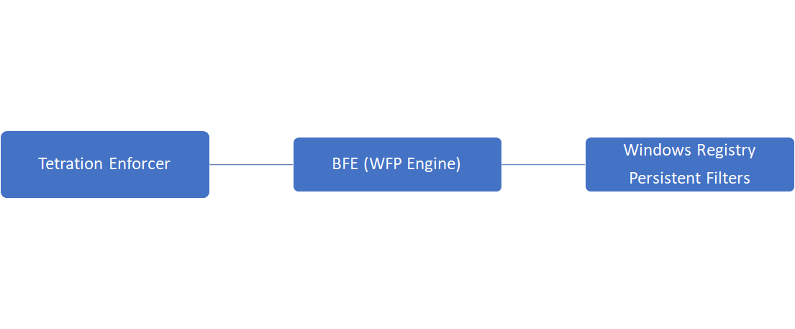

Pros
- WFP filtering takes less time and less CPU utilization to configure the policies. Please check the doc: https://drive.google.com/file/d/1YtKoLP-fx2L90bNOxC0aFhPs4tKTHtCY/view?usp=sharing
This addresses the current solution drawback of high CPU consumption while configuring the policies.
- Multiple rules can be added or deleted in a single transaction. This reduces the time taken to configure the rules, addressing the other drawback of the current solution.
- Fine control over filter configuration and management of network traffic filtering by defining our own sublayer and assigning proper weight to filters
- Firewall engine supports stateful filtering only. It is possible to do stateless filtering using WFP filters (same as Linux)
- Filter configuration does not depend on current Firewall state (network profiles) or Group Policies.

Cons
- WFP filters cannot be disabled like Firewall rules
- WFP Filters can not be deleted using filter Name
- As there is no UI, user does not have any visibility in the configured filters
We need to provide utilities like iptables to list , delete the configured filters.
- WFP filters can be configured even if 3rd party firewall is configured. But Network behavior will be unpredictable. If 3rd party firewall is using callout (kernel mode driver) it can override the filter actions. There is no visibility of the configured filters.

Platforms supported
WFP Filtering is supported by all OSs from Windows VISTA onwards.
We will start with Windows OS 2019 as the pilot OS and extend the support to other Windows Version. We will make sure that modules are compatible to other Window OS.

High level Design

Prerequisite
In 1st phase we will NOT support 3rd party firewall to reduce the conflicts and network anomalies. If 3rd party firewall is configured, it needs to be disabled.
We will support group policies. Group policies rules are visible using Firewall UI and it does not use callout. We will coexist with Windows advanced Firewall when “preserve_rule” = ON

User level WFP API
We will make sure that we are providing the same functionality as the current solution.
We will use user level WFP APIs to achieve the same Filtering will be done at ALE layer.It will be stateful filtering.
WFP objects provider, sublayer and fitters will be persistent.
All the filters generated by enforcer rules will belong to a sublayer. A sublayer will be linked to a provider.
To prevent port scanning, filters will be added at other layers. To block outbound ICMP destination unreachable message , filters will be added at OUTBOUND_ICMP_ERROR_V4 AND OUTBOUND_ICMP_ERROR_V6 layers. To block outbound TCP RESET, filters will be added at INBOUND_TRANSPORT_V4_DISCARD and INBOUND_TRANSPORT_V6_DISCARD layers.
If we encounter noticeable issues like run time high CPU usage, Network Performance degradation that cannot be resolved using user mode implementation, we will explore callouts(kernel level driver)

Note : We will NOT WORK as a 3rd party FIREWALL..

Controlling configured Firewall Rules
While configuring the policies , windows enforcer provides an option to preserve the already configured rules. Windows Enforcer either delete the configured firewall rules or keep the rules.
To preserve the rules for WFP filters
- In Domain or non-domain environment, Keep the current Firewall rules. Firewall rules are added to the default sublayer.
To delete the firewall rules
- In non Domain environment , disable firewall
- In Domain environment, use local group policies (if possible) to disable Domain policies.
For more information about AD and WFP :
https://tetration.atlassian.net/wiki/spaces/SEN/pages/376864769/Manage+WFP+filters+in+AD+environment

Components Affected

Windows Sensor Installation
For 1st release
- Windows Installer PowerShell script will provide the option to enforce the policies using Windows Firewall Engine or WFP filters
  - If Installer script is run with option “enforcer_type=WFP” Tetration enforcer will use WFP for policy configuration.
  - Default behavior will be the current one , use Windows Firewall.
- If user selects the WFP filter , installer script will not check the network profile state. The configuration will be saved in sensor_config.
- For upgrade , there will not be any changes in the upgrade script. For the 1st release, the default option will be “Windows Firewall”. If user wants to use WFP, sensor_config should be modified manually and restart the service.

Windows Enforcer
Note : The following steps will be executed ONLY IF “enforcement_enabled=true” in agent config file as it is done today

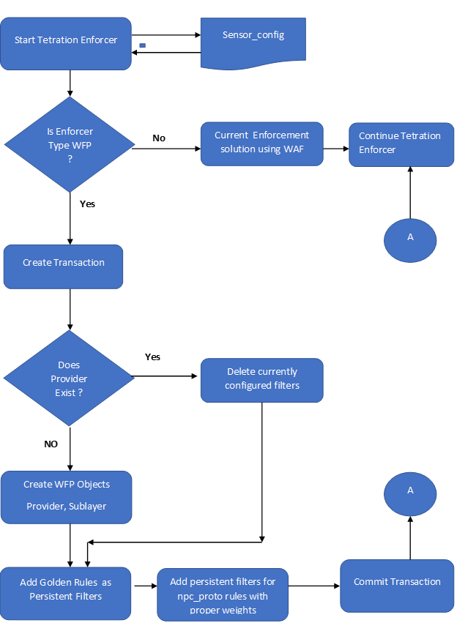
Details
- When Enforcer Service starts (after reboot or after upgrade or fresh install) it will read enforcement_type from sensor_config.
- If enforcement_type is WAF or enfocement_type is undefined, use windows advanced firewall to enforce the policies. (Default behavior)
- If enforcement_type is WFP
- Determine whether WFP is being used for the 1st time. It will be determined by the provider key.
- If provider key does not exist ( fresh install or upgrade from firewall to WFP or service restart )
  - Create a transaction
  - Create a Provider Object
  - Create a Sublayer
  - Add enforcer policy rule version as sublayer description
  - Link sublayer to provider key
  - Add golden rules as WFP Persistent filters
  - Link Filters to Provider key
  - Add a generic filter to bypass LISTEN traffic
  - Commit Transaction
  - FwpmFilterSubscribeChanges() to register a callback to notify filter changes to enforcer filters (add/delete)
  - Delete tetration enforcer policies implemented as “Firewall rules” if any exists.

- If provider key exists ( Windows enforcer service restart after upgrade or reboot or manual service restart)
  - Create a transaction
  - Delete already configured filters from the sublayer
  - Add golden rules as WFP Persistent filters
  - Add enforcer policies from npc_proto file as WFP persistent filters
  - Link Filters to Provider key
  - Add a generic filter to bypass LISTEN traffic
  - Commit Transaction
  - FwpmFilterSubscribeChanges() to register a callback to notify filter changes (add/delete)
  - Delete tetration enforcer policies implemented as “Firewall rules” if any exists.

- When enforcer service stops
  - The configured WFP filters WILL NOT be deleted when Windows agent service is stopped.
  - Configured callbacks will be unregistered.

- Switching from WFP to Windows Advanced Firewall may not work because using Windows Firewall API requires a specific firewall state.

Windows Sensor Uninstallation
- Delete WFP filters, sublayer , provider after stopping windows enforcer service.
- Enable Windows Firewall if disabled earlier

Filter Properties
- Every filter will be linked to Provider GUID.
- All the TET filters will belong to the same sublayer
- Filters will be configured in the same order the network policies are received from backend.
- All the filters will have exact weight.
- For a new filter , weight will be (weight assigned to last filter - 1).
- Sublayer will have weight As we do not have a callout , sublayer weight will not be important in decision making.

Deviation of enforced policies
- Deviation due to change in enforced Policies:
All the WFP filters will be added to a single sublayer. The changes in the enforced network policy will be detected by subscribing to the notifications.
- Create a session
- Create provider if it does not exist
- Add Sublayer if does not exist
- Add filters for policies
- Add rule_id -> filter_id mapping
- FwpmFilterSubscribeChanges - to detect changes for filters configured (Add or delete) .
- If a new filter is added to the sublayer by any 3rd party utility
  - Callback function will get called
  - Send the filter id and action (ADD) to the separate thread to handle it
  - The newly added filter information can be sent to backend
  - Delete the filter by filter id
- If filter is deleted by any 3rd party utility,
  - Callback function will get called
  - Send the filter id and action (DELETE) to the separate thread to handle it
  - Fetch rule_id by filter id
  - Add filter for the rule_id

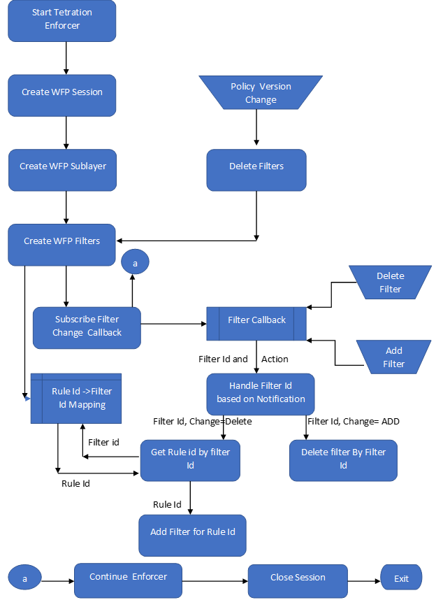

Deviation due to change in policy version:
- Create a transaction
- Delete the already configured filters from sublayer
- Add the new filters for network policies
- Add rule_id ->filter_id mapping
- Commit transaction

Debugging and Diagnosing Problems
For debugging and diagnosing purpose , we can use the Windows built-in utilities. We can provide our own customized utilities as well.
We will use Windows built-in utilities
- Netsh wfp commands to check currently configured filters
- Turn on audit log for packet drop or packet connection
- Turn on audit log for Policy changes like Filters added/deleted, sublayer changes

We will provide our own customized utilities to
- List all the filters configured by enforcer
Tet_wfp_utility.exe -l all
- List all the filters with action “block”
Tet_wfp_utility.exe -l action <block|permit>
- Delete specific filter by filter id or filter name
Tet_wfp_utility.exe -d filter id <filter id>
Tet_wfp_utility.exe -d filter name <filter name>
- Filter to NPC rule mapping

Major Tasks
Major tasks are
- Windows Installer - Define a flag to switch to use WFP and update sensor_config
- Windows Uninstaller - Delete WFP filters if enfocement_type “WFP”
- Windows Enforcer
  - Start Service :
Configure WFP objects (Provider, Sublayer)
Define Security descriptors and access control to prevent access to WFP objects
Generate WFP filters from Golden policies
Define other necessary filters (for socket listen and port scanning prevention)
  - Runtime :
Enumerate WFP objects
Delete WFP filters
Configure WFP filter from network policies in the optimal way
Weight assignment based on filter priorities
  - Deviation mechanism based on notifications
    - Define callbacks to notify changes in sublayer (add and delete)
    - Define callback to notify changes in filters (add and delete)
    - Trigger Deviation based on changes in WFP objects
  - Stop Service :
    - Unregister callbacks
  - Write the above mentioned utilities to assist debugging
- Performance (CPU , MEMORY , TIME) while configuring rules and runtime
- Testing with Domain Group Policies

Test Plan
- End to end testing
- Agent regression testing
- Domain based Testing
Test for all the supported Windows OS
Testing should be based on
- Number of rules (1 - 1000)
- Complexity of rules (ip range , port range, ip sets )
- Filtering for different networking packets (UDP , TCP. ICMP , IGMP, IPV4, IPV6 etc) Inbound and Outbound

Use 3rd party tools
- Iperf
- Nmap (port scanning)
- Wireshark
- ntttcp

Please follow Test cases:
https://tetration.atlassian.net/wiki/pages/resumedraft.action?draftId=367067333&atlOrigin=eyJpIjoiMWNhYTJiNjVjMGQ2NDkyOGIyNGFlOTkyMTIzZTNmMDEiLCJwIjoiYyJ9

References
WFP Overview
https://drive.google.com/file/d/1RnScvm51AlYReGLSRDaiEvWb_LXrMAjW/view?usp=sharing
WFP Architecture
https://docs.microsoft.com/en-us/windows/win32/fwp/windows-filtering-platform-architecture-overview
WFP auditing
https://docs.microsoft.com/en-us/windows/win32/fwp/auditing-and-logging

ALE Description
https://docs.microsoft.com/en-us/windows/win32/fwp/application-layer-enforcement--ale-
https://docs.microsoft.com/en-us/windows/win32/fwp/ale-stateful-filtering
User mode APIs - https://docs.microsoft.com/en-us/windows-hardware/drivers/network/wfp-user-mode-management-functions

AD and WFP
https://tetration.atlassian.net/wiki/spaces/SEN/pages/376864769/Manage+WFP+filters+in+AD+environment

Appendix
ALE - Application Layer Enforcement
BFE - BaseFiltering Engine
WAF - Windows Advanced Firewall
WFP - Windows Filtering Platform

