🏗️ ARIA — Complete Architecture Walkthrough
Here's the full architecture you can draw or explain on a whiteboard, organized in layers.

High-Level Flow
Raw Flight Data
↓
[1] DATA LAYER — PySpark + Delta Lake
↓
[2] ML LAYER — XGBoost Models + MLflow
↓
[3] MCP LAYER — Tool Registry + Client
↓
[4] ORCHESTRATION LAYER — LangGraph State Machine
↓
[5] PRESENTATION LAYER — Streamlit Dashboard
↓
Business Decision (Pricing Recommendation)

Layer-by-Layer Breakdown
1️⃣ Data Layer — Azure Databricks + PySpark + Delta Lake
Raw CSV/Synthetic Data
↓
PySpark DataFrame
↓ (clean, dedupe, filter outliers)
↓ (feature engineering: month, day_of_week, is_weekend,
↓ is_peak_hour, route, delay_category)
↓
Delta Lake Table: aria_flights
- ACID transactions
- Schema enforcement
- Time travel
- 500K records (designed to scale to 28M+)
Say this: "This is the Bronze-to-Silver transformation in medallion architecture terms — raw data cleaned and enriched into an analytics-ready Delta table."

2️⃣ ML Layer — XGBoost + MLflow
Delta Lake (aria_flights)
↓
┌──────────────┬──────────────┬──────────────┐
▼ ▼ ▼
Demand Model Pricing Model Revenue Model
(XGBoost) (XGBoost) (XGBoost)
R²=0.8843 R²=0.9969 R²=0.9999
│ │ │
└──────────────┴──────────────┘
↓
MLflow Tracking
- Experiment: /ARIA-Experiment
- Logged: params, metrics, model artifacts
- Versioned run IDs for reproducibility
Say this: "Each model solves a distinct business question — how many seats sell, what price to charge, what's the resulting revenue — rather than one monolithic model trying to do everything."

3️⃣ MCP Layer — Standardized Tool Communication
┌─────────────────────────────────────────────┐
│ MCP TOOL REGISTRY │
│ ┌─────────────┐ ┌──────────────┐ ┌────────┐│
│ │forecast_ │ │recommend_ │ │optimize││
│ │demand │ │price │ │_revenue││
│ │ │ │ │ │ ││
│ │schema + │ │schema + │ │schema +││
│ │connected: │ │connected: │ │connect:││
│ │Databricks, │ │Databricks, │ │Databr, ││
│ │MLflow, │ │MLflow │ │MLflow, ││
│ │Delta Lake │ │ │ │Delta ││
│ └─────────────┘ └──────────────┘ └────────┘│
└─────────────────────────────────────────────┘
↓
MCP CLIENT
mcp_client.call_tool(name, params)
- Standard interface for ALL tools
- Auto audit logging of every call
- Service status checks
Say this: "Agents never call forecast_demand() directly — they call mcp_client.call_tool('forecast_demand', params). This decouples agent logic from tool implementation, so adding a new tool — like a competitor-pricing scraper — doesn't require touching any agent code."

4️⃣ Orchestration Layer — LangGraph State Machine
ARIAState (shared TypedDict)
{route, month, day_of_week, ticket_price,
demand_result, pricing_result,
revenue_result, final_report}

START
↓
┌─────────────────┐
│ demand_agent_node│ → writes demand_result to state
└─────────────────┘
↓
┌─────────────────┐
│pricing_agent_node│ → reads demand_result.load_factor
│ │ writes pricing_result to state
└─────────────────┘
↓
┌─────────────────┐
│revenue_agent_node│ → reads demand + pricing results
│ │ writes revenue_result to state
└─────────────────┘
↓
┌─────────────────┐
│ report_agent_node│ → formats final business report
└─────────────────┘
↓
END
Say this: "Each node is a pure function: takes the state, does its job, returns an updated state. LangGraph manages execution order and state propagation — I just define the graph structure with add_edge() calls."

5️⃣ Presentation Layer — Dashboard
Streamlit / displayHTML Dashboard
- Sidebar: route, airline, date, capacity inputs
- KPI cards: seats predicted, recommended price, revenue
- Load factor gauge chart
- Price vs revenue curve
- Multi-route comparison table
- Agent execution trace (audit trail)

🖼️ Full System Diagram (How To Draw It)
Let me generate a visual diagram you can actually show in the interview.That's the full architecture you can point to during the interview — five layers, top to bottom: data, ML, MCP, orchestration, and presentation, with the explicit flow of how state moves through each stage.
A few things worth saying out loud while walking through it:
The data → ML boundary is where you'd mention medallion architecture if asked — raw data is your Bronze, the cleaned Delta table is Silver, and the trained models technically produce Gold-layer outputs (predictions/recommendations).
The MCP box sitting between ML and LangGraph is deliberate and worth emphasizing — it's not that LangGraph calls the models directly. The agents go through mcp_client.call_tool(), which is what lets you say "the orchestration layer doesn't know how a tool is implemented, only that it conforms to the registered schema."
The shared state object running through all four LangGraph nodes is the one detail interviewers tend to probe — be ready to explain that pricing_agent_node doesn't receive load_factor as a function argument passed manually; it reads it off the same state dict that demand_agent_node wrote to, because LangGraph merges each node's return value back into the graph's state.
If they ask you to extend this diagram live (e.g., "where would RAG fit in?"), the natural answer is a new tool registered in the MCP layer — something like retrieve_competitor_fares() backed by a vector store — that any node can call the same way, without touching the graph structure.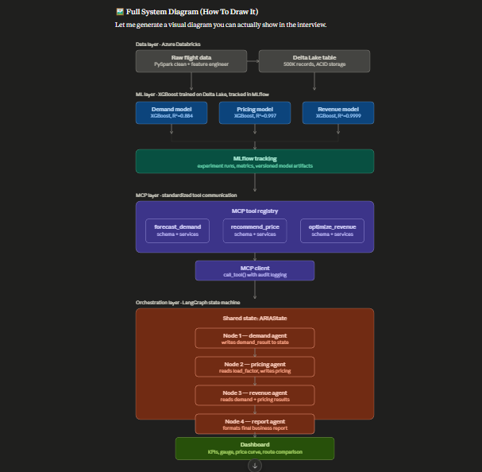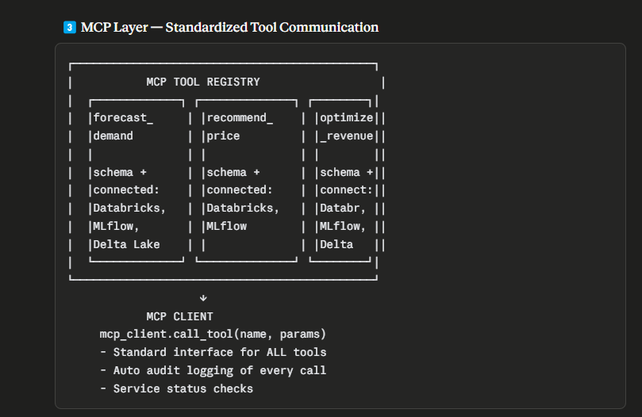
That's the full architecture you can point to during the interview — five layers, top to bottom: data, ML, MCP, orchestration, and presentation, with the explicit flow of how state moves through each stage.
A few things worth saying out loud while walking through it:
The data → ML boundary is where you'd mention medallion architecture if asked — raw data is your Bronze, the cleaned Delta table is Silver, and the trained models technically produce Gold-layer outputs (predictions/recommendations).
The MCP box sitting between ML and LangGraph is deliberate and worth emphasizing — it's not that LangGraph calls the models directly. The agents go through mcp_client.call_tool(), which is what lets you say "the orchestration layer doesn't know how a tool is implemented, only that it conforms to the registered schema."
The shared state object running through all four LangGraph nodes is the one detail interviewers tend to probe — be ready to explain that pricing_agent_node doesn't receive load_factor as a function argument passed manually; it reads it off the same state dict that demand_agent_node wrote to, because LangGraph merges each node's return value back into the graph's state.
If they ask you to extend this diagram live (e.g., "where would RAG fit in?"), the natural answer is a new tool registered in the MCP layer — something like retrieve_competitor_fares() backed by a vector store — that any node can call the same way, without touching the graph structure.
1. What is the real use case? (The problem ARIA solves)
Airlines sell a fixed, perishable resource — once a plane departs, an empty seat is revenue lost forever. Airline Revenue Management exists to answer one question continuously, for every flight, every day: "What price should this seat be sold at, right now, to maximize total revenue?"
That decision depends on three things working together:
"Today an airline revenue analyst has to manually pull booking data, eyeball demand trends, check competitor prices, and decide whether to raise or lower fares — across hundreds of routes, multiple times a day. It doesn't scale, it's slow, and it's inconsistent between analysts. ARIA replaces that manual judgment with an autonomous agent pipeline that does the same reasoning — forecast demand, decide a price, evaluate the revenue outcome — in under 3 minutes per route, consistently, at any scale."

2. What are the outputs / what do we achieve?
Be very concrete here — this is what they're actually listening for:
Output | What it tells the business
Predicted seats sold + load factor | How full will this flight actually be — not guessed, modeled
Recommended ticket price | The specific dollar figure to charge, not "raise prices a bit"
Predicted revenue + max possible revenue | The gap between what you're earning and what you could earn
Action recommendation (INCREASE PRICE / MAINTAIN / OPTIMAL) | A clear, automatic decision — no analyst judgment call needed
Audit trail of every agent decision | Why the system recommended what it did — needed for trust and compliance
"The end output isn't a dashboard for its own sake — it's a single actionable number: 'this route is underpriced by $145 a ticket, here's the recommended action.' That's the kind of decision a revenue analyst makes manually today, and ARIA produces it automatically, with the reasoning trace to back it up."

3. How is MCP connected? (This is the one they'll dig into)
This is the part to be precise about, because "I used MCP" without explaining the mechanics sounds like a buzzword. Here's the honest, structural answer:
MCP sits between your orchestration layer (LangGraph) and your actual ML models. It is not the agents themselves — it's the contract layer that lets agents call tools without knowing how those tools are implemented.
Concretely, in ARIA:
- Tool registry — each ML capability (forecast_demand, recommend_price, optimize_revenue) is registered as an MCP tool with a defined name, input schema, output schema, category, and a list of which backend services it depends on (Azure Databricks, MLflow, Delta Lake).
- MCP client — instead of a LangGraph node calling forecast_demand() as a raw Python function, it calls mcp_client.call_tool("forecast_demand", params). The client looks up the tool in the registry, validates it exists, executes it, and logs the call — params, result, timestamp — automatically.
- Why this matters structurally: the LangGraph node has zero knowledge of how demand forecasting works internally. If tomorrow you swap the XGBoost model for an LSTM, or move the model behind a Databricks Model Serving REST endpoint instead of an in-process function, the agent code doesn't change at all — only the registry entry's implementation changes. That's the actual value: decoupling agent orchestration from tool implementation.
"MCP is the layer that makes the system extensible. LangGraph decides the sequence of agent reasoning — demand, then pricing, then revenue. MCP is what each of those agents calls through, so adding a new capability — say, a competitor fare scraper — means registering a new tool, not rewriting any agent. In production this would be a real network-accessible MCP server, so even teams outside my own LangGraph graph could discover and call the same forecasting tool through the same protocol."

One-line answer if they want it tight:
"The use case is automating airline pricing decisions that are normally manual and slow. The output is a concrete price recommendation plus the projected revenue gap it closes. MCP is the standardized layer that lets the LangGraph agents call the underlying ML models — demand, pricing, revenue — without being coupled to how those models are implemented or where they're hosted."

