Bitmask TSP Route Planner
(Travelling Salesman Problem using Bitmask Dynamic Programming)
Project Report submitted for the partial fulfilment of grade for the course

Data Structures and Algorithms -3 (25CS2103E)
in

A.Y. 2026-2027

Submitted by
Chandra Prakash – 2500031353
Jashwanth – 2520030579
Muntha Krisha Vamshi Yadav – 2520030344

Team Number: 19
Section: 1

Under the guidance of

Dr. Anuradha

Professor, CSE

Hyderabad-500090, Telangana, India.

K L (Deemed to be) University
DEPARTMENT OF COMPUTER SCIENCE ENGINEERING / COMPUTER SCIENCE AND INFORMATION TECHNOLOGY/ARTIFICIAL INTELLIGENCE & DATA SCIENCE



DECLARATION

The Mini Project Report entitled “Bitmask TSP Route Planner” is a record of bona fide work carried out by Chandra Prakash – 2500031353, Jashwanth – 2520030579, and Muntha Krisha Vamshi Yadav – 2520030344, submitted in partial fulfilment of the requirements for the B.Tech programme at K L (Deemed to be) University. The work presented in this report is prepared for the course Data Structures and Algorithms - 3 (25CS2103E).

Chandra Prakash – 2500031353
Jashwanth – 2520030579
Muntha Krisha Vamshi Yadav – 2520030344

K L (Deemed to be) University
DEPARTMENT OF COMPUTER SCIENCE ENGINEERING / COMPUTER SCIENCE AND INFORMATION TECHNOLOGY
CERTIFICATE

This is to certify that the mini project report entitled “Bitmask TSP Route Planner” is a bona fide work done and submitted by Chandra Prakash – 2500031353, Jashwanth – 2520030579, and Muntha Krisha Vamshi Yadav – 2520030344 in partial fulfilment of the requirements for the award of the Bachelor of Technology degree at K L (Deemed to be) University during the academic year 2026–2027.

Signature of the Supervisor

Signature of the HOD Signature of the External Examiner

ACKNOWLEDGEMENT

We express our sincere gratitude to everyone who supported us during the development of this project. Their encouragement and assistance helped us complete the implementation and documentation.

We express our sincere appreciation to our project guide, Dr. Anuradha, Professor, CSE, for her guidance, feedback, and encouragement throughout the project.

We express our gratitude to Dr. P.Venkateshwar Rao (CSE)/Dr. Khaja Shareef (CSIT)/ Dr. Sreenath Itikela (AI&DS), Head of the Department for Computer Science Engineering/ Department for Computer Science and Information Technology/Department of Artificial Intelligence and Data Science for providing us with adequate facilities, ways and means by which we are able to complete this project-based Lab.

We thank the faculty and staff of K L (Deemed to be) University, our classmates, and our families for their support and cooperation throughout this project.

Chandra Prakash – 2500031353
Jashwanth – 2520030579
Muntha Krisha Vamshi Yadav – 2520030344

TABLE OF CONTENTS

S.No. | Contents | Page no.
1. | Abstract | 6
2. | Introduction | 7
3. | Literature survey | 8-9
4. | Problem Statement and Objectives | 10
5. | Hardware and Software requirements | 11
6. | Implementation | 12
7. | Results & Discussion | 13-14
8. | Conclusion & Future Scope | 15
9. | References | 16

1.ABSTRACT

The Bitmask TSP Route Planner is a Java application that solves the Travelling Salesman Problem (TSP), which asks for a minimum-cost cycle that visits every city exactly once and returns to the starting city. The application accepts city names and a travel-cost matrix as input, then uses Bitmask Dynamic Programming to explore subsets of visited cities without repeatedly solving the same subproblems. Each state records the minimum cost of reaching a particular current city after visiting the set represented by a bitmask. A parent table stores predecessor cities so that the optimal route can be reconstructed after the minimum cycle cost is found. The program displays the ordered route, total travel cost, and measured algorithm execution time. A Java Swing visualization draws the cities and connects them according to the computed route, making the result easier to understand. The implementation is modular: city data, the result object, the TSP solver, the visualizer, and the main input/output flow are separated into individual Java files. The algorithm runs in O(n²·2ⁿ) time and O(n·2ⁿ) auxiliary space, making it suitable for relatively small instances while illustrating an important dynamic-programming optimization technique. Future versions can expose the solver through a REST API and provide a web dashboard with interactive maps and saved route scenarios.
Team Name: Team 19 – Bitmask TSP Route Planner

Team Logo (if any): Not used

Team Members:
- Chandra Prakash – 2500031353
- Jashwanth – 2520030579
- Muntha Krisha Vamshi Yadav – 2520030344

- INTRODUCTION

The Travelling Salesman Problem is a classic combinatorial optimization problem. Given a set of cities and the travel cost between each pair, the goal is to find the least-cost tour that visits each city exactly once and returns to the starting point. A direct brute-force approach checks an enormous number of possible tours, so its running time grows factorially with the number of cities. This project implements a more systematic approach using Dynamic Programming with bitmasking.
In this implementation, each city is assigned an index, and a binary mask represents the subset of cities already visited. The DP table stores the best known cost for each visited subset and current city. Once all cities have been included, the solver adds the cost of returning to the starting city and reconstructs one optimal route using predecessor information. Java Swing is used to display the route. The report describes related approaches, the problem and objectives, implementation requirements, core modules, results, limitations, and possible future extensions.

- LITERATURE SURVEY
1. Held–Karp Dynamic Programming: Held and Karp's classic work established a dynamic-programming approach for sequencing problems, forming the basis for subset-based exact TSP algorithms. The method uses subsets and endpoint states to avoid redundant route calculations.
2. Bellman’s Dynamic Programming Principle: Bellman’s work explains how a large optimization problem can be divided into smaller overlapping subproblems and solved by reusing optimal substructure.
3. Google OR-Tools TSP Guide: OR-Tools documents practical routing models and demonstrates how route optimization is represented in software systems. It is a useful comparison point for extending this educational solver.
4. NetworkX Traveling Salesman Documentation: NetworkX provides graph-oriented TSP utilities and illustrates how a route can be represented and analyzed using graph data structures.
5. CP-Algorithms Bitmask Dynamic Programming: This resource explains bitmask DP patterns and subset-state transitions that are relevant to representing visited cities.
6. GeeksforGeeks TSP Using Dynamic Programming: This tutorial demonstrates the standard DP-with-bitmask formulation and helps compare recurrence relations and complexity.
7. Java Swing Tutorial: Oracle’s Swing documentation explains the GUI components and custom painting approach used to draw cities and route edges.
8. Java Collections Framework: The Java documentation describes List and ArrayList, which are used to store cities and reconstruct the route.
These sources provide background on exact TSP algorithms, bitmask state representation, graph modeling, and Java visualization. The current project is an educational implementation rather than a production navigation service.

- Problem Statement and Objectives

Problem Statement: A clear and specific articulation of the problem, outlining its importance.
To compute and visualize a minimum-cost TSP tour using Bitmask Dynamic Programming.

Problem Description: A concise explanation of the issue or challenge that needs to be solved.
Finding the best tour by checking every possible order becomes expensive as the number of cities increases. The project uses DP states and bitmasks to reduce repeated calculations and returns a complete cycle.
Objectives:
Identify the Project's Purpose:
Objectives:
• Accept city names and a square travel-cost matrix.
• Use a bitmask to represent the visited-city subset.
• Apply Dynamic Programming to calculate minimum costs for states.
• Reconstruct and display one optimal route and its total cost.
• Visualize the route using Java Swing.
• Report algorithm execution time and document complexity and limitations.

- HARDWARE AND SOFTWARE REQUIREMENTS
Hardware Requirements:
- • Computer/laptop capable of running Java.
- • Keyboard and display for console input and output.
- • No dedicated GPU or network connection required.
Software Requirements:
- • Windows, Linux, or macOS.
- • Java Development Kit (JDK 17 or compatible version).
- • Visual Studio Code or another Java IDE.
- • Java Swing (included with standard desktop JDK distributions).

- IMPLEMENTATION

Module 1 – DP state initialization and start state:
int totalMasks = 1 << n;
double[][] dp = new double[totalMasks][n];
int[][] parent = new int[totalMasks][n];
for (int mask = 0; mask < totalMasks; mask++) {
Arrays.fill(dp[mask], Double.POSITIVE_INFINITY);
Arrays.fill(parent[mask], -1);
}
dp[1][0] = 0;
Module 2 – Bitmask transition:
int newMask = mask | (1 << next);
double newCost = dp[mask][current] + distance[current][next];
if (newCost < dp[newMask][next]) {
dp[newMask][next] = newCost;
parent[newMask][next] = current;
}
Module 3 – Close the cycle:
int fullMask = totalMasks - 1;
for (int city = 1; city < n; city++) {
double totalCost = dp[fullMask][city] + distance[city][0];
// Keep the city with the smallest totalCost.
}
Module 4 – Route reconstruction and visualization:
// Follow parent[mask][current] backwards to city 0,
// reverse the recovered sequence, append city 0,
// then pass the path to RouteVisualizer.showRoute(cities, path).
The complete application is divided across Main.java, TSP.java, TSPResult.java, City.java, and RouteVisualizer.java. The code excerpts above show the key algorithmic modules; the full source code should be maintained in the project repository.

- RESULTS & DISCUSSION
Test case: 4 cities A, B, C, and D with the symmetric cost matrix:
0 10 15 20
10 0 35 25
15 35 0 30
20 25 30 0
Expected minimum tour cost: 80. One optimal route is A → B → D → C → A (the reverse cycle has the same cost for this symmetric matrix).
The console displays the optimal route, minimum cost, and execution time. The Swing window draws the cities and joins them in the order of the selected route.
SCREENSHOTS
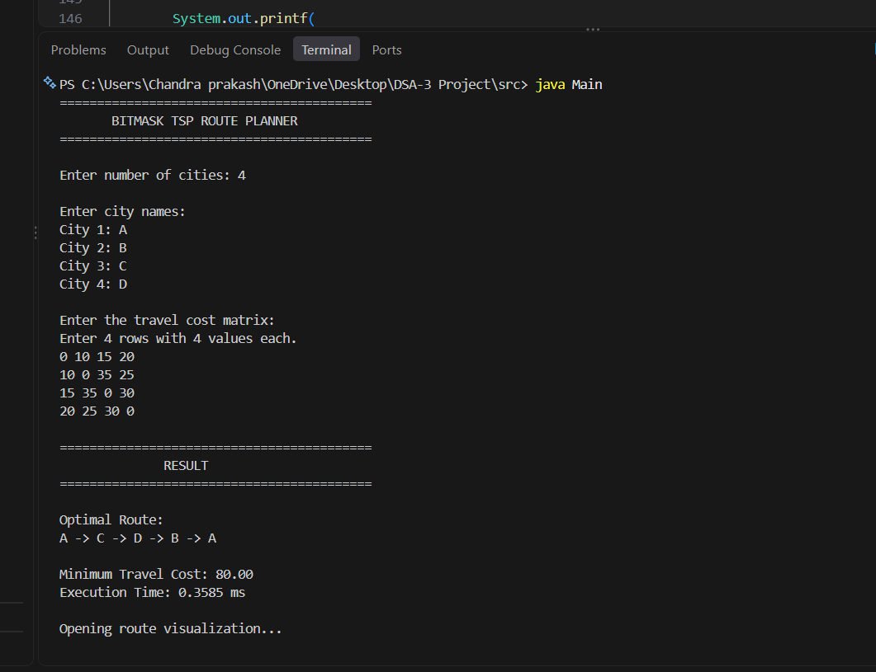

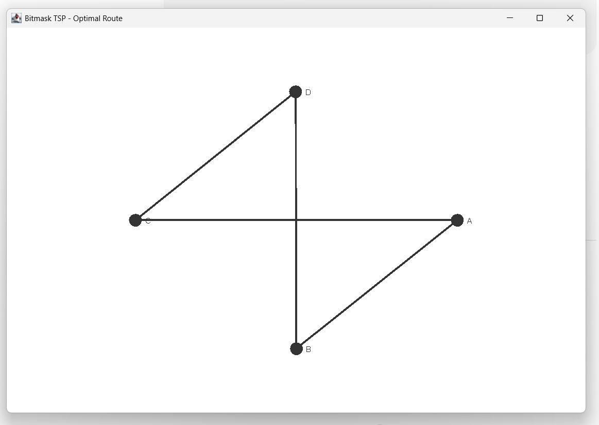

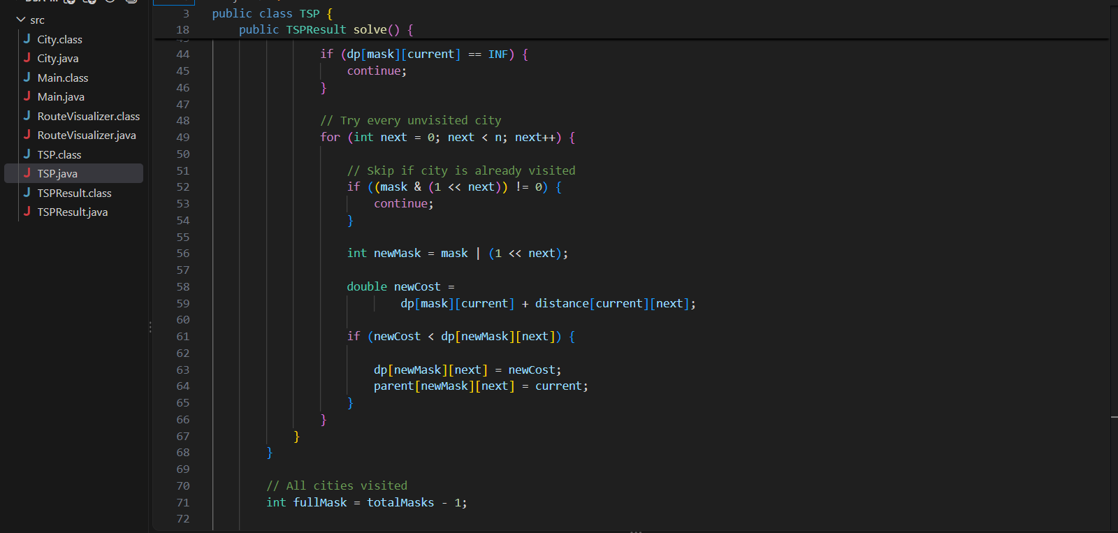

- CONCLUSION & FUTURE SCOPE
The Bitmask TSP Route Planner demonstrates how Dynamic Programming and bitmasking can solve the Travelling Salesman Problem exactly for small instances. The application accepts a cost matrix, computes the minimum-cost Hamiltonian cycle, reconstructs the route using predecessor information, and displays the result through a Java Swing visualization. Its modular Java design separates the algorithm from input/output and graphics, which makes the project easier to test and extend. The approach improves substantially over brute-force enumeration for suitable input sizes, although its exponential time and memory requirements remain a limitation.

Future Scope:
• Build a React/HTML/CSS dashboard for adding, editing, and removing cities.
• Create a Java Spring Boot REST API so the solver can be called by a frontend.
• Add interactive maps and coordinate-based distance calculations.
• Support importing/exporting city matrices as CSV or JSON.
• Add validation for invalid costs, missing routes, and excessively large inputs.
• Compare exact Bitmask DP with nearest-neighbour and other heuristic methods.
• Store previous route scenarios and results in a database.

- REFERENCES

1. Held, M. and Karp, R. M. (1962), A Dynamic Programming Approach to Sequencing Problems. https://doi.org/10.1002/nav.3800100110
2. Google OR-Tools, Traveling Salesperson Problem. https://developers.google.com/optimization/routing/tsp
3. NetworkX documentation, Traveling Salesman Problem. https://networkx.org/documentation/stable/reference/algorithms/generated/networkx.algorithms.approximation.traveling_salesman.traveling_salesman_problem.html
4. CP-Algorithms, Bitmask Dynamic Programming. https://cp-algorithms.com/dynamic_programming/bitmask.html
5. GeeksforGeeks, Travelling Salesman Problem using Dynamic Programming. https://www.geeksforgeeks.org/travelling-salesman-problem-using-dynamic-programming/
6. Oracle Java Tutorials, Performing Custom Painting / Swing. https://docs.oracle.com/javase/tutorial/uiswing/painting/
7. Oracle Java API, List. https://docs.oracle.com/en/java/javase/17/docs/api/java.base/java/util/List.html
8. Oracle Java API, ArrayList. https://docs.oracle.com/en/java/javase/17/docs/api/java.base/java/util/ArrayList.html
9. Wikipedia, Travelling Salesman Problem (background overview). https://en.wikipedia.org/wiki/Travelling_salesman_problem
10. Wikipedia, Held–Karp algorithm (background overview). https://en.wikipedia.org/wiki/Held%E2%80%93Karp_algorithm

