A CASE-STUDY BASED REPORT
ON
Student Academic Risk Prediction and Early Intervention Using Machine Learning
submitted in partial fulfilment of the requirements for the Course
MACHINE LEARNING
BACHELOR OF TECHNOLOGY
in
A.Y.: 2026-27
by
Name Chandra Prakash Verma roll 2500031353
Name Harshith Sirpuri roll 2520030572
Under the Esteemed guidance of
Mr. Shaik Asif
Asst.Professor, Dept. of CSE




INDEX
Abstract
Introduction
Background
Motivation for the Project
Overview of the Work Carried Out
Scope and Responsible-Use Statement
Problem Statement
Case-Study Scenario
Central Case-Study Question
Formal Problem Definition
Objectives that Guide the Study
Assumptions and Limitations
Dataset and Exploratory Data Analysis
About the Dataset
Purpose of EDA
Preparation Steps Actually Performed
EDA Exploration - Implementation
Summary of EDA Findings
Algorithm Selection and Implementation
Results and Graphs
Conclusion
References
ABSTRACT
The Student Academic Risk Prediction and Early Intervention System is a supervised machine-learning prototype that estimates whether a student belongs to an At-Risk or Not-At-Risk class using six academic indicators: attendance percentage, previous grades, assignment performance, internal marks, participation score, and backlog subjects. The case study demonstrates a complete workflow from dataset inspection and exploratory data analysis (EDA) to preprocessing, model training, evaluation, and prediction for a new student. The project uses a synthetic dataset containing 1,000 records and seven columns: six numerical input features and one categorical binary target, At_Risk. EDA checks the dataset structure, target balance, missing values, duplicate rows, feature distributions, and relationships among variables. The data is divided into 80% training and 20% testing subsets using stratification. StandardScaler is fitted only on the training data, and its learned parameters are applied to the training, test, and new-student records. Logistic Regression learns coefficients from the training data and converts a weighted sum into an estimated probability through the sigmoid function. A baseline threshold of 0.50 converts the probability to a YES/NO output. On the 200-record synthetic test split, the model achieved 88.50% accuracy, 87.38% precision, 90.00% recall, and 88.67% F1-score. The results demonstrate the implementation pipeline but do not establish real-world institutional performance. Real/public-data validation, threshold evaluation, and model comparison are recommended before any operational use.
Keywords: student academic risk; supervised learning; binary classification; Logistic Regression; StandardScaler; exploratory data analysis; early-warning decision support.
1. INTRODUCTION
1.1 Background
Educational institutions collect many academic indicators, including attendance, marks, assignment performance, classroom participation, and backlog history. Reviewing these indicators one by one for many students can be time-consuming. A machine-learning classifier can combine multiple indicators and produce a consistent early-warning signal that faculty can review alongside other relevant information.
1.2 Motivation for the Project
The motivation is to demonstrate how supervised learning can assist with early identification of students who may benefit from additional academic support. The intended use is to help prioritize human review and support such as tutoring, attendance follow-up, or access to learning resources. A prediction must not be treated as a definitive judgment about a student.
1.3 Overview of the Work Carried Out
The work includes loading and inspecting a CSV dataset, checking missing values and duplicates, examining class balance, plotting feature distributions and correlations, creating a stratified train/test split, standardizing inputs, fitting Logistic Regression, evaluating predictions, and demonstrating a new-student prediction. The report also records model parameters, performance graphs, and limitations so that the workflow can be reproduced and reviewed.
1.4 Related Research Context
Martins et al. [1] studied early prediction of higher-education student outcomes using enrollment-time academic, demographic, and socio-economic information. Their work highlights the challenge of class imbalance and the need to look beyond accuracy alone. Yakubu and Abubakar [2] used university student-information-system data to predict CGPA-based academic success and included Logistic Regression among their approaches; its variables and findings are specific to the study context. Villar and de Andrade [3] compared several supervised algorithms for dropout and academic-success prediction, reporting strong results from tuned boosting models and examining imbalance handling and explainability. These studies support the relevance of student-outcome prediction, while their institution-specific data and differing target definitions limit direct comparison with the present synthetic binary prototype.
1.5 Scope and Responsible-Use Statement
This case study is a prototype using synthetic data, not a deployed student-monitoring system. It does not use real student records, and its metrics must not be generalized to a real institution. If developed further, the system should be validated on a suitable dataset, reviewed for bias and reliability, protected against unauthorized disclosure, and used only to support—not replace—faculty judgment.
2. PROBLEM STATEMENT
2.1 Case-Study Scenario
Consider a college department that wants to identify students who may be experiencing academic difficulty before a major examination or semester outcome. Faculty can examine six indicators—attendance, previous grades, assignment performance, internal marks, participation, and backlogs. The proposed prototype combines these indicators and returns an estimated probability and a binary At-Risk / Not-At-Risk result. Faculty may use that output as a prompt for a supportive review, not as an automatic disciplinary or academic decision.
2.2 Central Case-Study Question
Can a Logistic Regression classifier, trained on six academic indicators in a labelled synthetic dataset, predict the At_Risk = Yes/No label on held-out records and provide an interpretable baseline for an early-warning workflow?
2.3 Formal Problem Definition
Each record is represented by a feature vector x = (x1, x2, x3, x4, x5, x6), where the six components are the numerical academic indicators. The target y belongs to {0, 1}, with No mapped to 0 and Yes mapped to 1. The task is supervised binary classification. Logistic Regression calculates a score from the standardized features, converts it to P(y = 1), and assigns YES when the probability is at least 0.50; otherwise, it assigns NO.
2.4 Objectives that Guide the Study
• Inspect the structure, type, completeness, and distribution of the student dataset.
• Use EDA graphs to understand class balance and feature-level patterns.
• Apply an 80:20 stratified split and fit StandardScaler using training data only.
• Train Logistic Regression and report learned coefficients and intercept.
• Evaluate the held-out test predictions with accuracy, precision, recall, F1-score, and a confusion matrix.
• Demonstrate an end-to-end prediction for a new student and document assumptions and limitations.
2.5 Assumptions and Limitations
The labels are synthetic and were prepared for prototype demonstration; they are not verified institutional outcomes. The 0.50 threshold is a baseline decision threshold, not a threshold optimized through a separate validation study. Only one primary classifier is used. The model has not been externally validated, and an estimated probability should not be interpreted as a calibrated real-world risk percentage without additional evaluation.
3. DATASET AND EXPLORATORY DATA ANALYSIS
3.1 About the Dataset
The project dataset, Student_Academic_Risk_Dataset.csv, contains 1,000 synthetic student records and seven columns. Six columns are numerical inputs; At_Risk is the categorical binary target. The target distribution is balanced at 500 No and 500 Yes records.
Column | Type | Role / Meaning
Attendance_Percentage | Numerical | Percentage of classes attended
Previous_Grades | Numerical | Previous academic performance
Assignment_Performance | Numerical | Assignment performance indicator
Internal_Marks | Numerical | Internal assessment marks
Participation_Score | Numerical | Participation score on a 1–10 scale
Backlog_Subjects | Numerical | Count of backlog subjects
At_Risk | Categorical (binary) | Target: No = Not At Risk; Yes = At Risk

3.2 Data Quality Checks
Check | Observed result | Interpretation
Shape | (1000, 7) | 1,000 records and 7 columns
Missing values | 0 | No missing cells detected
Duplicate rows | 0 | No exact duplicate records detected
Target classes | No: 500; Yes: 500 | Balanced class counts
Training / testing | 800 / 200 | 80% train and 20% test; stratified split

3.3 Descriptive Statistics
Feature | Mean | Std. dev. | Min | Median | Max
Attendance Percentage | 74.60 | 11.68 | 40.00 | 75.10 | 100.00
Previous Grades | 63.81 | 14.98 | 30.00 | 64.35 | 100.00
Assignment Performance | 68.41 | 14.92 | 30.00 | 68.55 | 100.00
Internal Marks | 65.93 | 13.54 | 27.50 | 65.90 | 100.00
Participation Score | 5.95 | 1.94 | 1.00 | 6.00 | 10.00
Backlog Subjects | 1.18 | 1.06 | 0.00 | 1.00 | 5.00

Purpose of these checks: establish that the CSV is readable and complete, understand feature scales, and identify the target distribution before model training. These summary statistics describe the generated prototype dataset only.
3.4 EDA Exploration - Implementation
EDA was performed using Python, pandas, and Matplotlib. The following core checks were run before training; the full application also displays feature-level plots and the correlation matrix.
df = pd.read_csv("Student_Academic_Risk_Dataset.csv")
print(df.shape)
print(df.isnull().sum())
print(df.duplicated().sum())
print(df["At_Risk"].value_counts())
EDA Visual Findings
Figure 1. Target Class Distribution
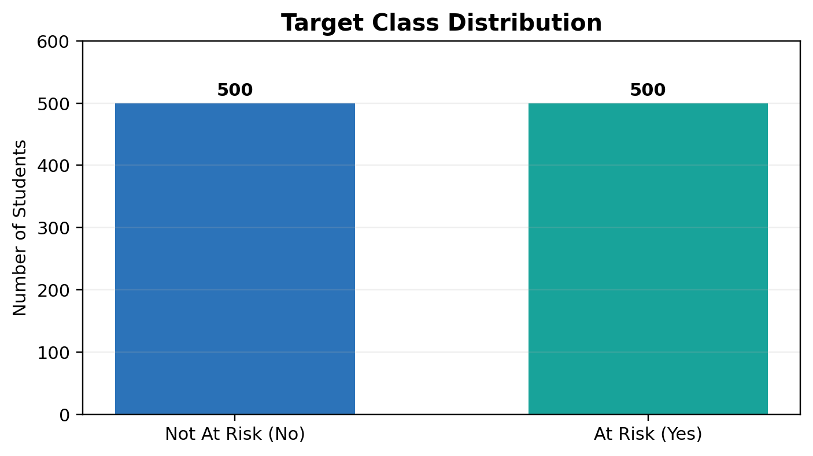
Figure 1. Equal representation of the two target classes: 500 Not At Risk and 500 At Risk records.
Interpretation: the two target classes have equal counts in this synthetic dataset. Balance does not guarantee strong predictive performance.
Figure 2. Attendance Distribution by Risk Class
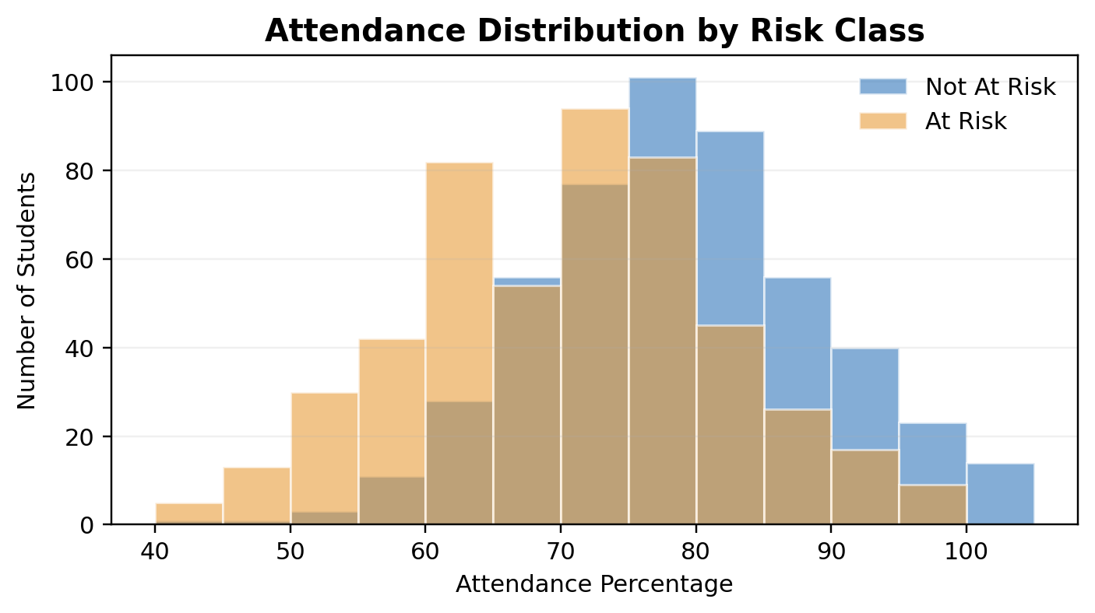
Figure 2. Attendance distributions overlap; the At-Risk group has lower average attendance in this generated dataset.
In the dataset, mean attendance is 78.73% for Not At Risk and 70.47% for At Risk. The overlap shows why attendance alone is not enough to classify every student.
3.5 Summary of EDA Findings
Figure 3. Backlogs vs Risk Class
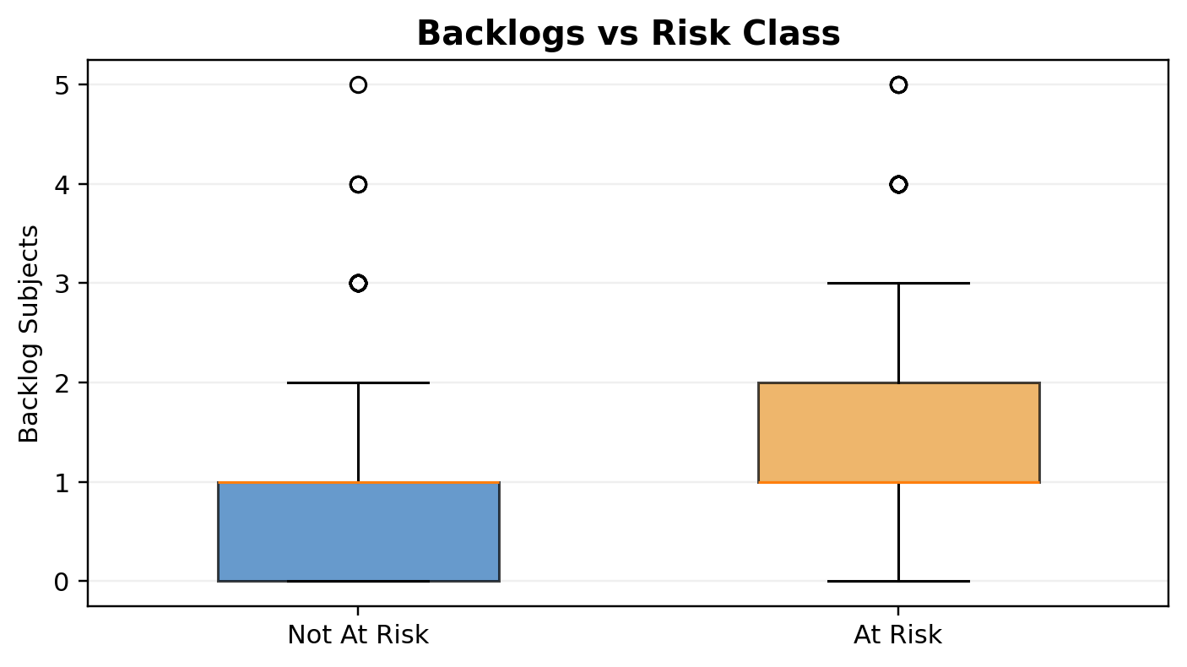
Figure 3. Boxplot comparing backlog counts in the Not-At-Risk and At-Risk groups.
Mean backlog count is 0.822 for Not At Risk and 1.532 for At Risk. This describes association, not causation.
Figure 4. Correlation Matrix of Numerical Features
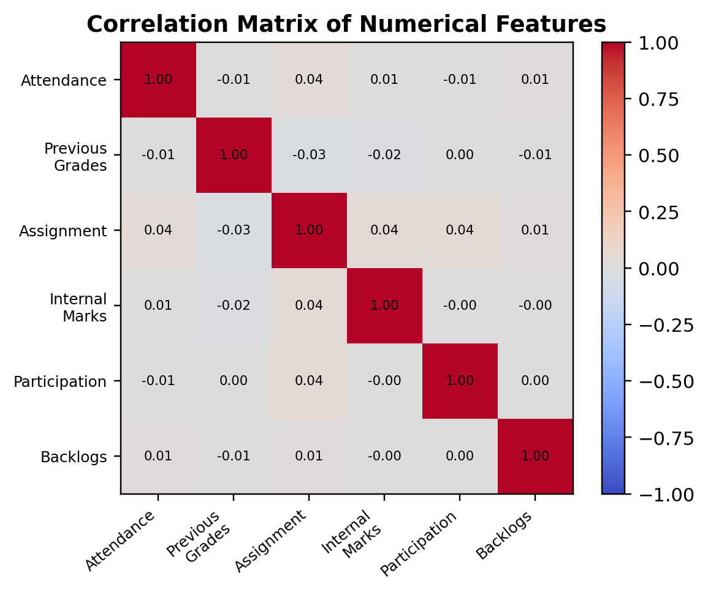
Figure 4. Pairwise correlations among the six numerical input features; the diagonal equals 1 because each feature is correlated with itself.
The off-diagonal feature-to-feature correlations are close to zero, indicating little evidence of strong pairwise linear association. The matrix includes only input features, not the At_Risk target; near-zero correlation does not rule out nonlinear relationships.
Overall EDA Findings
• The dataset has 1,000 records, six numerical predictors, and one binary categorical target.
• No missing values or exact duplicate rows were detected; target counts are 500 No and 500 Yes.
• At-Risk records have lower average attendance and higher average backlog counts in this synthetic dataset.
• Feature distributions overlap, so the model uses all six indicators instead of a single feature.
4. ALGORITHM SELECTION AND IMPLEMENTATION
4.1 Learning Type and Algorithm Choice
The project uses supervised learning because each training record has a known At_Risk label. The task is binary classification, and Logistic Regression was selected as an interpretable baseline that provides class probabilities and is aligned with the current Machine Learning syllabus. More complex models may be evaluated in future work.
4.2 Preprocessing and Train/Test Split
The target is encoded as No = 0 and Yes = 1. train_test_split uses test_size = 0.20, stratify = y, and random_state = 42, creating 800 training records and 200 test records. StandardScaler learns the means and standard deviations from the 800 training records using fit_transform. The same scaler then transforms the training and test inputs. It is not fitted on the test set, which avoids using test-set information during preprocessing.
x_scaled = (x − μ) / σ
4.3 Logistic Regression Calculation
During model.fit(), Logistic Regression learns the coefficients and intercept that optimize its classification objective on the training records. For a new record, it calculates a weighted sum of the standardized features and applies the sigmoid function to obtain a probability.
z = b₀ + b₁x₁ + b₂x₂ + … + b₆x₆
P(At Risk) = 1 / (1 + e^(−z))
The baseline decision rule is P(At Risk) ≥ 0.50 → YES; otherwise → NO. The value 0.50 is a probability-to-class threshold, not an input feature or a separately calculated risk score. It has not been optimized on a separate validation set.
4.4 Core Training Code
X = df[features]
y = df["At_Risk"].map({"No": 0, "Yes": 1})

X_train, X_test, y_train, y_test = train_test_split(
X, y, test_size=0.20, stratify=y, random_state=42
)
scaler = StandardScaler()
X_train_scaled = scaler.fit_transform(X_train)
X_test_scaled = scaler.transform(X_test)

model = LogisticRegression(random_state=42)
model.fit(X_train_scaled, y_train)
y_pred = model.predict(X_test_scaled)
y_prob = model.predict_proba(X_test_scaled)[:, 1]
4.5 Example Prediction
For the example student (attendance 55, previous grades 45, assignment performance 48, internal marks 42, participation 2, backlogs 3), the training-set scaler produces standardized values of approximately −1.7145, −1.2349, −1.3476, −1.7821, −1.9851, and +1.7229. Applying the learned coefficients gives z ≈ 9.0271; the sigmoid probability is approximately 0.99988 (99.99%). Since this exceeds 0.50, the prototype predicts YES — At Risk. The prediction is an example from synthetic data, not a verified assessment of a real student.
5. WORKED EXAMPLE AND SCALER PARAMETERS
StandardScaler uses the training-set mean and scale (standard deviation in this dataset) from the 800 training records, not the statistics calculated over all 1,000 records. The values below reproduce the preprocessing step used for the example student.
Feature | Raw value | Training mean (μ) | Training std (σ) | Scaled value
Attendance Percentage | 55 | 74.86225 | 11.58473 | -1.7145
Previous Grades | 45 | 63.72100 | 15.15947 | -1.2349
Assignment Performance | 48 | 68.32413 | 15.08191 | -1.3476
Internal Marks | 42 | 66.32138 | 13.64777 | -1.7821
Participation Score | 2 | 5.88125 | 1.95515 | -1.9851
Backlog Subjects | 3 | 1.17375 | 1.05998 | 1.7229

Weighted Sum
z = 0.05145 + (-1.26624 × -1.7145) + (-0.91054 × -1.2349) + (-0.65599 × -1.3476) + (-0.90048 × -1.7821) + (-0.44002 × -1.9851) + (1.34537 × 1.7229)
z ≈ 9.0271
Sigmoid Probability and Decision
P(At Risk) = 1 / (1 + e^(−9.0271)) ≈ 0.99988 = 99.99%
P(At Risk) ≥ 0.50 → Prediction = YES (At Risk)
This calculation shows the complete prediction path: raw inputs → StandardScaler → learned coefficients and intercept → weighted sum → sigmoid probability → 0.50 threshold → binary result.
6. RESULTS AND GRAPHS
The model is evaluated on the held-out 20% test split (200 records). All numbers and plots below are produced by the fixed stratified split with random_state = 42 and the trained Logistic Regression pipeline.
Metric | Formula / meaning | Observed result
Accuracy | (TP + TN) / Total | 88.50%
Precision | TP / (TP + FP) | 87.38%
Recall | TP / (TP + FN) | 90.00%
F1-score | 2 × Precision × Recall / (Precision + Recall) | 88.67%

Confusion Matrix and Performance Metrics
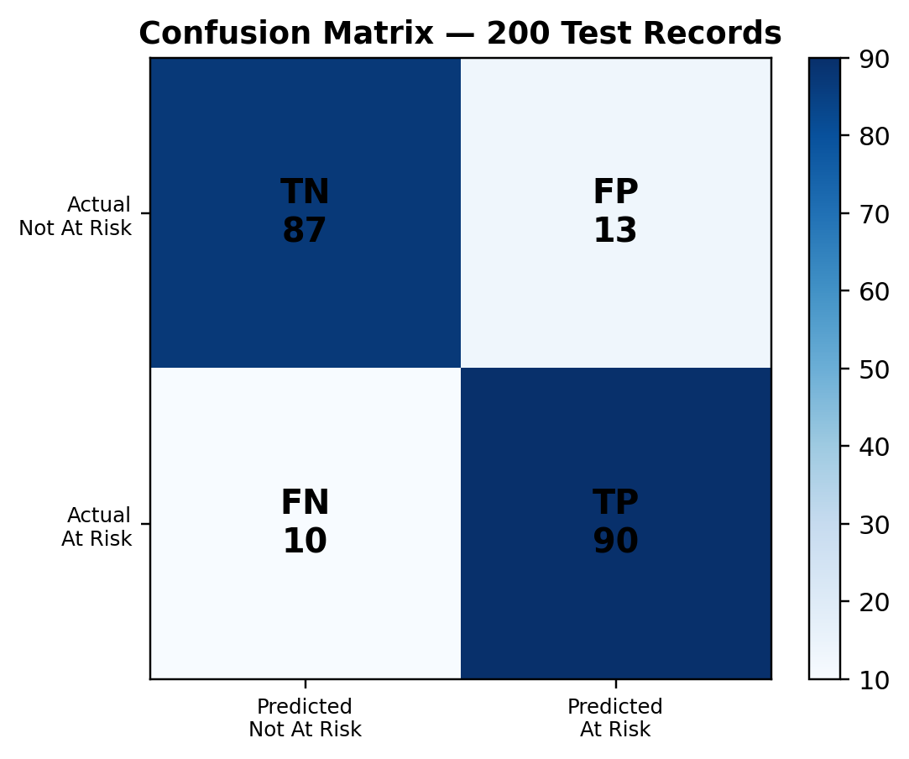  Figure 5. Confusion matrix: TN = 87, FP = 13, FN = 10, TP = 90. | 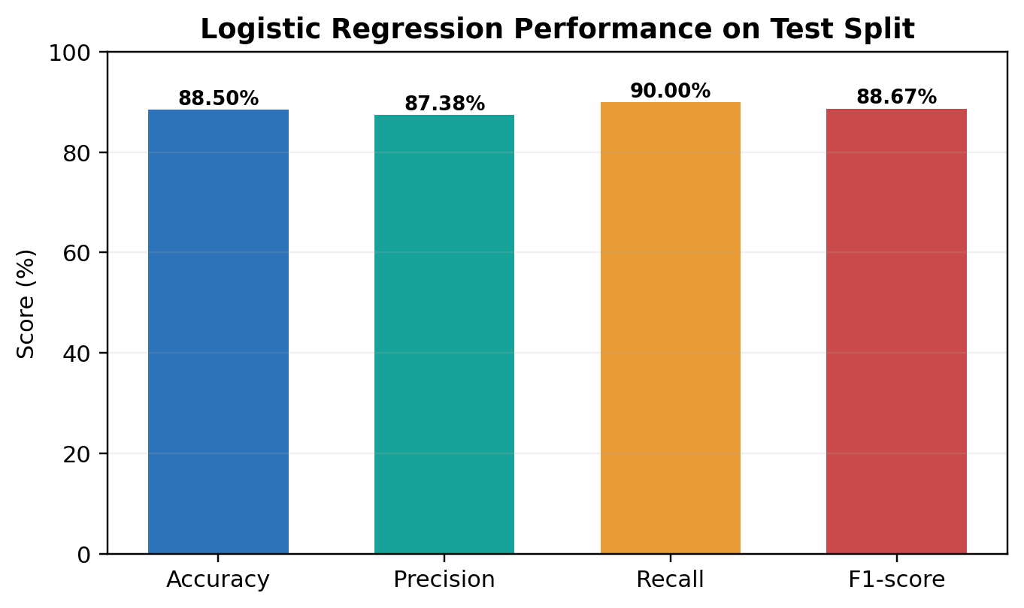  Figure 6. Accuracy, precision, recall, and F1-score on the synthetic test split.

The model correctly classified 87 Not-At-Risk records (true negatives) and 90 At-Risk records (true positives). It produced 13 false positives and 10 false negatives. Thus, 177 of 200 records were classified correctly, giving 88.50% accuracy. Recall is particularly relevant for an early-warning use case because false negatives represent At-Risk-labelled records that the model predicts as Not At Risk. Precision also matters because false positives can trigger unnecessary follow-up. These results require validation on suitable real/public data before operational use.
6.1 MODEL COEFFICIENTS AND INTERPRETATION
Model parameter | Learned value
Attendance Percentage | -1.26624
Previous Grades | -0.91054
Assignment Performance | -0.65599
Internal Marks | -0.90048
Participation Score | -0.44002
Backlog Subjects | +1.34537
Intercept | +0.05145

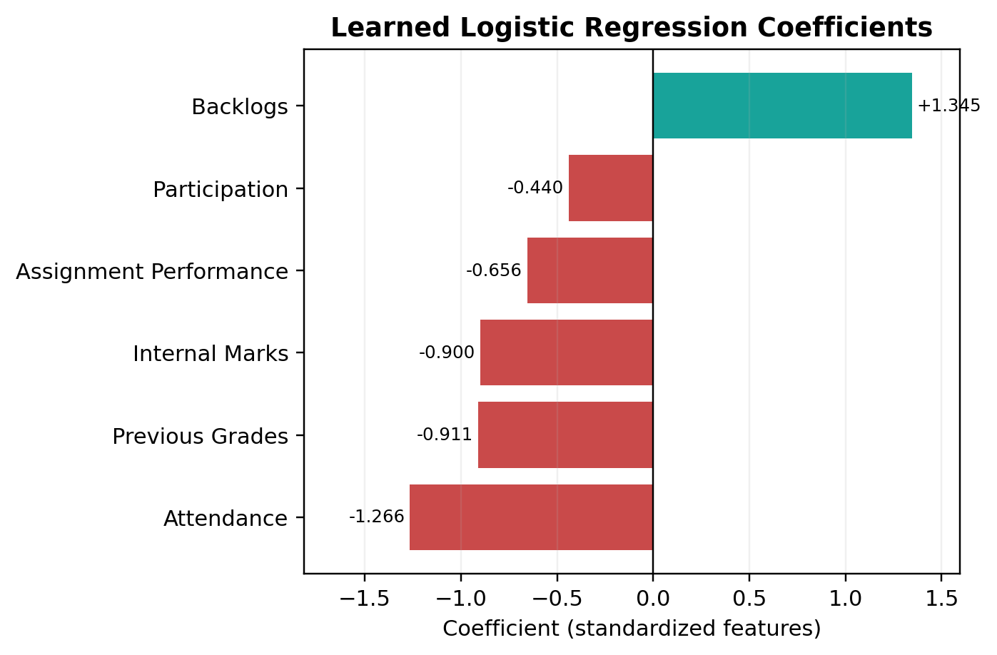
Figure 7. Learned Logistic Regression coefficients for the standardized input features.
Positive coefficients indicate that higher values of the corresponding standardized feature are associated with higher At-Risk log-odds, holding other features constant. Negative coefficients indicate the opposite direction. In this trained model, Backlog Subjects has a positive coefficient (+1.34537), while Attendance, Previous Grades, Assignment Performance, Internal Marks, and Participation have negative coefficients. Coefficients are learned automatically during model.fit(); they are not manually assigned. Coefficient signs and magnitudes describe this trained synthetic-data model and should not be treated as causal effects.
Interpretation of the Result
The worked example obtains 99.99% predicted probability because the six input values form a strong At-Risk pattern under the learned parameters. This probability is model output, not a guarantee of academic failure. A 0.50 threshold is used as a baseline; changing it can change the precision/recall trade-off. Threshold selection should be evaluated on appropriate validation data before real-world use.
7. CONCLUSION
This case study demonstrates an end-to-end supervised-learning workflow for a Student Academic Risk Prediction System. A 1,000-record synthetic dataset was inspected using EDA, checked for missing values and duplicates, and split into 800 training and 200 test records using stratification. StandardScaler was fitted on the training data only. Logistic Regression learned six feature coefficients and an intercept, generated probabilities through the sigmoid function, and used a 0.50 baseline threshold to provide a binary YES/NO prediction.
On the synthetic test split, the model achieved 88.50% accuracy, 87.38% precision, 90.00% recall, and 88.67% F1-score. The confusion matrix and performance graphs document both correct predictions and errors. EDA showed a balanced target and differences in mean attendance and backlog counts between classes, but the overlapping distributions confirm that no single feature fully separates the target classes.
Limitations and Future Work
• The dataset is synthetic; these metrics are not evidence of real-world institutional performance.
• The 0.50 decision threshold is a baseline and has not been optimized using validation data.
• Only Logistic Regression is reported as the main baseline; future work can compare Decision Tree, Random Forest, and boosting models.
• A suitable real or public dataset should be used for external validation, fairness review, and probability calibration before any operational deployment.
• The system should support human review and academic assistance rather than automatically making consequential decisions about students.
REFERENCES
[1] M. V. Martins, D. Tolledo, J. Machado, L. M. T. Baptista, and V. Realinho, “Early Prediction of Student’s Performance in Higher Education: A Case Study,” in Trends and Applications in Information Systems and Technologies, 2021. DOI: https://doi.org/10.1007/978-3-030-72657-7_16
[2] M. N. Yakubu and A. M. Abubakar, “Applying machine learning approach to predict students’ performance in higher educational institutions,” Kybernetes, vol. 51, no. 2, pp. 916–934, 2021. DOI: https://doi.org/10.1108/K-12-2020-0865
[3] A. Villar and C. R. V. de Andrade, “Supervised machine learning algorithms for predicting student dropout and academic success: a comparative study,” Discover Artificial Intelligence, vol. 4, article 2, 2024. DOI: https://doi.org/10.1007/s44163-023-00079-z
Dataset used: Student_Academic_Risk_Dataset.csv (synthetic prototype dataset supplied with the project).
Signature of the Team members
Chandra Prakash Verma (2500031353)
Harshith Sirpuri (2520030572)

