STUDENT ACADEMIC RISK PREDICTION SYSTEM
Exploratory Data Analysis (EDA) Report
Chandra Prakash Verma (2500031353) | Harshith Sirpuri (2520030572)
Purpose: understand the dataset before model training by checking structure, quality, distributions, class balance, and relationships among academic indicators.

1. EDA Objective
EDA is the stage used to understand the dataset before machine-learning training. For this project, the analysis examines data structure, missing values, duplicates, target balance, numerical distributions, and relationships among the academic indicators. EDA is descriptive and identifies associations rather than proving causation.

2. Dataset Overview
Dataset type: Synthetic prototype dataset.
Size: 1,000 student records × 7 columns (6 inputs + 1 target).
Column | Data type | Role
Attendance_Percentage | Numerical | Input feature
Previous_Grades | Numerical | Input feature
Assignment_Performance | Numerical | Input feature
Internal_Marks | Numerical | Input feature
Participation_Score | Numerical | Input feature
Backlog_Subjects | Numerical | Input feature
At_Risk | Categorical (binary) | Target: Yes / No

3. Data Quality Checks
Check | Result | Interpretation
Dataset shape | (1000, 7) | 1,000 records, 7 columns
Missing values | 0 | No missing values detected
Duplicate rows | 0 | No exact duplicate records detected
Target classes | 500 No / 500 Yes | Balanced binary target
Conclusion: The dataset is complete, contains no duplicate rows, and has a perfectly balanced binary target.

4. Target Distribution
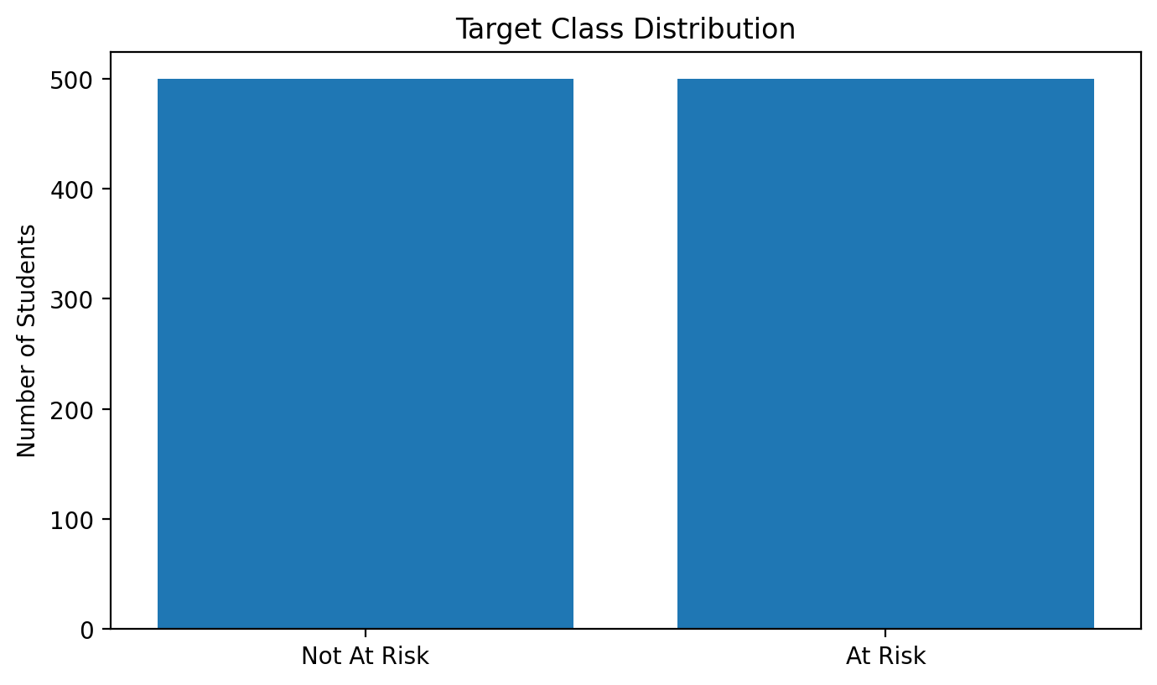
Figure 1. Target-class distribution: 500 Not At Risk and 500 At Risk students.
Finding: The two target classes are equally represented, which is helpful for the baseline classification experiment.

5. Numerical Feature Distributions
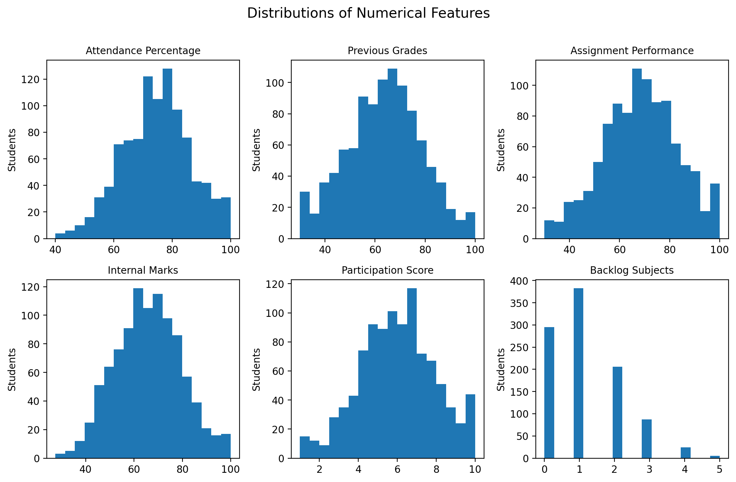
Figure 2. Distribution of the six numerical academic input features.

Descriptive Statistics
Feature | Mean | Std | Min | Median | Max
Attendance Percentage | 74.60 | 11.68 | 40.00 | 75.10 | 100.00
Previous Grades | 63.81 | 14.98 | 30.00 | 64.35 | 100.00
Assignment Performance | 68.41 | 14.92 | 30.00 | 68.55 | 100.00
Internal Marks | 65.93 | 13.54 | 27.50 | 65.90 | 100.00
Participation Score | 5.95 | 1.94 | 1.00 | 6.00 | 10.00
Backlog Subjects | 1.18 | 1.06 | 0.00 | 1.00 | 5.00
EDA note: Each feature has a different numerical range, which is one reason StandardScaler is applied before Logistic Regression.

6. Attendance Analysis
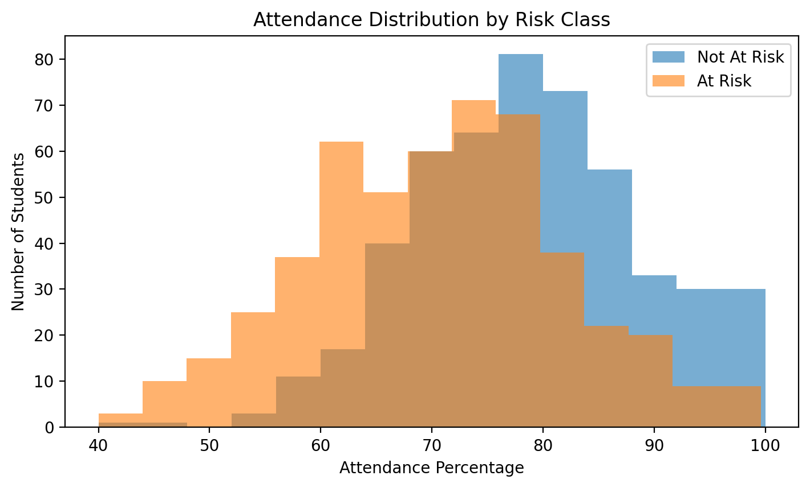
Figure 3. Attendance distribution by risk class.
Observation: Mean attendance is 78.73% for Not At Risk and 70.47% for At Risk. The distributions overlap, so attendance alone cannot perfectly separate the classes.

7. Backlog Analysis
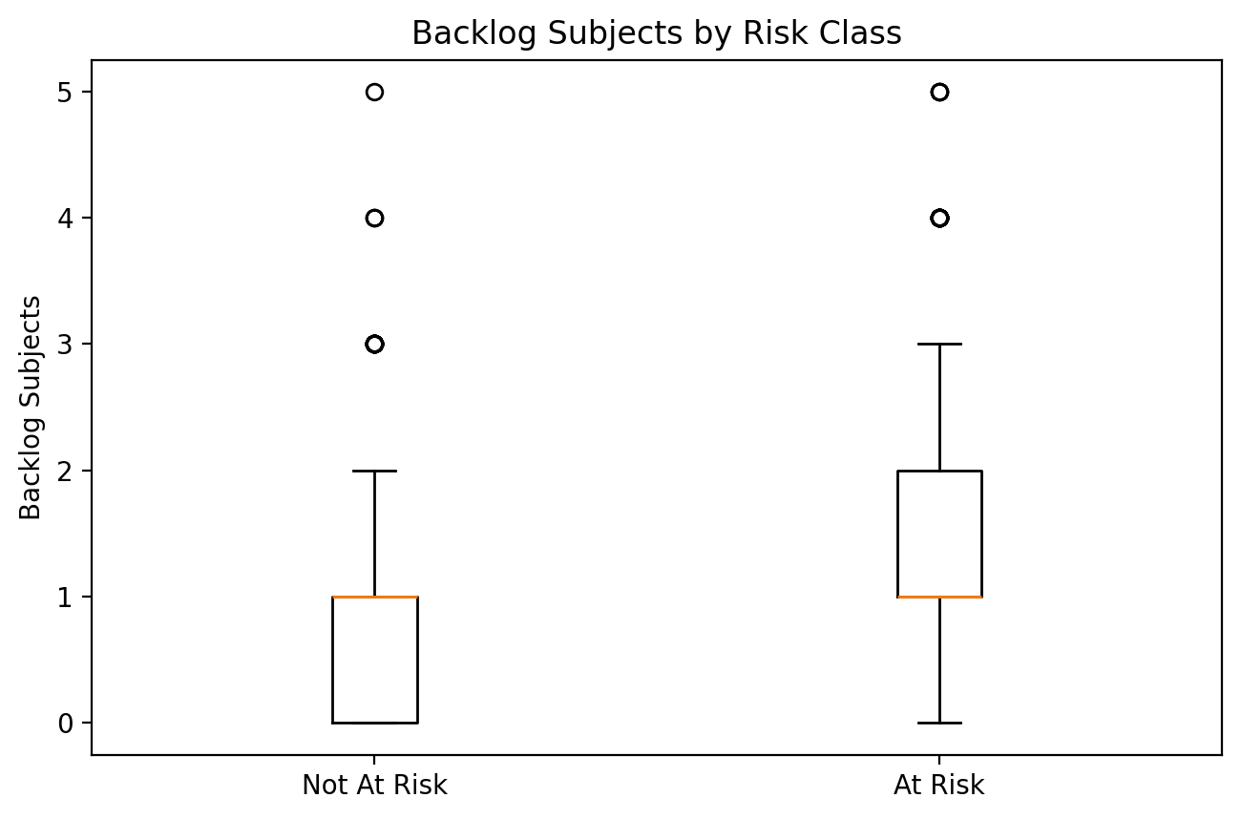
Figure 4. Backlog subjects by risk class.
Observation: Mean backlogs are 0.822 for Not At Risk and 1.532 for At Risk. The At Risk group shows a higher backlog tendency.

8. Group-wise Academic Indicators
Feature | Not At Risk Mean | At Risk Mean
Attendance Percentage | 78.73 | 70.47
Previous Grades | 67.59 | 60.02
Assignment Performance | 71.29 | 65.53
Internal Marks | 69.20 | 62.66
Participation Score | 6.19 | 5.71
Backlog Subjects | 0.82 | 1.53

9. Correlation Analysis
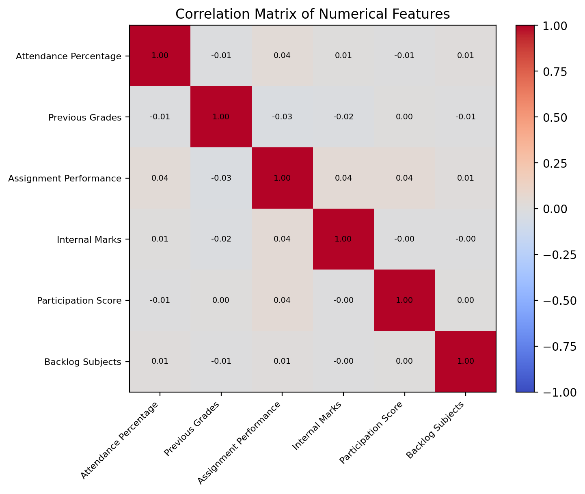
Figure 5. Correlation matrix for the six numerical input features.
Key observation: Feature-to-feature correlations are close to zero in this synthetic dataset, so there is little evidence of strong pairwise linear redundancy among the six inputs.

10. Association with the Target
Feature | Correlation with At_Risk | Direction
Attendance Percentage | -0.354 | Negative
Previous Grades | -0.253 | Negative
Internal Marks | -0.241 | Negative
Assignment Performance | -0.193 | Negative
Participation Score | -0.124 | Negative
Backlog Subjects | 0.336 | Positive
Interpretation: Attendance (-0.354) and backlog subjects (+0.336) have the strongest absolute linear associations with the binary target, followed by previous grades (-0.253), internal marks (-0.241), assignment performance (-0.193), and participation (-0.124). These values describe the synthetic dataset and are not causal effects.

11. Overall EDA Findings
• Dataset contains 1,000 records, six numerical predictors, and one binary categorical target.
• No missing values and no duplicate rows were found.
• Target classes are balanced at 500 Not At Risk and 500 At Risk records.
• Attendance and previous academic indicators are lower on average in the At Risk group, while backlog count is higher.
• Feature distributions overlap, so no single feature completely separates the two classes.
• Pairwise feature correlations are very small in the synthetic dataset.
• Using all six features together is more appropriate than relying on a single indicator.

12. Implications for Model Building
Based on the EDA, the project uses all six academic indicators as model inputs. StandardScaler is applied because the features have different numerical ranges. Logistic Regression is then used as the interpretable binary classification baseline and evaluated on an unseen 20% test split.

13. EDA Limitations and Cautions
Synthetic data: The dataset is a prototype and does not represent a particular institution.
Descriptive analysis: EDA identifies patterns and associations but does not prove that a feature causes academic risk.
Generalization: The observed distributions and associations should be rechecked on a suitable real or public dataset before deployment.

Appendix A. Core EDA Program
df = pd.read_csv("Student_Academic_Risk_Dataset.csv")
print(df.shape)
print(df.dtypes)
print(df.isnull().sum())
print(df.duplicated().sum())
print(df["At_Risk"].value_counts())
# Example visualizations
plt.hist(df["Attendance_Percentage"], bins=15)
plt.boxplot([
df[df["At_Risk"]=="No"]["Backlog_Subjects"],
df[df["At_Risk"]=="Yes"]["Backlog_Subjects"]
])

Appendix B. EDA Interpretation for Presentation
What is EDA?: EDA means Exploratory Data Analysis: understanding data before model training.
Are the classes balanced?: Yes. There are 500 Not At Risk and 500 At Risk records.
Any missing or duplicate data?: No missing values and no duplicate rows were found.
Which features show stronger target association?: Attendance and backlogs show the strongest absolute linear associations in this synthetic dataset.
Does EDA prove causation?: No. It shows patterns and associations, not causation.

