JENKINS OWN RESEARCH :
1.2 nics one for public DHCP : eth 0 : NAT eth1 : host only
Now one might get up while other will not(allow only one eth up). So, delete : “ /etc/NetworkManager/system-connections/Wired connection 1”
Now both eth up : eth0 and eth1

2.Allow traffic from VM
Wind+X = Run terminal(ADMIN)
Inbound:
netsh advfirewall firewall add rule name="Allow Inbound Traffic from 192.168.56.102" protocol=any dir=in remoteip=192.168.56.102 action=allow
Outbound
netsh advfirewall firewall add rule name="Allow Outbound Traffic to 192.168.56.102" protocol=any dir=out remoteip=192.168.56.102 action=allow

3.delete a job from cli :
i.manage Jenkins > tools and actions > jenkins cli > download jar file > run the command.
ii. Admin>config>apitoken (create this api)
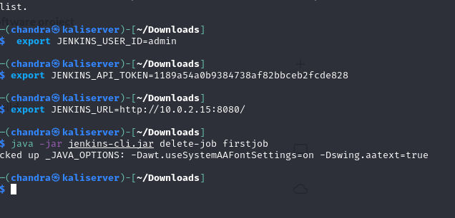
JOB IS DELETED !
4. Jenkins jobs >>
I.create jobs : [on shell ]
II. paramaterized job
iii. cronjob scheduling (auto build)

5.install crome :
Sudo apt install wget
Wget https://..... (the google .deb)
Dpkg -i “google.deb”
Google-chrome
6.set time zone :
i. $sudo apt-get install ntp
ii. .etc/ntp.conf > “ server time1.google.com ibrust “
iii. $sudo systemctl restart ntp
iv. to see : $timedatectl , $ntpq -p
v. if required : $timedatectl set-timezone Asia/Kolkata

8.Push to git for 1st time
i. cd path/to/Jenkins
ii. git init
iii. git add .
iv. git commit -m “initial commit”
v. add remote repository : git remote add origin git@github.com:chandraprakashpatra/Jenkins_connect.git
vi. git branch -M main
vii. git push -u origin main
extra : if it says no permission : then go to ~/.ssh/ > cat id_rsa.pub > copy the key > add it to the git >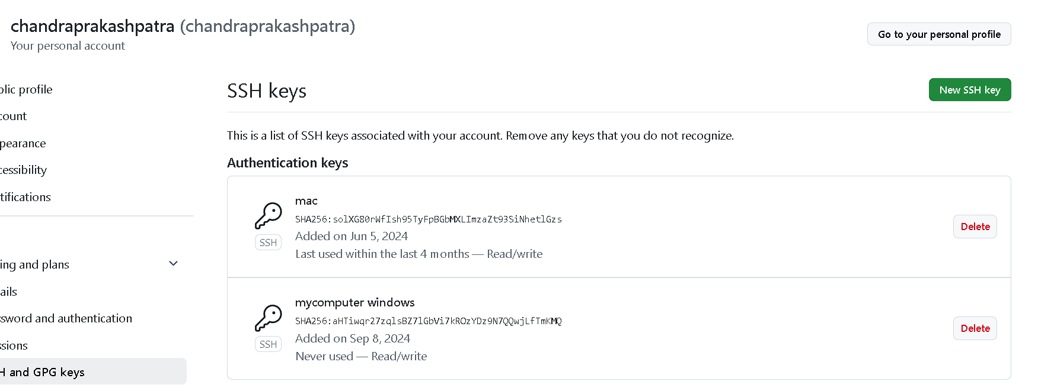
then try pushing:
. git push -u origin main .
DONE !
9A. DEV > GIT > JENKINS SERVER:
i. OPEN GIT REPOS > then copy the “https ://rep…git“
ii. create job freestyle > select git button and ass your public repository from clipboard. >> ok
iii. build it and find the job at > /var/lib/Jenkins/myjob(as your git repository !)
9b and Run it >
iv. in the job configure > build steps > “python connect.py”
v. build it > it will bring the code and search the code in the job’s workspace and will try to run it .> success!

