**Artificial Intelligence Poker Project Report**

**Chandraprakash**

**Abstract:** In AI Poker project, we have made a poker agent to play the poker game against the opponent. The agent plays a game based on the current holding hands(cards).

**Introduction :**  The agent is made to play the poker game against the opponent agent. We have applied the fewer methods to make our agent well.

**Methods :**

We have made the agent which follows the as below :

* There are eight hands in poker game, the agent has to analyze hands, according to current holding hands.
* The hands are straightened by below ranks :

i) Straight Flush

ii) Four of a Kind

iii) Full House

iv) Flush

v) Straight

vi) Three of a Kind

vii) Two Pair

viii) One Pair

ix) High Cards

* Now, the hands evaluation is done by the defined function **def handstrength(hand)** which converts the cards into a list to pick the suits and numbers of the hand.

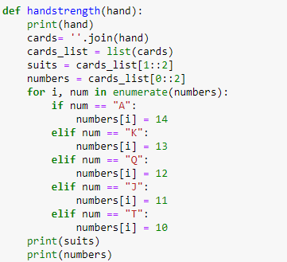

* To get the common cards and determine hands as four of a kind, full house and three of a kind default_dict has been used and assigned them to variables number_dict and suits_dict.
* These variables have been used to analyze hands.

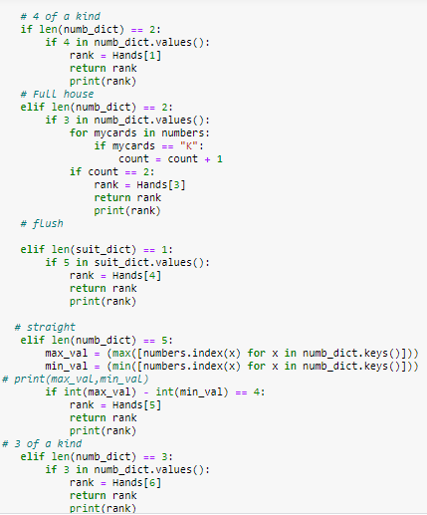

* We have ranked the hands in the function itself by declaring the **rank = Hands[]** and then these ranks have been used to perform the action i.e. to check, Fold or All in.

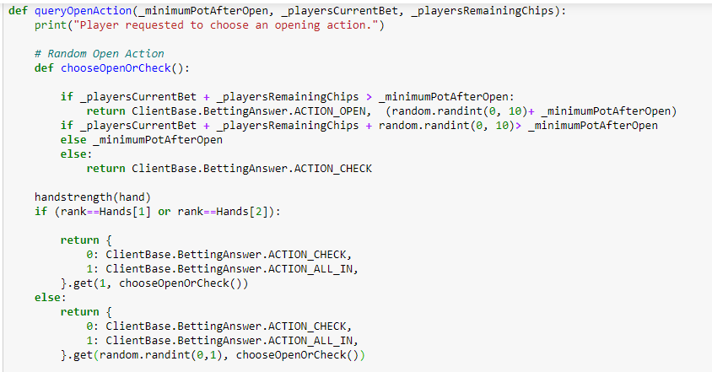

* Flow Diagram :

**Pre tournament Result :** We had played pre-tournament with our team and tried to make our agent best to win the game, however, the opponent agent was performed well and won the match.

**Observation & Conclusion :** In pre tournament, we learnt the better implementation of the agent from the opponent agent. Our made agent tried to perform well in pre tournament, however the learning was achieved from the opponent agent performance and we will try to make our existing agent better.

---------------------------------------------XXXXX-------------------------------------------------