**IRCP-INTERFACE DB TABLE DESIGN (V1.0)**

**create** **table** **if** **not** **exists** TBL_IRAS_FILE_HEADER(file_id **varchar**(8) **primary** **key**,

read_time **datetime** **not** **null**,

complete_time **datetime** **not** **null**,

org_name **varchar**(4) **not** **null**,

trans_date **datetime** **not** **null**,

header_valid **varchar**(1) **not** **null**,

no_of_appt **numeric**(5) **not** **null**,

appt_amount **numeric**(9,2) **not** **null**,

nric_hash **numeric**(16) **not** **null**,

amount_hash **numeric**(7) **not** **null**,

no_of_release **numeric**(5) **not** **null**,

rel_amount **numeric**(9,2) **not** **null**,

trailer_valid **varchar**(1) **not** **null**) **Engine**=**InnoDB**;

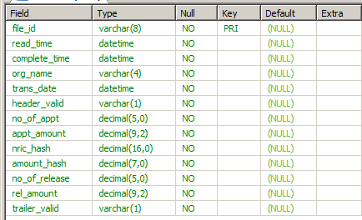

**create** **table** TBL_IRAS_FILE_DETAILS(

file_id **varchar**(8) **not** **null**,

nric **varchar**(16) **not** **null**,

nric_reformat **varchar**(16) **not** **null**,

case_id **varchar**(9) **not** **null**,

tax_type **numeric**(3) **not** **null**,

cust_name **varchar**(90) **not** **null**,

amount_due **numeric**(9,2) **not** **null**,

appt_date **datetime** **not** **null**,

rel_date **datetime** **not** **null**,

file_date **datetime** **not** **null**,

isvalid **varchar**(1) **not** **null**,

error_code **numeric**(2) **not** **null**,

**foreign** **key**(file_id) **references** TBL_IRAS_FILE_HEADER(file_id)) **Engine**=**InnoDB**;

