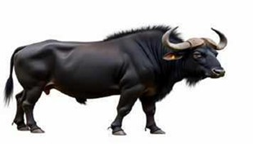
Average Milk Yield: 12-18 liters per day

Gir

Species: Bos indicus

Fig. 1: Live Stock Species 1

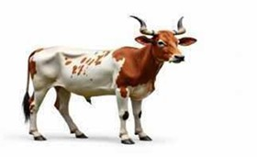
Fig. 2: Live Stock Species 3

- Black Coat
- Largest of Indian buffalo breeds
- Heavy build
- Horns drooping downward and backward
- Massive head
Primary Purpose: Dairy
Average Milk Yield: 10-15 liters per day

Murrah
Species: Bubalus bubalis
Origin: Haryana (Rohtak, Jind, Hisar districts)

Key Characteristics
- Jet black coat
- Tightly coiled horns
- Massive body structure
- Well-developed udder
- High milk fat content
Primary Purpose: dairy
Origin: Gir forest of South Kathiawar, Gujarat

Key Characteristics
- Convex forehead (prominent bulge)
- Long pendulous ears
- White to reddish-brown coat with patches
- Prominent hump
- Lyre-shaped horns
Primary Purpose: Dual purpose- milk and draught
Average Milk Yield: 10-12 liters per day

Machine Learning Overview
ML is mainly divided into two approaches, such as supervised learning and unsupervised learning. The supervised ML approach is defined by its use of labelled datasets, whereas the unsupervised learning uses ML algorithms to analyse and cluster unlabeled datasets. An unsupervised ML approach can detect hidden patterns in data without human supervision.

Impact of our project:
- Supports farmers & vets with instant identifi- cation
- Improves livestock management efficiency
- Reduces dependency on manual expertise
- Increases economic productivity in dairy in- dustry

Application Features
Making it easy in an area with poor network connections, just by clicking an image user can know each and every detail about their cattle and buffalo, this fig shows the main points of our project.

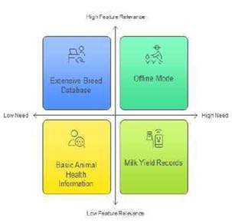
Fig. 4: Feature Relevance

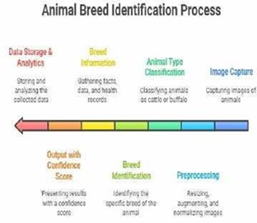
Fig. 5: Animal Breed Identification Process

- Literature Review
Image-based breed recognition of cattle and buf- faloes has emerged as a significant research area with the advancement of Artificial Intelligence (AI), Machine Learning (ML), and deep learning tech- niques. Recent studies emphasize the need for ac- curate and automated systems to support livestock management, increase productivity, and assist farm-
ers with real-time breed identification.
Pranjal Khairnar et al. proposed a deep learn- ing–based model specifically for Indian cattle and buffalo breeds using image processing approaches. Their study highlights the effectiveness of convolu- tional neural networks (CNNs) in extracting breed- specific visual features and demonstrates improved classification accuracy using real-world datasets.
- Similarly, AI-based practical tools such as Cattle Lens have been developed to provide real- time breed detection, showcasing the application of trained models for field use.
- Another Scribd-based work specifically fo- cuses on CNN-driven breed recognition for Indian breeds, reinforcing the relevance of deep learning in this domain.
- Earlier research and educational resources, such as the SlideShare presentation, introduce foun- dational ML and image processing methods for cattle breed categorization, offering insights into traditional techniques that paved the way for ad- vanced AI models.
- More recent innovations include an ensemble learning algorithm presented by EAI, which inte- grates multiple classifiers to enhance recognition performance through improved feature extraction and robust decision-making mechanisms.
- The availability of high-quality datasets sig- nificantly impacts model accuracy. The Kaggle dataset provides a comprehensive collection of cow and buffalo images that supports training, test- ing, and performance benchmarking for AI-based breed recognition systems. Such datasets enable researchers to train models capable of handling variations in pose, lighting, and background.
- Foundational studies have also contributed to the broader field of livestock identification. Shen et al. discussed monitoring technologies used in individual animal identification and behavior track- ing, offering insights into early technological frame- works.
- Bello and Abubakar developed software tools for cattle identification to improve livestock man- agement efficiency,
- while Bello et al. extended this work by proposing real-time monitoring through multimedia

networks, emphasizing the importance of continu- ous animal tracking.
- Biometric-based identification approaches have been studied extensively. Barron et al. ex- amined biometric markers for animal identification, which form a basis for modern visual recognition systems.
- Kumar and Singh positioned visual animal biometrics as an emerging frontier, outlining its potential for non-invasive cattle recognition.
[11][12] Furthermore, Zin et al. implemented one of the early deep- learning-based cow identifica- tion systems, demonstrating the feasibility of deep CNNs for livestock recognition tasks.
[13] Collectively, these studies highlight a strong progression from traditional image processing tech- niques to advanced deep learning frameworks. The literature indicates that CNN-based and ensem- ble learning models, supported by large annotated datasets, play a crucial role in achieving accurate and reliable image-based breed recognition of cattle and buffaloes in India. This evolution underscores the growing importance of AI-driven solutions for modern livestock management and precision agri- culture.
- Abbreviations and Acronyms
AI (Artificial Intelligence), CNN (Convolutional Neural Network), RGB (Red-Green-Blue)
- Data Acquisition
High-resolution images of cattle and buffalo breeds from publicly available datasets and field studies in India form the basis for model develop- ment.
- METHODOLOGY
The proposed approach employs a deep learning pipeline, primarily utilizing CNN architectures for feature extraction and classification. The workflow includes:
Data Collection: Gathering labeled images of Indian cattle and buffalo breeds from open-source datasets, mobile apps, and contributions from na- tional livestock agencies.[8]
Preprocessing: Standardizing image input (resiz- ing, normalization), data augmentation to improve generalization (rotation, flipping, color adjustment), and background removal or segmentation. [4] [3]
Model Design: Using state-of-the-art deep learn- ing algorithms (e.g., EfficientNet, ResNet, YOLO for detection), possibly coupled with ensemble methods for improved robustness. A voting mecha- nism can be incorporated for final classification.[4] Training: Split dataset into training, validation, and test sets ensuring breed balance. Train with transfer learning on pre-trained weights followed by
fine-tuning on the breed dataset.[8]
Deployment: Integrate the model into a user- friendly mobile/web application with automated im- age capture, breed prediction, result display, and feedback for model improvement.[3]
TABLE I: TABLE I

Breed | Accuracy (%) | Precision (%) | Recall (%)
Gir cattle | 95 | 96 | 94
Murrah buffalo | 94 | 95 | 93
Sahiwal cattle | 93 | 92 | 91
[l]Jaffarabadi buffalo | 92 | 91 | 90

A. Equations
Important CNN formulas applied in the model include:

Convolution Operation:
F (x, y) = ΣΣI(x + m, y + n) ∗ K(m, n)

ReLU Activation:
f (x) = max(0, x)

Softmax Classification:
Softmax(z_{i}) = e^{z}i /Σe^{z}j

Loss Function (Cross Entropy):
L = −Σy_{i}log(p_{i})
Algorithms
- HARDWARE AND SOFTWARE REQUIREMENTS
Software Requirements

Operating System
- Windows 10 / 11 (64-bit)
- Ubuntu 20.04+ / Linux (recommended for model training)

Algorithm 1 Image-Based Breed Recognition of Cattle and Buffalo in India 1: Input: Raw digital images of cattle and buffalo
(field photographs or dataset images)
2: Output: Predicted breed label for each input image

3: Step 1: Image Acquisition
4: Collect images using digital cameras, smart- phones, or existing databases

5: Step 2: Preprocessing
6: Resize images to a fixed dimension (e.g., 224x224 pixels)
7: Normalize pixel intensity values
8: Apply data augmentation (e.g., rotations, flips, brightness/contrast adjustments)

9: Step 3: Region of Interest Extraction
10: Detect and crop the animal’s body or head using object detection (e.g., YOLO, SSD models)
11: Discard unnecessary background portions to focus only on the animal

12: Step 4: Feature Extraction
13: Pass cropped images through a convolutional neural network (CNN)
14: Extract high-level visual features at relevant CNN layers

15: Step 5: Model Training
16: Split data into training and validation/test sets
17: Train the breed classification model using la- beled images and extracted features
18: Adjust weights via backpropagation to mini- mize classification loss

19: Step 6: Prediction and Classification
20: Feed test images into the trained model
21: Output the predicted breed label (e.g., Sahiwal, Murrah, etc.)

22: Step 7: Evaluation
23: Calculate performance metrics: Accuracy, Pre- cision, Recall, F1-score
24: Optionally, generate confusion matrix and ana- lyze misclassification. =0

Programming Languages
- Python 3.8+ (primary language for ML and CV)
- Optional: MATLAB (for research prototyping)

Software Tools & Frameworks
- TensorFlow / Keras or PyTorch (for CNN model development)
- OpenCV (image preprocessing, augmentation)
- NumPy, Pandas (data handling)
- Matplotlib, Seaborn (visual analysis and plot- ting)
- Scikit-learn (evaluation metrics, splitting dataset)
- Jupyter Notebook, Google Colab, or VS Code

Dataset Tools
- LabelImg or CVAT for annotation
- Kaggle API (if fetching datasets)
- Google Drive / Cloud Storage (dataset hosting)

Deployment Software (optional)
- Flask / FastAPI for backend deployment
- Android Studio (if deploying on mobile)
- TensorFlow Lite / ONNX Runtime for lightweight inference
Hardware Requirements
For Model Training (High Performance) 1.For Large Dataset or Heavy Training
- NVIDIA RTX 3080 / 3090 / A6000
- 64 GB RAM
- 1–2 TB SSD
- Suitable for 50k+ livestock images

For Deployment (Low Cost Edge or Field Use)
- Mobile Phones with: 4 GB RAM minimum
- Octa-core CPU
- Android 10+
- Good camera (12MP+)
- Edge Devices (optional):
  - Raspberry Pi 4 (with Coral USB Accelera- tor)
  - NVIDIA Jetson Nano / Xavier NX

Camera Requirements for Field Image Cap- ture
  - Smartphone or DSLR
  - Minimum 12 MP resolution
  - Good lighting support
  - Stable focus & close-range image capture

Network Requirements (optional)
  - If cloud training or mobile inference:
    - Stable internet (10 Mbps+)
    - Cloud GPU access (AWS, GCP, Kaggle, Colab)
TABLE II: Component Specification
Component | Recommended Specification
CPU | Intel i7 / Ryzen 7 or higher
GPU  RTX 2060 / RTX 3060  or higher (CUDA support) | [l]NVIDIA GTX 1660 /
RAM  (32 GB recommended) | Minimum 16 GB
Storage  (for dataset & checkpoints) | SSD 256 GB+
Power  training runs | [l]Stable power supply for long

- Conclusion
Image-based breed recognition offers a practical solution for farmers, government agencies, and vet- erinarians in India. The proposed system achieves high reliability and speed, supporting better farm management, disease control, and breed conserva- tion. Future work may include mobile app deploy- ment and expansion to additional livestock types
- Acknowledgment
The authors would like to thanks the live- stock farmers, agencies, and respected Prof. Manoj Agrawal, Project Guide, Department of Computer Science and Engineering, Chameli Devi Group of Institutions, Indore, for his valuable guidance, continuous support, and motivation throughout the completion of this research work.
References
- Pranjal Khairnar, Prajakta Aher, Vishakha Aher, Pratiksha Sonawane, Mrs. P.R. Pingale. “Image Based Breed Recognition for Cattle and Buffaloes of India.” International Research Journal of Modernization in Engineering Technology and Science, 2025. https://www.irjmets.com/upload newfiles/ irjmets71000001726/paper file/irjmets71000001726.pdf

- “Cattle Lens.” Scribd, 2025. https://www.scribd.com/ document/928434849/Cattle-Lens
- “AI Breed Recognition For Cattle and Buffaloes in India.” Scribd, 2025. https:
//www.scribd.com/presentation/916941283/
AI-Breed-Recognition-for-Cattle-and-Buffaloes-in-India
- “Paper Presentation on Cattle Breed Detection and Cate- gorization using Image Processing and Machine Learning.” SlideShare, 2023.
- “Ensemble Learning Algorithm for Cattle Breed Identi- fication using Computer Vision Techniques.” EAI, 2024. https://eudl.eu/doi/10.4108/eai.23-11-2023.2343338
- “Cows and Buffalo Computer Vision Dataset.” Kag- gle, 2025. https://www.kaggle.com/datasets/raghavdharwal/ cows-and-buffalo-computer-vision-dataset
- M. Shen, L. Liu, L. Yan, M. Lu, W. Yao, and X. Yang, “Review of monitoring technology for animal individual in animal husbandry”, Nongye Jixie Xuebao = Transactions of the Chinese Society for Agricultural Machinery, vol. 45, no. 10, pp. 245-251, 2014.
- R. W. Bello, and S. Abubakar, “Development of a Software Package for Cattle Identification in Nigeria,” Journal of Applied Sciences and Environmental Management, vol. 23, no. 10, pp. 1825-1828, 2019. DOI: https://dx.doi.org/10. 4314/jasem.v23i10.9.
- R. W. Bello, A. Z. H. Talib, and A. S. A. B. Mohamed, “A Framework for Real-time Cattle Monitoring using Multime- dia Networks”, International Journal of Recent Technology and Engineering, vol. 8, issue 5, 2020.
- U. G. Barron, F. Butler, K. McDonnell, and S. Ward, “The end of the identity crisis? Advances in biometric markers for animal identification”, Irish Veterinary J., vol. 62, no. 3,
pp. 204–208, 2009.
- S. Kumar, and S. K. Singh, “Cattle Recognition: A New Frontier in Visual Animal Biometrics Research”, Proceed- ings of the National Academy of Sciences, India Section A: Physical Sciences 1-20, 2019.
- V. Kate, A. Jaiswal and A. Gehlot, ”A survey on distributed deadlock and distributed algorithms to detect and resolve deadlock,” 2016 Symposium on Colossal Data Analysis and Networking (CDAN), Indore, India, 2016, pp. 1-6, doi: 10.1109/CDAN.2016.7570873.
- T. T. Zin, C. N. Phyo, P. Tin, H. Hama, and I. Kobayashi, “Image technology based cow identification system using deep learning”, Proceedings of the International MultiCon- ference of Engineers and Computer Scientists 1, 2018.

- 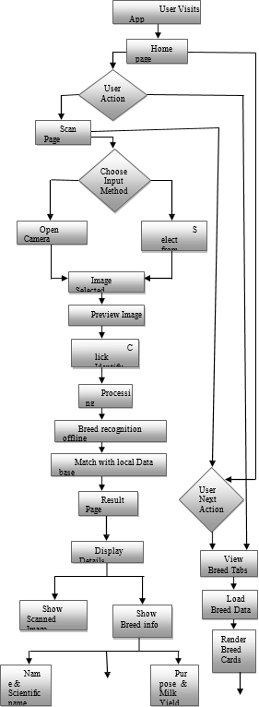

Fig. 6: Flow Chart

