**Veniding Mechine**

**Chandra Mohan**

**Implementation method:**

Insert the coin in text box then select the drink.

1. If you enter sufficient amount for choosen item it will dispance.
2. If amount is not sufficient for choosen item it will show the error.
3. **Design Considerations:**

**Technical Considerations:**

Using through Javascript, HTML bootstrap developer this application. Wanted to implement in Angular 6 but environmnt is giving issue.

In this used Quantity and price is static, In real time scenario I will fetch all the data from the backend and use dynamic data.

1. **Technical Architecture Design:**
2. **Method to use the developed system :**

**Operating steps:**

1. Without entering the coin, select the item. It will throw error.

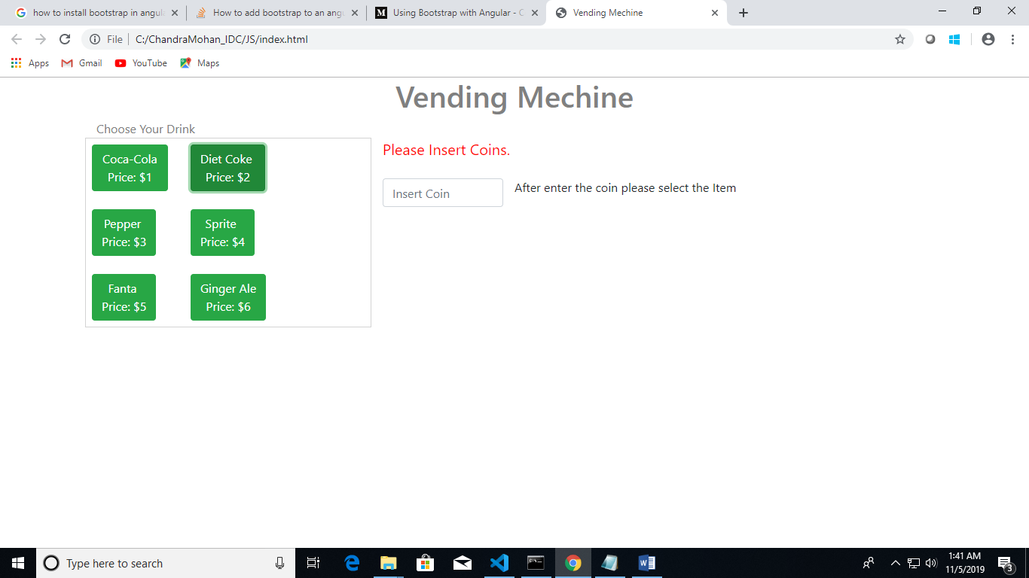

1. Enter the coin and select the item. If item price is more than coin ntrd, it will throw error.

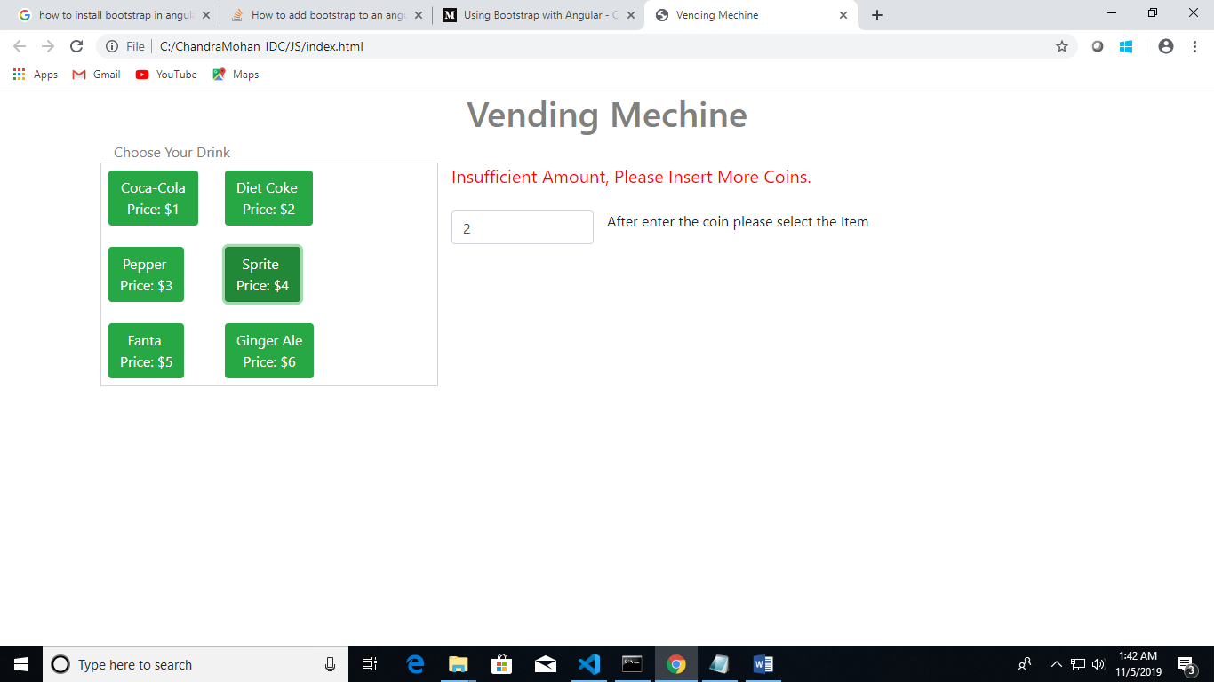

1. Inserted amount is sufficient for the iem seeced, it will dispance and its showing remaing amount and selected items.

Item count will get reduced.

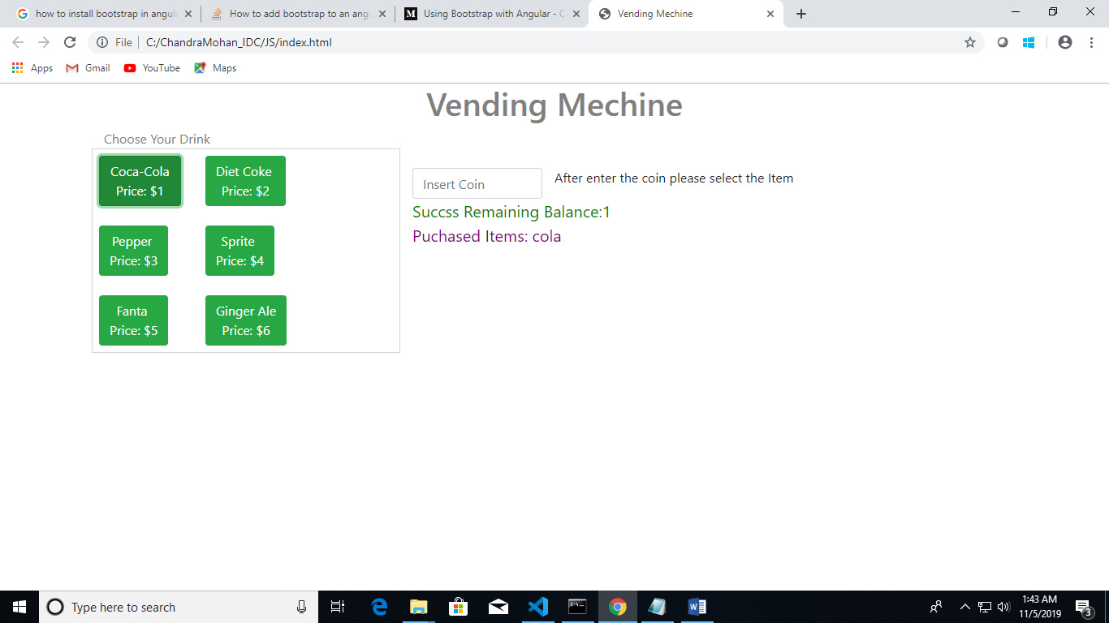

1. If you selected item which Is not available, its showing out of stock message

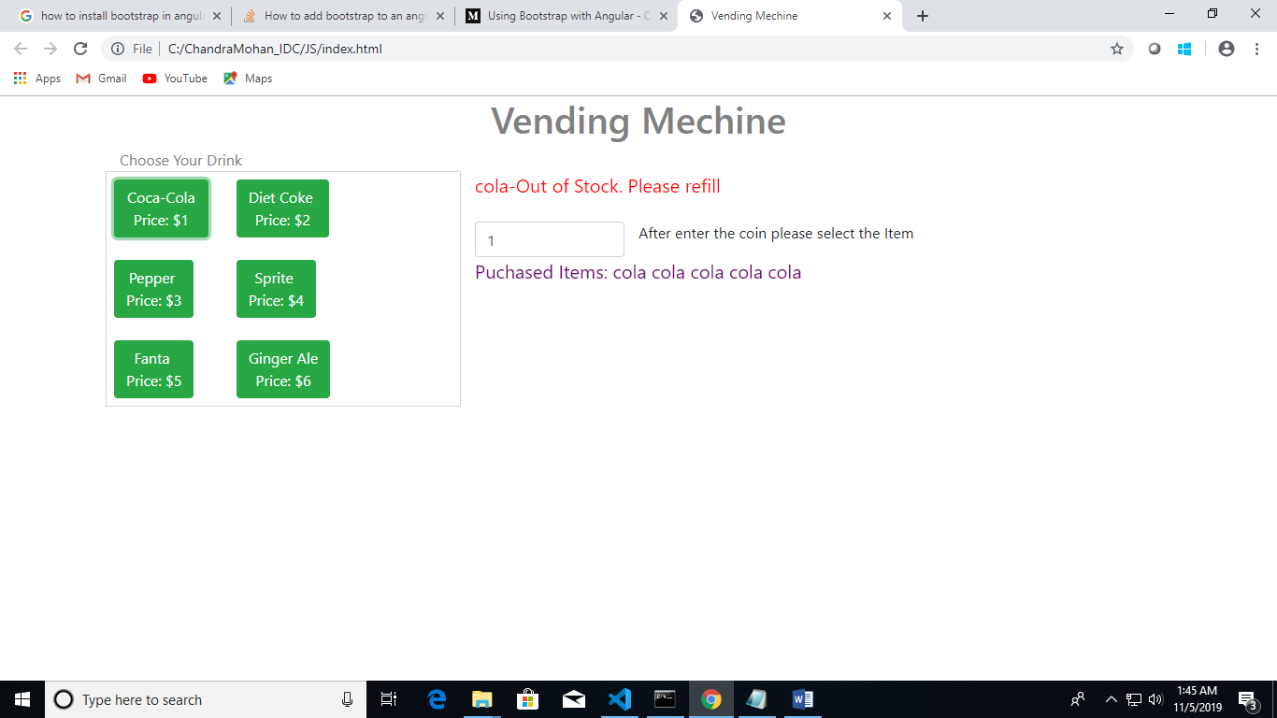

1. **Class & Sequence Diagram:**

Steps:

1. Insert the coin
2. Select the item from the list
3. If selected item amount is sufficint for inserted amount, it will dispance.
4. Otherwise it will show error
5. Without insert coin, select the item. It will show error.