R1–R5: Consolidated Research Evidence and Manuscript Draft
Network-slicing intent interpretation | Frozen experiments, publication tables, reviewer-response matrix
Status: evidence-grounded draft, not a revised or re-reviewed conference submission. Figures are recreated from frozen aggregate counts, not new model runs.

1. Recommended paper framing and scope
Suggested title: From Phrase Robustness to Selective Autonomy: A Controlled Safety and Reliability Evaluation for Explainable Network-Slicing Intent Classification
Central question: How do phrase generalization, strict KPI feasibility, candidate masking, uncertainty escalation, and semantic verification affect the reliability and autonomous coverage of a three-class network-slicing intent classifier? The classes are eMBB, URLLC and mMTC. This is service-type recommendation/selection under a synthetic catalogue—not admission control, deployment, live orchestration, or demonstrated zero-touch assurance.
Scope boundary: R1 uses separately generated 3,000-row corpora for five seeds; R2 audits 1,200 frozen requests plus a distinct 100-decision E5 subset; R3–R5 use the same 840-development/360-held-out split. Do not pool their denominators or imply all five experiments are one uniform train/test run.

2. Consolidated methodology

R1 — phrase-family generalization and lexical ablation
Five seeds (42–46), each with 3,000 synthetic intents balanced over three classes. L1 original text; L2 disjoint class-associated phrase-family holdout (generic cases excluded); L3 neutral generic wording plus observable KPI information; L4 observable KPI-only text. A five-fold training-CV model-selection pipeline was repeated for each condition. L3 and L4 map to identical downstream feature vectors. L2 and L1 test populations differ, so L2 is not an accuracy gain over L1.

R2 — strict feasibility re-audit
The frozen legacy candidate screen omitted mobility, used permissive bounds and fell back to the full catalogue for an empty candidate set. A direction-aware Strict V2 oracle evaluates latency, throughput, reliability, density and mobility; missing KPIs are unconstrained and an empty feasible set remains empty. It was applied to 1,200 existing intents without regenerating decisions. A separate audit maps 100 frozen E5 decisions by exact intent text.

R3 — strict masking with out-of-fold feasible-mass calibration
The exact 1,200-row frozen E5 realization was split into 840 development and 360 held-out requests (seed 42). Gradient Boosting probability vectors were combined with the frozen R2-V2 feasible sets. Hard masking alone sometimes forced a low-support feasible class when nominal truth and constraints conflicted; the final rule escalates empty feasible sets or feasible-probability mass below 0.548631598726, selected on five-fold out-of-fold development predictions. Final held-out results were evaluated once.

R4 — uncertainty-aware selective escalation
R4 retains every R3 escalation, then additionally escalates R3-autonomous decisions with top-1 minus top-2 probability margin below the development-calibrated frozen cutoff 0.7097637192002952. Confidence, entropy, margin and feasible-mass error-detection signals were examined on development data. The frozen R4 rule was applied to the same 360 held-out cases, without test-set retuning.

R5 — independent lexical semantic-support verification
R5 checks only the 306 cases remaining autonomous after R4. A development-only TF-IDF unigram/bigram representation (1,786 features; 840 development cases; 280 per class prototype) provides a class-support signal. The frozen support-margin cutoff is -0.0275677986595984. R5 is a verification/escalation layer, not a replacement classifier; it does not correct predicted classes. The 360-case evaluation was followed by category audits and 10,000 paired case-level bootstrap resamples (seed 42), with no held-out threshold adjustment.

3. Publication-ready results

Table 1. R1 phrase conditions (five-seed means ± standard deviations)
Condition | Accuracy | Macro-F1
L1 Original | 0.9311 +/- 0.0065 | 0.9311 +/- 0.0065
L2 Phrase-family held-out | 0.9549 +/- 0.0081 | 0.9548 +/- 0.0081
L3 Generic + KPI | 0.8920 +/- 0.0080 | 0.8920 +/- 0.0078
L4 KPI-only | 0.8920 +/- 0.0080 | 0.8920 +/- 0.0078
L1 versus L3/L4: macro-F1 drop = 0.0392 ± 0.0089 (3.92 percentage points). L2 uses a different test population; L3 and L4 are representation-equivalent, not independent replications.

Table 2. R2 strict feasibility audit (different denominators)
Population | Outcome | Count
1,200 requests | Legacy over-accepted candidate set | 229 (19.08%)
1,200 requests | Strict-empty feasible set | 14 (1.17%)
100 E5 decisions | Selected false-feasible | 3 (3.00%)
100 E5 decisions | Autonomously accepted false-feasible | 2 (2.00%)
The old E5 “100% contract validity” is validity under the implemented permissive screen only; it is not full five-KPI feasibility.

Table 3. Frozen R3–R5 held-out results (same 360 cases)
Stage | Autonomous / escalated | Correct / wrong auto | Coverage | Auto accuracy | Selective risk
R3 | 341 / 19 | 329 / 12 | 94.72% | 96.48% | 3.52%
R4 | 306 / 54 | 301 / 5 | 85.00% | 98.37% | 1.63%
R5 | 280 / 80 | 278 / 2 | 77.78% | 99.29% | 0.71%
Accuracy and selective risk are conditional on autonomous acceptance; all-case correct autonomous proportions are 91.39% (R3), 83.61% (R4), and 77.22% (R5). Thus lower risk is purchased with lower autonomous throughput.
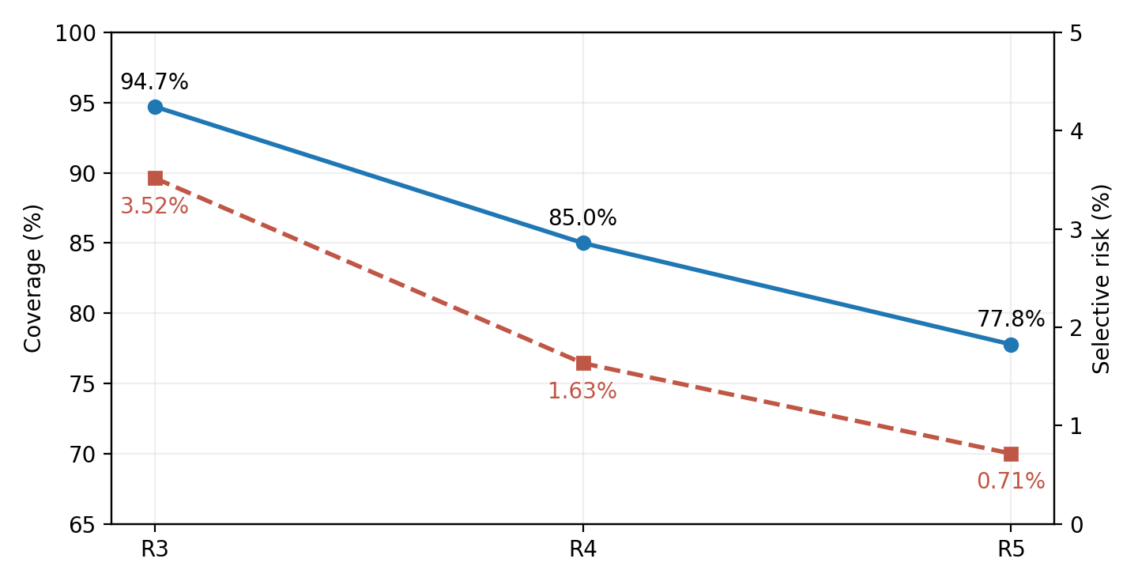
Figure 1. Frozen risk–coverage operating points on the same 360-case held-out set.
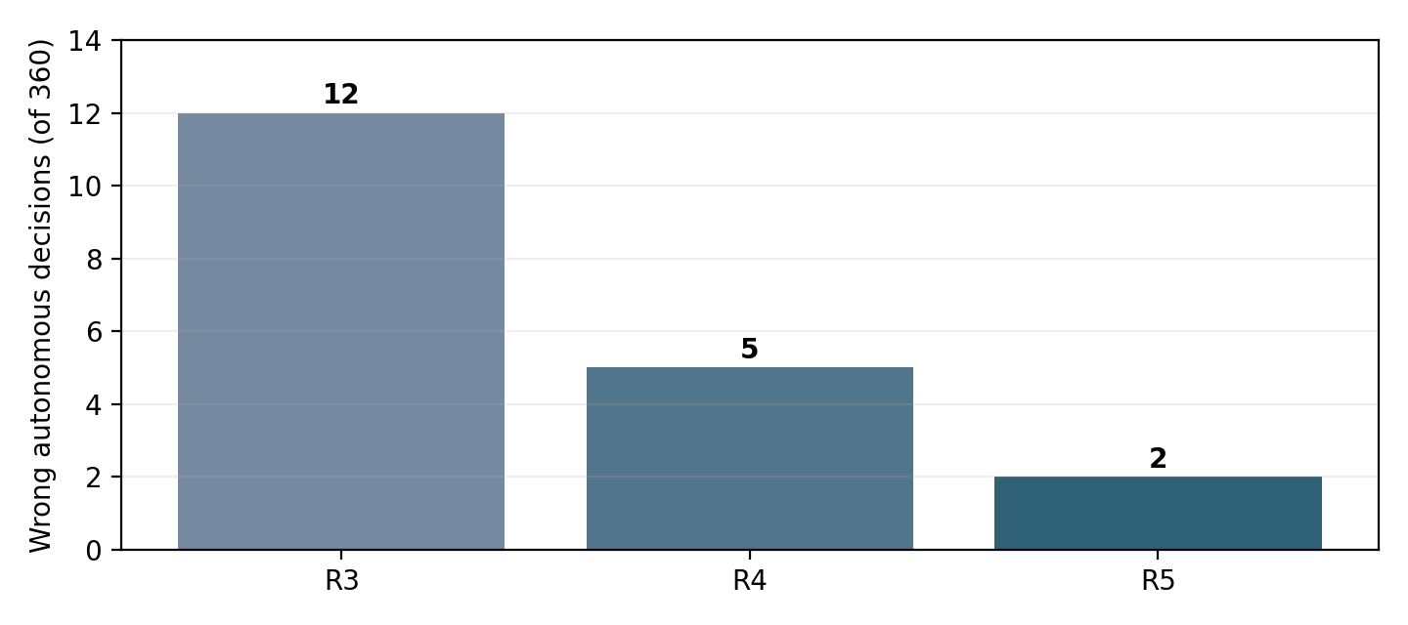
Figure 2. Residual wrong autonomous decisions. These are not total wrong predictions among all 360 cases.
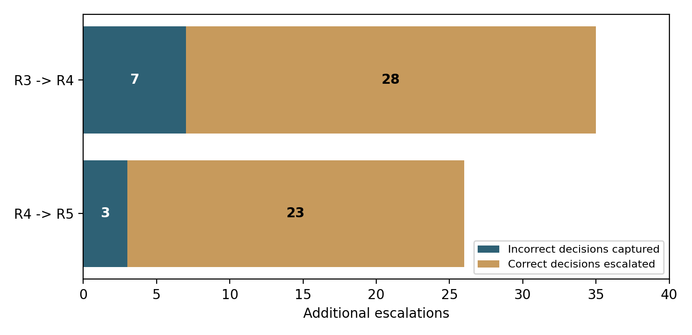
Figure 3. Each additional safeguard captures some errors but also escalates correct decisions.

Table 4. R5 category-specific audit
Category | R4 auto | R4 wrong | R5 flagged | Errors captured | Correct flagged
Generic | 88 | 1 | 24 | 1 | 23
Known | 123 | 0 | 0 | 0 | 0
Unseen | 95 | 4 | 2 | 2 | 0
R4 to R5: 26 extra escalations = 3 wrong decisions caught + 23 correct decisions withheld; 60% of the five residual errors captured, but only 11.54% of additional escalations captured an error. The 23 unnecessary escalations were all generic cases. The remaining two errors (IDs 658, 810) were unseen-intent cases above the frozen semantic threshold.

Uncertainty and statistical reporting
R4 selective risk = 1.634% (bootstrap 95% CI 0.328–3.226%); R5 = 0.714% (0–1.812%). Observed absolute reduction = 0.920 percentage points, with paired-bootstrap 95% CI -0.053 to 2.184 percentage points. The interval includes zero. Observed relative R4-to-R5 reduction is 56.29%, but statistical superiority is not established at 95%. Coverage cost = 7.22 points (95% CI 4.72–10.00 points). Five R4 residual errors limit precision.

4. Strongest contributions and novelty positioning
• Evidence-based deconfounding: separate class-associated phrase-family holdout and observable-KPI ablation challenge an easy random-row-split interpretation. The finding is bounded phrase-family robustness, not open-world language understanding.
• Safety-contract correction: the strict five-KPI audit exposes the difference between a permissive screen and operationally meaningful catalogue feasibility, including explicit empty-set outcomes.
• Selective safety architecture evaluated end-to-end on one frozen test split: strict candidate masking, out-of-fold mass escalation, margin-based escalation and lexical-support verification yield measurable risk–coverage curves.
• Failure-mode transparency: quantifies correct-case escalation costs, high-confidence residual errors, generic/unseen differences and bootstrap uncertainty, rather than claiming an unconditional performance gain.
Novelty claim to avoid: first agentic network-slicing system, first explainable slice orchestrator, semantic understanding from TF-IDF, production-grade reliability, or proof that R5 statistically beats R4. The contribution is a controlled, reproducible interaction and safety-trade-off study.

5. Manuscript-ready Results section (draft)
Phrase-generalization controls (R1) yielded a five-seed mean accuracy of 0.9311 ± 0.0065 under original text and 0.8920 ± 0.0080 when use-case wording was removed while preserving observable KPI information. The corresponding macro-F1 reduction was 0.0392 ± 0.0089. The phrase-family-held-out condition achieved 0.9549 ± 0.0081 accuracy, but it excluded generic cases and therefore is not directly comparable with the original population. Generic+KPI and KPI-only conditions generated equivalent downstream features, revealing a representation-level redundancy rather than two independent results.
Strict feasibility re-analysis (R2) identified 229/1,200 (19.08%) cases in which the legacy candidate screen over-accepted at least one candidate. Fourteen requests had no strictly feasible catalogue class. Among 100 frozen E5 decisions, three were false-feasible under the strict oracle, including two autonomous acceptances. This shows that label correctness and permissive screen validity do not establish strict KPI feasibility.
On the common 360-case held-out split, frozen R3 accepted 341 cases autonomously, with 12 errors (3.52% selective risk; 94.72% coverage). R4 escalated 35 additional cases, capturing seven errors and withholding 28 correct decisions, reducing selective risk to 1.63% at 85.00% coverage. R5 escalated 26 further cases, capturing three errors and withholding 23 correct decisions, reducing selective risk to 0.71% at 77.78% coverage. The 10,000-resample paired bootstrap interval for the R4-to-R5 absolute selective-risk difference included zero; these improvements are descriptive operating-point comparisons, not statistically conclusive superiority.

6. Manuscript-ready Discussion section (draft)
The experiments identify complementary failure modes rather than a single dominant accuracy metric. R1 suggests lexical cues contribute to classification, yet the model retains nontrivial performance without them; the class-conditioned generator still restricts the meaning of generalization. R2 shows why an apparently correct service label can be incompatible with the request’s full KPI constraints. R3 resolves this safety problem through strict masking and selective abstention, rather than forcing a low-probability feasible class. R4 detects low-margin mistakes but misses confident errors. R5 offers a distinct lexical-support check that captures three of five such residual errors. However, the generic-category false escalations show that stronger assurance can materially reduce autonomy. The resulting evidence supports a risk–coverage design space, not an unqualified claim of better classification across all requests.

7. Manuscript-ready Limitations and Future Work (draft)
All experiments use synthetic requests and a fixed three-class service catalogue. Class-conditioned phrase pools, labels assigned before KPI blending, and parser-dependent observable features limit conclusions about genuine ambiguity and open-world intent generalization. R1 uses five seeds but a restricted generator; R2 decision-level strict feasibility is demonstrated on only 100 E5 decisions; R3–R5 share a single 360-case held-out realization and R5 has only five R4 residual errors. The R5 risk-reduction bootstrap interval includes zero. TF-IDF support measures lexical similarity, not semantic entailment. Escalation is modeled as abstention; downstream human/operator correction, actuation, resource availability, production latency and end-to-end lifecycle control were not tested. Existing E1–E5 explainability and agentic-trial limitations remain unless separately corrected in the manuscript.
Future work should evaluate independent operator-authored intents, unseen services and domains, a fresh untouched test split, calibrated risk targets and operator-defined escalation costs; compare semantic encoders and symbolic consistency guards; assess grouped/on-manifold explanation perturbations; and measure real control-loop latency and post-escalation outcomes. Category-aware verification is a hypothesis prompted by R5 generic false escalations, not a validated improvement; any redesigned policy needs development-only calibration and a fresh held-out evaluation.

8. Reviewer-response audit against the earlier ICIITCEE 2027 review
The review rated novelty 2/5, framing 2/5, methodology 2/5, explainability rigour 2/5, results 3/5, related work 3/5, reproducibility 2/5, limitations 4/5, presentation 3/5, overall 2/5. These are ORIGINAL reviewer scores, not predicted updated scores. The status below evaluates evidence coverage, not likely acceptance.
Reviewer concern | Status | Required manuscript action
Novelty / significance | Partly addressed | Reframe around strict-feasibility audit + layered selective risk/coverage; avoid first-of-kind claims.
Problem framing / phrase leakage | Partly addressed | R1 phrase-family holdout and KPI ablation; still synthetic class-conditioned generation.
Methodology / split discipline | Substantially strengthened | R1 five seeds, R3–R5 frozen 840/360 and development-only thresholds; disclose differing cohorts.
Feasibility contract | Addressed for new analysis | R2 strict five-KPI V2 shows 229 over-acceptances; relabel original E5 100% as legacy-screen validity.
Candidate screening as hard constraint | Addressed in R3 | Strict mask and OOF feasible-mass escalation; distinguish from original E1–E5 pipeline.
Explainability faithfulness | Still open in original E1–E5 | Rename raw/log median ablation as perturbation sensitivity; do not claim on-manifold faithfulness.
E5 critic/retry evidence | Still open in original E5 | Report zero observed retries and inferior error capture vs confidence at equal budget.
Statistical claims | Partly addressed | R5 paired bootstrap with CI crossing zero; E4 five-seed interval remains exploratory.
Related work / standards | Still requires manuscript editing | Add precise positioning versus intent models, standards, O-RAN and orchestration.
Reproducibility / timing | Partly addressed | Frozen SHA manifests support provenance; still report software, hardware, API/model versions, batching.
Limitations / clarity | Strengthened | State synthetic scope, no deployment, risk-coverage denominator and legacy/strict contracts.

9. Submission checklist and evidence provenance
☐ Preserve E1–E5 original results and describe R1–R5 as subsequent frozen reviewer-response experiments; do not silently replace earlier baseline figures.
☐ Verify the revised manuscript’s dataset/sample/seed labels for every table. R1 3,000 per seed, R2 1,200 or 100, R3–R5 840/360.
☐ Define coverage = autonomous/360; selective risk = wrong autonomous/autonomous; report correct autonomous/360 to expose throughput cost.
☐ Replace “semantic prior” with “lexical similarity prior” wherever character n-gram or TF-IDF is used; distinguish the R5 lexical verifier.
☐ Retain original reviewer scores as historical; a new editorial assessment requires reading the actual revised paper.
☐ Confirm references, page limit, format, figure placement and all E1–E5 statements against the final manuscript source before submission.

Source evidence consulted
R1_Phrase_Generalization_Experiment_Summary.docx; R2_Strict_Feasibility_Summary.docx; R3_Candidate_Masking_Complete_Findings_and_Closeout.docx; R4_Writeup.docx; R5.docx and frozen R5-11B/11C/11D results provided in conversation; technical_review_response.pdf (ICIITCEE 2027). Numerical tables and figures are transcriptions/visualizations of these frozen summaries, not independent reruns. Review text is an earlier review of E1–E5, not a review of this draft.

