What is Version Control?
GIT stands for:
G – Global
I – Information
T – Tracker

GIT = Global Information Tracker

Version Control is a system that helps you track, manage, and control changes made to files (usually source code) over time.
In simple words:
It keeps a history of your work so you can see who changed what, when, and why, and you can go back to earlier versions if needed.

About Version Control
What is “version control”, and why should you care?
Version control is a system that records changes to a file or set of files over time so that you can recall specific versions later.

Local Version Control Systems
Many people’s version-control method of choice is to copy files into another directory (perhaps a time-stamped directory, if they’re clever).
This approach is very common because it is so simple, but it is also incredibly error prone.
It is easy to forget which directory you’re in and accidentally write to the wrong file or copy over files you don’t mean to.
To deal with this issue, programmers long ago developed local VCSs that had a simple database that kept all the changes to files under revision control.

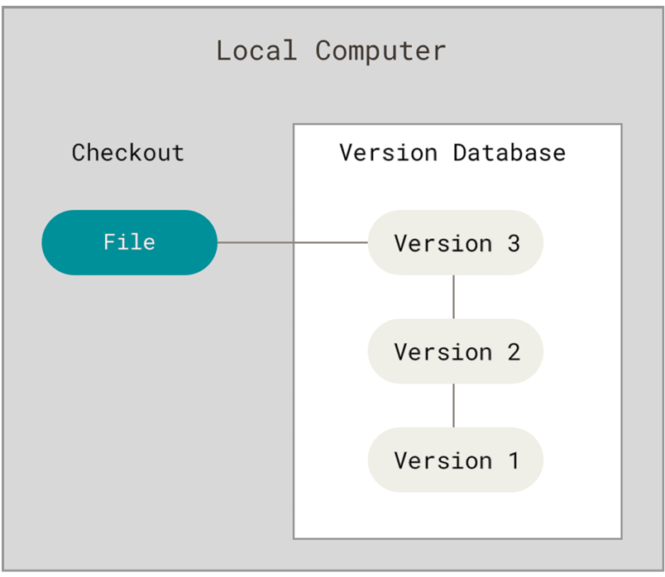

One of the most popular VCS tools was a system called RCS, which is still distributed with many computers today.
RCS works by keeping patch sets (that is, the differences between files) in a special format on disk; it can then re-create what any file looked like at any point in time by adding up all the patches.

Centralized Version Control Systems
The next major issue that people encounter is that they need to collaborate with developers on other systems.
To deal with this problem, Centralized Version Control Systems (CVCSs) were developed.
These systems (such as CVS, Subversion, and Perforce) have a single server that contains all the versioned files, and a number of clients that check out files from that central place.
For many years, this has been the standard for version control.

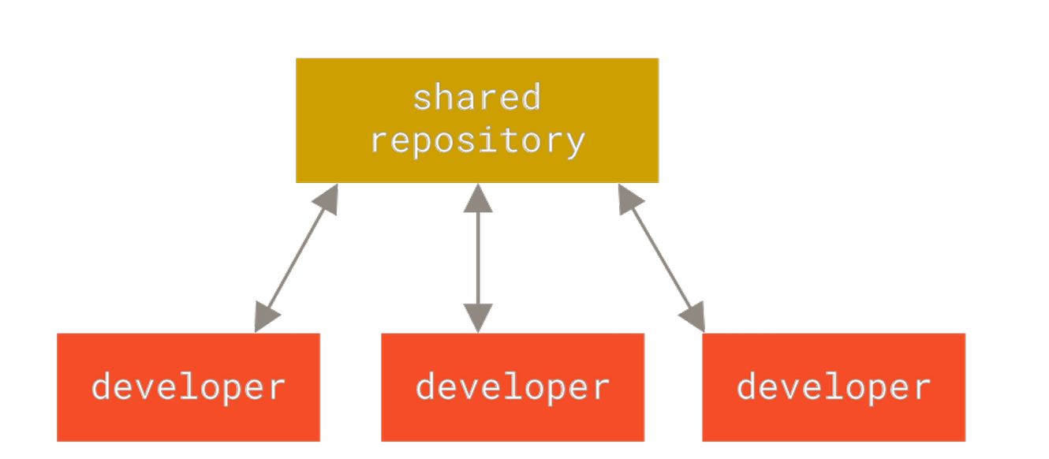

Distributed Version Control Systems
This is where Distributed Version Control Systems (DVCSs) step in.
In a DVCS (such as Git, Mercurial or Darcs), clients don’t just check out the latest snapshot of the files; rather, they fully mirror the repository, including its full history.
Thus, if any server dies, and these systems were collaborating via that server, any of the client repositories can be copied back up to the server to restore it.
Every clone is really a full backup of all the data.

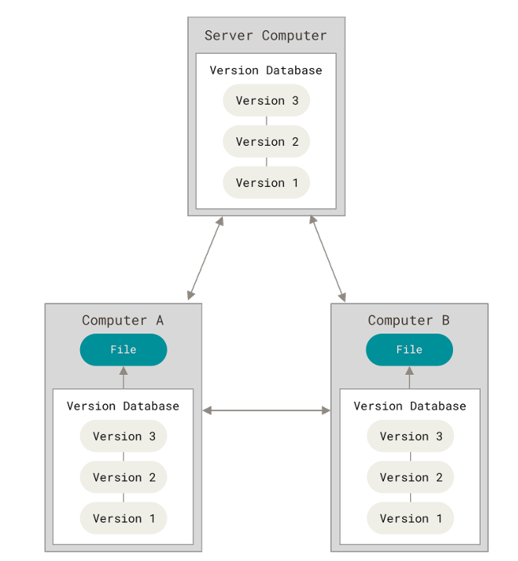

A Short History of Git
As with many great things in life, Git began with a bit of creative destruction and fiery controversy.
The Linux kernel is an open source software project of fairly large scope.
During the early years of the Linux kernel maintenance (1991–2002), changes to the software were passed around as patches and archived files.
In 2002, the Linux kernel project began using a proprietary DVCS called BitKeeper.
In 2005, the relationship between the community that developed the Linux kernel and the commercial company that developed BitKeeper broke down, and the tool’s free-of-charge status was revoked.
This prompted the Linux development community (and in particular Linus Torvalds, the creator of Linux) to develop their own tool based on some of the lessons they learned while using BitKeeper.
Some of the goals of the new system were as follows:
• Speed
• Simple design
• Strong support for non-linear development (thousands of parallel branches)
• Fully distributed
• Able to handle large projects like the Linux kernel efficiently (speed and data size)

Since its birth in 2005, Git has evolved and matured to be easy to use and yet retain these initial qualities.
It’s amazingly fast, it’s very efficient with large projects, and it has an incredible branching system for non-linear development.

Why Version Control is Important
1. Track Changes
- Records every modification to files
- Lets you compare old and new versions
2. Collaboration
- Multiple developers can work on the same project
- Avoids overwriting each other’s work
3. Backup & Recovery
- If something breaks, you can revert to a stable version
- Prevents data loss
4. Experiment Safely
- Create branches to try new features
- Merge changes only when they work correctly

Types of Version Control Systems
1. Local Version Control
- Stores versions on your local machine
- Example: manual backups (not common today)
2. Centralized Version Control (CVCS)
- One central server
Examples:
  - SVN(Subversion)
  - CVS(Concurrent Versions System)
3. Distributed Version Control (DVCS)
- Every developer has a full copy of the repository
- Examples:
  - Git (most popular)
  - Mercurial

Example (Real-Life Analogy)
Think of a Microsoft Docs file:
- You can see revision history
- Restore previous versions
- Multiple people can edit together
➡ That’s version control for documents; Git does the same for code.

Most Popular Tool
Git
Used with platforms like:
- GitHub
- GitLab
- Bitbucket

1. What is Git?
Git is a distributed version control system used to track code changes and collaborate with teams.
Key Benefits
✔ Version history
✔ Team collaboration
✔ Rollback changes
✔ Branch-based development

2. Git Basics & Common Commands
2.1 Install & Configure Git
Download Git for Windows
Open this link in your browser:
https://git-scm.com/download/win
✔ Download starts automatically
✔ File name like: Git-2.xx.x-64-bit.exe

Install Git (IMPORTANT OPTIONS)
Double-click the installer and follow these exact selections:
✔ Step-by-step choices
- Select Components
  - “Git Bash Here”
  - “Git GUI Here”
  - “Add Git to PATH” (very important)
- Adjust PATH Environment
  - Git from the command line and also from 3rd-party software
- Default Editor
  - Choose VS Code (recommended) or Notepad++
- Keep all other options default
- Click Install
Restart Terminal
After installation:
- Close Command Prompt / PowerShell
- Open new terminal
Now test:
git --version
✔ Expected output:
git version 2.xx.x.windows.x

Verify Git in VS Code
Open VS Code terminal:
git --version
If it works here → you’re good

If Still Not Working (PATH Fix)
Manual PATH Check (Windows)
- Press Win + R → type sysdm.cpl
- Go to Advanced → Environment Variables
- Under System variables → Path
- Ensure these exist:
C:\Program Files\Git\cmd
C:\Program Files\Git\bin
- If missing → Add them
- Restart PC (recommended)

LINUX
sudo apt update
sudo apt install git -y

macOS
brew install git
or
xcode-select --install

After Git Works (Next Mandatory Setup)
Run once:
git config --global user.name "Your Name"
git config --global user.email "your@email.com"
Verify:
git config --list

2.2 Creating a Repository

Creating a Git Repository (git init)
To start using Git for a project, you first need to create a Git repository. This is done using the command:
git init

What does git init do?
- Creates a new, empty Git repository
- Adds a hidden .git folder to your project
- Enables Git to start tracking changes in that directory
The .git folder stores:
- Commit history
- Branch information
- Configuration settings

Step-by-Step Example
1. Create or open a project folder
mkdir my-project
cd my-project
2. Initialize Git
git init
it will create a repository called master
If you want to create a named repository, main, give the following command
>git init main

Output:
Initialized empty Git repository called main in C:/my-project/.git/

Check Repository Status
git status
This shows:
- Untracked files
- Staged files
- Current branch (usually main)

Staging:
What is Staging in Git?
Staging is an intermediate step between modifying files and committing them to the repository.
It lets you choose exactly what changes you want to include in the next commit.

Git’s Three Main Areas
Working Directory → Staging Area → Repository
(edit files) (git add) (git commit)

Area | Meaning
Working Directory | Where you edit files
Staging Area (Index) | Where you prepare selected changes
Repository | Where commits are stored

Why Staging Is Important
Without staging, every change would be committed together.
Staging allows you to:
✔ Commit only relevant changes
✔ Create clean, meaningful commits
✔ Separate features, bug fixes, and formatting
✔ Review changes before committing

Example: Staging in Action
Modify Files (let assume these two files are already there(Login.java, Setting.java))
Login.java
public class Login {
public static void main(String args[]) {
System.out.println("Please login.");
}
}
Setting.java
public class Setting {
public static void main(String args[]) {
System.out.println("Set me");
}
}

You edit two files:
Login.java
System.out.println(“You have logged in.”);

Setting.java
System.out.println(“You did the settings.”);
Check Status
git status
Output:
modified: login.py
modified: settings.py
Stage Only One File
git add login.py
Now:
git status
staged: login.py
not staged: settings.py
Commit Staged Changes
git commit -m "Fix login validation"
Only Login.java is committed.

To display whatever we did use the following command
>git log

Key Staging Commands
Command | Purpose
git add file.txt | Stage a specific file
git add . | Stage all changes
git reset file.txt | Unstage a file
git status | View staging state

Undoing Changes
git checkout -- file.txt # Discard changes
git reset HEAD file.txt # Unstage file
git revert commit_id # Undo a commit safely

What is GitHub?
GitHub is a cloud-based platform used to store, manage, and collaborate on Git repositories.
It allows developers to share code, track changes, and work together from anywhere.
GitHub is NOT Git
- Git → Version control tool (runs on your computer)
- GitHub → Online service that hosts Git repositories

Simple Definition
GitHub is an online platform where Git repositories are stored and developers collaborate using Git.

Why GitHub Is Used
✔ Store code safely online
✔ Collaborate with teams
✔ Track changes & history
✔ Review code using Pull Requests
✔ Manage tasks using Issues
✔ Automate workflows (GitHub Actions)

How GitHub Works
Local Computer (Git)
↓ push
GitHub Repository (Cloud)
↑ pull
Other Developers
Working with GitHub
Steps in Working with GitHub (End-to-End Workflow)
These are the standard industry steps used in real projects (Java/Spring Boot/Django / React / Docker / any tech).

STEP 1: Install & Configure Git (One Time)
Check Git:
git --version
Configure user:
git config --global user.name "Your Name"
git config --global user.email "your@email.com"

STEP 2: Create a Repository on GitHub
- Login to github.com
- Click New Repository
- Enter:
  - Repository name
  - Public / Private
- Do NOT add README (for first practice)
- Click Create Repository

STEP 3: Create Project Locally
mkdir my-project
cd my-project
Initialize Git:
git init
Create a file:
echo "# My Project" > README.md
Commit:
git add .
git commit -m "Initial commit"

STEP 4: Connect Local Repo to GitHub
Copy repository URL from GitHub.
git remote add origin https://github.com/username/my-project.git
Verify:
git remote -v

STEP 5: Push Code to GitHub
git branch -M main
git push -u origin main
✔ Code appears on GitHub

STEP 6: Daily Work Cycle (MOST IMPORTANT)
1. Pull Latest Code
git pull origin main
2. Create Feature Branch
git checkout -b feature-login
3. Make Changes
Edit / add files
4. Stage & Commit
git add .
git commit -m "Added login feature"
5. Push Branch
git push origin feature-login

STEP 7: Create Pull Request (PR)
On GitHub:
- Click Compare & Pull Request
- Add description
- Submit PR
✔ Team reviews code
✔ CI runs (if configured)

STEP 8: Merge Pull Request
After approval:
- Click Merge
- Delete branch (optional)

STEP 9: Update Local Main Branch
git checkout main
git pull origin main

STEP 10: Resolve Merge Conflicts (If Any)
Git shows conflict:
<<<<<<< HEAD
=======
>>>>>>> feature-branch
Steps:
- Open file
- Fix manually
- Remove markers
- Commit
git add .
git commit -m "Resolved merge conflict"

STEP 11: Using GitHub Actions (CI/CD)
Create:
.github/workflows/ci.yml
Example:
name: Django CI
on: [push]
jobs:
test:
runs-on: ubuntu-latest
steps:
- uses: actions/checkout@v4
- run: pip install -r requirements.txt
- run: python manage.py test
✔ Runs automatically on every push

STEP 12: Clone an Existing Repository
git clone https://github.com/username/project.git
cd project

STEP 13: Common GitHub Commands
Command | Purpose
git clone | Copy repo
git push | Upload code
git pull | Download changes
git branch | Manage branches
git checkout | Switch branches
git merge | Merge branches
git rebase | Clean history

3. Branching in Git
3.1 What is a Branch?
A branch is an independent line of development.
Default branch: main or master

3.2 Branch Commands
git branch # List branches
git branch feature-login # Create branch
git checkout feature-login # Switch branch
git checkout -b feature-ui # Create + switch

4. Merging Branches
4.1 Merge a Branch
git checkout main
git merge feature-login
✔ Combines feature branch into main

5. Resolving Merge Conflicts
5.1 When Conflicts Occur
Conflicts happen when same lines are modified in different branches.
Conflict Markers Example
<<<<<<< HEAD
console.log("Main branch");
=======
console.log("Feature branch");
>>>>>>> feature-login

5.2 How to Resolve
- Open conflicted file
- Decide correct code
- Remove conflict markers
- Save file
- Commit changes
git add file.js
git commit -m "Resolved merge conflict"

6. Remote Repositories (GitHub)
6.1 Add Remote
git remote add origin https://github.com/user/repo.git
6.2 Push & Pull
git push origin main
git pull origin main

7. Pull Requests (PR)
7.1 What is a Pull Request?
A Pull Request is a request to merge your branch into another branch (usually main).

7.2 PR Workflow
- Create a feature branch
- Push branch to GitHub
- Open Pull Request
- Review code
- Merge PR
git push origin feature-login
✔ Enables code review & collaboration

8. Git Rebase (Optional but Important)
git checkout feature-login
git rebase main
Keeps commit history clean
Avoid rebasing shared branches

9. Introduction to GitHub Actions (CI/CD)
9.1 What is GitHub Actions?
GitHub Actions automate workflows like:
- Build
- Test
- Deploy
Triggered on events like:
✔ Push
✔ Pull Request

9.2 Basic GitHub Actions Workflow
Create file:
.github/workflows/ci.yml
Example: Node.js CI
name: Node CI

on: [push]

jobs:
build:
runs-on: ubuntu-latest

steps:
- uses: actions/checkout@v4
- name: Install dependencies
run: npm install
- name: Run tests
run: npm test

10. Important Git Commands (Quick List)
Command | Purpose
git init | Create repo
git clone | Copy repo
git add | Stage files
git commit | Save changes
git branch | Manage branches
git merge | Merge branches
git pull | Fetch + merge
git push | Upload changes
git rebase | Reapply commits
git stash | Save work temporarily

11. Best Practices
✔ Commit often
✔ Write meaningful messages
✔ Use feature branches
✔ Review PRs
✔ Pull before push

Hands-on Git practice exercises
Below are step-by-step Hands-on Git Practice Exercises from beginner → intermediate → advanced, designed exactly for practice, not theory.
You can do these on your local machine + GitHub.

Git Hands-On Practice Exercises

LEVEL 1: Git Basics (Beginner)
Exercise 1: Create Your First Repository
- Create a new folder:
mkdir git-practice
cd git-practice
- Initialize Git:
git init
- Create a file:
touch README.md
- Add text to README.md
Git Practice Project
- Check status and commit:
git status
git add README.md
git commit -m "Initial commit"
✔ Outcome: First commit created

Exercise 2: Track File Changes
- Edit README.md
- Check differences:
git diff
- Commit changes:
git add .
git commit -m "Updated README"
✔ Outcome: Learn file tracking

LEVEL 2: Branching & Merging

Exercise 3: Create and Switch Branches
git branch feature-login
git checkout feature-login
Create file:
touch login.txt
echo "Login Feature" > login.txt
Commit:
git add .
git commit -m "Added login feature"

Exercise 4: Merge Branch
git checkout main
git merge feature-login
✔ Outcome: Feature merged successfully

LEVEL 3: Merge Conflicts

Exercise 5: Create a Merge Conflict
- On main branch:
echo "Main branch change" > conflict.txt
git add .
git commit -m "Main branch update"
- Switch to feature branch:
git checkout feature-login
echo "Feature branch change" > conflict.txt
git add .
git commit -m "Feature branch update"
- Merge:
git checkout main
git merge feature-login

Exercise 6: Resolve Conflict
- Open conflict.txt
- Fix conflict manually
- Save file
- Commit:
git add conflict.txt
git commit -m "Resolved merge conflict"
✔ Outcome: Conflict resolved

LEVEL 4: Remote Repository (GitHub)

Exercise 7: Push to GitHub
- Create a repo on GitHub (no README)
- Link remote:
git remote add origin https://github.com/username/git-practice.git
- Push:
git push -u origin main

Exercise 8: Pull Changes
- Edit README.md on GitHub UI
- Pull changes locally:
git pull origin main
✔ Outcome: Sync local & remote

LEVEL 5: Pull Requests

Exercise 9: Create a Pull Request
- Create new branch:
git checkout -b feature-profile
- Add file:
touch profile.txt
git add .
git commit -m "Added profile feature"
git push origin feature-profile
- Create PR on GitHub
- Merge PR
✔ Outcome: PR workflow learned

LEVEL 6: Rebase & Stash

Exercise 10: Rebase
git checkout feature-profile
git rebase main
✔ Outcome: Clean commit history

Exercise 11: Stash Changes
git stash
git stash list
git stash pop
✔ Outcome: Temporary save work

LEVEL 7: GitHub Actions (CI/CD)

Exercise 12: Create GitHub Action
- Create file:
.github/workflows/ci.yml
- Add content:
name: Git Practice CI

on: [push]

jobs:
test:
runs-on: ubuntu-latest
steps:
- uses: actions/checkout@v4
- run: echo "CI Running Successfully"
- Push code:
git add .
git commit -m "Added GitHub Action"
git push
✔ Outcome: CI runs automatically

BONUS CHALLENGES (Interview-Ready)
Challenge 1
- Delete a branch locally and remotely
git branch -d feature-login
git push origin --delete feature-login

Challenge 2
- Squash commits using rebase
git rebase -i HEAD~3

Challenge 3
- Restore deleted file
git checkout HEAD~1 -- filename

Final Outcome
After these exercises, you will be able to:
✔ Work confidently with Git
✔ Handle merge conflicts
✔ Collaborate using PRs
✔ Use GitHub Actions
✔ Clear Git interview questions

Git + React / Spring Boot project
Below is a complete hands-on Git + React + Spring Boot project, designed like a real industry workflow.
You’ll practice Git daily operations, branching, PRs, conflict resolution, and CI with GitHub Actions.

Git + React + Spring Boot Full Practice Project
Project Title
Customer Management System
Tech Stack
- Frontend: React
- Backend: Spring Boot
- Database: MySQL (or H2 for practice)
- Version Control: Git + GitHub
- CI/CD: GitHub Actions

Project Structure
customer-management/
│
├── backend/
│ └── customer-service/
│ ├── src/main/java
│ ├── src/main/resources
│ └── pom.xml
│
├── frontend/
│ └── customer-ui/
│ ├── src/
│ └── package.json
│
└── README.md

PHASE 1: Git Repository Setup
Exercise 1: Initialize Git
mkdir customer-management
cd customer-management
git init
Create README:
echo "# Customer Management System" > README.md
git add .
git commit -m "Initial project setup"

Exercise 2: Push to GitHub
- Create repo on GitHub
- Connect remote:
git remote add origin https://github.com/username/customer-management.git
git push -u origin main

PHASE 2: Spring Boot Backend (Git Practice)
Backend Features
- Add Customer
- Get Customers
- Delete Customer

Exercise 3: Backend Feature Branch
git checkout -b backend-setup
Create Spring Boot app:
mkdir backend
Add files → commit:
git add backend
git commit -m "Spring Boot backend setup"
Merge:
git checkout main
git merge backend-setup

Exercise 4: Customer API Branch
git checkout -b backend-customer-api
Add:
- Customer.java
- CustomerController.java
- CustomerRepository.java
Commit:
git add .
git commit -m "Customer CRUD API"
git push origin backend-customer-api

Create Pull Request → Merge

PHASE 3: React Frontend (Git Practice)
Frontend Features
- Add Customer Form
- Customer List
- Delete Customer

Exercise 5: React Setup Branch
git checkout -b frontend-setup
npx create-react-app frontend/customer-ui
Commit:
git add frontend
git commit -m "React app setup"
git push origin frontend-setup

PR → Merge

Exercise 6: React Customer UI
git checkout -b frontend-customer-ui
Add:
- CustomerForm.js
- CustomerList.js
- Axios integration
Commit:
git add .
git commit -m "Customer UI with API integration"

PHASE 4: Git Merge Conflict (REAL PRACTICE)
Exercise 7: Create Conflict
- Modify README.md in main
- Modify same lines in frontend-customer-ui
Merge:
git checkout main
git merge frontend-customer-ui
Resolve conflict → commit:
git add README.md
git commit -m "Resolved README conflict"

PHASE 5: Environment Config & Rebase
Exercise 8: Rebase Feature Branch
git checkout frontend-customer-ui
git rebase main
✔ Clean history

PHASE 6: GitHub Actions CI/CD

Exercise 9: Backend CI
Create file:
.github/workflows/backend-ci.yml
name: Backend CI

on: [push]

jobs:
build:
runs-on: ubuntu-latest
steps:
- uses: actions/checkout@v4
- name: Build Backend
run: mvn clean install
working-directory: backend/customer-service
Commit & push:
git add .
git commit -m "Backend CI workflow"
git push

Exercise 10: Frontend CI
.github/workflows/frontend-ci.yml
name: Frontend CI

on: [push]

jobs:
build:
runs-on: ubuntu-latest
steps:
- uses: actions/checkout@v4
- run: npm install
working-directory: frontend/customer-ui
- run: npm run build
working-directory: frontend/customer-ui

PHASE 7: Advanced Git Exercises
Delete Branches
git branch -d backend-customer-api
git push origin --delete backend-customer-api

Stash Unfinished Work
git stash
git stash pop

Rollback Commit
git revert commit_id

FINAL LEARNING OUTCOMES
After completing this project, you will be able to:
✔ Work on real Git workflows
✔ Manage React + Spring Boot in one repo
✔ Use feature branches & PRs
✔ Resolve merge conflicts confidently
✔ Implement CI pipelines
✔ Answer Git interview questions with confidence

Same project with Docker
Below is the same Customer Management System (React + Spring Boot), now fully Dockerized, exactly the way it’s done in real projects.
You’ll practice Docker + Git + CI/CD together.

React + Spring Boot + MySQL + Docker Project
Project Name
Customer Management System (Dockerized)

Final Project Structure
customer-management/
│
├── backend/
│ ├── Dockerfile
│ ├── pom.xml
│ └── src/
│
├── frontend/
│ ├── Dockerfile
│ ├── package.json
│ └── src/
│
├── docker-compose.yml
├── .github/
│ └── workflows/
│ └── docker-ci.yml
│
└── README.md

PHASE 1: Spring Boot Backend (Docker)
Backend REST API (Recap)
- GET /api/customers
- POST /api/customers
- DELETE /api/customers/{id}

Backend Dockerfile
backend/Dockerfile
FROM maven:3.9.6-eclipse-temurin-17 AS build
WORKDIR /app
COPY pom.xml .
RUN mvn dependency:go-offline
COPY src ./src
RUN mvn clean package -DskipTests

FROM eclipse-temurin:17-jdk
WORKDIR /app
COPY --from=build /app/target/*.jar app.jar
EXPOSE 8080
ENTRYPOINT ["java","-jar","app.jar"]

Backend application.properties
spring.datasource.url=jdbc:mysql://mysql:3306/customerdb
spring.datasource.username=root
spring.datasource.password=root
spring.jpa.hibernate.ddl-auto=update

PHASE 2: React Frontend (Docker)
Frontend Dockerfile
frontend/Dockerfile
FROM node:18 AS build
WORKDIR /app
COPY package.json package-lock.json ./
RUN npm install
COPY . .
RUN npm run build

FROM nginx:alpine
COPY --from=build /app/build /usr/share/nginx/html
EXPOSE 80

React API Configuration
// src/api.js
import axios from "axios";

export default axios.create({
baseURL: "http://localhost:8080/api"
});

PHASE 3: Docker Compose (MAIN PART)
docker-compose.yml
version: "3.8"

services:
mysql:
image: mysql:8
container_name: mysql-db
restart: always
environment:
MYSQL_ROOT_PASSWORD: root
MYSQL_DATABASE: customerdb
ports:
- "3306:3306"

backend:
build: ./backend
container_name: customer-backend
ports:
- "8080:8080"
depends_on:
- mysql

frontend:
build: ./frontend
container_name: customer-frontend
ports:
- "3000:80"
depends_on:
- backend

PHASE 4: Run the Entire Project
Build & Run
docker-compose up --build
Access
- Frontend → http://localhost:3000
- Backend → http://localhost:8080/api/customers
- MySQL → localhost:3306

PHASE 5: Git + Docker Workflow (Important)
Feature Branch Example
git checkout -b docker-setup
Add:
- Dockerfiles
- docker-compose.yml
Commit:
git add .
git commit -m "Dockerized frontend, backend, and MySQL"
git push origin docker-setup

Create Pull Request → Merge

PHASE 6: Common Docker Issues (Practice)
Backend fails to connect to MySQL
✔ Fix: Use service name mysql, not localhost

React API not working
✔ Fix:
baseURL: "http://backend:8080/api"
(inside Docker network)

PHASE 7: GitHub Actions – Docker CI
.github/workflows/docker-ci.yml
name: Docker CI

on: [push]

jobs:
build:
runs-on: ubuntu-latest
steps:
- uses: actions/checkout@v4

- name: Build Docker Images
run: docker-compose build
✔ Validates Docker build on every push

PHASE 8: Advanced Practice Tasks
Task 1
- Add .dockerignore for frontend & backend
node_modules
target

Task 2
- Use environment variables for DB password

Task 3
- Add health check for backend container

FINAL SKILLS YOU GAIN
After this project, you can confidently say:
✔ “I can dockerize React + Spring Boot apps”
✔ “I know Docker Compose for multi-container apps”
✔ “I use Git feature branches & PRs”
✔ “I implement CI pipelines with Docker”
✔ “I can debug Docker networking issues”

