1. Write a Java class **Author** with following features:

Instance variables (fields) :

**firstName** for the author’s first name of type String.

**lastName** for the author’s last name of type String.

**bookName** for the book has written by the author of type String

Constructors:

Default constructor

**public Author (String firstName, String lastName)**: A constructor with parameters, it creates the Author object by setting the two fields to the passed values.

**public Author (String firstName, String lastName, String bookName)**: A constructor with parameters, it creates the Author object by setting the three fields to the passed values.

Instance methods:

**public void setFirstName (String firstName)**: Used to set the first name of author.

**public void setLastName (String lastName)**: Used to set the last name of author.

**public void setBookName(String bookName)**: Used to set the book name.

**public String getFirstName()**: This method returns the first name of the author.

**public String getLastName()**: This method returns the last name of the author.

**public String getBookName()**: This method returns the book name of the written book by the author.

**public String toString()**: This method printed out author’s details to the screen

**Finally write test class TestAuthor to test the functionalities you implemented**.

* Create three objects with the defined constructors (one is with default, one is with two parameterized constructor and one is with three parameterized constructor).
* Display the values of second object by using getters.
* Display the values of the third object by using the toString() method.
* Display the values of first object by using getters.
* This time create an object with default constructor. What is your observation?
* Create one reference and try to display the values. What is your observation?
* Assign second object to the reference and display the values.

1. A class called **Employee**, which models an employee with an id, name and salary, is designed as shown in the following class diagram. The method **raiseSalary(percent)** increases the salary by the given percentage. Write the Employee class.

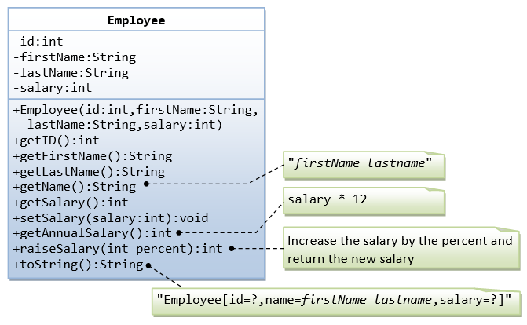

Observe the salary field is defined with the datatype int in the class diagram. Is it the correct way of definition? If you want to change the datatype of salary field, what is the type you want to change?

Finally write a test class TestEmployee.java to test all the functionalities of the class.

1. A class called **InvoiceItem**, which models an item of an invoice, with id, description, quantity and unit price, is designed as shown in the following class diagram. Write the **InvoiceItem** class.

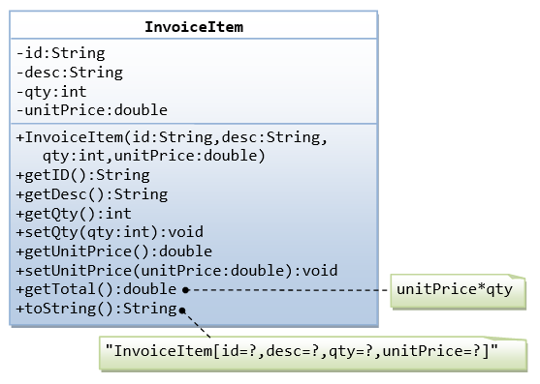

Create the class with shown fields in the class diagram.

Write a test class TestInvoiceItem.java to test the functionalities of InvoiceItem class.