**Joining meeting with Polycom**

# **Issues with RoundTable cameras**

Please be aware that after the recent update of Microsoft Teams the Polycom RoundTable devices, are no longer supported. You will be able to connect the device and use it as a speakerphone in a Teams meeting but the video (camera) will not work.

## Join Teams Meeting via Web browser

If you would like to use video during your Teams Meeting, then please use MS Teams with browser to join meeting via Polycom device as outlined below. Please use Microsoft Edge browser or Google chrome.**Steps to Join meeting**

* Open Teams in Web browser: <https://teams.microsoft.com>.
* When you have opened Teams in web browser go to the Calendar icon:



Find and Join your meeting.

When Teams meeting Joined click the 3 dots.



Press on Show device Settings.

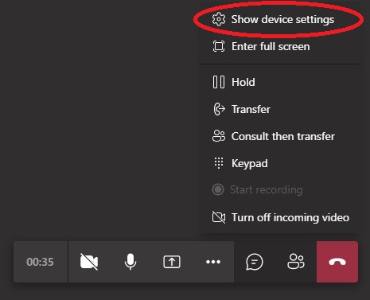

Check if Polycom is selected on Speaker & Microphone.

Under Camera please select Polycom CX5100/CX5500 Active Speaker Video.

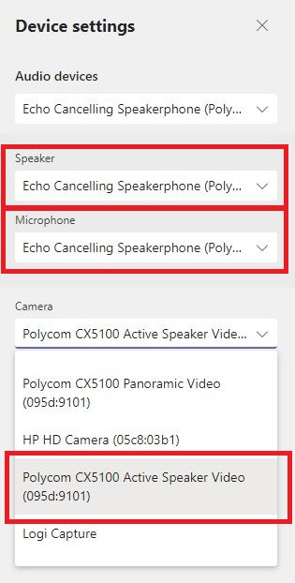

**What you can do with MS teams in Browser during meeting**

* You can share desktop, Window, Power point
* You Can raise Hand, Pin others, Mute others
* You view Meeting chat, start and stop recording

**What you cannot do MS teams on Browser during meeting**

* Background blur and custom background option is not available
* You can not share Video , Photo or Audio system with other participants
* You can’t allow others to control your desktop