XDevCamp

Magento Workshop 2

Performance & Development

Vinai Kopp

Setup and Configuration

The workshop is designed to be followed on a Magento CE 1.6 Installation with the custom example modules Example_Brand and Example_MultiOptionCart. For Innovate attendees a VirtualBox image is available that contains a preconfigured environment.
If you prefer to use your own development environment, you may install the tgz archive of the source and the DB dump.

The code for the hands-on labs is available in pre-baked snipplets in a separate archive file for your convenience.

Workshop Resources:
A. VirtualBox VM Image (includes all workshop assets)
Magento_Workshop.vdi
B. Magento Workshop Files Archive (Magento, the pre-baked code and the DB-dump)
Magento_Workshop_Full.tgz
C. Archive containing pre-baked code snipplets
Magento_Workshop2_Code.tgz

Preparations with the Innovate VirtualBox Image:
1. Fire up the VirtualBox VM using the supplied disk image
2. Open the Firefox Browser (a shortcut button is on the desktop)
3. If the Demo Magento homepage doesn't load automatically please visit
http://workshop.dev/
4. Open up the NetBeans IDE (there is a shortcut on the VM Desktop)

Preparations without the Innovate VirtualBox Image:
1. Unpack the archive Magento_Workshop_Full.tgz. It contains the example modules
Example_MultiOptionCart and Example_Brand.
2. Create a database and import the database dump Magento_Workshop.sql found in the
archive.
3. Execute the SQL, replacing “your-domain.dev” with whatever your development domain
is: UPDATE core_config_data SET value=”http://your-domain.dev/”
WHERE path LIKE ‘%base_url’;
4. Edit the settings in the file app/etc/local.xml file to point to the imported database.
5. Visit the homepage of the Magento Installation to confirm all is working
6. Open the Magento Installation in the IDE of your choosing

VirtualBox Image Authentication Credentials:
If you are using the VirtualBox VM you can use the following credentials:

Magento
Magento Frontend URL: http://workshop.dev/
Magento Admin URL: http://workshop.dev/admin
Magento Admin User: admin
Magento Admin Password: magento123

MySQL
PhpMyAdmin URL: http://workshop.dev/phpmyadmin
MySQL Root User: root
MySQL Root Password: magento123

Linux
VM User: magento
VM Password: magento123

Directory Structure
In the VirtualBox Image all files can be found at /var/www/workshop. A project has already been created for you in NetBeans.
Inside the workshop directory you have the following sub directories:

/magento
The Magento Application Code as well as the example modules

/onepage-checkout-workshop
The Code for the other Innovate DevCamp Magento Workshop

/performance-workshop/Part One/Code
/performance-workshop/Part Two/Code
The pre-baked Code Snipplets for the hands-on Labs

/performance-workshop/Part One/Lab N
/performance-workshop/Part Two/Lab N
The Code as it is before the specified hands-on Lab begins

/performance-workshop/Part One/Lab N finished
/performance-workshop/Part Two/Lab N finished
The Code as it is after the specified hands-on Lab

Workshop Part One:
Example_Brand

Lab 1 - The DB Connection Profiler
Open the brands page
1. In the Browser, click on the Brands Category in the top Navigation

Enable the Profiler Display
1. Log in to the Magento admin interface at http://workshop.dev/admin
2. Select the page “System > Configuration” from the top navigation
3. Select the Developer section on the bottom left
4. In the Debug panel switch the Profiler option to Yes and save
5. Reload the front end brands page. Notice the Profiler output at the bottom
of the page and that there is no data displayed (yet).

Enable DB Connection Profiling
1. In the IDE, open the file magento/app/etc/local.xml
2. Add the a node from code block 01-01 in the node
global/resources/default_setup/connection after the <active> node.

Code Block 01-01:

<profiler>true</profiler>

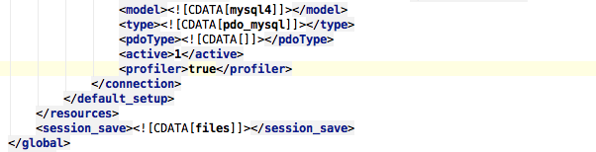

3. Clear the Configuration Cache under “System > Cache Management”

Test the DB Profiler

Reload the brands page in the front end and notice the Profiler now displays some statistics.
The numbers will be different depending on the hardware and software setup you are using.

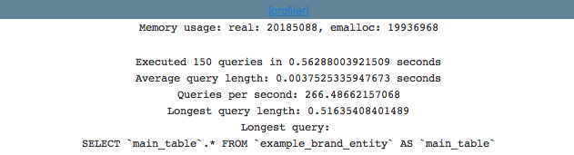

Lab 2 - Collection Caching
Locate the block class.
1. Find the block type by visiting the Admin Panel Page “CMS > Static Blocks”.
2. Select the block “Example Brand List”
3. Notice the block type example_brand/list.

Alternatively you could enable template path hints with block names to find the used block class.

Initialize the Collection Cache
1. Open the file magento/app/code/local/Example/Brand/Block/List.php
2. Add the code block 02-01 to the method _prepareBrandCollection()

Code Block 02-01:

$brands->initCache(Mage::app()->getCache(), 'brandlist', array());

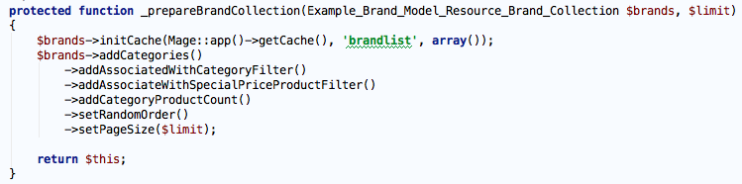

Test the Code
Reload the brands page once and notice there is no big difference in speed as the cache entry only was created.
Reload the page again and notice the Profiler no longer lists the collection query as the slowest one.

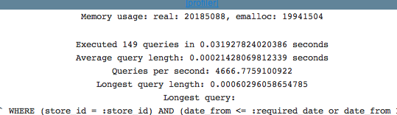

Add Cache Invalidation
On the brands category page only brands are listed, which are associated with at least one category and one or more product with a special price.

Assert the current page does not reflect changes once the collection is cached by removing all category associations for a brand
1. Check the brand collection is cached (by checking the profiler output).
2. Choose one of the listed brands (how about the one on the top left)
3. Log in to the Magento admin interface at http://workshop.dev/admin
4. Navigate to “Catalog > Manage Categories”
5. Select the chosen brand’s category and choose the empty option for the “Brand”
Attribute. Save the category change.
6. Do the same for the brand’s category in the “Special Deals” category branch.
7. Reload the brands page and notice that it indeed not change
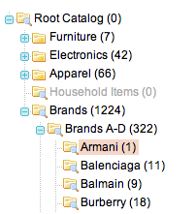
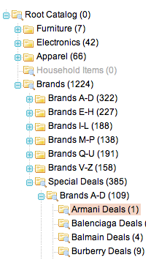

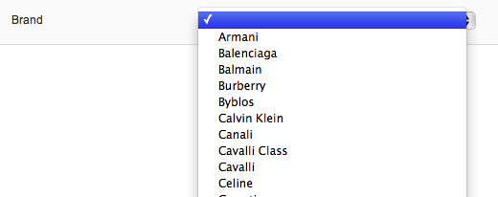
Add Cache Tags for the Categories
1. Open the file magento/app/code/local/Example/Brand/Block/List.php
2. Add the cache tag constants Mage_Catalog_Model_Category::CACHE_TAG and
Mage_Catalog_Model_Product::CACHE_TAG to the collection cache initialization.
The whole change is in code block 02-02.

Code Block 02-02:

$brands->initCache(Mage::app()->getCache(), 'brandlist', array(
Mage_Catalog_Model_Category::CACHE_TAG,
Mage_Catalog_Model_Product::CACHE_TAG
));

Test the Code
Since the collection is already cached with no associated code blocks, the cache needs to be cleared once manually for the change to take effect.
1. Go to the Cache Management and refresh the “Collection Data” cache.
2. Reload the brands page on the front end to regenerate the cache entry.
3. Briefly take note of the current brand order
4. In the admin panel, change any attribute and save the change.
5. Reload the brands page and notice the collection was no longer cached.
The collections SELECT is listed in the profiler again and the order of categories
changed.
6. Reload the page one more time to assert the collection has been cached again.
7. If you have time go ahead and check it also works for products.

Lab 3 - Entity Cache Tags

Now the collection cache is refreshed every time a category or product is updated, but that is not the case for the brands themselves. If a new brand is added, or an existing one is modified, we still need to update the cache manually.

Add a custom cache tag to the brand entity
1. Open the file magento/app/code/local/Example/Brand/Model/Brand.php
2. Add the cache tag constant CACHE_TAG with the value ‘example_brand’ to the head of
the class Example_Brand_Model_Brand
3. Add the protected var $_cacheTag to the class head with the value of the constant (see
code block 03-01).

Code Block 03-01:

const CACHE_TAG = 'example_brand';

protected $_cacheTag = self::CACHE_TAG;

4. Add the brand cache tag to the collection cache initialization in the method
Example_Brand_Block_List::_prepareBrandCollection() as shown in
code block 03-02.

Code Bock 03-02:

$brands->initCache(Mage::app()->getCache(), 'brandlist', array(
Mage_Catalog_Model_Category::CACHE_TAG,
Mage_Catalog_Model_Product::CACHE_TAG,
Example_Brand_Model_Brand::CACHE_TAG
));

Test the Code
1. Refresh the “Collection Data” cache manually.
2. Reload the brands page to regenerate the cache record.
3. Visit the Page “Catalog > Manage Brands”.
4. Select a brand, change its name and save it.
5. Reload the brands page and check the result is not from the cache.

Lab 4 - Block Caching
This is an additional possibility to cache data in Magento. Which option to choose depends on the circumstances.

Enable block html caching for the brands page.
1. Open the file magento/app/code/local/Example/Brand/Block/List.php
2. Add the protected method _construct() as shown in code block 04-01.

Code Block 04-01:

protected function _construct()
{
$this->setCacheLifetime(false);
$this->setCacheTags(array(
Mage_Catalog_Model_Category::CACHE_TAG,
Mage_Catalog_Model_Product::CACHE_TAG,
Example_Brand_Model_Brand::CACHE_TAG
));
parent::_construct();
}

Test the Code
1. Reload the brands page to generate the block cache record.
2. Update a Category, Product or Brand entity through the admin interface.
3. Reload the brands page and check the result is not from the cache.

Workshop Part Two:
Example_MultiOptionCart

Lab 05 - The Code Profiler
The issue
1. Visit the Example Multioption Product Page (the link is in the header)
2. Choose some random variants in the selects for three rows.
3. Enter a quantity for those three rows
4. Note the time it takes when you submit the form

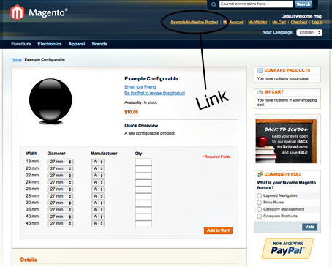

Enable the Code Profiler
1. Open the magento/index.php file and remove the comment character # on line 64 as
shown in the code block 05-01).
Code Block 05-01:

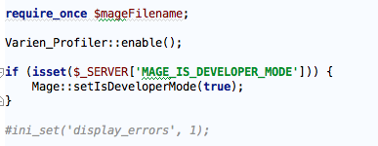

2. Reload the multioption product page on the front end to check on the bottom of the page
the code profiler is working.

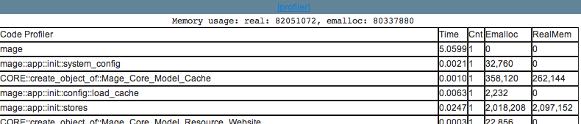

If the profilerdata is not visible, enable the profiler output as described in the first part of this workshop:
1. Log in to the admin panel at http://workshop.dev/admin
2. Visit the page “System > Configuration”
3. Select the Developer section on the bottom left
4. In the “Debug” panel switch the “Profiler” option to “Yes” and click Save
5. Reload the multioption product page on the front end to check the profiler is enabled.

Measure performance
1. Add some products to the cart using the form on the multioption page
2. Notice the profiler only displays the data from the cart page, because you
are redirected to the checkout/cart/index page.
So we need a different way to view the profiling data.
3. Disable the profiler output again in the admin panel at “System > Configuration >
Developer > Debug”.
4. Keep the call to Varien_Profiler::enable()in the index.php file enabled.

Log profiling data through an Event Observer
Create the extension Example_Profiler
Remember you can use the pre-baked code to copy & paste from if you don’t want to type all.

1. Create the module registration file magento/app/etc/modules/Example_Profiler.xml
Add the code block 05-02 as the contents of that file.

Code Block 05-02:

<?xml version="1.0"?>
<config>
<modules>
<Example_Profiler>
<active>true</active>
<codePool>local</codePool>
<depends>
<Mage_Core/>
</depends>
</Example_Profiler>
</modules>
</config>

2. Create the directories magento/app/code/local/Example/Profiler/etc
3. Create the file magento/app/code/local/Example/Profiler/etc/config.xml
4. Add the code block 05-03 as the contents of that file

Code Block 05-03:

<?xml version="1.0"?>
<config>
<global>
<models>
<example_profiler>
<class>Example_Profiler_Model</class>
</example_profiler>
</models>
</global>
<frontend>
<events>
<controller_front_send_response_after>
<observers>
<example_profiler>
<type>model</type>
<class>example_profiler/observer</class>
<method>controllerFrontSendResponseAfter</method>
</example_profiler>
</observers>
</controller_front_send_response_after>
</events>
</frontend>
</config>

5. Create the directory magento/app/code/local/Example/Profiler/Model and the file app/code/local/Example/Profiler/Model/Observer.php with code block 05-04 as the content.

Code Block 05-04:

<?php

class Example_Profiler_Model_Observer
{
public function
controllerFrontSendResponseAfter(Varien_Event_Observer $observer)
{
// Only write to log if the profiler is enabled
$timers = $this->_getTimerData();
if ($timers) {
$data = $this->_getTableHeadData();
$data = array_merge($data, $timers);

$f = fopen('var/log/profiler.log', 'a');
foreach ($data as $row) {
fwrite($f, implode(', ', $row) . "\n");
}
fclose($f);
}
}

protected function _getTimerData()
{
$timers = Varien_Profiler::getTimers();
foreach ($timers as $name => $timer) {
$sum = Varien_Profiler::fetch($name, 'sum');
$count = Varien_Profiler::fetch($name, 'count');
$emalloc = Varien_Profiler::fetch($name, 'emalloc');
$realmem = Varien_Profiler::fetch($name, 'realmem');

// Filter out entries of little relevance
if ($sum < .0010 && $count < 10 && $emalloc < 10000) {
continue;
}
$data[] = array($name, number_format($sum, 4), $count,
number_format($emalloc), number_format($realmem));
}
return $data;
}

protected function _getTableHeadData()
{
$data = array();
$data[] = array();
$data[] = array('Request URI: ' .
Mage::app()->getRequest()->getServer('REQUEST_URI'));
$data[] = array('Request Date: ' . date('Y-m-d H:i:s'));
$data[] = array('Memory usage: real: ' . memory_get_usage(true),
'emalloc: ' . memory_get_usage());
$data[] = array();
$data[] = array('Timer Name', 'Time', 'Count', 'Emalloc',
'RealMem');

return $data;
}
}

Test the Code
1. Flush the Magento configuration cache
2. Add some products to the cart using the form on the multioption page
3. Study the profiler data written to the file magento/var/log/profiler.log

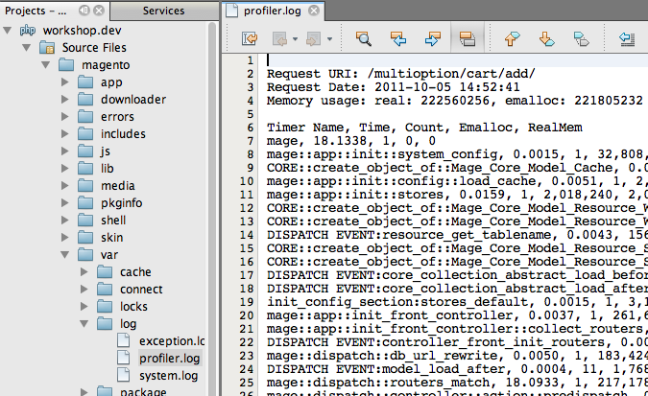

Lab 6 - Formatting the Profiler Data
Currently the profiler output is not really human readable.
Update the observer to log to a text table.
1. Open the file magento/app/code/local/Example/Profiler/Model/Observer.php
2. Add the the method _getDataAsTextTable() from code block 06-01

Code Block 06-01:

protected function _getDataAsTextTable(array $data)
{
$table = new Zend_Text_Table(array('columnWidths' => array(1)));
$widths = array();
foreach ($data as $rowData)
{
$row = new Zend_Text_Table_Row();
foreach ($rowData as $idx => $cell) {
$width = mb_strlen($cell);
if (! isset($widths[$idx]) || $widths[$idx] < $width)
{
$widths[$idx] = $width;
}
$row->appendColumn(new Zend_Text_Table_Column(strval($cell)));
}
$table->appendRow($row);
}
$table->setColumnWidths($widths);

return $table->render();
}

3. Update the method controllerFrontSendResponseAfter() to
reflect code block 06-02

Code 06-02:

public function
controllerFrontSendResponseAfter(Varien_Event_Observer $observer)
{
$timers = $this->_getTimerData();
if ($timers)
{
$data = $this->_getTableHeadData();
$data = array_merge($data, $timers);

$out = $this->_getDataAsTextTable($data);
$f = fopen('var/log/profiler.log', 'a');
fwrite($f, $out);
fclose($f);
}
}

Test the Code
1. Delete the file magento/var/log/profiler.log
2. Add some products to the cart using the form on the multioption page
3. Study the changes in the data written to the file magento/var/log/profiler.log

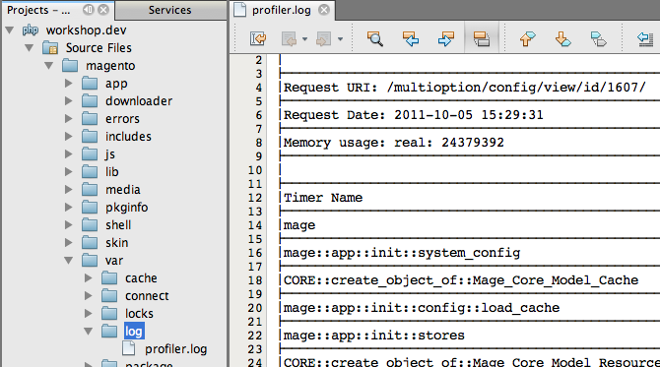

Modify Observer to sort Profiling Data by Time
1. Open the file app/code/local/Example/Profiler/Model/Observer.php
2. Add the method _sortTimers() from the code block 06-03 to the observer class.

Code Block 06-03:

protected function _sortTimers(array $a, array $b)
{
if ($a[1] === $b[1])
{
return 0;
}
return $a[1] < $b[1] ? 1 : -1;
}

3. Add the call usort(...) to the method _getTimerData() as shown
in code block 06-04.

Code Block 06-04:

protected function _getTimerData()
{
$timers = Varien_Profiler::getTimers();
foreach ($timers as $name => $timer) {
$sum = Varien_Profiler::fetch($name, 'sum');
$count = Varien_Profiler::fetch($name, 'count');
$emalloc = Varien_Profiler::fetch($name, 'emalloc');
$realmem = Varien_Profiler::fetch($name, 'realmem');

// Filter out entries of little relevance
if ($sum < .0010 && $count < 10 && $emalloc < 10000) {
continue;
}
$data[] = array($name, number_format($sum, 4), $count,
number_format($emalloc), number_format($realmem));
}
usort($data, array($this, '_sortTimers'));
return $data;
}

Test the Code
1. Delete the file magento/var/log/profiler.log
2. Add some products to the cart using the form on the multioption page
3. Study the changes in the data written to the file magento/var/log/profiler.log.
Notice the records are listed in descending order by time.

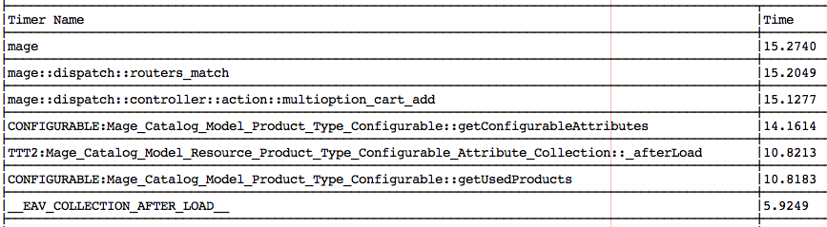

Lab 07 - Finding and Fixing the Issue
Now that we have readable profiler data, we can analyze it and implement a solution

Notice the entry in the profiling data from adding the products to the cart with the timer name
CONFIGURABLE:Mage_Catalog_Model_Product_Type_Configurable::getConfigurableAttributes

Also notice the Count column says the method was called multiple times (the exact number depends on the number of products you added to the cart).

1. Open magento/app/code/core/Mage/Catalog/Model/Product/Type/Configurable.php
2. Find the method getConfigurableAttributes()
3. Notice the results of the method are cached on the specified product model
using the method setData()

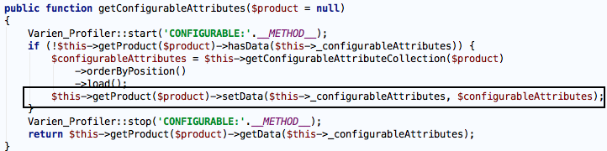

4. Open magento/app/code/local/Example/MultiOptionCart/controllers/CartController.php
5. Notice a new clone of the product model is used for each call
to $cart->addProduct()

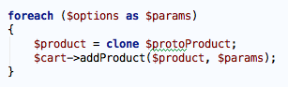

So what is happening? The collection of configurable attributes is loaded again for each product.

Implement a Solution
1. Before the foreach ($options as $params)loop, add a call to
getConfigurableAttributes() on the prototype product model as shown in
code block 07-01.

Code Block 07-01:

try
{
$protoProduct->getTypeInstance(true)
->getConfigurableAttributes($protoProduct);
foreach ($options as $params)
{
$product = clone $protoProduct;
$cart->addProduct($product, $params);
}

$cart->save();

Test the Code
1. Delete the file magento/var/log/profiler.log
2. Add some products to the cart using the form on the multioption page
3. Study the changes in the data written to the file magento/var/log/profiler.log.

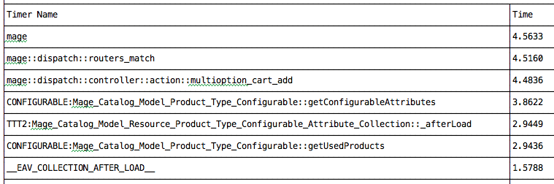

4. Disable the profiling by commenting out the call to Varien_Profiler::enable() in
the magento/index.php file when you are done.

