Innovate 2011 DevCamp

Magento Workshop 1

Customizing the Onepage Checkout

Vinai Kopp

Setup and Configuration

The workshop is designed to be followed on a Magento CE 1.6 Installation. For Innovate attendees a VirtualBox image is available that contains a preconfigured environment.
If you prefer to use your own development environment, you may install the TGZ archive of the source and the DB dump.

The code for the hands-on labs is available in pre-baked snipplets in a separate archive file for your convenience.

Workshop Resources:
A. VirtualBox VM Image (includes all workshop assets)
Magento_Workshop.vdi
B. Magento Workshop Files Archive (Magento, the pre-baked code and the DB-dump)
Magento_Workshop_Full.tgz
C. Archive containing only the pre-baked code snipplets
Magento_Workshop1_Code.tgz

Preparations with the Innovate VirtualBox Image:
1. Fire up the VirtualBox VM using the supplied disk image
2. Open the Firefox Browser (a shortcut button is on the desktop)
3. If the Demo Magento homepage doesn't load automatically please visit
http://workshop.dev/
4. Open up the NetBeans IDE (there is a shortcut on the VM Desktop and in the toolbar)

Preparations without the Innovate VirtualBox Image:
1. Unpack the archive Magento_Workshop_Full.tgz.
2. Create a database and import the database dump Magento_Workshop.sql found in the
archive.
3. Execute the SQL, replacing “your-domain.dev” with whatever your development domain
is: UPDATE core_config_data SET value=”http://your-domain.dev/”
WHERE path LIKE ‘%base_url’;
4. Edit the settings in the file magento/app/etc/local.xml file to point to the imported
database.
5. Visit the homepage of the Magento Installation to confirm all is working
6. Open the Magento Installation in the IDE of your choice
7. Log into the admin panel and navigate to “System > Configuration”. Select “Shipping
Method” on the left and make sure only one shipping method is enabled.

VirtualBox Image Authentication Credentials:
If you are using the VirtualBox VM you can use the following credentials:

Magento
Magento Frontend URL: http://workshop.dev/
Magento Admin URL: http://workshop.dev/admin
Magento Admin User: admin
Magento Admin Password: magento123

MySQL
PhpMyAdmin URL: http://workshop.dev/phpmyadmin
MySQL Root User: root
MySQL Root Password: magento123

Linux
VM User: magento
VM Password: magento123

Directory Structure
In the VirtualBox Image all files can be found at /var/www/workshop. A project has already been created for you in NetBeans.
Inside the workshop directory you have the following sub directories:

/magento
The Magento Application Code as well as the example modules

/onepage-checkout-workshop/Code
The pre-baked Code Snipplets for the hands-on Labs

/onepage-checkout-workshop/Lab N
The Code as it is before the specified hands-on Lab begins

/onepage-checkout-workshop/Lab N finished
The Code as it is after the specified hands-on Lab

/performance-workshop/
The Code for the other Innovate DevCamp Magento Workshop

Lab 01 - Create an empty Module
1. Open the IDE project
2. Create the file magento/app/etc/modules/Example_Checkout.xml and add
the code block 01-01 as the contents of that file.

Code Block 01-01:

<?xml version="1.0"?>
<config>
<modules>
<Example_Checkout>
<active>true</active>
<codePool>local</codePool>
<depends>
<Mage_Checkout/>
<Mage_Core/>
</depends>
</Example_Checkout>
</modules>
</config>

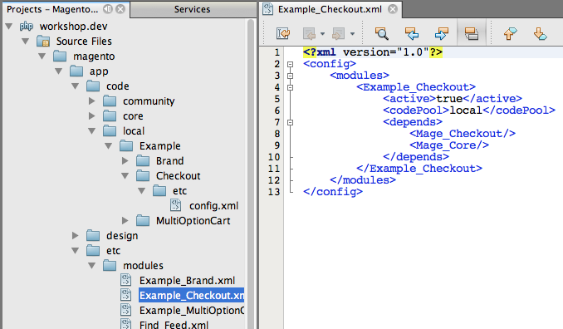

3. Create the directory magento/app/code/local/Example/Checkout/etc. Please note the
capitalization of the directory names.
4. Create the file magento/app/code/local/Example/Checkout/etc/config.xml and add
the code block 01-02 as the contents of the file.

Code 01-02:

<?xml version="1.0"?>
<config>

</config>

Test the Code
Since the module doesn’t do anything yet, we can only check if Magento recognizes it exists.
Every time you make a change to a configuration file you must refresh the configuration cache to make it take effect.

Clear the Cache so Magento “sees” our module
1. Log in to the admin panel at http://workshop.dev/admin
2. Navigate to “System > Cache Management”

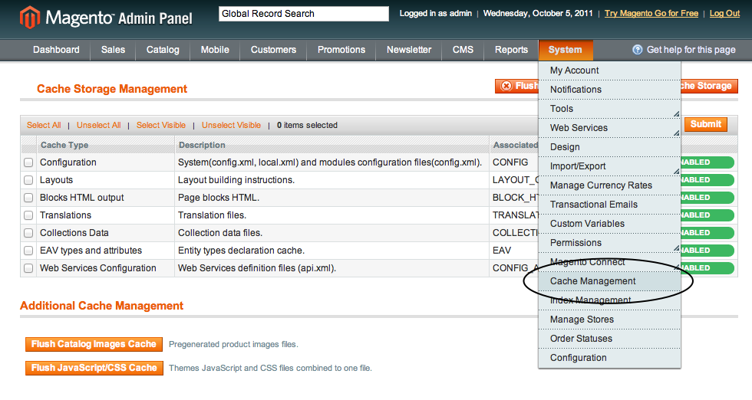
3. Select the checkbox in the top row marked Configuration
4. Click the Submit button to refresh the configuration cache
5. Navigate to the page “System > Configuration”
6. Select the section “Advanced” on the bottom left

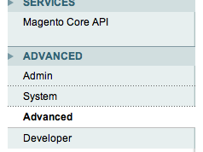

7. Click on the blue title panel labeled “Disable Module Output” to expand it
8. Check our module Example_Checkout is listed

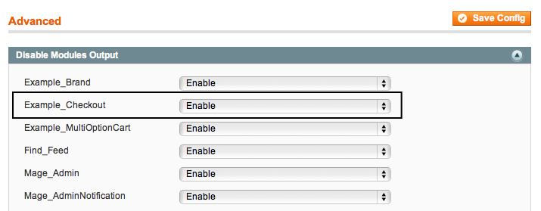

Since Example_Checkout is listed it means Magento is picking up our configuration.

Lab 02 - Add Code to hook in the Checkout
1. Add the bold code from block 02-01 inside the <config> node in the
magento/app/code/local/Example/Checkout/etc/config.xml file.
Please note, there is no whitespace before or after the text contents of the
<Example_Checkout> node.

Code 02-01:

<?xml version="1.0"?>
<config>
<frontend>
<routers>
<checkout>
<args>
<modules>
<Example_Checkout
before="Mage_Checkout">Example_Checkout</Example_Checkout>
</modules>
</args>
</checkout>
</routers>
</frontend>
</config>

2. Create the directory magento/app/code/local/Example/Checkout/controllers
Note the directory name "controllers" is plural and in all lower case.
3. Create the file
magento/app/code/local/Example/Checkout/controllers/OnepageController.php
and add the code block 02-02 as the contents.

Code 02-02:

<?php

require_once 'Mage/Checkout/controllers/OnepageController.php';
class Example_Checkout_OnepageController
extends Mage_Checkout_OnepageController
{
}

Lab 03 - Create Methods to add our logic
1. Open the file
magento/app/code/local/Example/Checkout/controllers/OnepageController.php
2. Add the code block 03-01 into the class Example_Checkout_OnepageController.

Code 03-01:

public function saveBillingAction()
{
parent::saveBillingAction();
$this->_checkSkipShippingMethod();
}

public function saveShippingAction()
{
parent::saveShippingAction();
$this->_checkSkipShippingMethod();
}

protected function _checkSkipShippingMethod()
{
$helper = Mage::helper('core');

// Check the session hasn’t expired
$body = $this->getResponse()->getBody();
if ($body)
{
$result = $helper->jsonDecode($this->getResponse()->getBody());
if (array_key_exists('goto_section', (array)$result)
&& 'shipping_method' === $result['goto_section']
)
{
}
}
}

Test the Code
Currently we can only test the module by verifying it does not trigger an exception.
1. Clear the configuration cache (see Lab 1 for detailed instructions).
2. On the front end, add a product to the cart and proceed to the checkout.
3. If the checkout loads without errors your code is working.

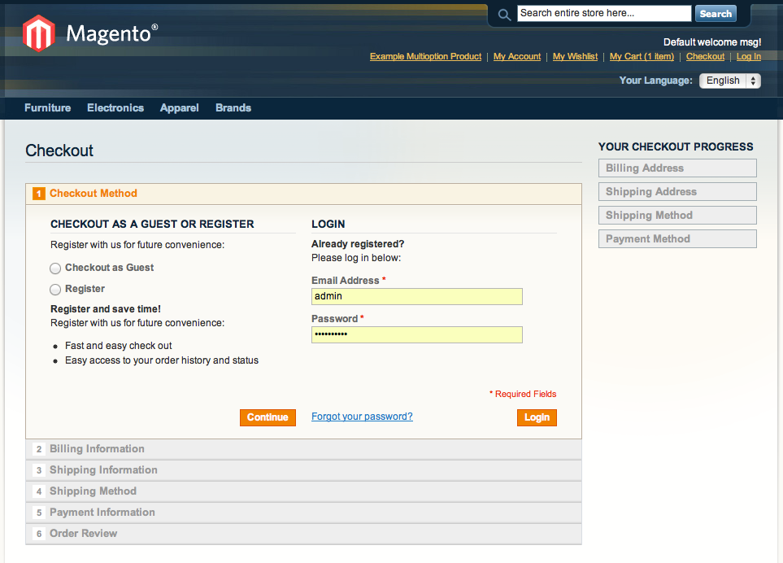

Lab 04 - Check the available Shipping Methods
1 Open the file
magento/app/code/local/Example/Checkout/controllers/OnepageController.php
2. Add the code from the block 04-01 into the inner if() section of the method
_checkSkipShippingMethod()

Code 04-01:

$onepage = $this->getOnepage();
$shippingMethods = $this->_getAvailableShippingMethods($onepage);
if (count($shippingMethods) === 1)
{
}

3. Add the new method _getAvailableShippingMethods() from code block 04-02
into the class Example_Checkout_OnepageController.

Code 04-02:

protected function _getAvailableShippingMethods(
Mage_Checkout_Model_Type_Onepage $onepage)
{
$address = $onepage->getQuote()->getShippingAddress();
$methods = array();
foreach ($address->getGroupedAllShippingRates() as $carrier)
{
foreach ($carrier as $rate)
{
$methods[] = $rate->getCode();
}
}
return $methods;
}

Lab 05 - Select the Shipping Method and Continue
1. Add the code block 05-01 into the inner if() block in the method
_checkSkipShippingMethod() in the file
magento/app/code/local/Example/Checkout/controllers/OnepageController.php

Code 05-01:

$onepage->getQuote()->setTotalsCollectedFlag(false);
$onepage->saveShippingMethod($shippingMethods[0]);

$this->getLayout()->getUpdate()->setCacheId(null);

$result['goto_section'] = 'payment';
$result['update_section'] = array(
'name' => 'payment-method',
'html' => $this->_getPaymentMethodsHtml()
);
$result['allow_sections'] = array('shipping', 'shipping_method');

$onepage->getCheckout()
->setStepData('shipping_method', 'complete', true);

$this->getResponse()->setBody($helper->jsonEncode($result));

Test the Code
Now the module is complete we can check everything works as planned.
1. If you haven’t done so yet, add a product to the cart and proceed to the checkout.
2. Select Checkout as a Guest or Register
3. Fill the Billing Information form. Select the “Ship to this address” option below the
form and click the Continue button.
4. Check the next step is the Payment Information step and in the progress bar on the
right Flat Rate is selected as the current shipping method.
If so the saveBillingAction() method works as expected.
5. Now check the saveShippingAction() method. Click on the header of the Shipping
Information step to back up to that step.
6. Click the Continue button. Once again the Shipping Method step should be skipped and
the Payment Information step should be visible.

