Copied the file from local to hdfs by following command

***hadoop fs -copyFromLocal word-count.txt /user/acadgild/hadoop/***

After this executed the following command

***Hadoop fs -appendToFile - /user/acadgild/hadoop/word-count.txt***

And copied some dummy text loren epsum

And pressed the Ctrl + D

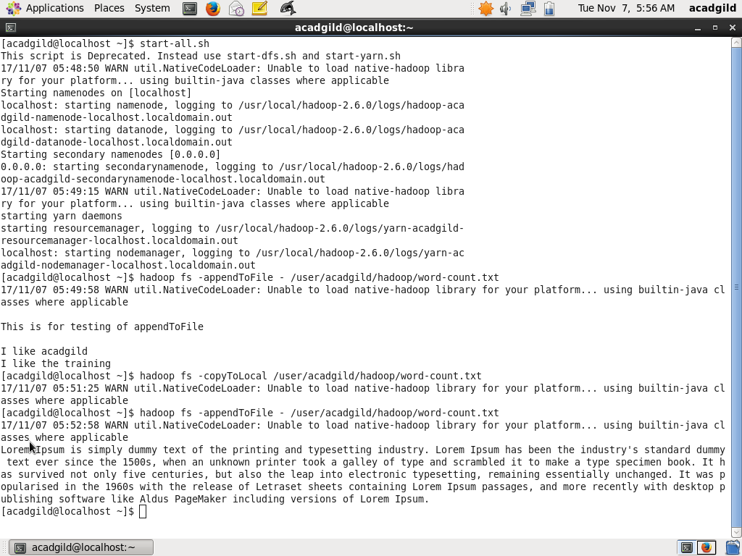

And moved the file to local directory and observed the changes in the file

***Hadoop fs -copyToLocal /user/acadgild/hadoop/word-count.txt***

