Create file in /home/acadgild/max-temp.txt and moved to hadoop folder strecture /user/acadgild/hadoop folder

And given permissions by following command ( owner and group all access )

Hadoop fs -chmod 770 /user/acadgild/hadoop/max-temp.txt

Following are the commands used for it

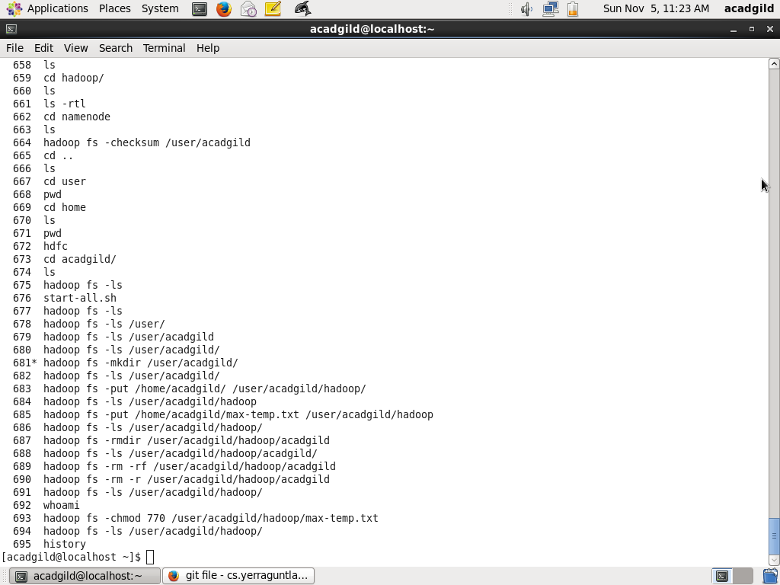

Final directory created

