- Write a java code with the class named ‘acad’ and a method ‘main’. Hard Code the program with two integers and print the sum of those two.

Java class created in eclipse

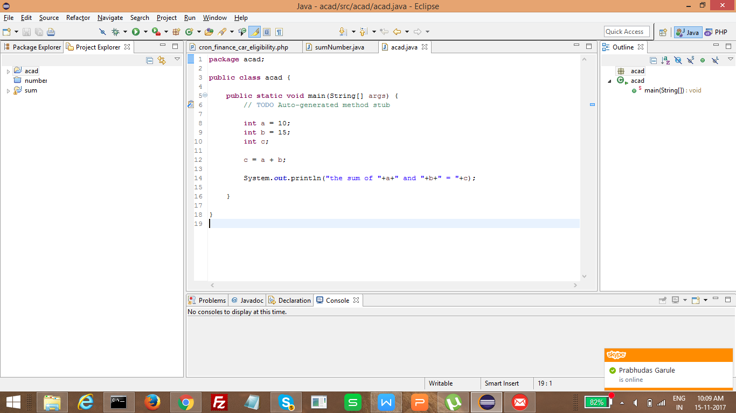

Source Code

package acad;

public class acad {

public static void main(String[] args) {
// TODO Auto-generated method stub

int a = 10;
int b = 15;
int c;

c = a + b;

System.out.println("the sum of "+a+" and "+b+" = "+c);

}

}

Created the jar file

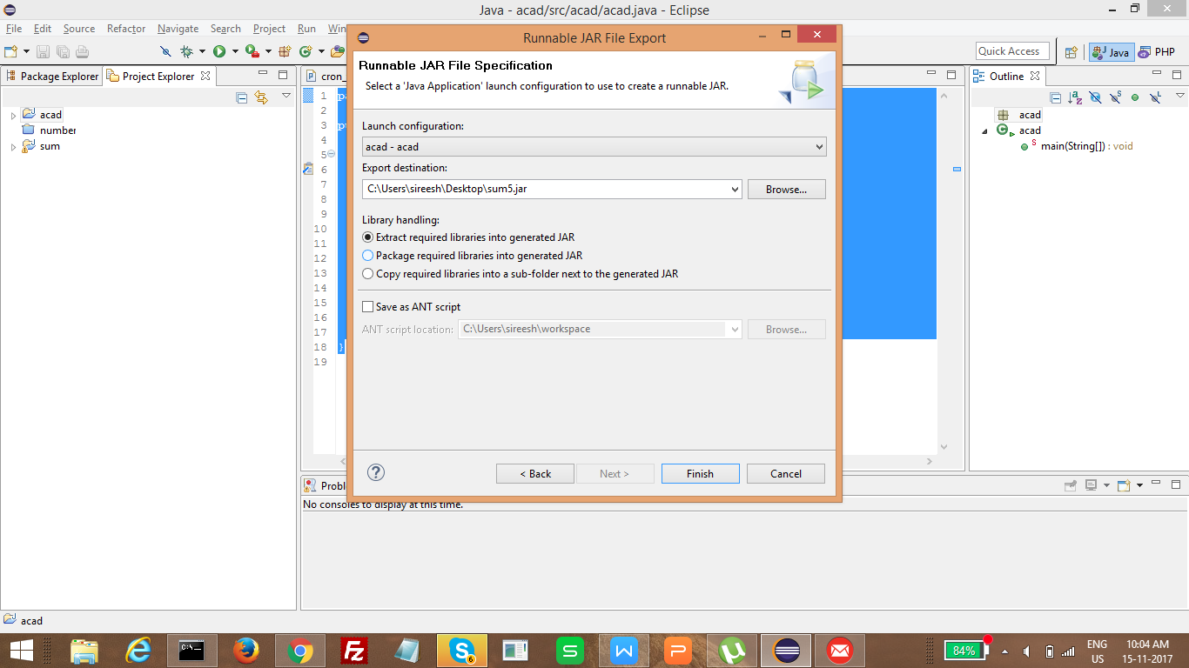

Executed in commandline

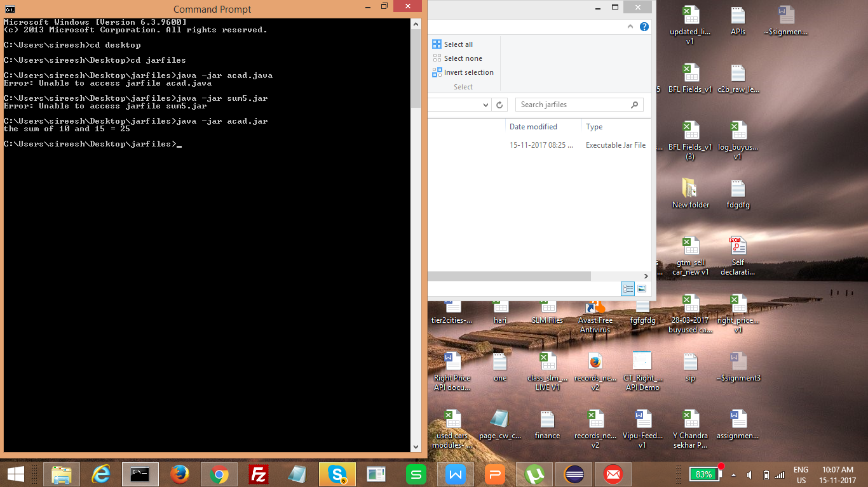

- Rewrite the above code, where, inputs are provided by the user at runtime and the output is printed.

Java class created in eclipse

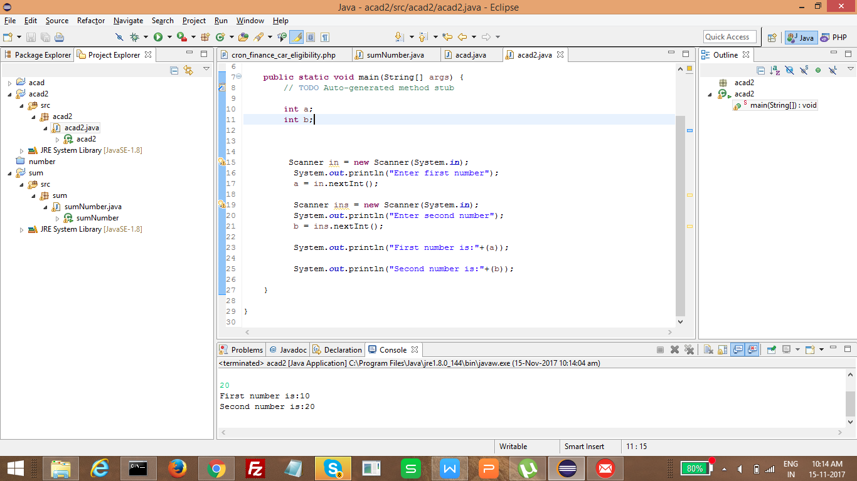

Source Code

package acad2;

import java.util.Scanner;

public class acad2 {

public static void main(String[] args) {
// TODO Auto-generated method stub

int a;
int b;

Scanner in = new Scanner(System.in);
System.out.println("Enter first number");
a = in.nextInt();

Scanner ins = new Scanner(System.in);
System.out.println("Enter second number");
b = ins.nextInt();

System.out.println("First number is:"+(a));

System.out.println("Second number is:"+(b));

}

}

Created Jar file

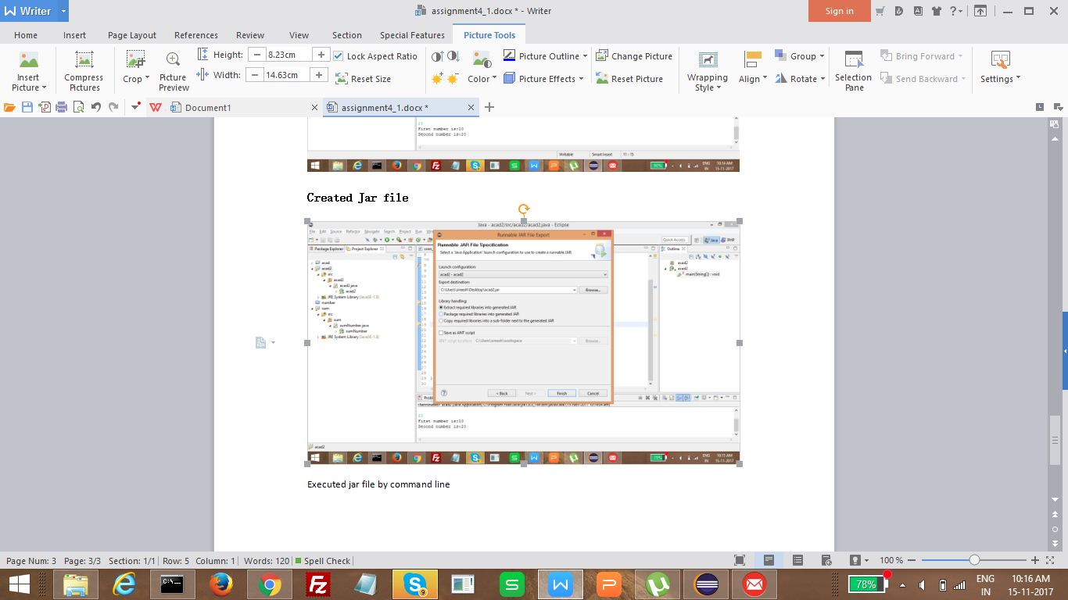

Executed jar file by command line

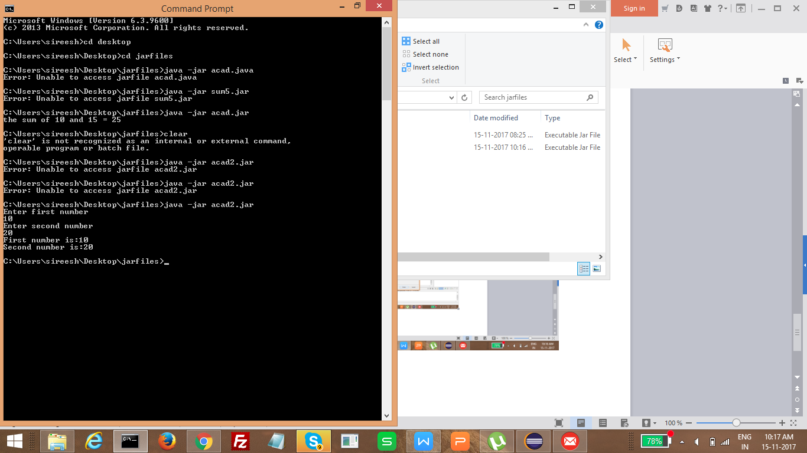

- Write a program with method name sum() that accepts two parameters from user and print the sum of two numbers. Output format should be as: First number is: Second number is: Sum is:

Java class created in eclipse

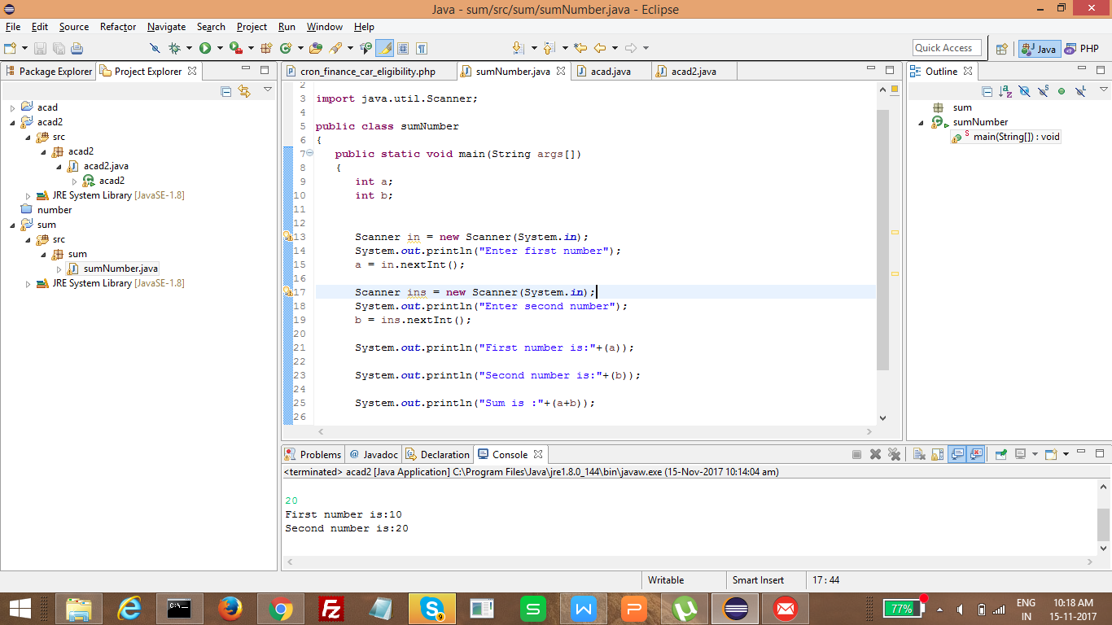

Source Code

package sum;

import java.util.Scanner;

public class sumNumber
{
public static void main(String args[])
{
int a;
int b;

Scanner in = new Scanner(System.in);
System.out.println("Enter first number");
a = in.nextInt();

Scanner ins = new Scanner(System.in);
System.out.println("Enter second number");
b = ins.nextInt();

System.out.println("First number is:"+(a));

System.out.println("Second number is:"+(b));

System.out.println("Sum is :"+(a+b));

}
}

Jar file created

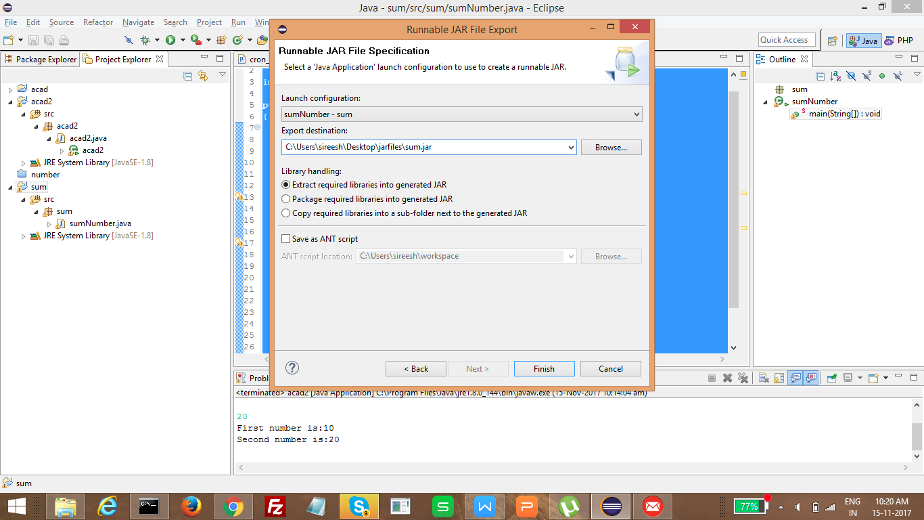

Executed in Commandline

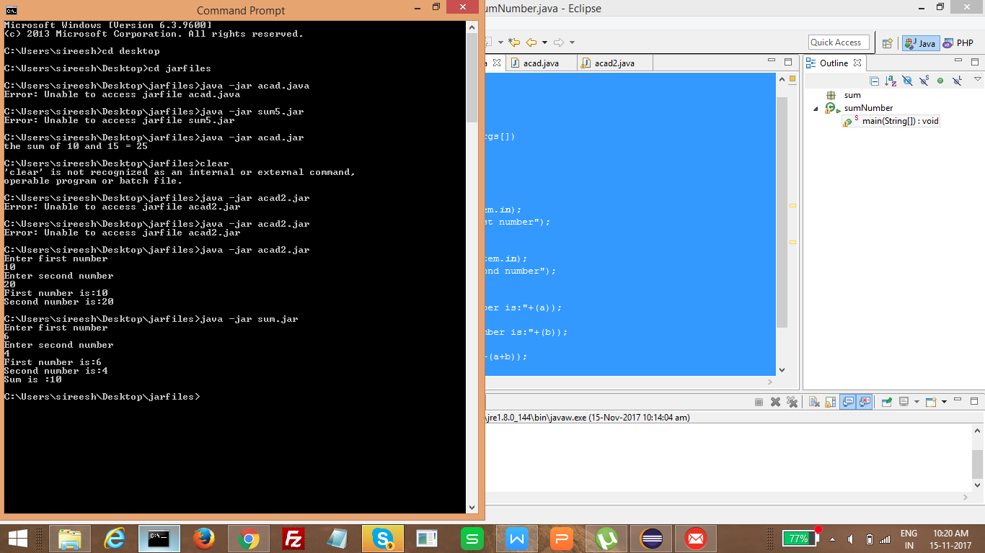

- Write a program to accepts two numbers from stdin and find all the odd as well as even numbers present in between them.

Crated a java class

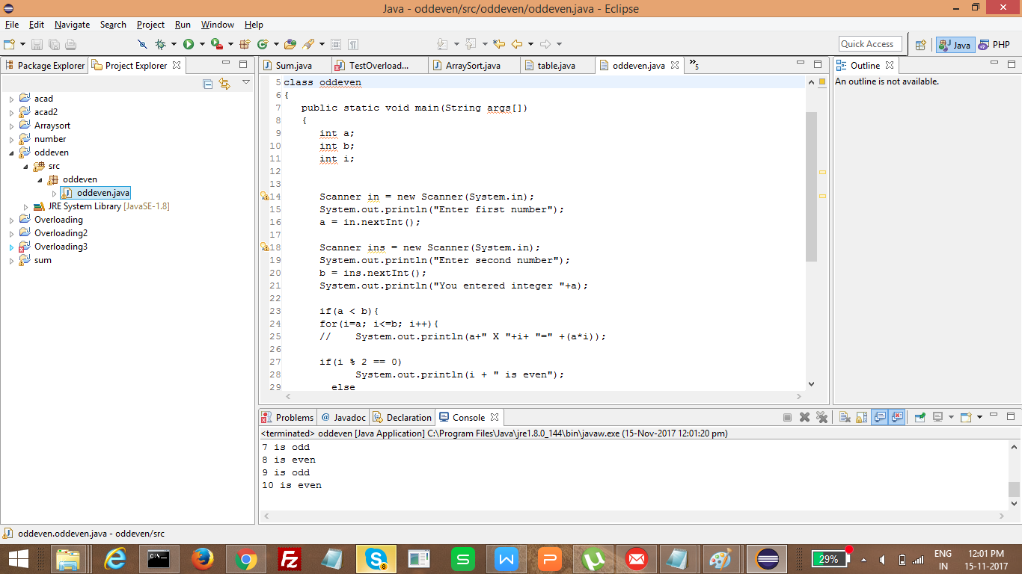

Source Code

package oddeven;

import java.util.Scanner;

class oddeven
{
public static void main(String args[])
{
int a;
int b;
int i;

Scanner in = new Scanner(System.in);
System.out.println("Enter first number");
a = in.nextInt();

Scanner ins = new Scanner(System.in);
System.out.println("Enter second number");
b = ins.nextInt();
System.out.println("You entered integer "+a);

if(a < b){
for(i=a; i<=b; i++){
// System.out.println(a+" X "+i+ "=" +(a*i));

if(i % 2 == 0)
System.out.println(i + " is even");
else
System.out.println(i + " is odd");
}
}else if(a > b){
for(i=a; i>=b; i--){
// System.out.println(a+" X "+i+ "=" +(a*i));

if(i % 2 == 0)
System.out.println(i + " is even");
else
System.out.println(i + " is odd");
}
}
}

}

Created jar file

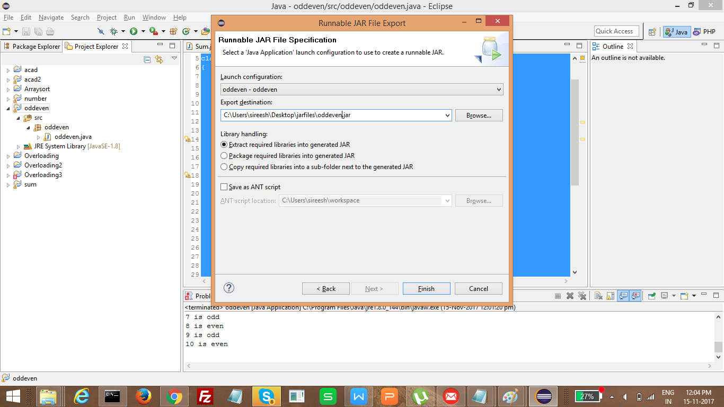

Executed on command line

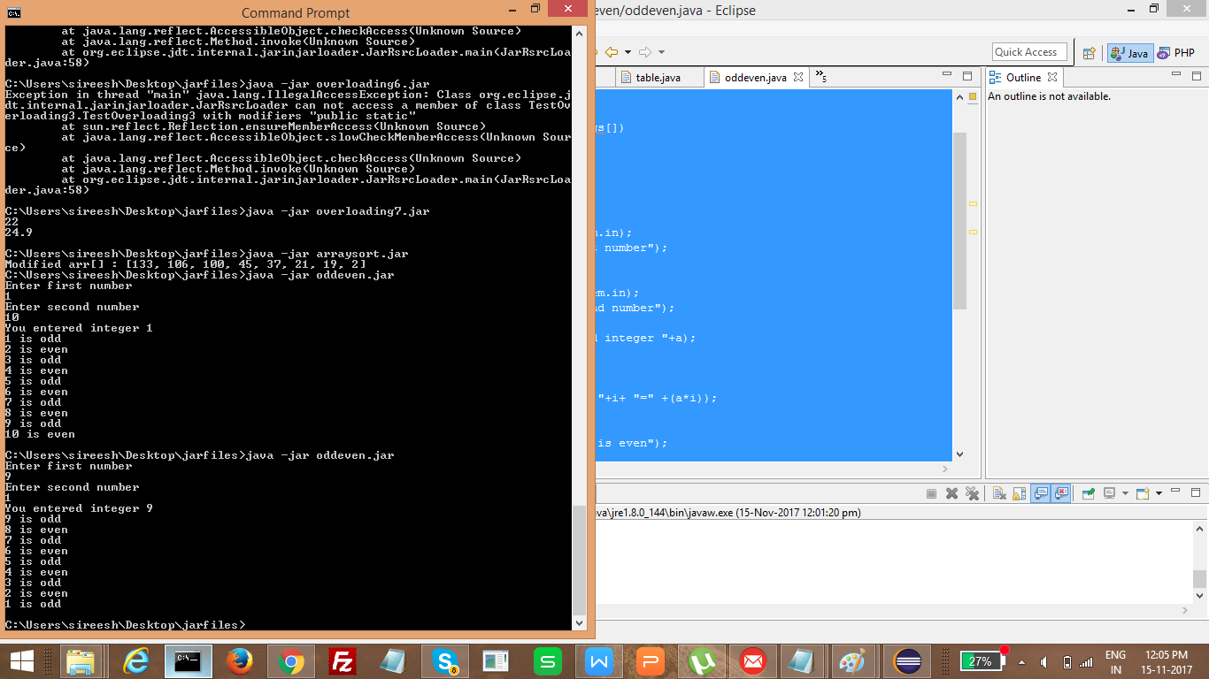

- Joe is scared to go to school. When her dad asked the reason, joe said she is unable to complete the task given by her teacher. The task was to find the “first 10 multiples” of the number entered from stdin . Eg

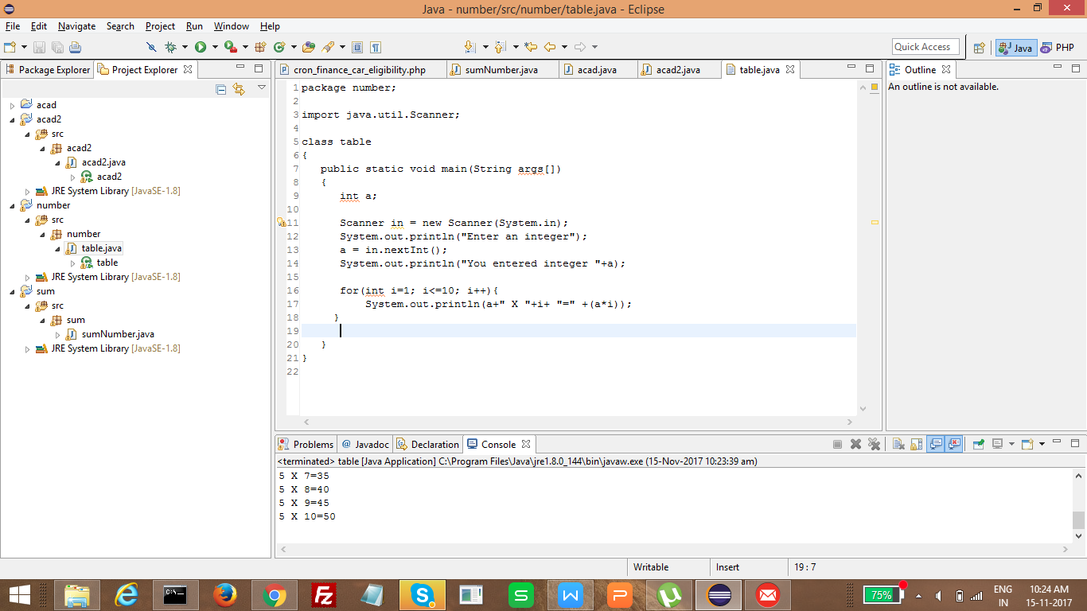

Souce code

package number;

import java.util.Scanner;

class table
{
public static void main(String args[])
{
int a;

Scanner in = new Scanner(System.in);
System.out.println("Enter an integer");
a = in.nextInt();
System.out.println("You entered integer "+a);

for(int i=1; i<=10; i++){
System.out.println(a+" X "+i+ "=" +(a*i));
}

}
}

Created Jar file

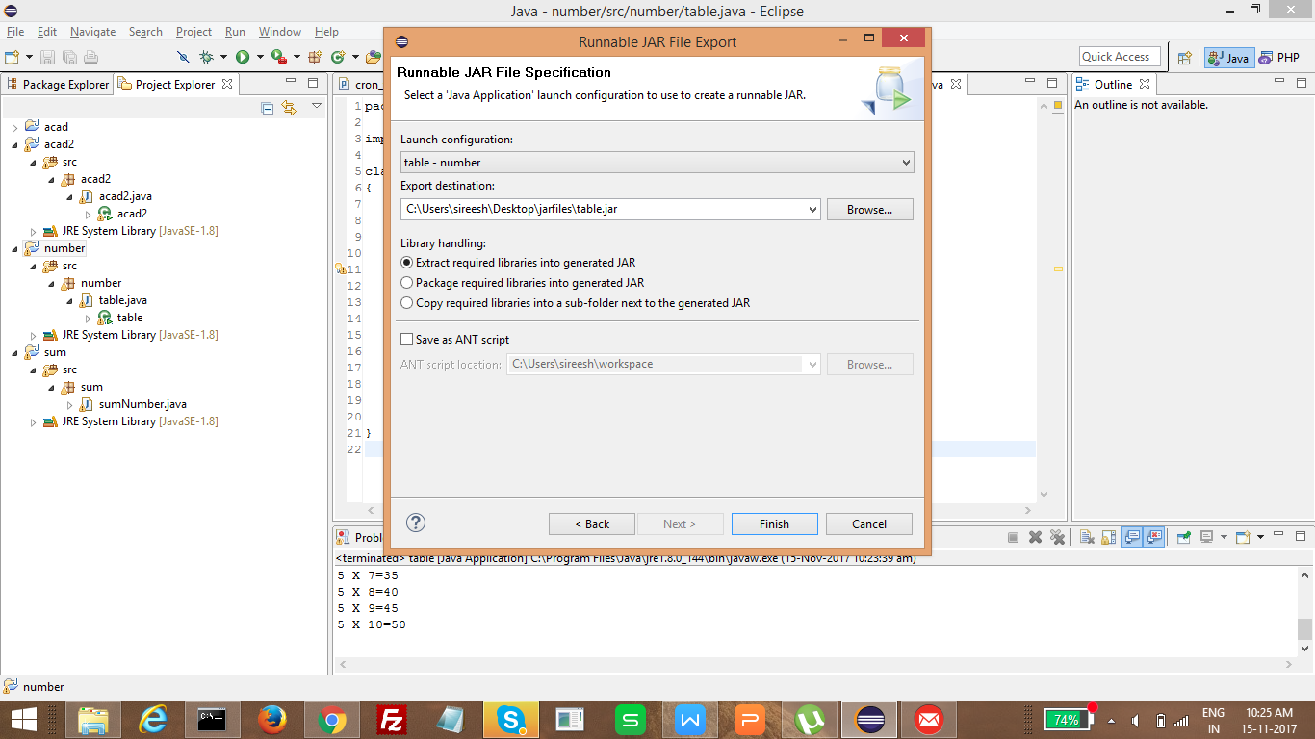

Executed jar file

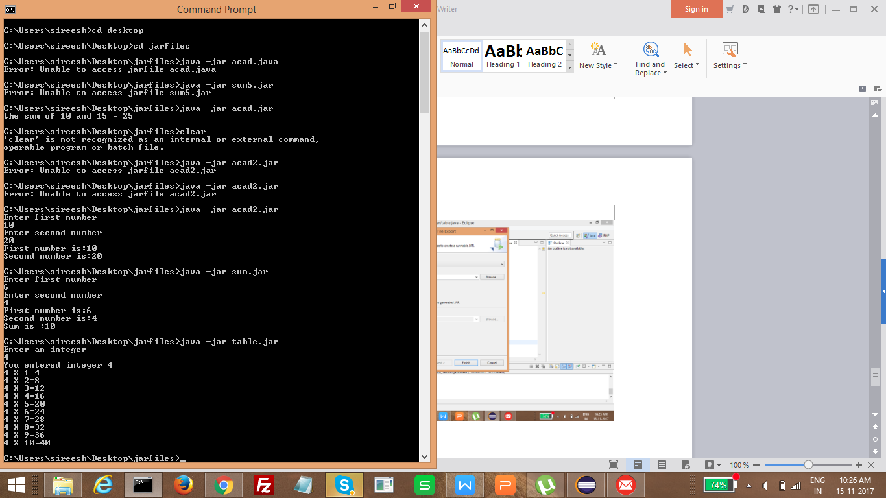

- Write a program consisting method sum() and demonstrate the concept of method overloading using this method

If a class has multiple methods having same name but different in parameters, it is known as Method Overloading.
If we have to perform only one operation, having same name of the methods increases the readability of the program.
Suppose you have to perform addition of the given numbers but there can be any number of arguments, if you write the method such as a(int,int) for two parameters, and b(int,int,int) for three parameters then it may be difficult for you as well as other programmers to understand the behavior of the method because its name differs.
So, we perform method overloading to figure out the program quickly.
Advantage of method overloading
Method overloading increases the readability of the program.
Different ways to overload the method
There are two ways to overload the method in java
- By changing number of arguments
- By changing the data type
1. By changing number of arguments
Java class created on eclipse

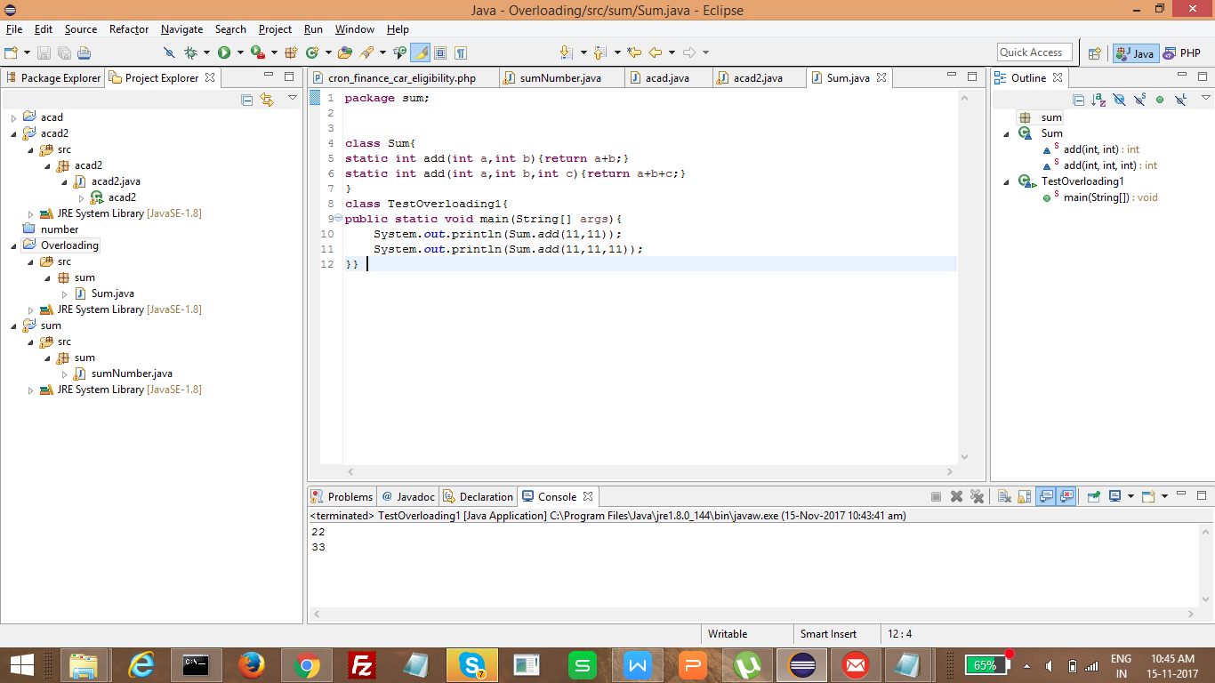

Source Code

package sum;

class Sum{
static int add(int a,int b){return a+b;}
static int add(int a,int b,int c){return a+b+c;}
}
class TestOverloading1{
public static void main(String[] args){
System.out.println(Sum.add(11,11));
System.out.println(Sum.add(11,11,11));
}}
Created Jar file

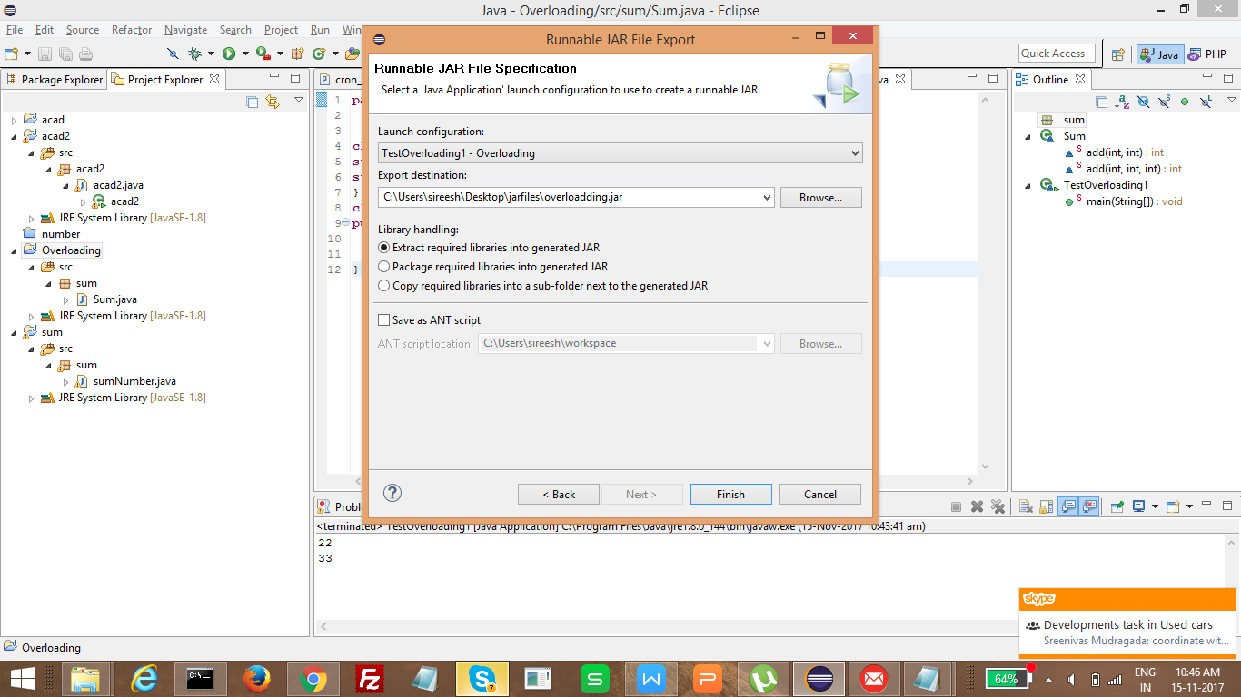

Executed jar file in command line

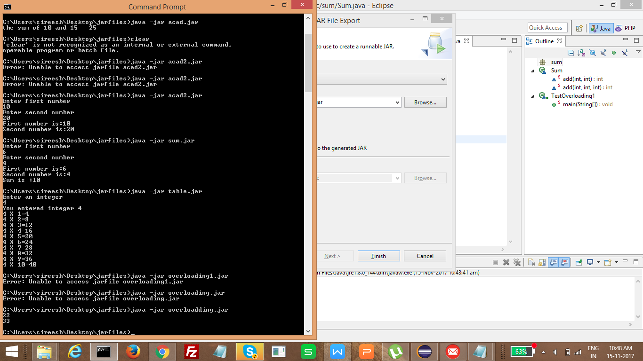

2. By changing the data type
Class file created in eclipse

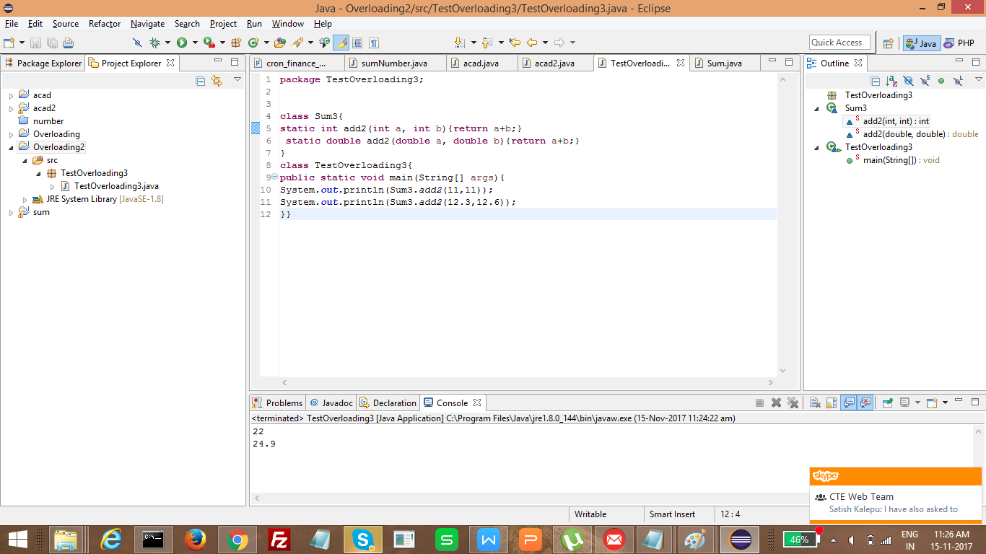

Source Code

package TestOverloading3;

class Sum3{
static int add2(int a, int b){return a+b;}
static double add2(double a, double b){return a+b;}
}
class TestOverloading3{
public static void main(String[] args){
System.out.println(Sum3.add2(11,11));
System.out.println(Sum3.add2(12.3,12.6));
}}

Jarfile created

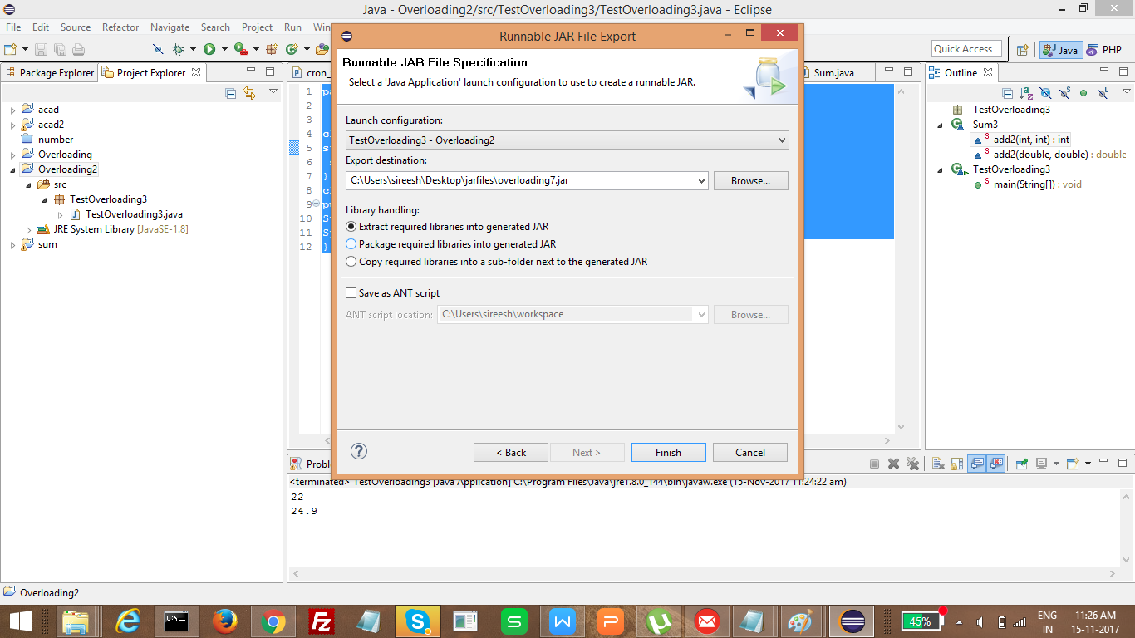
Jar file executed in commadline

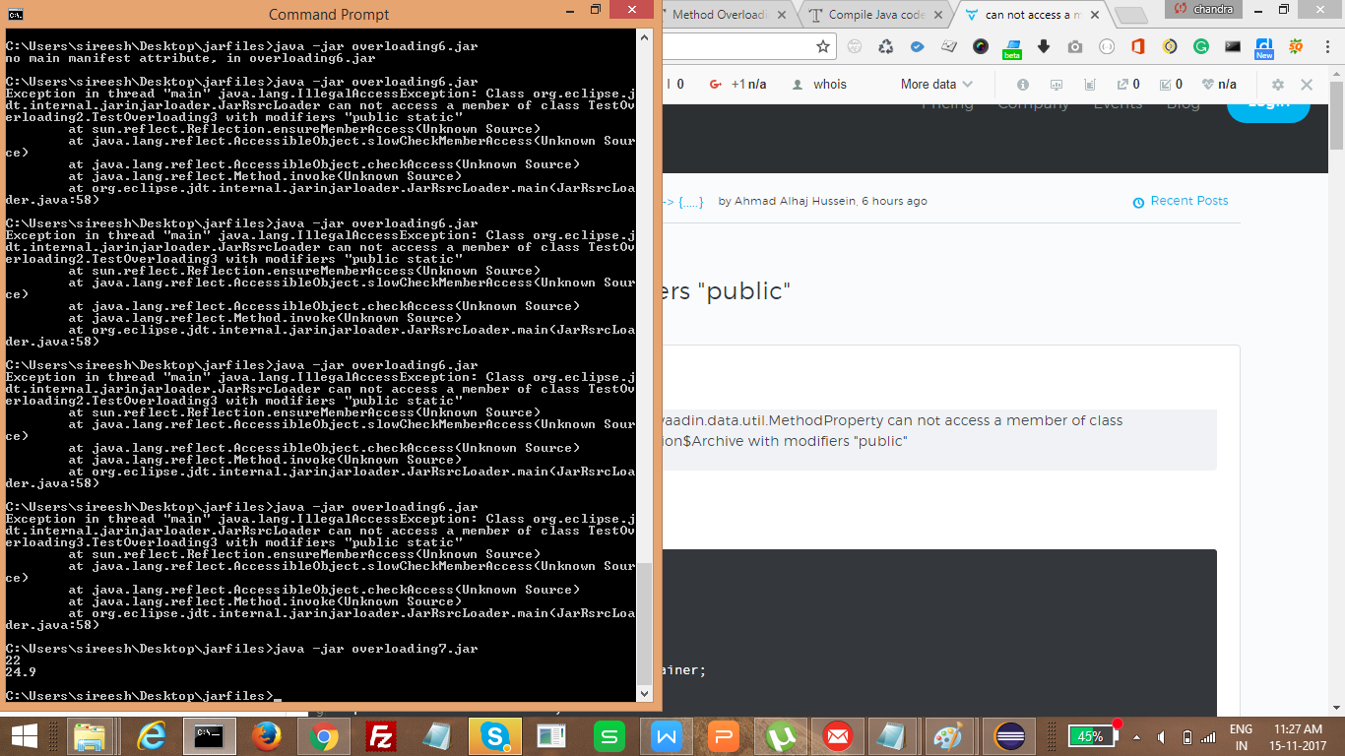

- Can you overload a method with same return type.? Explain your answer with proper logic.

No. We can not create. It will create the errors.

In java, method overloading is not possible by changing the return type of the method only because of ambiguity. Let's see how ambiguity may occur:

Following method creating errors

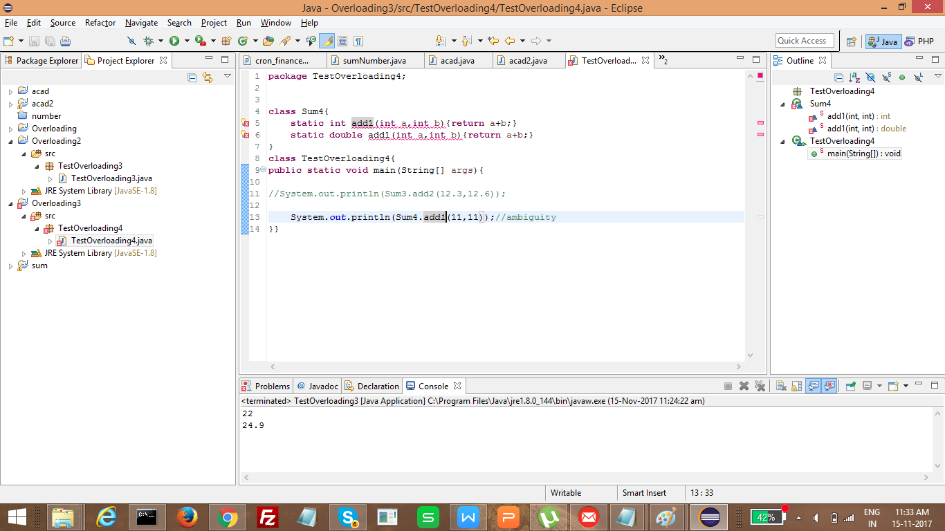

8) Write a program in java using Arrays, that sorts the element in descending order.

Create java class

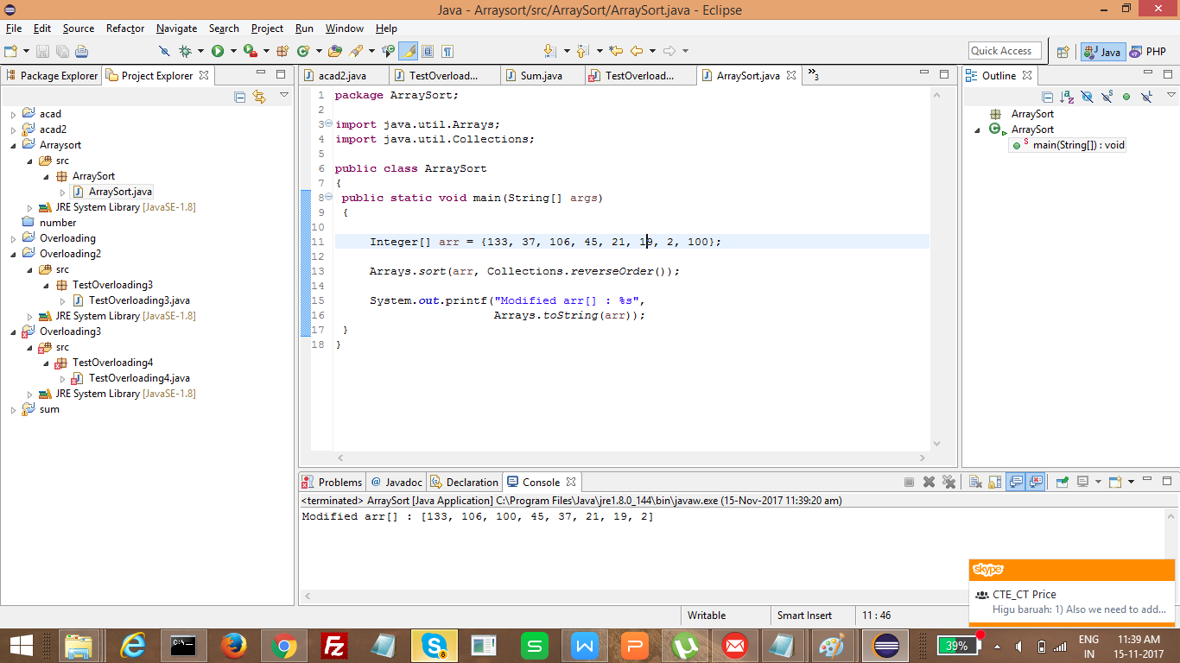

Source Code

package ArraySort;

import java.util.Arrays;
import java.util.Collections;

public class ArraySort
{
public static void main(String[] args)
{

Integer[] arr = {133, 37, 106, 45, 21, 19, 2, 100};

Arrays.sort(arr, Collections.reverseOrder());

System.out.printf("Modified arr[] : %s",
Arrays.toString(arr));
}
}

Created jar file

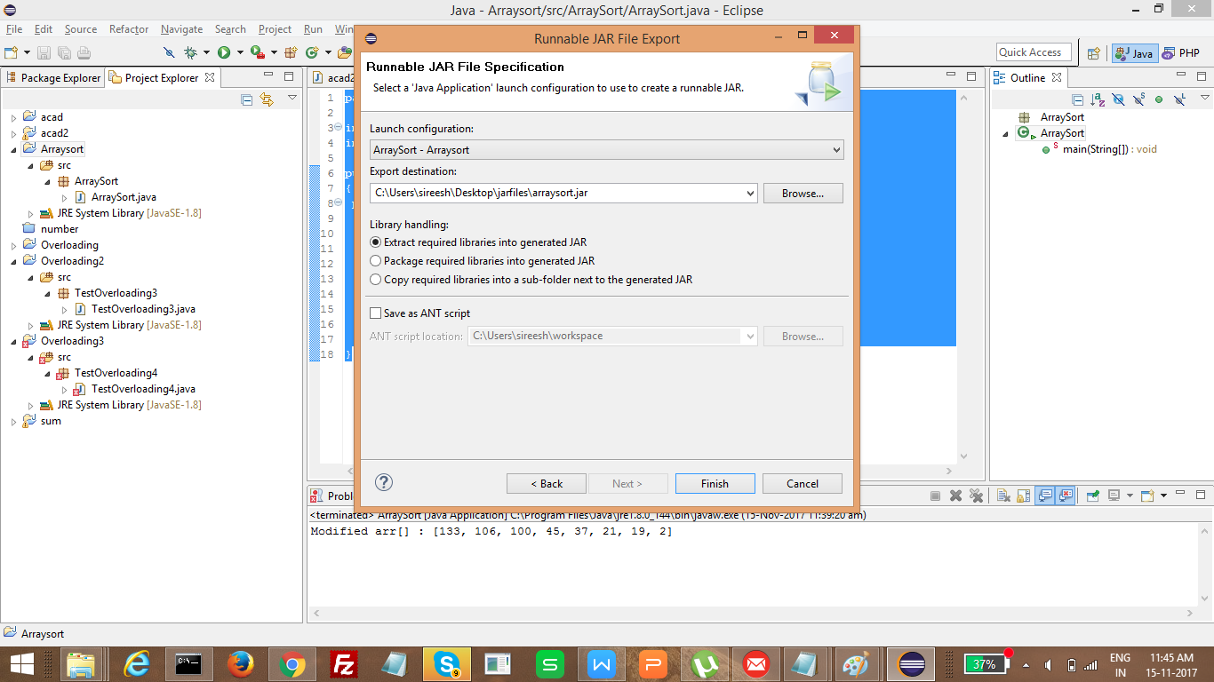

Executed jar file

