Word count pig coding

1.Created word file and moved to hdfs by following command

***hdfs fs -put /home/acadgild/hdfs_word.txt /user/acadgild/***

2. Created a pig file which counts the words and moved to hdfs environment

**hdfs fs -put /home/acadgild/word_count.pig /user/acadgild/**

**Word file on hdfs environment**

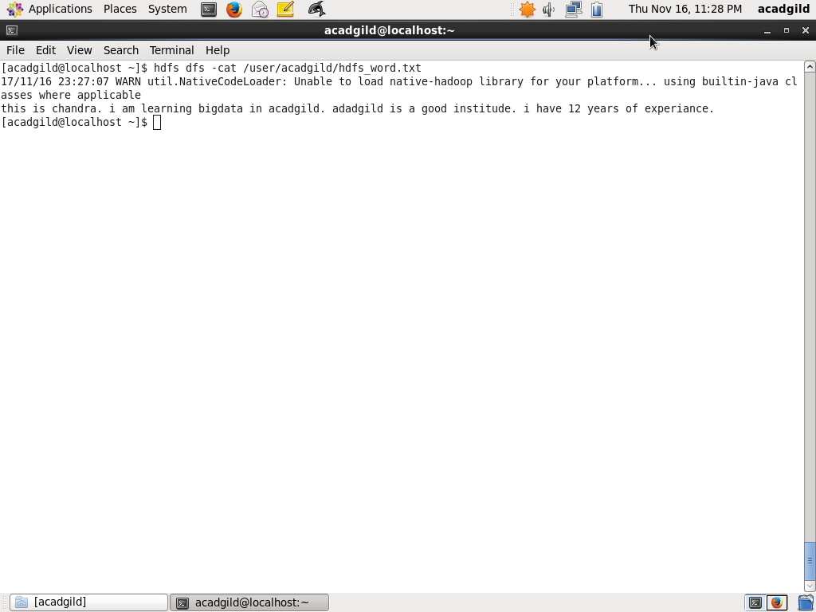

**Pig file on hdfs environment**

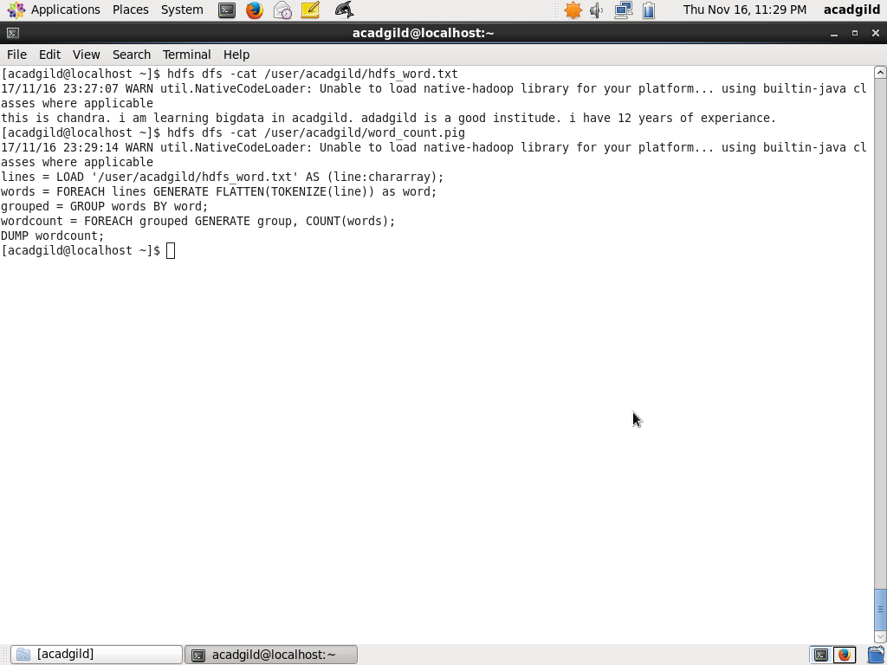

**Output**

Command

Pig hdfs://localhost:9000/user/acadgild/word_count.pig

