- What is median? Explain it with an example.

It is a measure of the center of data. The median usually is found
when we have an ordered distribution. It is computed as follows. We arrange
the numerical data from smallest to largest. If n denotes the size of the set
of data then the median can be found by using the median rank
MR =(n + 1)/2

If MR is a whole number then the median is the value in that position. If
MR ends in .5, we take the sum of the adjacent positions and divide by 2.

Unlike the mode, the median always exists and is unique. But it may or may
not be one of the given data values.
Note that extreme values (smallest or largest) do not affect the median.

Example-
Among groups of 40 students interviewed at each of 10 different colleges,
18, 13, 15, 12, 8, 3, 7, 14, 16, 3 said that they jog regularly. Find the median.

Solution.
First, arrange the numbers from smallest to largest to obtain
3 3 7 8 12 13 14 15 16 18
Next, compute the median rank MR = 10+1
2 = 5.5. Hence, the median is
(12+13)/2 = 12.5

- What is Mean/Average/Arithmetic Mean? Explain it with an example.

Another most widely used measure of the center is the arithmetic mean
or simply mean. The mean of a set of N numbers x1, x2, ..., xN, denoted by
x, is defined as
x = (x1 + x2 + ... + xn)/N
.
Unlike the median, the mean can be affected by extreme values since it uses
the exact value of each data.

Example :
If nine school juniors averaged 41 on the verbal portion of the PSAT test, at
most how many of them can have scored 65 or more?

Solution.
We have that x = 41 and N = 9 so that x1 + x2 + · · · + x9 = 41 × 9 = 369.
Since 6×65 = 390 > 369 and 5×65 = 325 then at most 5 students can score
more than 65.

Example:
If the numbers x1, x2, ..., xN occur with frequencies m1,m2, ...,mN respectively
then what is the mean in this case?

Solution.
The mean is given by
x =(m1x1 + m2x2 + ... + mNxN)/m1 + m2 + · · · + mN
.

The figure below gives the relationships among the measures of central tendency

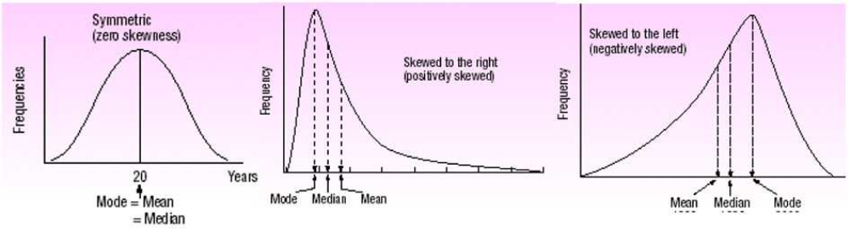

- Examples on Quartiles.

Example:
Listed below are the commissions earned, in dollars, last month by a sample
of 15 brokers at Salomon Smith Barneys office.
2038 1758 1721 1637 2097
2047 2205 1787 2287 1940
2311 2054 2406 1471 1460

(a) Rank the data from smallest to largest.
(b) Find the median rank and then the median.
(c) Find the quartiles Q1 and Q3.

Solution.
(a) Arranging the data from smallest to largest we find
1460 1471 1637 1721 1758
1787 1940 2038 2047 2054
2097 2205 2287 2311 2406
(b) The median Q2 is the 50th percentile so that P = 50 and L50 =(15+1)2 = 8.
Thus, Q2 = 2038.
(c) Q1 is the 25th percentile so that L25 = ((15+1)· 25)/100 = 4 and so Q1 = 1721.
Similarly, Q3 is the 75th percentile so that P = 75 and L75 = ((15+1) · 75)/100 =12.
Thus, Q3 = 2205.

- Examples on Box Plot.

Alexanders Pizza offers free delivery of its pizza within 15 km. Alex, the
owner, wants some information on the time it takes for delivery. How long
does a typical delivery take? Within what range of times will most deliveries
be completed? For a sample of 20 deliveries, he determined the following
information:

Minimum value = 13 minutes
Q1 = 15 minutes
Median = 18 minutes
Q3 = 22 minutes
Maximum value = 30 minutes

Develop a box plot for the delivery times. What conclusions can you make
about the delivery times?
Solution.
The box plot is shown in Figure 32.1.

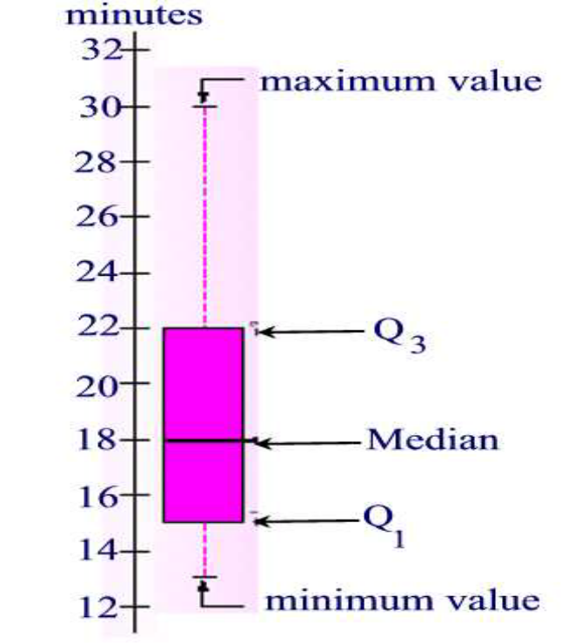

The box plot shows that the middle 50 percent of the deliveries take between
15 minutes and 22 minutes. The distance between the ends of the box, 7
minutes, is the interquartile range.
The interquartile range is the distance between the first and the third quartile. It tells us the
spread of the middle half of the data. The box plot also reveals that the distribution of delivery
times is positively skewed since the median is not in the center of the box and the distance
from the first quartile to the median is smaller than the distance from the median
to the third quartile.

- What is Variance and Standard Deviation?
We have seen that a remedy for the deficiency of the range is the use of
box and whisker plot. However, an even better measure of variability is the
standard deviation. Unlike the range, the variance combines all the values in
a data set to produce a measure of spread. The variance and the standard
deviation are both measures of the spread of the distribution about the mean.

If μ is the population mean of set of data then the quantity (x−μ) is called
the deviation from the mean. The variance of a data set is the arithmetic
average of squared deviation from the mean.

Note that the variance is nonnegative, and it is zero only if all observations
are the same.

The variance is the nicer of the two measures of spread from a mathematical
point of view, but as you can see from the algebraic formula, the physical
unit of the variance is the square of the physical unit of the data. For example,
if our variable represents the weight of a person in pounds, the variance
measures spread about the mean in squared pounds. On the other hand,
standard deviation measures spread in the same physical unit as the original
data, but because of the square root, is not as nice mathematically. Both
measures of spread are useful.

A step by step approach to finding the standard deviation is:
1. Calculate the mean.
2. Subtract the mean from each observation.
3. Square each result.
4. Add these squares.
5. Divide this sum by the number of observations.
6. Take the positive square root.

The reason that for s we use n−1 instead of n is because usually a sample does
not contain extreme values and we want s to be an estimate of _ therefore
by using n − 1 we make s a little larger than if we divide by n.

- What is Normal Distribution?
To better understand how standard deviations are used as measures of dispersion,
we next consider normal distributions. The graph of a normal distribution
is called a normal curve or a bell-shaped curve. The curve has
the following properties:

1. The curve is bell-shaped with the highest point over the mean μ.
2. It is symmetrical about the line through μ.
3. The curve approaches the horizontal axis but never touches or crosses it.
4. The points where the curve changes concavity occur at μ+_ and μ−_.
5. The total area under the curve is assumed to be 1.(0.5 to the left of the mean and 0.5 to the
right).

The data for a normal distribution are spread according to the following rules
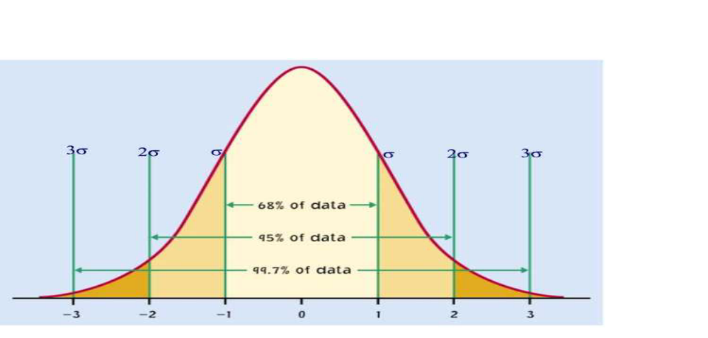

• About 68 percent of the data values will lie within one standard deviation
of the mean.
• About 95 percent of the data values will lie within two standard deviations
of the mean.
• About 99.7 percent of the data values will lie within three standard
deviations of the mean.
This result is sometimes referred to as the emperical rule, because the
given percentages are observed in practice.

- What is p-value and give an example?
In statistical significance testing, the p-value is the probability of obtaining a test statistic at least as extreme as the one that was actually observed, assuming that the null hypothesis is true. If the p-value is less than 0.05 or 0.01, corresponding respectively to a 5% or 1% chance of rejecting the null hypothesis when it is true (Type I error).
Example: Suppose that the experimental results show the coin turning up heads 14 times out of 20 total flips
* null hypothesis (H0): fair coin;
* observation O: 14 heads out of 20 flips; and
* p-value of observation O given H0 = Prob(≥ 14 heads or ≥ 14 tails) = 0.115.
The calculated p-value exceeds 0.05, so the observation is consistent with the null hypothesis — that the observed result of 14 heads out of 20 flips can be ascribed to chance alone — as it falls within the range of what would happen 95% of the time were this in fact the case. In our example, we fail to reject the null hypothesis at the 5% level. Although the coin did not fall evenly, the deviation from expected outcome is small enough to be reported as being "not statistically significant at the 5% level".
- What is sampling? How many sampling methods?
- Sampling is that part of statistical practice concerned with the selection of an unbiased or random subset of individual observations within a population of individuals intended to yield some knowledge about the population of concern.
There are four sampling methods: Simple Random (purely random), Systematic( every kth member of population), cluster (population divided into groups or clusters)
and stratified (divided by exclusive groups or strata, sample from each group) samplings.
- What is mode, mean, median, skewness, quartile, variance and standard deviation?
SAS Syntax:
Proc Univariate data=test;
Var X;
Run;

Mode:
The mode of a data sample is the element that occurs most often in the collection.

Median:
a median is described as the numeric value separating the higher half of a sample, a population, or a probability distribution, from the lower half. The median of a finite list of numbers can be found by arranging all the observations from lowest value to highest value and picking the middle one

Mean
Total sum divided by number of values

Quartile
first quartile (25th percentile)
second quartile (50th percentile)
third quartile (75th percentile)
kth percentile

Skewness
Skewness is a measure of the asymmetry of the data around the sample mean. If skewness is
negative, the data are spread out more to the left of the mean than to the right. If skewness is
positive, the data are spread out more to the right.

Kurtosis
Kurtosis is a measure of how outlier-prone a distribution is.

Standard deviation
the square root of an unbiased estimator of the variance of the population from which X is drawn, as long as X consists of independent, identically distributed samples.

Variance
describes how far values lie from the mean
var(x) %return 1.1429

Covariance
measure of how much two variables change together
y2=[1 3 4 5 6 7 8]
cov(x,y2) %return 2*2 matrix, diagonal represents variance

Linear Regression:
modeling the relationship between a scalar variable y and one or more variables denoted X. In linear regression, models of the unknown parameters are estimated from the data using linear functions.

SAS Syntax:
Proc Reg data=test;
Model y=x /tol vif;
Run;

One sample t-test
A t-test is any statistical hypothesis test in which the test statistic follows a Student's t distribution if the null hypothesis is supported.
proc ttest data=lib.hsb2 H0=50;
var write;
run;
This time the test rejects the null hypothesis at the default α = 0.05 significance level. The p value
has fallen below α = 0.05 and the 95% confidence interval on the mean does not contain 0.
Because the p value of the sample y is greater than 0.01, the test will fail to reject the null
hypothesis when the significance level is lowered to α = 0.01:

Pair t-test
A dependent group t-test is used when the observations are not independent of one another. In the example below, the same students took both the writing and the reading test.

Hence, you would expect there to be a relationship between the scores provided by each
student. The dependent group t-test accounts for this.
proc ttest data="D:\hsb2";
paired write*read;
run;
This time the test rejects the null hypothesis at the default α = 0.05 significance level.
The p value has fallen below α = 0.05 and the 95% confidence interval on the mean does not
contain 0. Because the p value of the sample y is greater than 0.01, the test will fail to reject the
null hypothesis when the significance level is lowered to α = 0.01:

Two sample t-test (Independent group t-test)

This t-test is designed to compare means of same variable between two groups. In our
example, we compare the mean writing score between the group of female students and the
group of male students. Ideally, these subjects are randomly selected from a larger population
of subjects.
Depending on if we assume that the variances for both populations are the same or not, the
standard error of the mean of the difference between the groups and the degree of freedom are
computed differently. That yields two possible different t-statistic and two different p-values.

When using the t-test for comparing independent groups, we need to test the hypothesis on
equal variance and this is a part of the output that proc ttest produces. The interpretation for
p-value is the same as in other type of t-tests.

proc ttest data="D:\hsb2";;
class female;
var write;
run;

- What is Hypothesis Testing. Explain terms used in Testing.
1). Null hypothesis:
The null hypothesis (denote by H₀ ) is a statement about the value of
a population parameter (such as mean), and it must contain the condition of equality and must be written with the symbol =, ≤, or ≤.
2). Alternative hypothesis
The Alternative hypothesis (denoted by H₁ ) is the statement that must be true if the null hypothesis is false.
3) Conclusion
a) Fail to reject the null hypothesis
b) Reject the null hypothesis.
4) Significance level
The probability of rejecting the null hypothesis when it is called
the significance level α , and very common choices are
α = 0.05 and α = 0.01
5) Example:
A sample of data for body temperature (n=106, x̄=98.20°, s =0.62),
for a 0.05 significance level, test the claim that the mean body temperature of health adults is equal to 98.6°F.
Solution: We have:
H₀ : μ=98.6 (original claim) H₁ : μ≠98.6
As n>30, the central limit theorem indicates that the distribution of sample means can be approximated by a normal distribution
z= (x̄ - μ)/ (σ/√n) = (98.20-98.6)/(0.62/√106) = -6.64
The test is two-sided because a sample mean significantly less than or greater than 98.6 is strong evidence against the null hypothesis that μ=98.6.
α/2 = 0.025, the left critical z value = -1.96, right z critical value = 1.96. For z between -1.96 and 1.96, we fail to reject H₀.
As z = -6.64, we reject the reject H₀ i.e. we reject the hypothesis that the mean body temperature of health adults is equal to 98.6°F.

Question. What is Central Limit Theorem?
As the sample size increases, the sampling distribution of sample
means approaches a normal distribution
If all possible random samples of size n are selected from a population with mean μ and
standard deviation σ, the mean of the sample means is denoted by μ _{x̄} , so
μ _{x̄} = μ
the standard deviation of the sample means is:
σ _{x̄} = σ⁄√ n

Example: Given that the population of men has normally distributed weights, with a
mean of 173 lb and a standard deviation of 30 lb, find the probability that
a. if 1 man is randomly selected, his weight is greater than 180 lb.
b. if 36 different men are randomly selected, their mean weight is greater that 180 lb.
Solution: a) z = (x - μ)/ σ = (180-173)/30 = 0.23
For normal distribution P(Z>0.23) = 0.4090
b) σ _{x̄} = σ/√n = 20/√ 36 = 5
z= (180-173)/5 = 1.40
P(Z>1.4) = 0.0808
%
Question: What is ANOVA?
ANOVA stands for Analysis of Variance. It is a statistical method for seeing how different several groups are on some quantitative measure. For example, we might want to know if marital status (single, married, cohabitating, divorced, widowed or separated, other) is related to weight. We could take a sample of people, ask their marital status, weigh them and then do an ANOVA to see how different the groups are.
Here weight is called the dependent variable and marital status the independent variable.
If there are more independent variables and they are all categorical, we get factorial ANOVA. For example, we might also want to look at sex in the above, since men generally weigh more than women.
If there are independent variables that are quantitative, then we get ANCOVA or Analysis of Covariance. We might, for example, want to include height in the above, since taller people tend to weigh more than shorter people.
When there are only two groups, the t-test is usually used, but a t-test is mathematically equivalent to an ANOVA with only two groups.
Question: If ANOVA is about comparing means, why is it called analysis of variance?
That is a very good question! Fortunately, it has a good answer.
Suppose we gather the data for the simplest case above. Lets say we wind the weights of (say) 20 single people, 30 married people, 10 cohabitating people, and so on. We can then take the mean of each groups. The means will not be the same in the different groups. Nor will all people in any group weigh the same. That is, for example, not all single people weigh the same amount.
We have variation within each group, and we have variation between groups. One way of measuring variation is with a statistic called the variance. If most of the variance is within groups, then we cannot conclude that the groups are different with regard to weight. On the other hand, if most of the variance is between groups, that is evidence that the groups differ. How do we decide which variance is bigger, and what it means? We analyze it. That is, we perform an ANOVA, an analysis of variance.
Question: ANOVA is the same as regression. Really!
Another common method of relating dependent variables to independent ones is regression. ANOVA, ANCOVA and regression are all the same, mathematically. Here is the one equation, in matrix algebra terms. It is the equation for ANOVA, ANCOVA and regression.
(skip if you want to ....)
If there are n subjects (e.g. people) and p variables (e.g. marital status, sex, height) then
Y + Xb + e
Where Y is a n x 1 vector of values on the dependent variable (weight)
X is an n x p matrix of values on the independent variables
b is a p x 1 vector of parameters to estimate
and
e is an n x 1 vector of errors
(end of math)
Question: If ANOVA is the same as regression, why do we have both?
ANOVA and regression arose in different substantive areas, and were developed by different people. ANOVA mostly arose in the field of agriculture, where people were concerned with questions such as the effect of different fertilizers on crop yields. A key person in its development was Ronald Fisher. Another field was the food and beverage industry; the inventor of the t-test, William Gossett (aka Student) worked for Guinness Brewing. Regression started in geography, where people were trying to figure out exactly how big the Earth was, and one key figure was Gauss.
Question: If ANOVA is the same as regression, why do the outputs look so different?
If you've done ANOVA and regression, or seen the output from programs that do them, or even read results in a paper, you'll know that the output looks very different. That's because they phrase the same question in different ways.
ANOVA is about partitioning the variance into within and between groups.
Regression is about finding an equation to relate the dependent variable to the independent variables.

Question: What is Hypothesis Testing?
A statistical hypothesis test is a method of making inferences about one or more populations using sample data. It can help us to handle uncertainty, minimise subjectivity and manage the risk of decision errors. For example, we can use hypothesis test to help answer the following questions with a certain level of confidence:
• Is process cycle time meeting customer expectations?
• Is product quality at one factory better than the other?
• Has the process improve or deteriorated?

Question: How to form Hypotheses?
A hypothesis test will have two opposing hypotheses, the null hypothesis and the alternative hypothesis.
The null hypothesis (H0)
• usually states that some parameter of a population, such as the mean, is not different from a specified value or from that of another population
• is assumed to be true unless sufficient evidence indicates the contrary
• is not proven true; you simply fail to disprove it
The alternative hypothesis (H1)
• states that the null hypothesis is wrong
• can also specify the direction of the difference

Question: How many types of Hypothesis Test and different types of Errors?
The null hypothesis usually specifies that a parameter equals a specific value. Depending on what you want to find out, you can choose an appropriate alternative hypothesis from the three options as shown in the following table.
To determine if… | Alternative hypothesis
Different from test mean | Two-tailed  H1: μ ≠ test mean
Less than test mean | One-tailed (left-tailed)  H1: μ < 0 minutes
Greater than test mean | One-tailed (right-tailed)  H1: μ > 0 minutes
Results of Hypothesis Test
The following table gives a summary of possible results of any hypothesis test.
 |  | Decision
 |  | Reject H0 | Do not reject H0
Truth | H0 is true | Type I Error | Right Decision
Truth | H1 is true | Right Decision | Type II Error
Type I Error - A type I error occurs when H0 is wrongly rejected. For example, in a clinical trial of a new drug, a type I error would occur if we concluded that the new drug produced a different effect when in fact there was no difference with the existing ones. A type I error is often considered to be more serious and therefore more important to avoid than a type II error. The hypothesis test procedure is therefore built to ensure that there is a 'low' probability of rejecting the null hypothesis wrongly. The probability of a type I error is also known as the alpha risk.
Type II Error - A type II error occurs when the H0 is not correctly rejected. In the new drug clinical trial example, a type II error would occur if it was concluded that the new drug did not produce a different effect from the existing ones when in fact it did. Such an error is most frequently due to insufficient sample sizes to identify the falseness of the null hypothesis. The probability of a type II error is also known as the beta risk and the the power of the test is 1 minus beta risk.

Question: Describe below important concepts used in Hypothesis testing?
Sample Size - Depending on level of acceptable risk and the sensitivity of the test required, an appropriate sample size must be taken. As sample size increases, Beta risk reduces and the power of the test increases. However, in determining the sample size, you should also consider practical limitations of cost, time and resources.
Significance level - The significance level, a , of a hypothesis test is the limit set on the probability of wrongly rejecting H0. It is set by the investigator in consideration of the consequence of such an error. If the investigator wants to avoid making a false claim, the significance level should be made as small as possible. A typical value for significance level is 0.05, but you can choose higher or lower values depending on the sensitivity required for the test and the consequences of incorrectly rejecting H0.
P-value - P-value is the probability of wrongly rejecting H0 or be seen as the risk of rejecting H0. Therefore, if the p-value is less than the significance level, you can reject the H0.
Confidence interval - A confidence interval is a range of likely estimates of a population parameter (e.g. mean or standard deviation) calculated based on sample data. Like a hypothesis test, it can be used to make inference about the population. For example, if the test value is not within a 95% confidence interval, you can reject H0 at the 0.05 significance llevel. It can also be used to evaluate the reliability of an estimated population parameter. For example, an estimate may not be precise if the interval is very wide.

Question: What is the logic of Hypothesis Test ?
Hypothesis testing starts by assuming that the null hypothesis is true. The test then determines how different the sample is from the assumptions in the null hypothesis. If the sample does not meet the assumptions, within a certain level of confidence, then HO is rejected.
Putting it in simple terms, hypothesis testing is about the ‘Signal’ to ‘Noise’ ratio. Signal is change or difference we are trying to detect and the Noise is the inherent variability in the system. If the ratio is small, then there is no signal, it is just noise (pure chance). On the other hand, if the ratio large, there is significant changes or differences over and above the noise.
Therefore, larger signals are easier to detect and on the other hand, larger noises make signals more difficult to detect. For instance, it is easier to prove a cycle time has reduced from 10 days to 5 days as compared to 10 days from 9 days. In addition, it is easier to detect changes if the variation is small (low noise).

Question: How to Conduct a Hypothesis Test?
The steps are similar for all hypothesis tests.
- Establish hypothesis
- Calculate statistics
Conclude based on significance level. If P <= α , reject H0 and if P > α , fail to reject H0.
Caution
Although hypothesis test provides statistical significance, we also need to assess practical significance by looking at the size of the difference between the average and the hypothesized mean. It is also important to remember that statistical significance is affected by sample size, so statistical and practical significance don’t necessarily go together.

Question. Can you outline the various steps in an analytics project?
Broadly speaking these are the steps. Of course these may vary slightly depending on the type of problem, data, tools available etc.
1. Problem definition - The first step is to of course understand the business problem. What is the problem you are trying to solve – what is the business context? Very often however your client may also just give you a whole lot of data and ask you to do something with it. In such a case you would need to take a more exploratory look at the data. Nevertheless if the client has a specific problem that needs to be tackled, then then first step is to clearly define and understand the problem. You will then need to convert the business problem into an analytics problem. I other words you need to understand exactly what you are going to predict with the model you build. There is no point in building a fabulous model, only to realise later that what it is predicting is not exactly what the business needs.
2. Data Exploration - Once you have the problem defined, the next step is to explore the data and become more familiar with it. This is especially important when dealing with a completely new data set.
3. Data Preparation – Now that you have a good understanding of the data, you will need to prepare it for modelling. You will identify and treat missing values, detect outliers, transform variables, create binary variables if required and so on. This stage is very influenced by the modelling technique you will use at the next stage. For example, regression involves a fair amount of data preparation, but decision trees may need less prep whereas clustering requires a whole different kind of prep as compared to other techniques.
4. Modelling – Once the data is prepared, you can begin modelling. This is usually an iterative process where you run a model, evaluate the results, tweak your approach, run another model, evaluate the results, re-tweak and so on….. You go on doing this until you come up with a model you are satisfied with or what you feel is the best possible result with the given data.
5. Validation – The final model (or maybe the best 2-3 models) should then be put through the validation process. In this process, you test the model using completely new data set i.e. data that was not used to build the model. This process ensures that your model is a good model in general and not just a very good model for the specific data earlier used (Technically, this is called avoiding over fitting)
6. Implementation and tracking – The final model is chosen after the validation. Then you start implementing the model and tracking the results. You need to track results to see the performance of the model over time. In general, the accuracy of a model goes down over time. How much time will really depend on the variables – how dynamic or static they are, and the general environment – how static or dynamic that is.

Question. What do you do in data exploration?
Data exploration is done to become familiar with the data. This step is especially important when dealing with new data. There are a number of things you will want to do in this step –
a. What is there in the data – look at the list of all the variables in the data set. Understand the meaning of each variable using the data dictionary. Go back to the business for more information in case of any confusion.
b. How much data is there – look at the volume of the data (how many records), look at the time frame of the data (last 3 months, last 6 months etc.)
c. Quality of the data – how much missing information, quality of data in each variable. Are all fields usable? If a field has data for only 10% of the observations, then maybe that field is not usable etc.
d. You will also identify some important variables and may do a deeper investigation of these. Like looking at averages, min and max values, maybe 10th and 90th percentile as well…
e. You may also identify fields that you need to transform in the data prep stage.

Question: What do you do in data preparation?
In data preparation, you will prepare the data for the next stage i.e. the modelling stage. What you do here is influenced by the choice of technique you use in the next stage.
But some things are done in most cases – example identifying missing values and treating them, identifying outlier values (unusual values) and treating them, transforming variables, creating binary variables if required etc,
This is the stage where you will partition the data as well. i.e create training data (to do modelling) and validation (to do validation).
Question: How will you treat missing values?
The first step is to identify variables with missing values. Assess the extent of missing values. Is there a pattern in missing values? If yes, try and identify the pattern. It may lead to interesting insights.
If no pattern, then we can either ignore missing values (SAS will not use any observation with missing data) or impute the missing values.
Simple imputation – substitute with mean or median values
OR
Case wise imputation –for example, if we have missing values in the income field.
Question: How will you treat outlier values?
You can identify outliers using graphical analysis and univariate analysis. If there are only a few outliers, you can assess them individually. If there are many, you may want to substitute the outlier values with the 1stpercentile or the 99th percentile values.
If there is a lot of data, you may decide to ignore records with outliers.
Not all extreme values are outliers. Not all outliers are extreme values.

Question: How will tackle insignificant variables, when are they significant.
You fit a multiple regression to examine the effect of a particular variable a worker in another department is interested in. The variable comes back insignificant, but your co-worker says that this is impossible as it is known to have an effect. What would you do?
Many reasons could have caused this:
- The study is underpowered.
- Even it's properly powered, type II error can still occur.
- A predictor or a set of predictors are collinear with your main outcome, inflating the variance, causing it to be non-significant. Similarly, you might have accidentally included a variable in the causal pathway.
- Your co-worker is wrong. For example, the coworker might have developed a strong impression on another analysis in which proper confounding variables were not included. While your model could have correctly include the confounding variables, and it turned out what your co-worker believes was just an illusion all along.
- Since bias can go both ways, it's also possible that your model is missing some important confounding variables.
- Your major predictor can be interaction with another predictor (e.g. sexes) in such a coincident way that the effects within each sex cancel out each other.
- You're examining a very specific subset of a large population.
- The operationalizaion of variables (or even research designs) can be different between your analysis and the analysis your colleague remembers. Sometimes just simple aggregation can change the performance of a predictor.
- Your have chosen to use a different reference group, which can cause the p-value of the set of dichotomous indicators to shift.
The studies referenced by your co-worker may not be externally valid (aka not generalizable)
to your studied population.

Question: How will tackle more number of variables in regression model?
You have 1000 variables and 100 observations. You would like to find the significant variables for a particular response. What would you do?
This is a really broad question. Significant variables for a particular response is up for so many interpretations I'm not sure how to even suggest an answer.
Generally, don't run a regression model on them as is because the number of predictors exceeds the number of cases. I'd perhaps strategize by:
- Clarifying with the questioner on whether the model is for prediction or proof of a concept.
- Implement some content-based selection, e.g. evaluate if the predictor even makes any sense to be included, draft a conceptual framework or causal diagram to aid filtering of the 1000 variables etc.
- Then, include some routine check such as getting rid one of any two variables that are highly collinear, getting rid of variables with profound amount of missing or variables that only contain a constant. Mix in with some operational decision factors such as cost of collecting the variables and burdens on the respondents, etc.
- Suggest some statistical data reduction or variable selection techniques. Emphasize on their pros and cons as well as key assumptions.

Emphasize on monitoring the type I error rate along the way and make necessary adjustment to avoid spurious findings.

Question: How do you assess the results of a logistic regression analysis?
You can use different methods to assess how good a logistic model is.
a. Concordance – This tells you about the ability of the model to discriminate between the event happening and not happening.
b. Lift – It helps you assess how much better the model is compared to random selection.
c. Classification matrix – helps you look at the false positives and true negatives.
Some other general questions you will most likely be asked:
- What have you done to improve your data analytics knowledge in the past year?
- What are your career goals?
- Why do you want a career in data analytics?
"What is a normal distribution? What would you think if your data didn't fit one?"
A normal distribution is a type of distribution where all the data is centered symmetrically around the mean datapoint, and most other data fit within standard deviations, etc.
If my data doesn't fit, either 1) My methods of measuring/processing data are wrong 2) My hypothesis about the nature of my data is wrong.

Other important Questions:
Questions:
Correct answers are marked in Red Bold, with reasons in blue. Incorrect choices are black, with reasons they are wrong in green.
1. In a truly normal frequency distribution
a. the mean always is the same as the standard deviation
Not at all; could have a negative mean, but standard deviation is always positive
b. the mean is never the same as the mode
Actually, it is always the same
c. the mode is never the same as the median
Actually, it is always the same
d. the mean always is the same as the median
Mean, median, and mode are all the same; skew = 0
2. How might the standard deviation (S) of a normal distribution be greater than the mean?
a. S is given by a square root, and the square root is larger than the fraction.
What does that have to do with anything?
b. In a normal distribution, the variance must equal the mean.
Not true, although it is true of a Poisson distribution (which we didn't get to)
c. If some scores are negative, the mean could be very small despite a large S.
The mean could be anything, even negative. Standard deviation is always positive...
d. The median would have to be less than the skew.
Since the skew of a normal distribution is zero, this is only true if the mean is negative
3. In a class of 100, the mean on a certain exam was 50, the standard deviation, 0. This means
a. half the class had scores less than 50
For the mean to be 50, the others would need scores above 50. If the scores are not all the same, there will be differences from the mean; those differences squared will add to a non-zero sum so standard deviation will be greater than zero.
b. there was a high correlation between ability and grade
You can't know about correlation from the distribution of a single variable -- what would it correlate with?
c. everyone had a score of exactly 50
A zero standard deviation means all scores are the same, and equal to the mean (what else could the mean be?)
d. half the class had 0's and half had 50's
That would make the mean = 25, and the standard deviation> 625 (25 squared for everyone)
4. The null hypothesis in an experiment would be
a. there is a high correlation between the independent and dependent variables
That could be an expectation, but the null hypothesis says there is no effect
b. changing the independent variable has no significant effect on the dependent variable
That is, every group (experimental or control or whatever) is a sample of the same population, even though the groups are differentiated by the independent variable.
c. changing the dependent variable causes a significant change in the independent variable
That's the opposite of the null hypothesis
d. the standard error of the dependent variable is greater than the mean of the independent variable
Isn't it amazing how random words in random order can sound like they mean something?
5. Suppose the mean on the final exam is 24 (of 40), with a standard deviation of 1.5. If you get a 21, how well do you do (relative to the rest of the class)?
a. very poorly--perhaps the lowest score
That's 2 standard deviations below the mean (z = -2.0). The fraction in the lower tail is 0.0228 only 2 1/4% did worse! (Assume it's roughly a normal distribution....)
b. not well, but somewhere in the C's
If only 2 1/4% did worse, there won't be many D's or E's, will there?
c. OK--about average
Average is a z near 0
d. nicely--better than the median
Assuming an approximately normal distribution, median is close to the mean...
6. You can claim that there is a significant difference between scores from two groups if
a. the difference between the means is large compared to the standard error
This is basically the definition of t (difference in means divided by standard error). A large t means you can reject the null hypothesis.
b. the means are large compared to the standard error
Size of means is irrelevant -- it's the difference that matters. You can't claim two groups differ if their means are the same, even if the means are 1,000,000 and standard errors are around 0.5.
c. the means are small compared to the standard error
As in (b) -- it's the difference between the means that matters
d. the difference between the standard deviations is large compared to the means
That's backwards -- it's difference between means, not standard deviations....
7. The correlation between a person's hair length and score on the midterm is very nearly zero. If your friend has a crewcut, your best guess as to what he got on the midterm is
a. the standard deviation of scores on the midterm
Why would standard deviation predict a score? The distribution of GRE scores has a mean of 500 and standard deviation of 100 -- 100 is not even a possible score!
b. the mean minus the standard deviation
Even less sensible that (a)
c. the mean plus the standard deviation
Same as (b)
d. the mean score
If correlation is zero, there is no added information from the other variable (hair length. Your best guess is the Expected Value, or the mean.
8. There is a low (but real) negative correlation between the amount of rain in a given summer and the amount the summer before. In the absence of any information except that this summer is wetter than usual, you are asked to guess next summer's rain. Your best guess:
a. somewhat more than the average summer rainfall
Negative correlation means you expect less
b. the average summer rainfall
Correlation was real (different from 0) so regression will do better than the mean
c. somewhat less than the average summer rainfall
Since the correlation is negative, more rain this year means less next. The correlation is weak (small), so the regression line has a low slope; that is, it won't be very different from the mean.
d. the standard deviation of the rainfall
A real nonsense answer.

Other References:

http://www.theguiding.com/showthread.php?9407-Statistics-Interview-Questions

