- Create user with name Techie and provide sudo access to user.
• useradd -m Techie → Creates a new user named Techie with a home directory.
• passwd Techie → Sets a password for the new user so they can log in.
• usermod -aG sudo Techie → Adds Techie to the sudo group, giving administrative privileges.
• su Techie → Switches to the new user account.
• whoami → Confirms the current logged-in user is Techie.

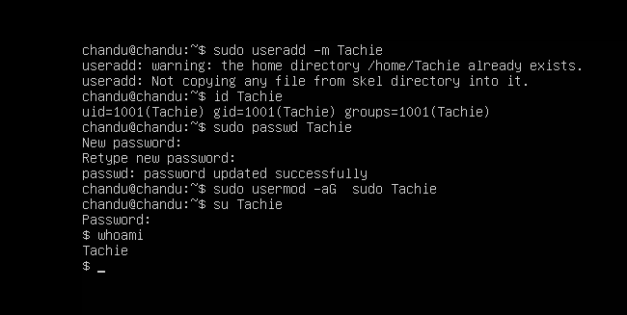

- Navigate to the home directory.
• cd ~ → The cd command changes the current working directory. Using ~ is a shortcut for the logged-in user’s home directory.
• pwd → Prints the current working directory. This confirms you are inside /home/username.
• The home directory is the default location where user files, configurations, and personal folders are stored.
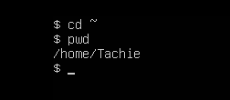

- Create a new directory.
mkdir → Stands for “make directory.” It is used to create a new folder in the current location.
Example: mkdir chandu_directory creates a folder named chandu_directory.
ls → Lists files and directories in the current path. This confirms that the new directory exists.
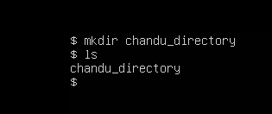

- List the contents of a directory.
• ls → Stands for “list.” It displays the contents of the current directory (files and subdirectories).
• Example: ls in the home directory shows folders like Desktop, Documents, Downloads, etc.
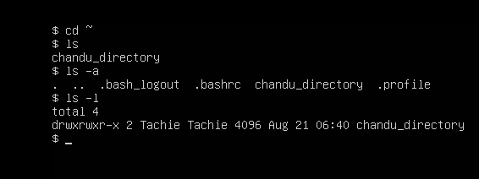

- Change the current directory.
• cd → Stands for “change directory.” It is used to move from the current working directory into another folder.
• Example: cd Documents moves into the Documents folder inside the home directory.
• pwd → Prints the current working directory, confirming the change.
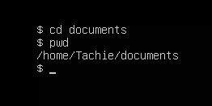

The cd command is essential for navigation in Linux, allowing you to move around the filesystem to access files and directories.

- Create a new empty file.
• touch → Used to create an empty file or update the timestamp of an existing file.
• Example: touch sample.txt creates a new file named sample.txt.
• If the file already exists, touch will not overwrite its content — it only updates the file’s access and modification time.
• ls → Lists files in the directory, confirming that the new file was created.
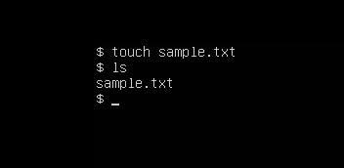

- View the contents of a file.
• cat → Stands for “concatenate.” It is used to display the contents of a file directly in the terminal.
• Example: cat techie.txt prints everything inside the file techie.txt.
• You can also use cat to join multiple files together:

cat file1.txt file2.txt > combined.txt
➝ Merges both files into combined.txt.
• cat is especially useful for quickly checking logs, configuration files, or text documents without opening an editor.
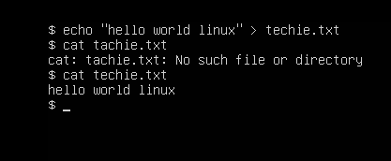

- Copy a file to another location.
• cp → Stands for “copy.” It is used to duplicate files or directories from one location to another.
• Example: cp techie.txt /home/chandu/Documents/ copies the file techie.txt into the Documents folder.
• The original file remains in the source directory, while a duplicate is created in the destination.
• Options:
- cp -r folder/ /path/ → Copies entire directories recursively.
- cp file1 file2 → Copies file1 into file2 (renaming if needed).
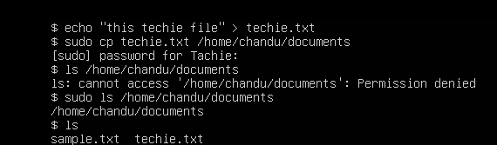

- Move a file to another location.
• mv → Stands for “move.” It is used to move files or directories from one location to another.
• Example: mv techie.txt /home/chandu/Documents/ moves the file into the Documents folder.
• Unlike cp, which creates a duplicate, mv removes the file from the source and places it in the destination.
• Rename usage: You can also use mv to rename a file:
mv techie.txt techie_renamed.txt
➝ Renames the file in the same directory.
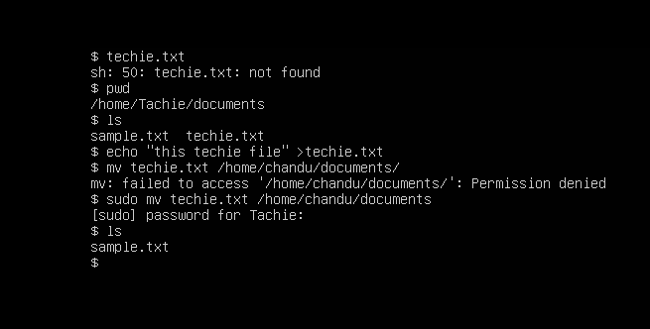

- Rename a file.

• mv → Stands for “move.” It is also used to rename files or directories.
• Example: mv techie.txt techie_renamed.txt renames the file in the same directory.
• Rename is essentially a “move” operation where the destination is the same directory but with a new name.

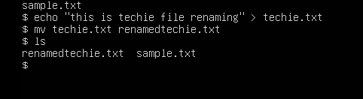

- Delete a file.
• rm → Stands for “remove.” It is used to delete files or directories.
• Example: rm temp.txt deletes the file permanently.
• Options:
- rm -i filename → Interactive mode, asks before deleting.
- rm -r directory_name → Deletes a directory and its contents recursively.
- rm -rf directory_name → Forcefully deletes a directory without confirmation ( use with caution).
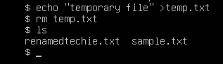

- Grant or revoke permissions on a file or directory.

→ Gives the owner read, write, and execute permissions, and gives group and others read and execute permissions.
· Options / Examples:
· chmod u+x filename → Grants execute permission to the owner.
· chmod u-x filename → Revokes execute permission from the owner.
· chmod g+w filename → Grants write permission to the group.
· chmod g-w filename → Revokes write permission from the group.
· chmod 644 filename → Owner can read/write, group and others can read.
· chmod 755 directory_name → Owner has full permission, group and others have read and execute

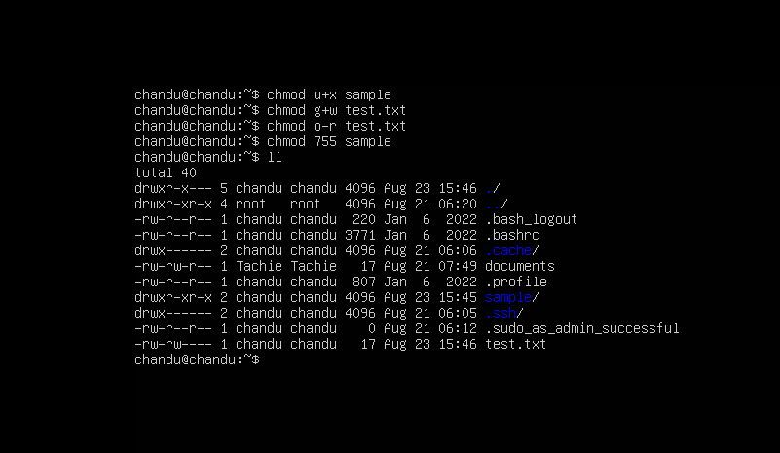

- View the current date and time.
· date → Displays the current date.
· Example: date → Shows the current date and time.
· Options:
· date +%Y-%m-%d → Displays the date in YYYY-MM-DD format.
· date +%H:%M:%S → Displays the current time in HH:MM:SS format.
· date +"%d-%m-%Y %H:%M:%S" → Displays both date and time in a specific format.
· timedatectl → Displays detailed information about the system date, time, and timezone.
Example: timedatectl → Shows the current time, timezone, and whether time synchronization is enabled.
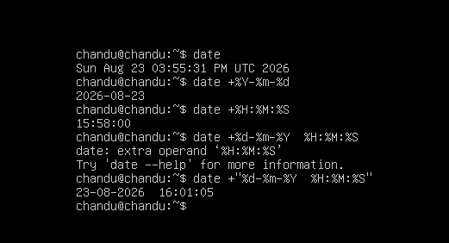

- Check the system uptime.
uptime → Displays how long the system has been running since it was last started/rebooted.
→ Shows the current time, system uptime, number of logged-in users, and system load average.
Options:
· uptime -p → Shows uptime in a simple, human-readable format.
· uptime -s → Shows the date and time when the system was started.
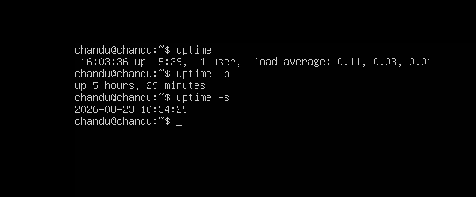

- View the running processes.
ps → Stands for “process status.” It is used to view the currently running processes.
→ Shows the processes running in the current terminal/session.
· Options:
· ps -ef → Displays all running processes with detailed information.
· ps aux → Displays all running processes along with CPU and memory usage.
· top → Continuously displays running processes and system resource usage in real time.
· htop → Interactive and user-friendly version of top (if installed).
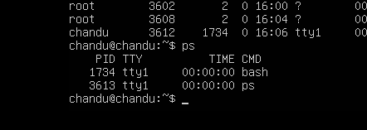

- Kill a running process.
· kill → Used to terminate or send a signal to a running process.
→ Terminates the process using its Process ID (PID).
Options:
· kill -9 PID → Forcefully terminates the process using SIGKILL.
· kill -15 PID → Gracefully terminates the process using SIGTERM.
·
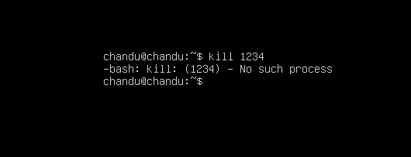
- Install a package using the package manager (e.g., apt or yum).
→ Installs the Nginx package on Ubuntu.
· Options:
· sudo apt update → Updates the package list.
· sudo apt install package_name → Installs a package.
· sudo apt remove package_name → Removes a package.
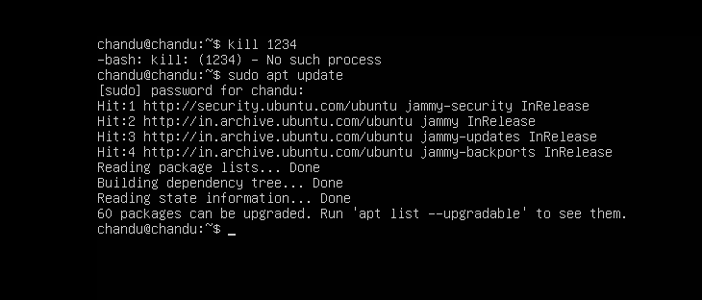

- Update the system packages.
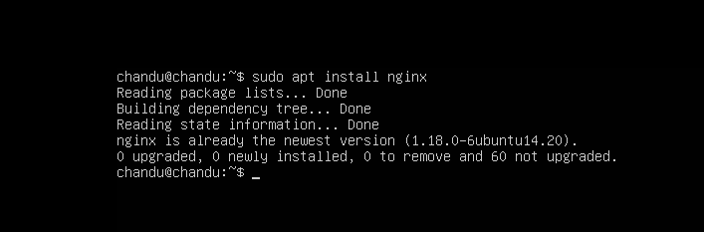
- Create a symbolic link.
ln -s → Used to create a symbolic link (soft link) to a file or directory.
→ Creates a symbolic link /home/user/app that points to /var/www/app.
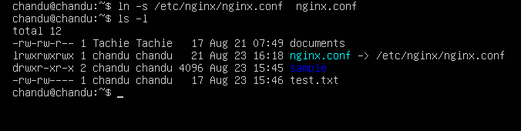
- Search for files using the find command.
find → Used to search for files and directories based on name, type, size, permissions, and other conditions.
→ Searches the entire system for a file named test.txt.
· Options:
· find /home -name "file.txt" → Searches for file.txt inside /home.
· find /home -type f -name "*.log" → Searches for all .log files.
· find /home -type d -name "backup" → Searches for a directory named backup.
· find /var -type f -size +100M → Finds files larger than 100 MB.
· find /tmp -name "*.tmp" -delete → Finds and deletes .tmp files.
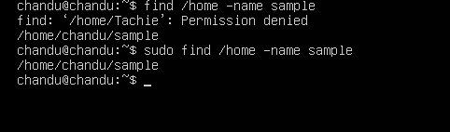
- Compress and decompress files using tar.
tar → Stands for “Tape Archive.” It is used to combine multiple files/directories into a single archive and extract them later.
tar by itself mainly archives files. With options like -z, -j, or -J, it also compresses them.

Decompress / Extract
· tar -xvf backup.tar → Extracts a .tar archive.
· tar -xzvf backup.tar.gz → Extracts a .tar.gz archive.

Important options
· -c → Create an archive
· -x → Extract an archive
· -v → Verbose; shows files being processed
· -f → Specifies the archive filename
· -z → Use gzip compression
· -j → Use bzip2 compression
· -J → Use xz compression
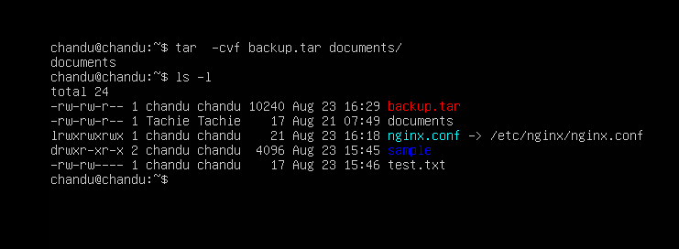

- Monitor system resources with top or htop.
• top → Default Linux command to monitor system resources.
- Displays CPU usage, memory usage, running processes, uptime, and load average.
- Useful for quickly checking system health.
• htop → Enhanced version of top.
- Provides a user-friendly interface with color coding.
- Allows scrolling, searching, and killing processes directly.
- Must be installed separately (sudo apt install htop on Ubuntu).
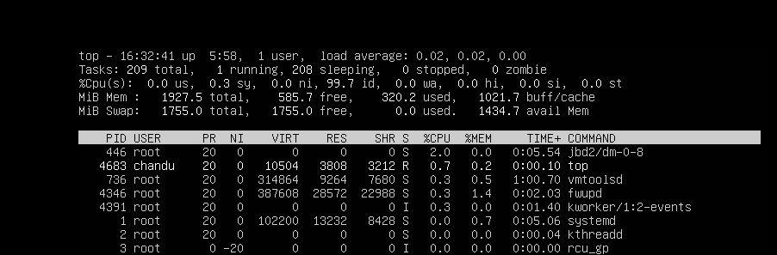
- Create and manage user groups.
• groupadd → Creates a new group.
• groupmod → Modifies group properties (rename, change GID).
• groupdel → Deletes a group.
• usermod → Adds/removes users from groups.
• id → Displays user’s UID, GID, and group memberships.

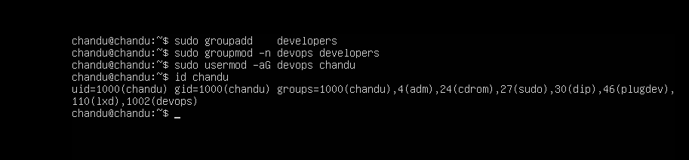

- Set up SSH password less authentication.
• Generates a key pair, copies the public key to the remote server, and logs in without a password.
• Purpose: Secure and convenient login for automation (e.g., Ansible, Git).
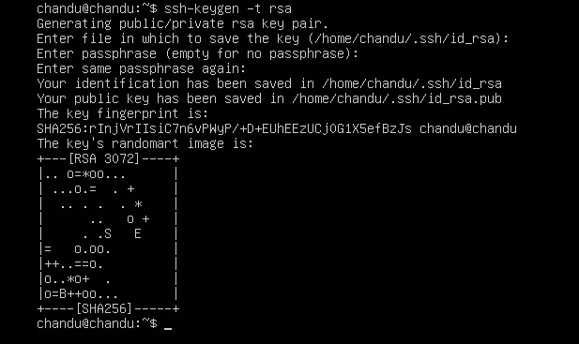

- Monitor log files using tail or grep.
• tail -f → live monitoring.
• grep → filter logs for specific patterns.
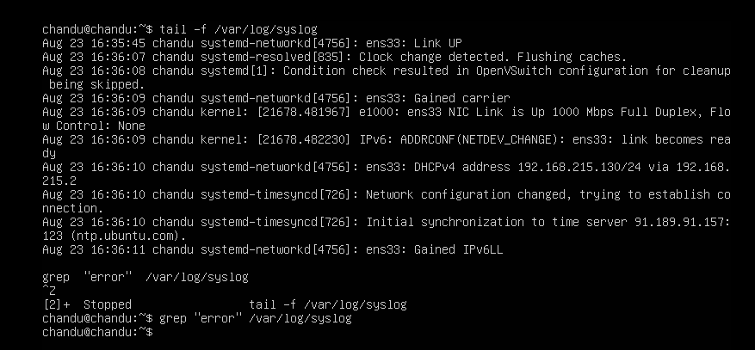

- Set up a web server (e.g., Apache or Nginx).
• Apache or Nginx serves web pages.
• Verify with http://localhost.
sudo apt install apache2 -y
sudo systemctl start apache2
sudo systemctl enable apache2
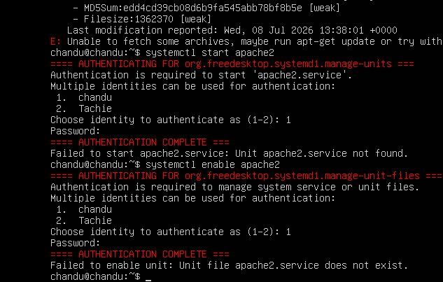

- Configure and secure a MySQL Database.
ets root password, removes test DB, disables remote root login.
sudo apt install mysql-server -y
sudo mysql_secure_installation
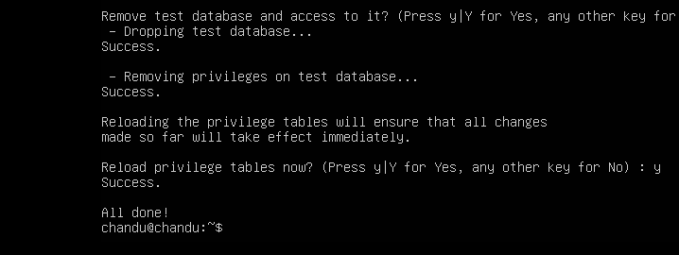
- Set up a Application Server (e.g.,Apache Tomcat)
sudo apt install tomcat9 -y
sudo systemctl start tomcat9
Application server for Java web apps.

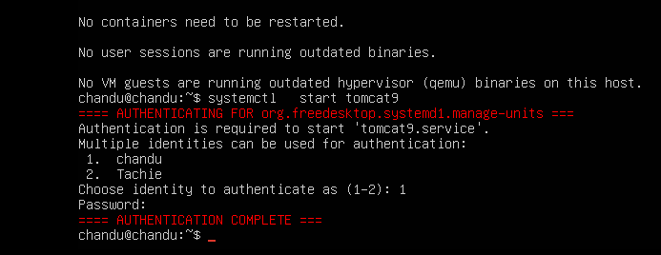
- create a service file for Apache Tomcat.(Should execute by using systemtctl command)
/etc/systemd/system/tomcat.service
[Unit]
Description=Apache Tomcat
After=network.target

[Service]
Type=forking
ExecStart=/usr/share/tomcat9/bin/startup.sh
ExecStop=/usr/share/tomcat9/bin/shutdown.sh
User=tomcat
Group=tomcat

[Install]
WantedBy=multi-user.target

sudo systemctl daemon-reload
sudo systemctl enable tomcat
sudo systemctl start tomcat

- Print specific columns from a delimited file.
awk -F',' '{print $1,$3}' file.csv
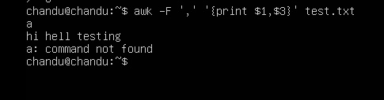
- Filter and print lines based on a specific pattern or condition.
grep "ERROR" logfile.txt
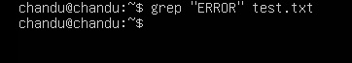
- Calculate and print the average, sum, or other statistics of a column.
awk '{sum+=$2} END {print "Average:", sum/NR}' file.txt
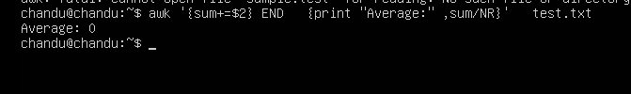
- Perform string manipulation, such as extracting substrings or changing case.
echo "HELLO" | tr 'A-Z' 'a-z'
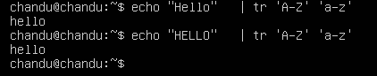
- Count the occurrences of a specific pattern in a file.
grep -c "ERROR" logfile.txt
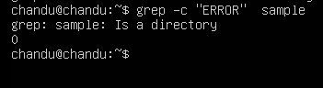
- Sort lines based on a specific field or column.
sort -t',' -k2 file.csv
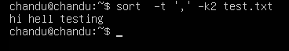
- Merge multiple files based on a common field or column.
join file1.txt file2.txt
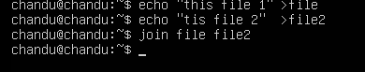
- Substitute text in a file using search and replace.
sed 's/old/new/g' file.txt
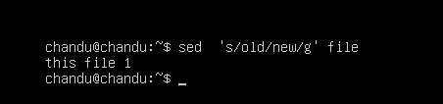
- Delete specific lines based on a pattern or line number.
sed '3d' file.txt
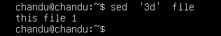
- Append or insert text before or after a specific pattern or line.
sed '/pattern/a\New line text' file.txt
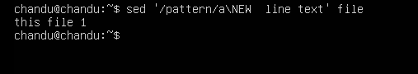
- Print only specific lines from a file.
sed -n '5,10p' file.txt
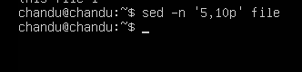
- Copy file from linux to windows machine
scp file.txt user@windows_host:/path/to/destination
- 5 use cases for AWK and 5 use cases for sed

AWK:
- Extract specific columns from CSV.
- Calculate averages/sums.
- Format reports.
- Filter rows by condition.
- Generate statistics from logs.
sed:
- Search and replace text.
- Delete specific lines.
- Insert text before/after a pattern.
- Substitute case or characters.
- Batch edit configuration files.

