VPC-Assignment-2
1.Create one VPC, with 1 public subnet and 1 private subnet.

Step 1: Create VPC with Subnets

A. Create the VPC
- In AWS Console, go to Services → VPC.
- On the left menu, click Your VPCs.
- Click Create VPC.
- Fill in details:
  - Name tag: Assignment2-VPC
  - IPv4 CIDR block: 10.0.0.0/16
  - Leave IPv6 blank (optional).
  - Tenancy: Default.
- Click Create VPC → ✅ VPC created.

B. Create Public Subnet
- In the VPC console, click Subnets → Create subnet.
- Select Assignment2-VPC.
- Name: Public-Subnet.
- Availability Zone: pick one (e.g., ap-south-1a).
- IPv4 CIDR block: 10.0.1.0/24.
- Click Create subnet.
- After creation, select the subnet → Actions → Edit subnet settings → enable Auto‑assign public IPv4 address → Save.

C. Create Private Subnet
- Again, click Subnets → Create subnet.
- Select Assignment2-VPC.
- Name: Private-Subnet.
- Availability Zone: same or different (e.g., ap-south-1b).
- IPv4 CIDR block: 10.0.2.0/24.
- Click Create subnet.
- Leave auto‑assign public IP disabled (default).

D. Create and Attach Internet Gateway
- In VPC console, click Internet Gateways → Create internet gateway.
- Name: Assignment2-IGW.
- Click Create internet gateway.
- Select it → Actions → Attach to VPC → choose Assignment2-VPC.

E. Configure Route Tables
- In VPC console, click Route Tables.
- You’ll see a default route table. Rename it Public-RT.
  - Edit routes → add route:
    - Destination: 0.0.0.0/0
    - Target: Internet Gateway (Assignment2-IGW).

  - Associate this route table with Public-Subnet.
- Create another route table → name Private-RT.
  - Leave only local route (10.0.0.0/16 → local).
  - Associate this route table with Private-Subnet.
  - (Optional) If you want outbound internet, later add a NAT Gateway here.)

✅ End Result
- VPC: Assignment2-VPC (10.0.0.0/16)
- Public Subnet: 10.0.1.0/24 (auto‑assign public IP enabled, IGW route)
- Private Subnet: 10.0.2.0/24 (no public IP, local route only)
- Internet Gateway: attached to VPC
- Route Tables: Public → IGW, Private → local

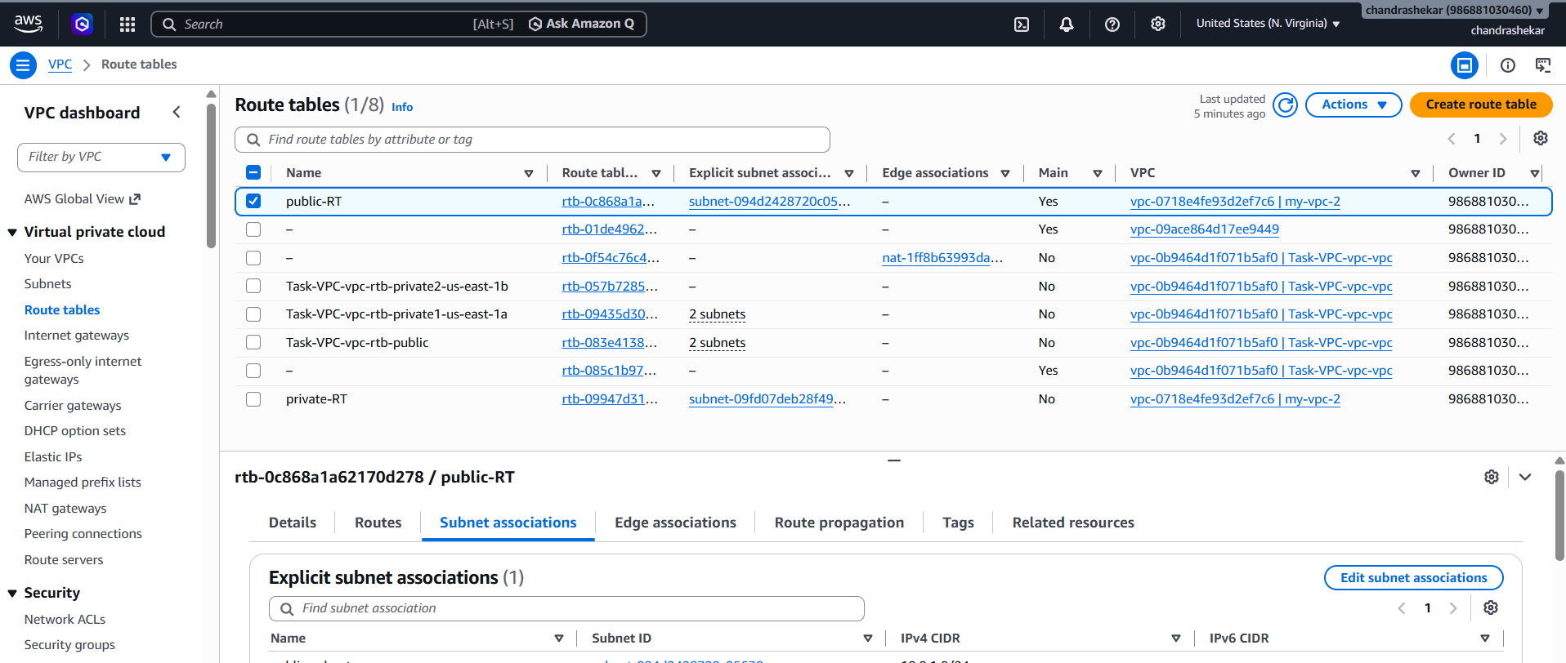
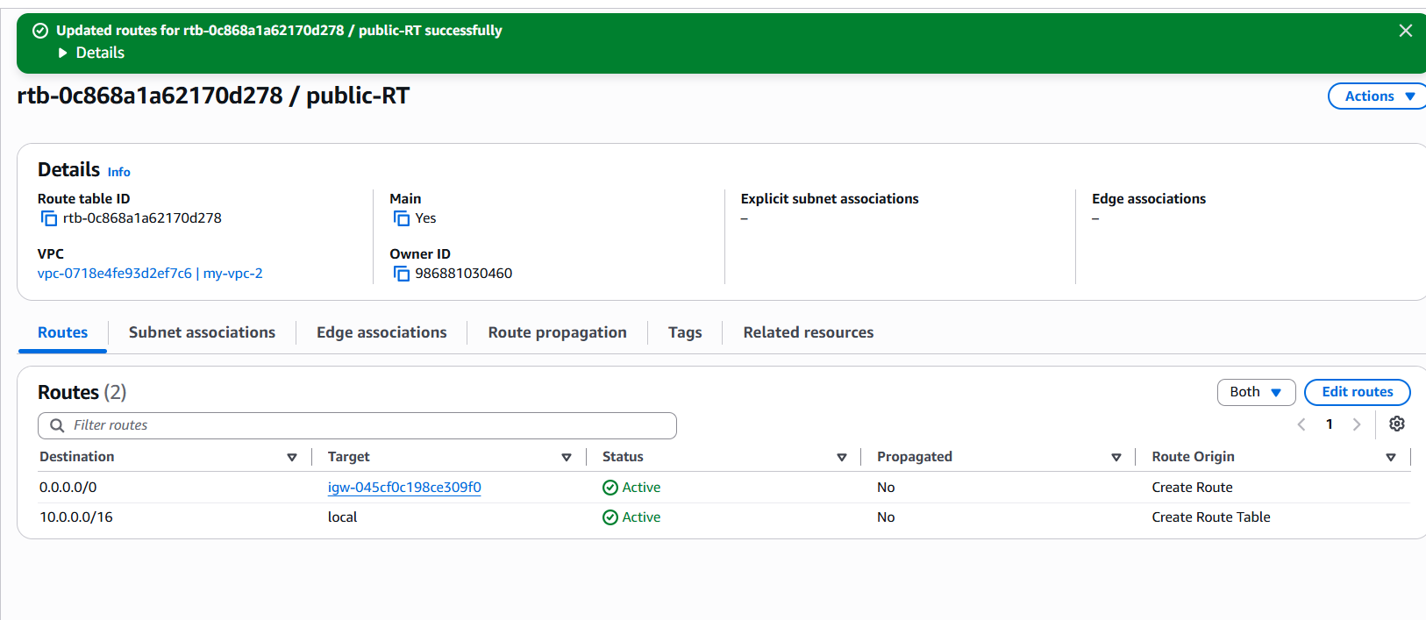

Enable VPC peering for cross-region.

🗂️ Step 1: Create Second VPC in Another Region
- In AWS Console, switch to us‑east‑1 (N. Virginia).
  - Go to VPC → Your VPCs → Create VPC.
  - Name: Today-Task-VPC.
  - CIDR block: 10.20.0.0/16.
  - Create → Done.
- Switch to us‑west‑2 (Oregon).
  - Create another VPC.
  - Name: Task2-West-VPC.
  - CIDR block: 10.30.0.0/16.
  - Create → Done.

🗂️ Step 2: Create Peering Connection
- Stay in us‑west‑2 region.
- Go to VPC → Peering Connections → Create Peering Connection.
- Fill details:
  - Name tag: CrossRegion-Peer.
  - Requester VPC: Task2-West-VPC (10.30.0.0/16).
  - Region: Select Another Region → us‑east‑1.
  - Accepter VPC: Today-Task-VPC (10.20.0.0/16).
- Click Create Peering Connection.
  - Status: Pending Acceptance.

🗂️ Step 3: Accept Peering Request
- Switch AWS Console region to us‑east‑1.
- Go to VPC → Peering Connections.
- Select the pending request.
- Click Actions → Accept Request.
- Status changes to Active ✅.

🗂️ Step 4: Update Route Tables
- In us‑east‑1 (Today-Task-VPC):
  - Go to Route Tables → Edit Routes.
  - Add route:
    - Destination: 10.30.0.0/16.
    - Target: Peering connection (pcx-xxxx).
  - Save.
- In us‑west‑2 (Task2-West-VPC):
  - Add route:
    - Destination: 10.20.0.0/16.
    - Target: Peering connection (pcx-xxxx).
  - Save.

🗂️ Step 5: Security Groups & NACLs
Ensure Security Groups allow inbound traffic from the peer VPC CIDR.
Ensure Network ACLs allow traffic between the two CIDRs.
Example SG rule:
  - Inbound → Source: 10.30.0.0/16 (for east VPC).
  - Inbound → Source: 10.20.0.0/16 (for west VPC).

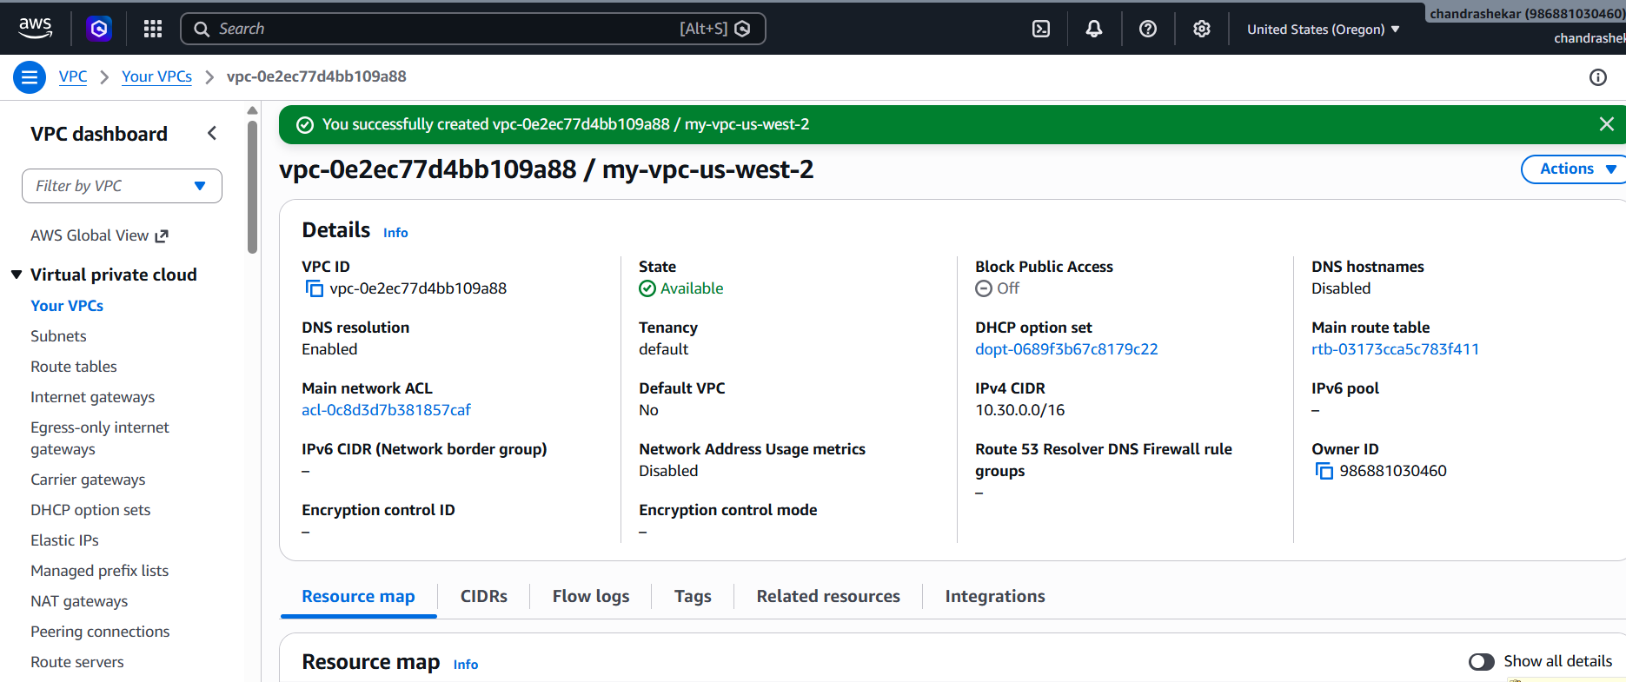
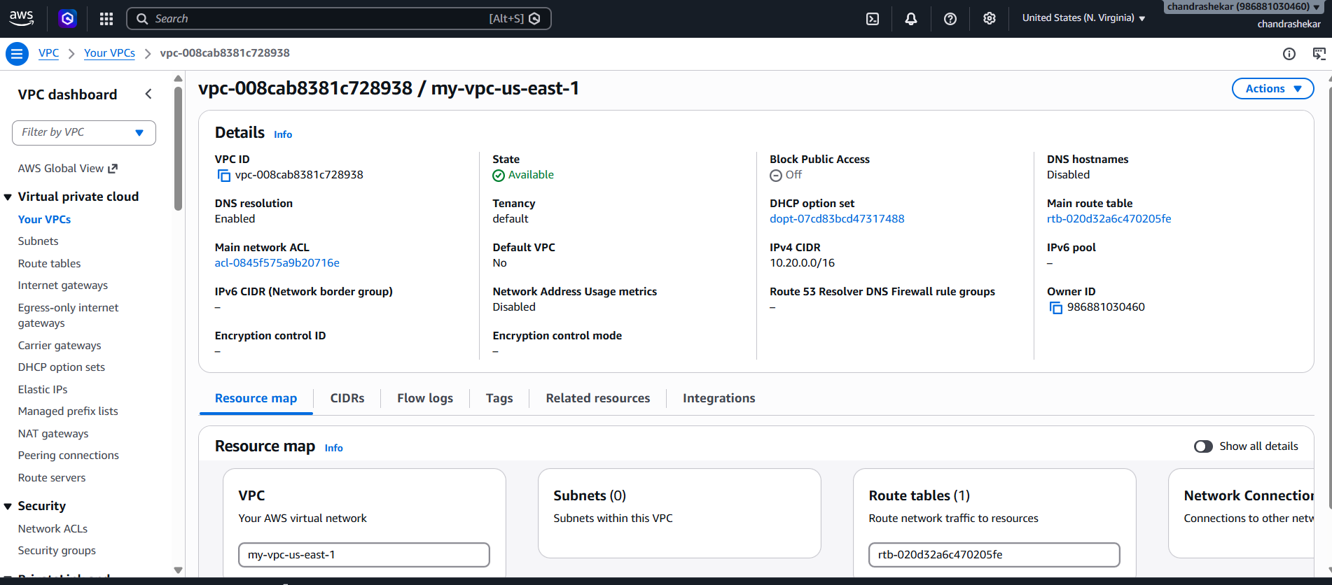
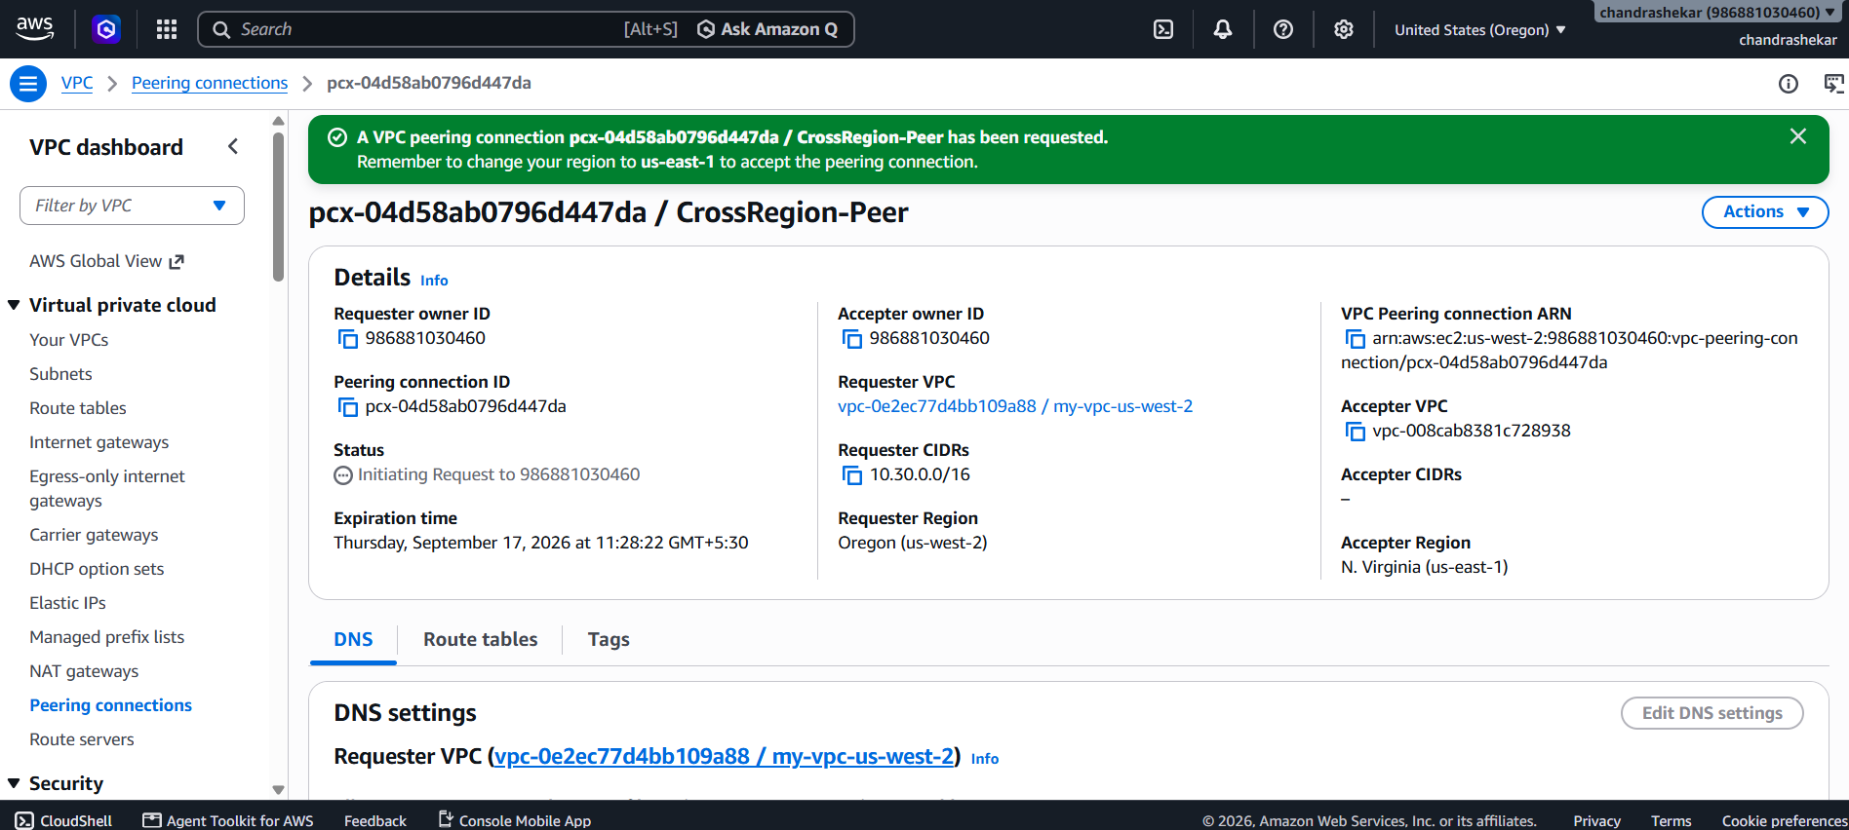
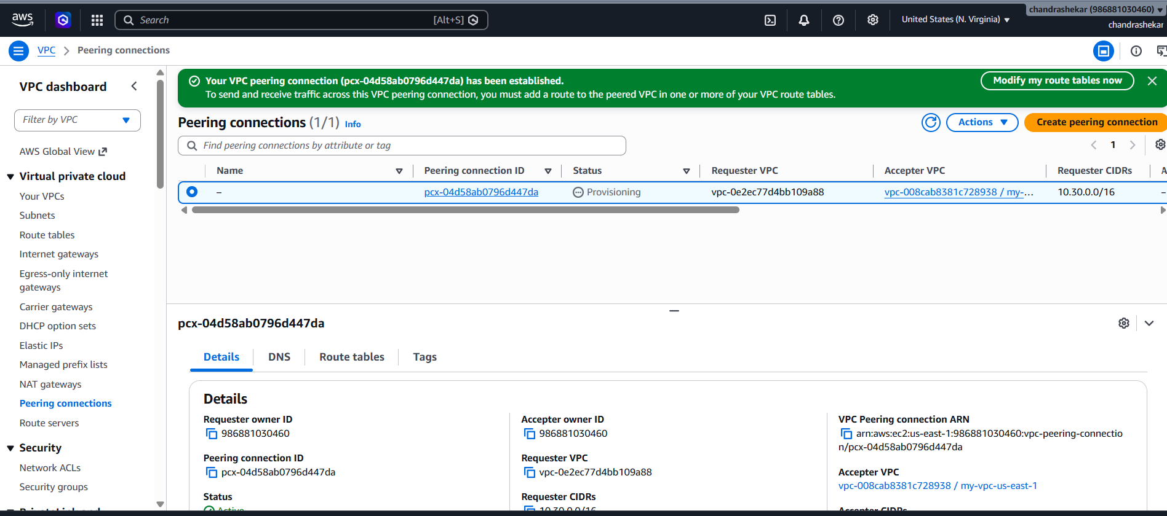
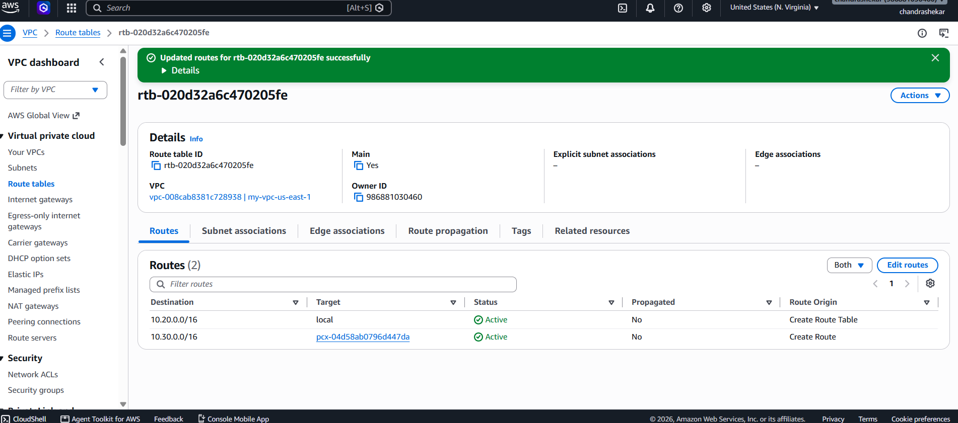
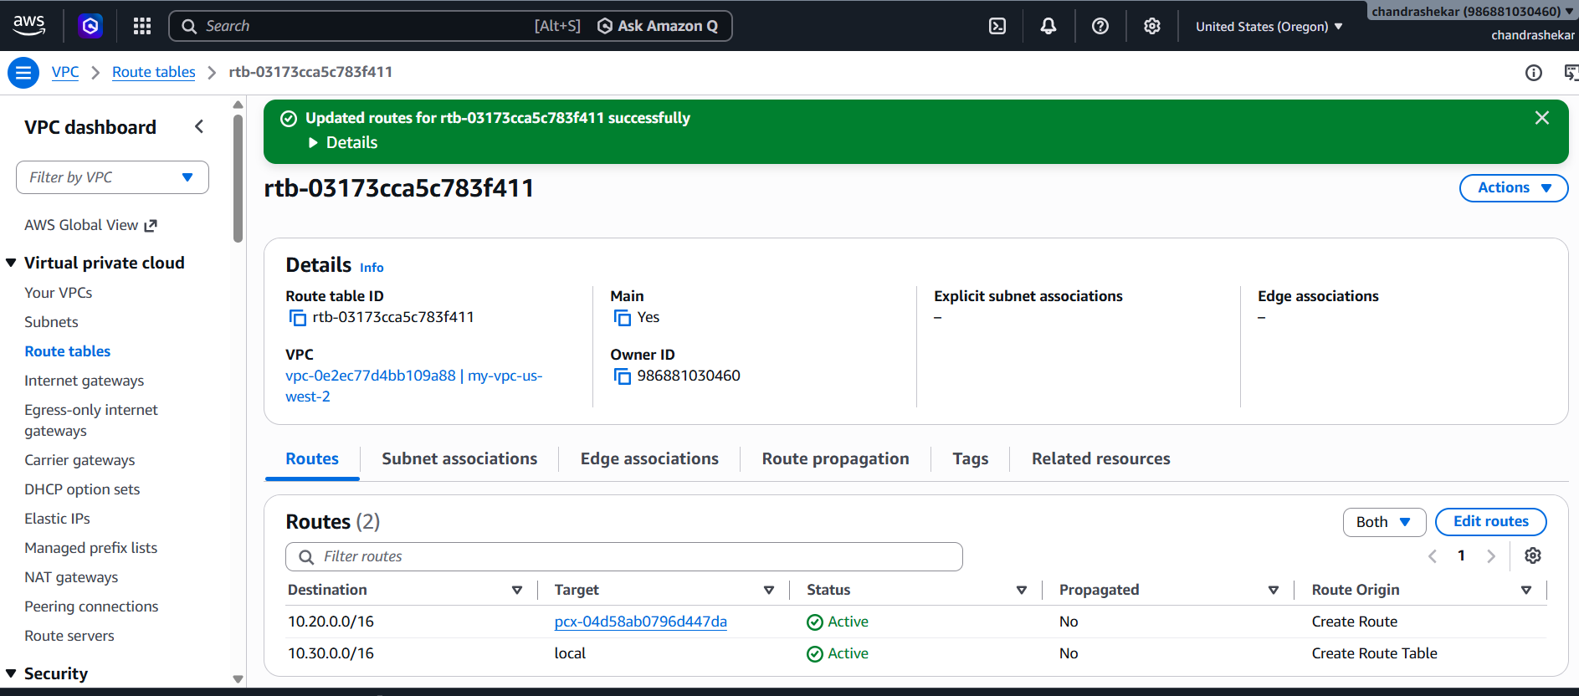

3.Enable VPC peering for cross-account (you can collaborate with your friend to do this task).

1.Create Your VPC
You need a VPC in your account to start the peering.
AWS Console → VPC → Your VPCs → Create VPC
- Region: us‑east‑1
- Name: Today-Task-VPC
- CIDR: 10.20.0.0/16
- Create at least one subnet (e.g., 10.20.1.0/24)

2.Friend Creates Their VPC
Your friend must also create a VPC in their account.
AWS Console → VPC → Your VPCs → Create VPC
- Region: us‑west‑2
- Name: Friend-West-VPC
- CIDR: 10.30.0.0/16
- Create at least one subnet (e.g., 10.30.1.0/24)

3.You Create Peering Request
Initiate the peering connection from your account.
AWS Console → VPC → Peering Connections → Create Peering Connection
- Name: CrossAccount-Peer
- Requester VPC: Today-Task-VPC
- Region: Another Region → us‑west‑2
- Accepter VPC ID: Friend’s VPC ID
- Account ID: Friend’s AWS Account ID
- Status: Pending Acceptance

4.Friend Accepts Peering Request
Your friend must accept the request in their account.
AWS Console → VPC → Peering Connections
- Select pending request
- Actions → Accept Request
- Status changes to Active ✅

5.Update Route Tables
Both sides must add routes for traffic to flow.
AWS Console → VPC → Route Tables → Edit Routes
- In your VPC: Destination 10.30.0.0/16 → Target: Peering connection
- In friend’s VPC: Destination 10.20.0.0/16 → Target: Peering connection

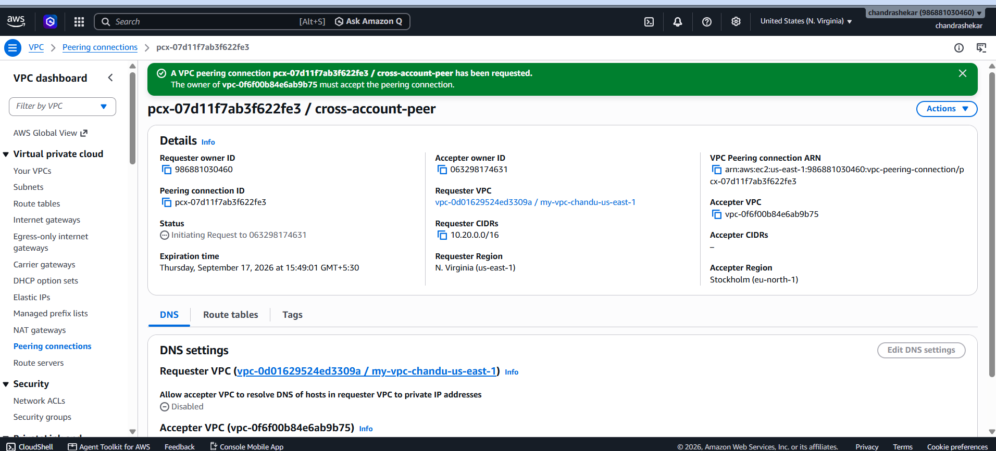
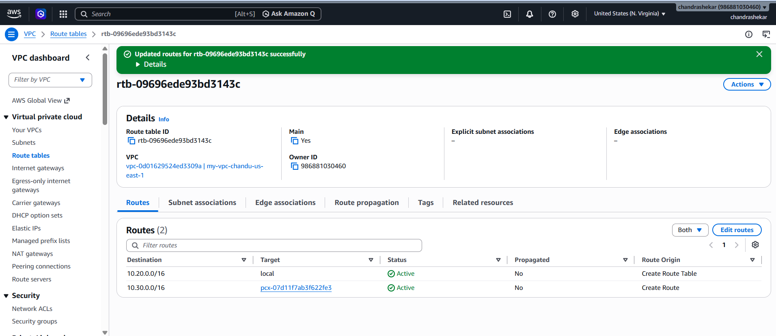
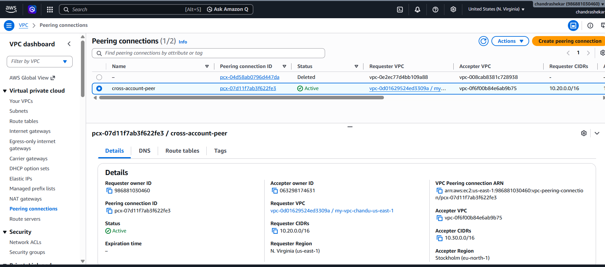

Configure Security Groups & NACLs
Allow traffic between the two CIDR ranges.
AWS Console → EC2 → Security Groups
- Your SG: allow inbound from 10.30.0.0/16
- Friend’s SG: allow inbound from 10.20.0.0/16
- Ensure NACLs allow traffic between both ranges

Test Connectivity with EC2
Verify the peering connection works.
AWS Console → EC2 → Launch Instance
- Launch one EC2 in each VPC
- Get private IPs
- From your EC2: ping friend’s EC2 private IP
- From friend’s EC2: ping your EC2 private IP
- If SG + NACL + routes are correct → ping succeeds 🎉

4.Set up a VPC Transit Gateway.
🗂️ Step 1: Create Transit Gateway
- In AWS Console → VPC → Transit Gateways → Create Transit Gateway.
- Fill details:
  - Name tag: My-TGW.
  - Description: Transit Gateway for multi‑VPC connectivity.
  - Amazon ASN: Leave default (64512) unless you need custom.
  - Default route table association/propagation: Enable (recommended for simple setups).
- Click Create Transit Gateway.
  - Status: Available ✅.

🗂️ Step 2: Attach VPCs to TGW
- Go to Transit Gateway Attachments → Create Attachment.
- Select:
  - Transit Gateway ID: My-TGW.
  - VPC: Choose your first VPC (e.g., Today-Task-VPC).
  - Subnets: Select at least one subnet per AZ.
- Repeat for your second VPC (e.g., Task2-West-VPC).
- Attachments will show Pending → Available once active.

🗂️ Step 3: Update Route Tables
- In each VPC’s Route Table:
  - Add route → Destination: CIDR of the other VPC.
  - Target: Transit Gateway (tgw-xxxx).
- Example:
  - In Today-Task-VPC: Route 10.30.0.0/16 → TGW.
  - In Task2-West-VPC: Route 10.20.0.0/16 → TGW.

🗂️ Step 4: Security Groups & NACLs
- Ensure EC2 SGs allow inbound traffic from peer VPC CIDRs.
- Example SG rules:
  - In East VPC SG → allow from 10.30.0.0/16.
  - In West VPC SG → allow from 10.20.0.0/16.

🗂️ Step 5: Test Connectivity
- Launch EC2 in each VPC (if not already).
- Get private IPs.
- From East EC2 → ping West EC2 private IP.
- From West EC2 → ping East EC2 private IP.
- If TGW + routes + SGs are correct → ping succeeds 🎉.

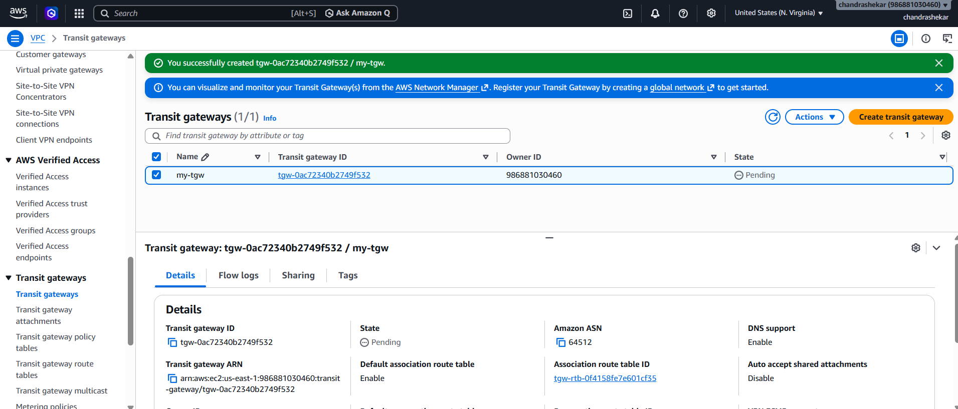
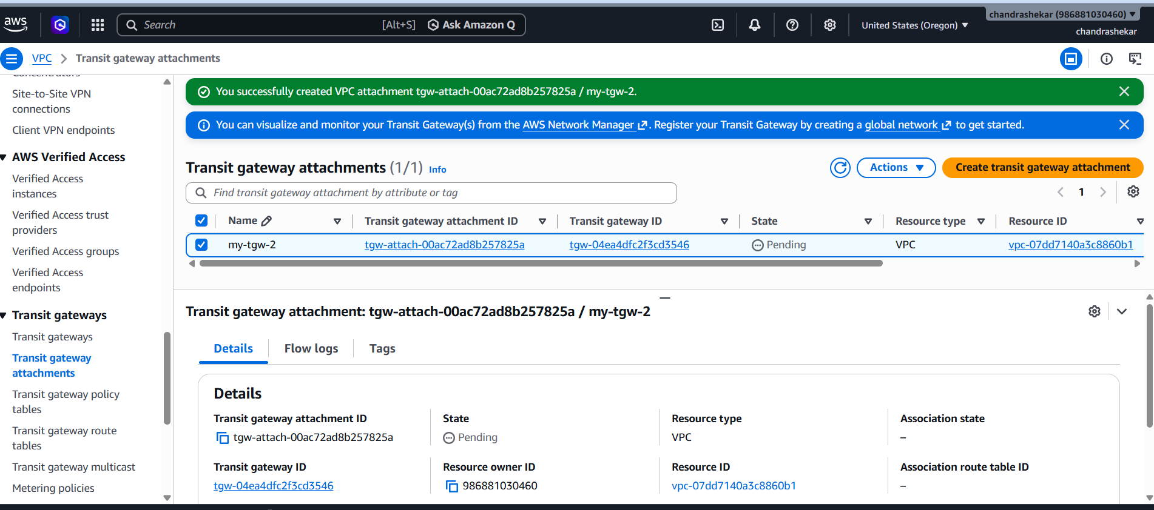
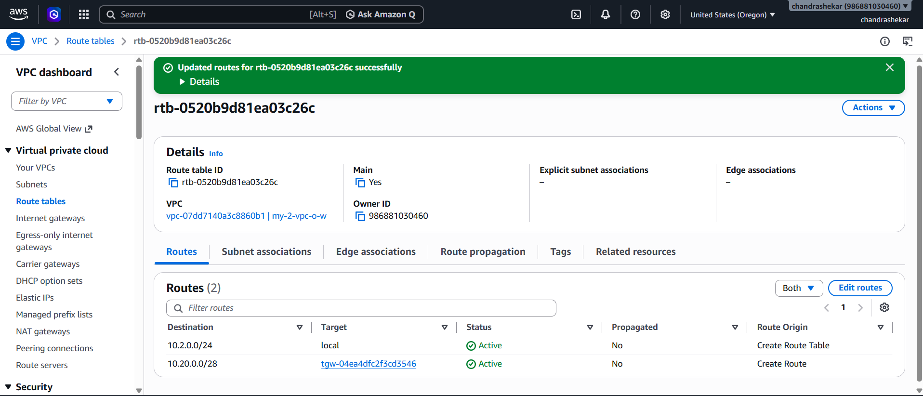
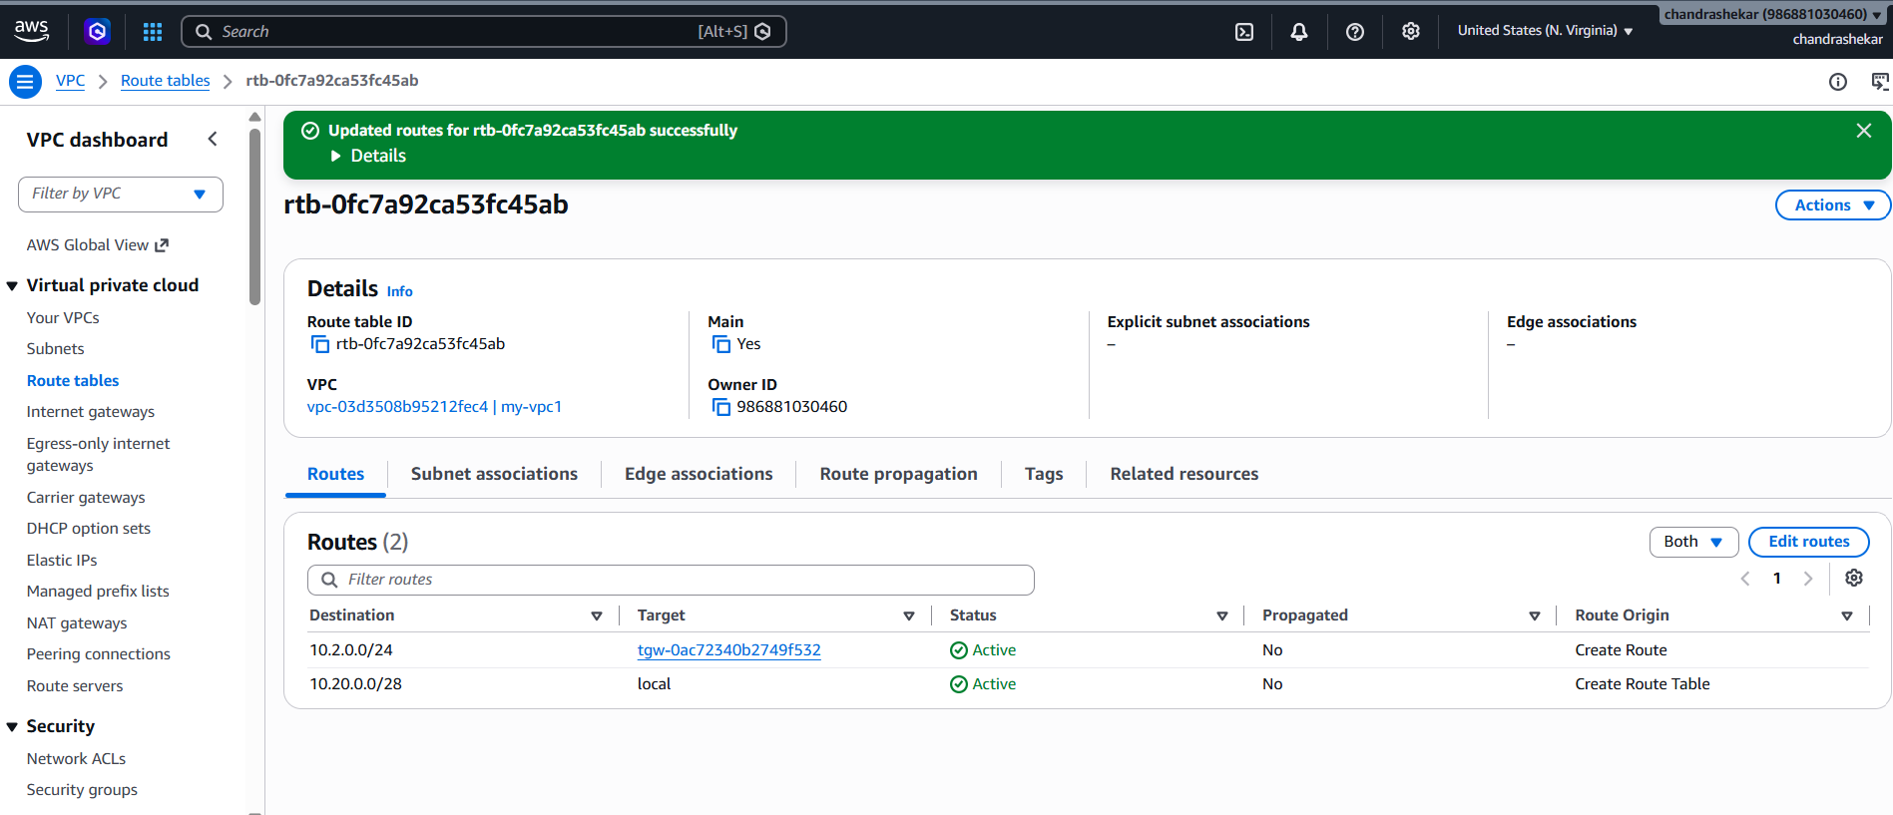

5.Set up a VPC Endpoint.
Goal: Allow a VPC to access an AWS service privately without using the public internet.
Steps
- Go to VPC → Endpoints.
- Click Create endpoint.
- Enter name:
Task5-S3-Endpoint
- Select AWS services.
- Select:
com.amazonaws.us-east-1.s3
- Choose Gateway type.
- Select VPC:
Today-Task-VPC
- Select the appropriate route table.
- Click Create endpoint.
- Verify the endpoint is successfully created.
Your Endpoint
Vpce-0b1b86b455b8cf70b
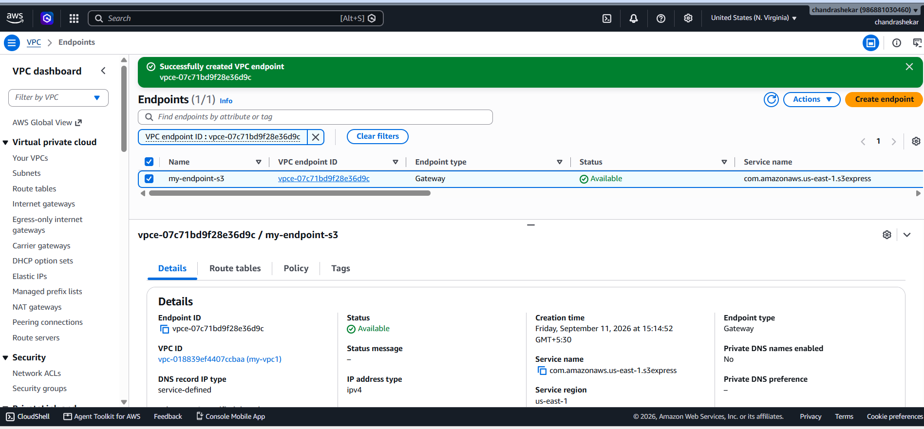
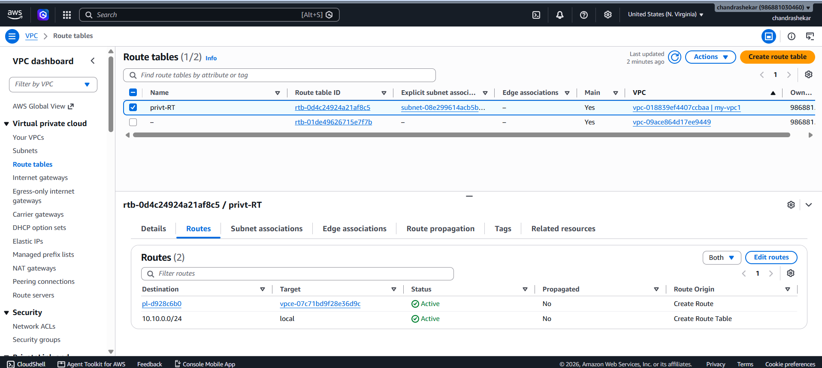

· Conclusion
This assignment demonstrates the core AWS networking concepts, including creating a VPC with public and private subnets, establishing cross-Region and cross-account VPC peering, setting up a VPC Transit Gateway, and creating a VPC Endpoint for private access to AWS services. It provides practical experience with VPC connectivity, routing, and network design in AWS.

