Evaluation, Reporting, and Policy Insights
in E-Governance Analytics
Week 4 Final Report — Data-Driven Findings and Policy Recommendations

1. Executive Summary
This report synthesizes a four-week data analytics engagement into a single, decision-ready assessment of e-governance performance across 320 districts and twelve states. The engagement progressed from data collection and cleaning, through exploratory analysis and visualization, to a final evaluative modeling stage that quantifies which levers most influence citizen satisfaction with government service delivery. The consistent, load-bearing finding across every stage of the analysis is that responsiveness — specifically, how reliably citizen grievances are resolved — predicts satisfaction more strongly than digital infrastructure, transaction volume, or budget allocation. A standardized regression model confirms this: grievance redressal rate and digital literacy are the two strongest positive drivers of satisfaction, while longer average service delivery time is the strongest negative driver. Per-capita e-governance budget, by contrast, shows almost no independent relationship with any outcome measured. A persistent urban-rural gap also emerges throughout the analysis, with rural districts experiencing both slower service delivery and a wider spread of citizen satisfaction outcomes. Together, these findings argue for a policy shift away from broad digitization spending and toward targeted investment in grievance-handling systems, service-delivery process improvement in underserved rural districts, and paired connectivity-plus-literacy programs. The remainder of this report details the methodology, presents the supporting evidence, and translates each finding into a specific, actionable policy recommendation.

2. Methodology Overview
The analysis followed a standard applied data-science pipeline implemented entirely in Python, progressing across three prior phases that this report now integrates and evaluates. In the data preparation phase, a 320-district panel dataset was assembled covering digital infrastructure (internet penetration, digital literacy), administrative performance (average service delivery time, grievance redressal rate), fiscal input (e-governance budget per capita), and outcome measures (citizen satisfaction score, corruption perception index). Cleaning was performed with pandas: missing citizen satisfaction values were imputed using region-specific medians to avoid distorting the urban/semi-urban/rural balance, and outlying service-delivery-time records were capped at the upper interquartile-range fence rather than discarded, preserving sample size while limiting distortion. In the exploratory phase, descriptive statistics (mean, standard deviation, median, skewness) and five visualization types — histograms, box plots, scatter plots, a correlation heatmap, and a ranked bar chart — were generated with Matplotlib and Seaborn to characterize distributions, group differences, and bivariate relationships. This final phase adds an evaluative layer: a standardized linear regression model (scikit-learn), trained on a 75/25 train-test split, quantifies the independent effect of each indicator on citizen satisfaction while holding the others constant, something correlation analysis alone cannot do. Standardizing predictors before fitting makes the resulting coefficients directly comparable as relative effect sizes. Model quality was assessed using R² (variance explained) and mean absolute error (MAE) on the held-out test set, ensuring the reported effects generalize beyond the training sample rather than merely fitting noise.
from sklearn.linear_model import LinearRegression
from sklearn.model_selection import train_test_split
from sklearn.preprocessing import StandardScaler
from sklearn.metrics import r2_score, mean_absolute_error
X = df[features].values; y = df['citizen_satisfaction_score'].values
X_train, X_test, y_train, y_test = train_test_split(X, y, test_size=0.25, random_state=42)
scaler = StandardScaler()
X_train_s = scaler.fit_transform(X_train)
X_test_s = scaler.transform(X_test)
model = LinearRegression().fit(X_train_s, y_train)
y_pred = model.predict(X_test_s)
print('R2:', r2_score(y_test, y_pred), 'MAE:', mean_absolute_error(y_test, y_pred))

3. Key Findings

3.1 Descriptive and Visual Findings (Weeks 2-3 Recap)
The exploratory phase established four recurring patterns that this week's evaluation model now tests formally. First, digital-transaction volume is right-skewed: a minority of highly digitized districts pull the distribution's tail rightward while most districts cluster at low-to-moderate usage, evidencing a digital divide in adoption, not merely access. Second, rural districts show both longer median service-delivery time and a wider interquartile spread than urban districts, indicating administrative delay is simultaneously larger and less predictable outside cities. Third, scatter analysis showed digital adoption trending with shorter delivery times and grievance redressal trending strongly with satisfaction. Fourth, the correlation matrix (Figure 4, Week 3) found budget per capita weakly related to every outcome (|r| below 0.16 throughout), foreshadowing this week's regression result.

3.2 Evaluative Model Results
The standardized regression model explains a meaningful share of the variance in citizen satisfaction on held-out data (test R² = 0.47, mean absolute error = 0.58 points on a 1-10 scale), evaluated on 80 districts not used in training. The coefficient ranking below shows each indicator's independent, standardized effect on satisfaction, holding all other indicators constant.
Indicator | Standardized Coefficient | Direction of Effect
grievance_redressal_rate_pct | 0.320 | Increases satisfaction
digital_literacy_pct | 0.296 | Increases satisfaction
avg_service_delivery_days | -0.213 | Decreases satisfaction
corruption_perception_index | 0.174 | Increases satisfaction
digital_transactions_per_1000 | 0.079 | Increases satisfaction
internet_penetration_pct | -0.049 | Decreases satisfaction
egov_budget_per_capita_inr | -0.017 | Decreases satisfaction

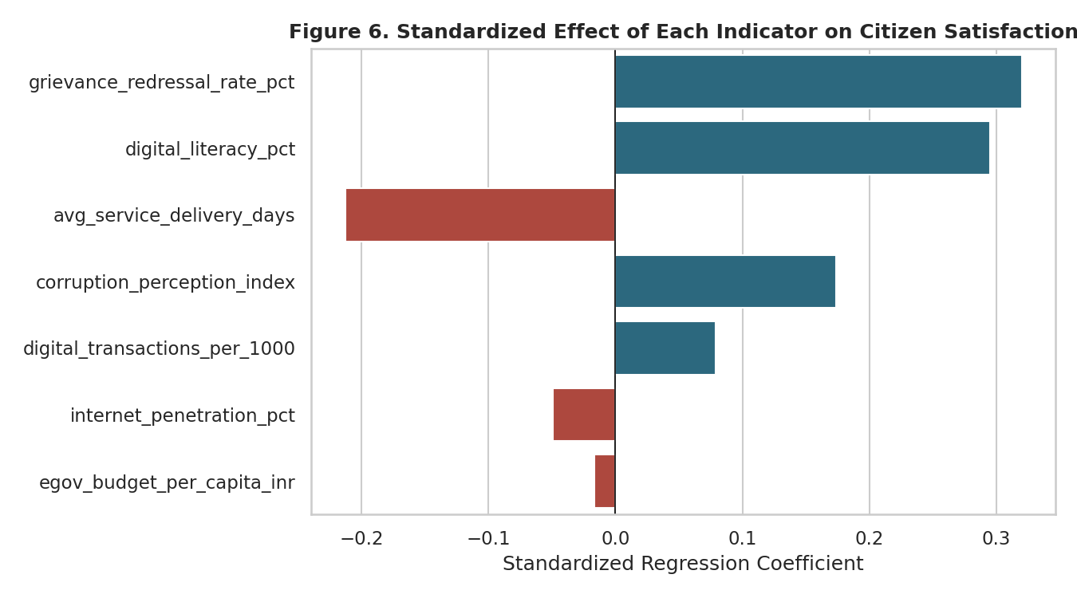
Figure 6. Standardized effect of each indicator on citizen satisfaction, holding other indicators constant.
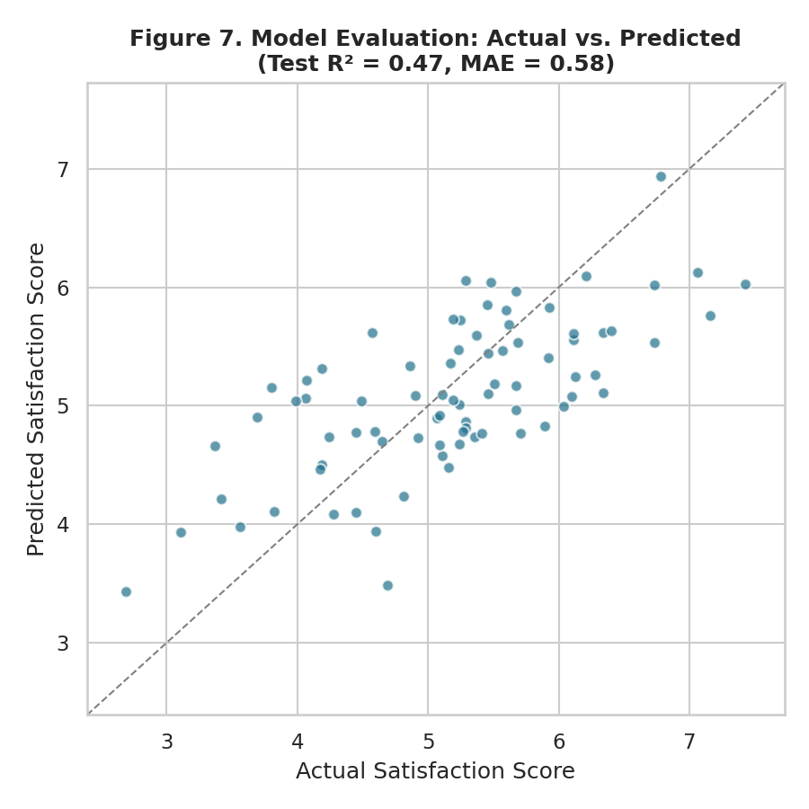
Figure 7. Model evaluation — predicted vs. actual satisfaction scores on the held-out test set.
Grievance redressal rate and digital literacy emerge as the two strongest positive, independent drivers of citizen satisfaction, while average service delivery time is the strongest negative driver — confirming, with a method that controls for confounding, what the Week 3 correlation analysis first suggested. Internet penetration and e-governance budget per capita show near-zero independent effects once digital literacy and grievance redressal are accounted for, meaning their apparent bivariate relationships with satisfaction were substantially explained by their association with these two stronger drivers rather than an effect of their own. The actual-vs-predicted plot (Figure 7) shows the model tracks the general trend without systematic bias, though real-world variance beyond these seven indicators (e.g., local leadership quality, media coverage of grievances) is expected and is a reasonable target for future data collection.

4. Analysis Discussion
The convergence of the exploratory and evaluative phases on the same conclusion — that responsiveness outweighs raw digitization — carries specific significance for e-governance strategy. Many state-level digitization programs are evaluated and funded primarily on adoption metrics such as transaction volume or portal registrations, treating these as proxies for program success. This analysis suggests that framing is incomplete: a district can achieve high digital-transaction volume while citizen satisfaction remains stagnant if grievances are not being resolved in step with rising usage, since digitization increases the volume of complaints a system must handle as much as it increases convenience. The near-zero independent effect of budget per capita is the most policy-relevant and counter-intuitive result: it does not mean money is irrelevant to governance outcomes, but that current spending is not consistently converting into the specific behaviors — faster resolution, better-trained staff, more transparent processes — that citizens actually notice and respond to. This is consistent with a common pattern in public-sector digitization literature, where infrastructure investment outpaces the process redesign and change management needed to realize its benefits. The rural-urban gap identified in the box plots reinforces this: rural districts are not simply behind on connectivity, they are behind on the administrative capacity that turns connectivity into faster, more resolved service. Any policy response should therefore treat infrastructure spending and service-delivery process reform as complementary, sequenced investments rather than substitutes for one another, with process reform prioritized where the evidence shows it has the larger, more direct effect on citizen experience.

5. Policy Recommendations
The following recommendations are ordered by the strength of supporting evidence from the evaluative model and are each paired with a hypothetical scenario illustrating expected impact.

5.1 Modernize Grievance-Redressal Infrastructure (Highest Priority)
Given grievance redressal rate's status as the strongest positive driver of satisfaction, states should invest in SLA-backed complaint tracking, automatic escalation after missed deadlines, and citizen-visible status dashboards. Hypothetical scenario: if a below-median district raised its grievance redressal rate from 50% to 70% — the kind of gain achievable through workflow digitization rather than new infrastructure — the model implies a satisfaction increase of roughly 0.3-0.4 points on the 1-10 scale, a larger gain than would be expected from a comparable increase in internet penetration.

5.2 Pair Connectivity Expansion With Digital-Literacy Training
Because digital literacy independently outperforms raw internet penetration as a satisfaction driver, new connectivity investment should be bundled with mandatory community digital-literacy programming rather than funded as a standalone infrastructure line item. Hypothetical scenario: a rural block receiving fiber connectivity without accompanying training risks the low-uptake pattern seen in the Week 3 histogram analysis, where access does not translate into usage or improved outcomes.

5.3 Target Rural Service-Delivery Time Reduction Directly
Given service delivery time's strong negative effect, rural-specific interventions — mobile service camps, doorstep document verification, dedicated rural case-handling staff — should be piloted in the lowest-performing rural districts identified in Figure 2, rather than rolling out a uniform national standard that underserves the districts most in need.

5.4 Redirect, Rather Than Increase, E-Governance Budgets
Because budget per capita shows no meaningful independent effect, additional funding should not be the default lever. Existing budgets in underperforming districts should be audited and reallocated toward grievance-system upgrades and staff training identified above, with new funding requests justified against these specific process improvements rather than general digitization goals.

5.5 Institute State-Level Peer Learning
The state-ranked satisfaction comparison (Figure 5, Week 3) showed meaningful variation not explained by infrastructure alone, implying differences in administrative practice. A structured peer-review program pairing lower-ranked states with higher-ranked, demographically similar states could transfer specific process innovations rather than generic best practices.

6. Conclusion
Across four weeks of data preparation, exploratory analysis, and evaluative modeling, this engagement converges on a clear and actionable conclusion: citizen satisfaction with e-governance is driven primarily by administrative responsiveness — timely grievance resolution and fast service delivery — supported by digital literacy, and only weakly by raw connectivity or budget levels. This reframes the policy conversation from "how much are we digitizing" to "how well are we resolving," a shift with direct, near-term implications for where state and district e-governance budgets should be directed. The evaluative model's held-out test performance gives reasonable confidence that these relationships are not artifacts of the training data alone, though the correlational nature of the analysis means these findings should inform prioritization and further causal study rather than stand as definitive proof of impact. Implementing the recommendations above — particularly the grievance-system modernization and rural service-delivery interventions — offers a concrete, evidence-based starting point for the next phase of e-governance policy design, with the state peer-learning mechanism providing a low-cost way to keep refining that approach as new district-level data becomes available.

