Exploratory Data Analysis and Visualization
for E-Governance Insights
Week 3 Task — EDA Strategy, Visual Insights & Policy Implications

1. Objective and Scope
This report presents a structured exploratory data analysis (EDA) of a district-level e-governance service-delivery dataset. Building on the cleaned dataset produced in Week 2, the goal is to move beyond raw numbers and surface the trends, distributions, and relationships that connect digital infrastructure, administrative performance, and citizen experience. The analysis combines descriptive statistics with five categories of visualization — histograms, box plots, scatter plots, a correlation heatmap, and a comparative bar chart — implemented in Python using pandas, Matplotlib, and Seaborn. Each technique is chosen deliberately for the question it is best suited to answer, and every figure is followed by an interpretation that ties the pattern observed back to a concrete governance or policy implication.

2. Data Preparation
The analysis uses a 320-district panel covering twelve states and three region types (Urban, Semi-Urban, Rural). The table below summarizes the schema after cleaning.
Field | Type | Description
district_id | string | Unique district identifier
state | categorical | State to which the district belongs
region_type | categorical | Urban / Semi-Urban / Rural classification
population_lakhs | numeric | District population (in lakhs)
internet_penetration_pct | numeric | % of population with internet access
digital_literacy_pct | numeric | % of population digitally literate
egov_budget_per_capita_inr | numeric | e-Governance budget per capita (INR)
digital_transactions_per_1000 | numeric | Online service transactions per 1,000 people
avg_service_delivery_days | numeric | Average time to deliver a government service (days)
grievance_redressal_rate_pct | numeric | % of citizen grievances resolved
citizen_satisfaction_score | numeric | Citizen-reported satisfaction (1-10 scale)
corruption_perception_index | numeric | Perceived transparency/integrity (0-100, higher = cleaner)

2.1 Recap of Week 2 Cleaning Steps
The dataset used here is the analysis-ready output of the previous week's preprocessing pipeline, which applied the following operations:
- Missing-value treatment: eight missing citizen_satisfaction_score values were imputed using the median score within each region_type, preserving the urban/semi-urban/rural distribution rather than a single global median.
- Outlier control: avg_service_delivery_days contained three extreme values (>60 days above the norm, likely data-entry errors); these were capped at the upper IQR fence (Q3 + 1.5 × IQR) rather than dropped, to retain the affected districts for other variables.
- Category standardization: state names were trimmed and title-cased to eliminate duplicate categories caused by inconsistent capitalization.
- Integrity checks: district_id was enforced as a unique string key, and duplicate rows were dropped (none were found).
With missing values resolved and outliers controlled, the dataset is now suitable for unbiased descriptive and visual analysis — cleaning artifacts will not distort means, variances, or plotted distributions.

3. Exploratory Analysis: Descriptive Statistics
Descriptive statistics were computed for all nine numeric indicators using df.describe() supplemented with skewness. This gives a first read on central tendency, spread, and asymmetry before any visualization is drawn.
import pandas as pd
df = pd.read_csv('egov_clean.csv')
numeric_cols = ['population_lakhs', 'internet_penetration_pct', 'digital_literacy_pct',
'egov_budget_per_capita_inr', 'digital_transactions_per_1000',
'avg_service_delivery_days', 'grievance_redressal_rate_pct',
'citizen_satisfaction_score', 'corruption_perception_index']
desc = df[numeric_cols].describe().T
desc['skew'] = df[numeric_cols].skew()
print(desc.round(2))
Variable | Mean | Std Dev | Min | Median | Max | Skew
population_lakhs | 16.63 | 11.20 | 2.60 | 20.95 | 2.09 | NaN
internet_penetration_pct | 56.22 | 18.67 | 17.00 | 71.63 | 0.10 | NaN
digital_literacy_pct | 41.84 | 15.95 | 5.00 | 53.25 | -0.09 | NaN
egov_budget_per_capita_inr | 93.81 | 53.18 | 15.00 | 115.33 | 1.67 | NaN
digital_transactions_per_1000 | 64.66 | 42.64 | 5.00 | 94.05 | 0.38 | NaN
avg_service_delivery_days | 18.87 | 4.19 | 9.20 | 21.70 | 0.20 | NaN
grievance_redressal_rate_pct | 59.27 | 8.85 | 34.10 | 65.00 | 0.09 | NaN
citizen_satisfaction_score | 5.09 | 0.98 | 2.04 | 5.67 | 0.01 | NaN
corruption_perception_index | 51.86 | 9.68 | 26.70 | 58.80 | 0.09 | NaN

Three observations stand out immediately from the summary table. First, citizen_satisfaction_score is close to symmetric (skew ≈ 0.01) and centers around 5.1 out of 10 — a middling, not a failing, score, but one with headroom for improvement. Second, egov_budget_per_capita_inr and population_lakhs are right-skewed (skew of 1.67 and 2.09), meaning a small number of districts receive disproportionately large per-capita budgets or house disproportionately large populations — both are candidates for log-transformation if used in later modeling. Third, avg_service_delivery_days has a moderate spread (std ≈ 4.2 days around a mean of 18.9), suggesting service timeliness is reasonably consistent nationally but still varies meaningfully district to district — exactly the kind of variance visualization can help explain.

4. Visualization Techniques
Five complementary chart types were selected, each targeting a distinct analytical question: shape of a single distribution (histogram), spread and outliers across a category (box plot), relationship between two continuous variables (scatter plot), relationships across all variables at once (correlation heatmap), and ranked comparison across a categorical grouping (bar chart).

4.1 Histograms — Understanding Distribution Shape
Histograms (with a kernel density overlay) are the natural first step for any numeric field: they reveal whether a variable is roughly normal, skewed, bimodal, or bounded, which in turn determines whether the mean or median is the more honest summary statistic.
import seaborn as sns, matplotlib.pyplot as plt
fig, axes = plt.subplots(2, 2, figsize=(11, 8))
hist_vars = ['digital_transactions_per_1000', 'avg_service_delivery_days',
'citizen_satisfaction_score', 'internet_penetration_pct']
for ax, col in zip(axes.flat, hist_vars):
sns.histplot(df[col], kde=True, ax=ax, bins=22)
plt.tight_layout(); plt.savefig('fig1_histograms.png', dpi=150)
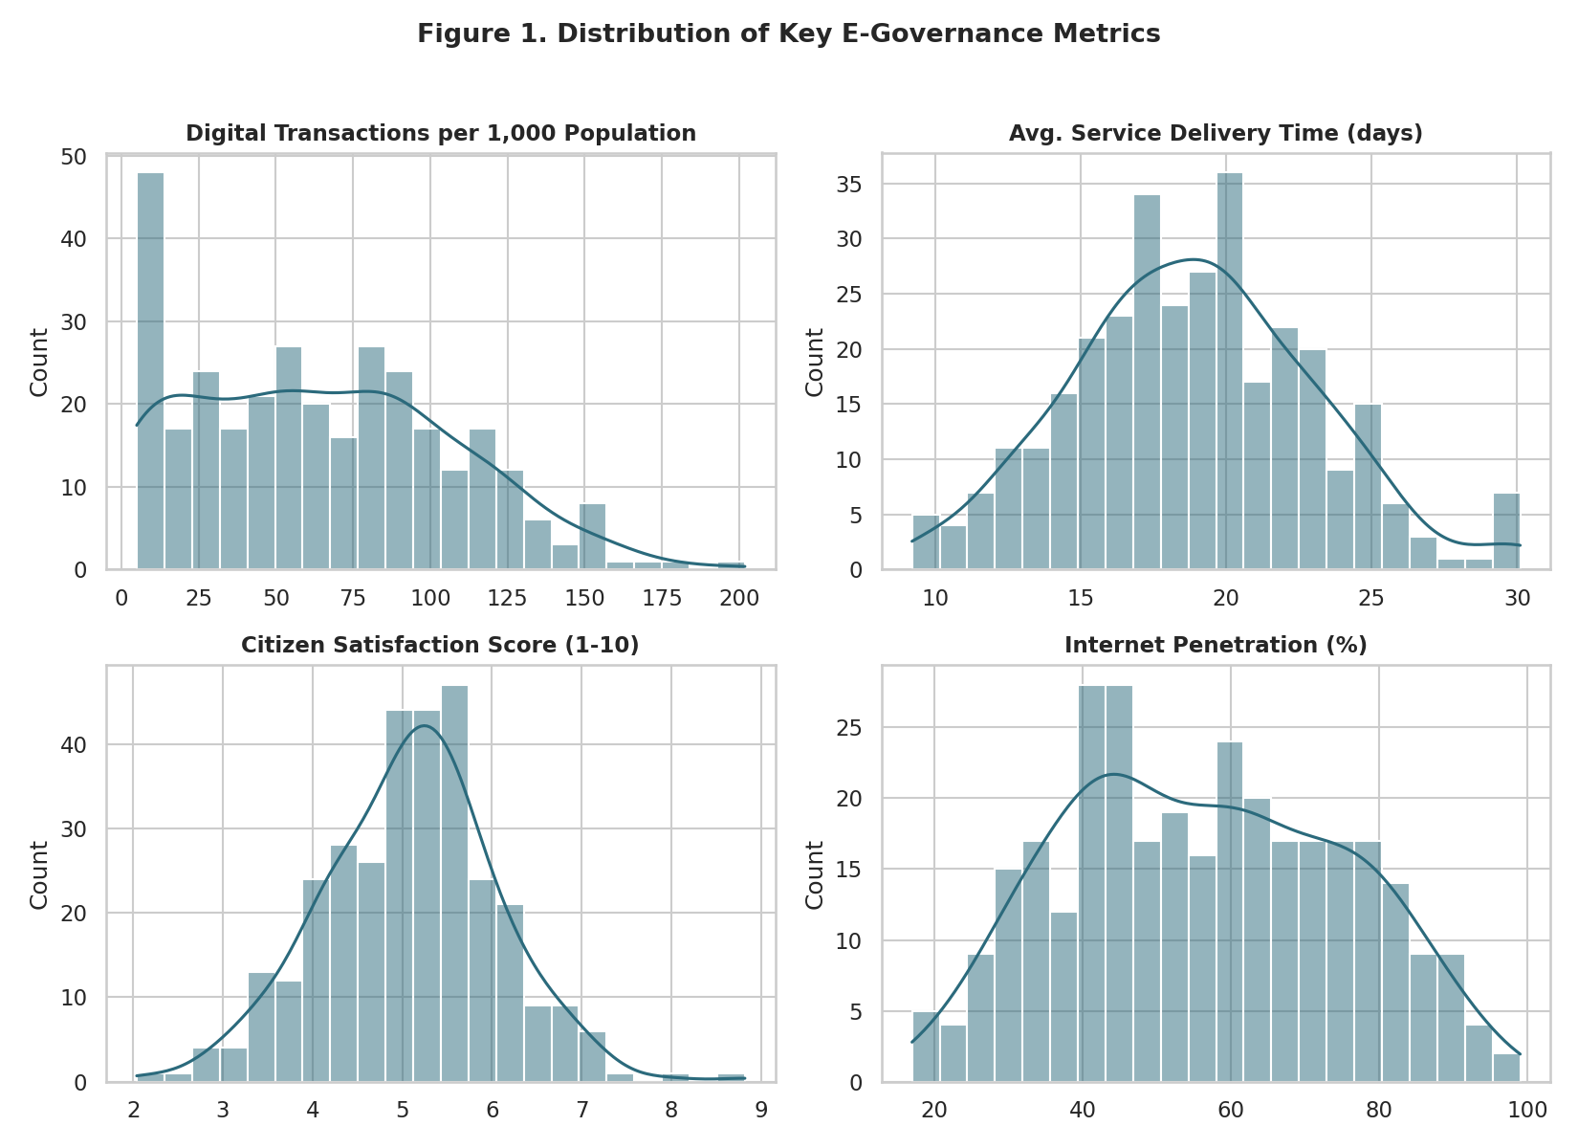
Figure 1. Distribution of digital transactions, service delivery time, citizen satisfaction, and internet penetration.
Digital transaction volume is right-skewed — most districts cluster at low-to-moderate usage while a minority of highly digitized districts pull the tail rightward, a classic "digital divide" pattern. Service delivery time and citizen satisfaction are both close to bell-shaped, confirming that most districts perform near the national average with only mild spread. Internet penetration is fairly flat/uniform across the 20-90% range rather than concentrated, meaning connectivity levels are genuinely heterogeneous across the country rather than clustered at either extreme.

4.2 Box Plots — Spread and Outliers Across Groups
Box plots were used to compare service delivery time and satisfaction across the three region types. Unlike a histogram, a box plot makes group-to-group comparison and outlier detection immediate — both essential for identifying which geography needs policy attention.
fig, axes = plt.subplots(1, 2, figsize=(11, 5))
sns.boxplot(data=df, x='region_type', y='avg_service_delivery_days',
order=['Urban', 'Semi-Urban', 'Rural'], ax=axes[0])
sns.boxplot(data=df, x='region_type', y='citizen_satisfaction_score',
order=['Urban', 'Semi-Urban', 'Rural'], ax=axes[1])
plt.tight_layout(); plt.savefig('fig2_boxplots.png', dpi=150)
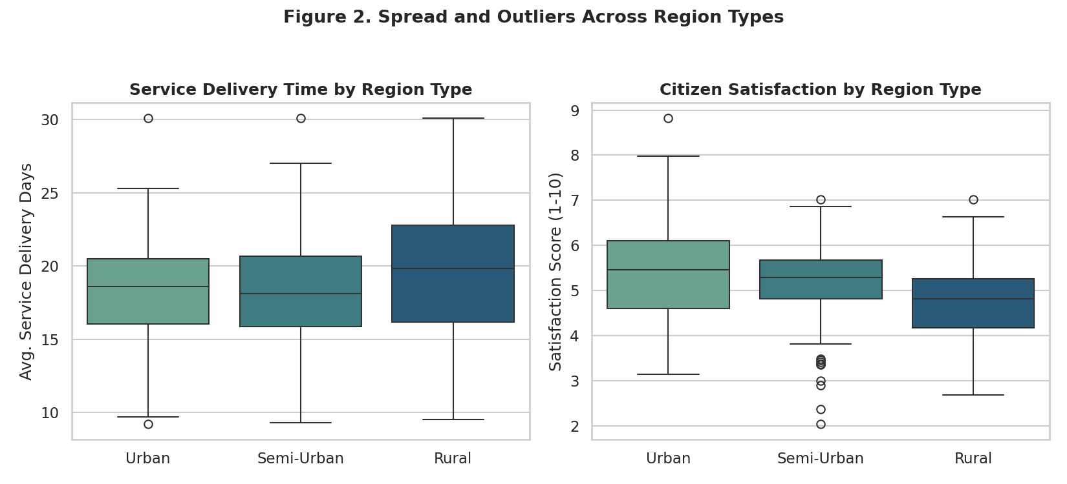
Figure 2. Service delivery time and citizen satisfaction compared across Urban, Semi-Urban, and Rural districts.
Rural districts show both a higher median service delivery time and a wider interquartile range than Urban districts — administrative delay is not only larger on average in rural areas but also less predictable. The satisfaction panel mirrors this: Urban districts cluster at higher satisfaction with fewer low outliers, while Rural districts show a longer lower tail, indicating pockets of particularly dissatisfied districts that a national-average figure would conceal.

4.3 Scatter Plots — Bivariate Relationships
Scatter plots (colored by region type) test two specific hypotheses: whether digital adoption is associated with faster service delivery, and whether grievance redressal drives citizen satisfaction.
fig, axes = plt.subplots(1, 2, figsize=(11, 5))
sns.scatterplot(data=df, x='digital_transactions_per_1000', y='avg_service_delivery_days',
hue='region_type', ax=axes[0], alpha=0.8)
sns.scatterplot(data=df, x='grievance_redressal_rate_pct', y='citizen_satisfaction_score',
hue='region_type', ax=axes[1], alpha=0.8)
plt.tight_layout(); plt.savefig('fig3_scatterplots.png', dpi=150)
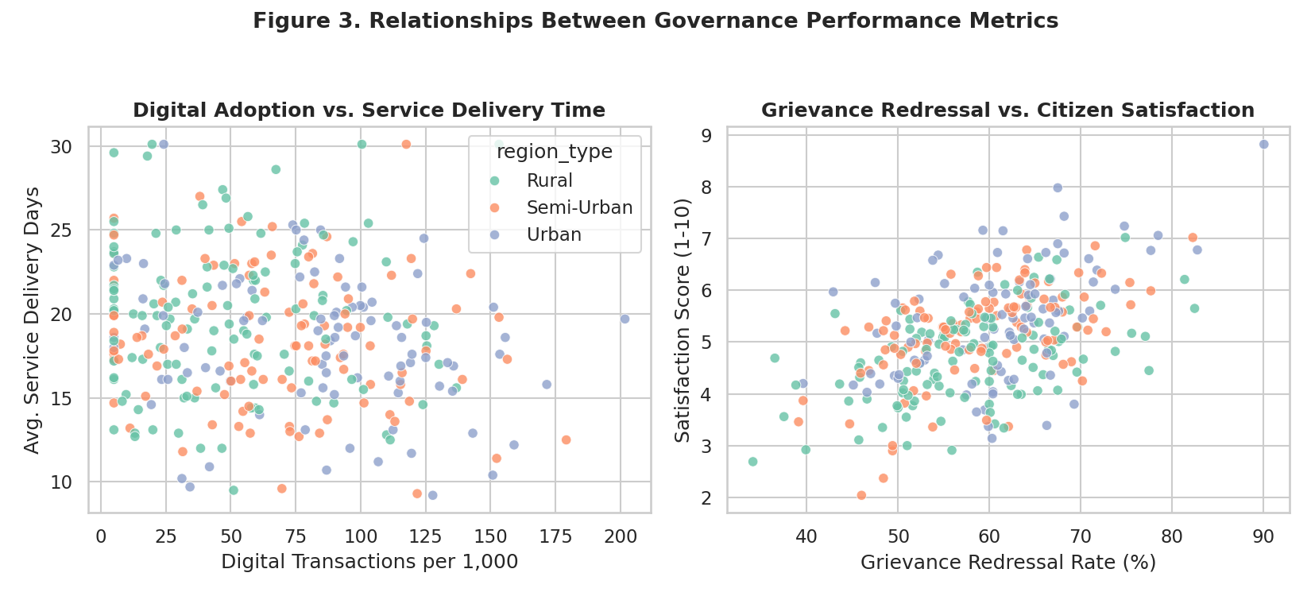
Figure 3. Digital adoption vs. service delivery time (left) and grievance redressal vs. citizen satisfaction (right).
The left panel shows a visible downward trend: districts with higher digital-transaction volumes tend to report shorter service delivery times, and this holds within each region type, not just because Urban districts happen to have both. The right panel shows an even clearer positive association — districts that resolve a larger share of grievances report materially higher satisfaction, reinforcing that responsiveness, not just service speed, is central to how citizens judge governance.

4.4 Correlation Heatmap — Whole-Dataset Relationships
A correlation heatmap was generated to view all pairwise relationships simultaneously, which is efficient for spotting which levers move which outcomes before building any predictive model.
corr = df[numeric_cols].corr()
sns.heatmap(corr, annot=True, fmt='.2f', cmap='vlag', center=0, square=True)
plt.tight_layout(); plt.savefig('fig4_heatmap.png', dpi=150)
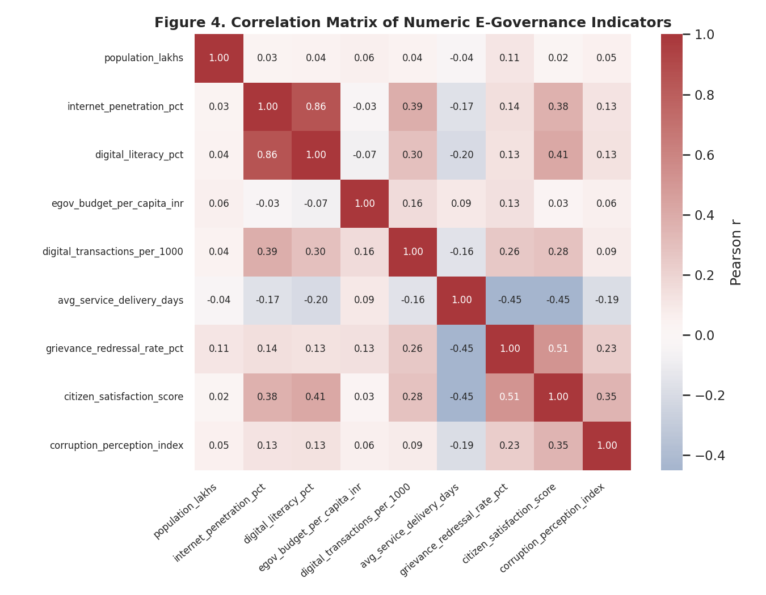
Figure 4. Correlation matrix across all nine numeric e-governance indicators.
Citizen satisfaction correlates most strongly with grievance redressal rate (r ≈ 0.51), followed by digital literacy (r ≈ 0.41) and internet penetration (r ≈ 0.38), and negatively with service delivery time (r ≈ -0.45). Internet penetration and digital literacy are themselves highly correlated (r ≈ 0.86), which is expected — connectivity and the skills to use it tend to grow together — but it also means the two should not both be treated as independent policy levers in isolation. Notably, budget per capita shows a weak correlation with every outcome variable (|r| < 0.16 throughout), an important and somewhat counter-intuitive finding explored further below.

4.5 Bar Chart — Ranked Comparison Across States
A horizontal bar chart ranks states by average citizen satisfaction, giving a direct, easily communicated comparison for a non-technical policy audience.
state_avg = df.groupby('state')['citizen_satisfaction_score'].mean().sort_values(ascending=False)
sns.barplot(x=state_avg.values, y=state_avg.index)
plt.tight_layout(); plt.savefig('fig5_state_bar.png', dpi=150)
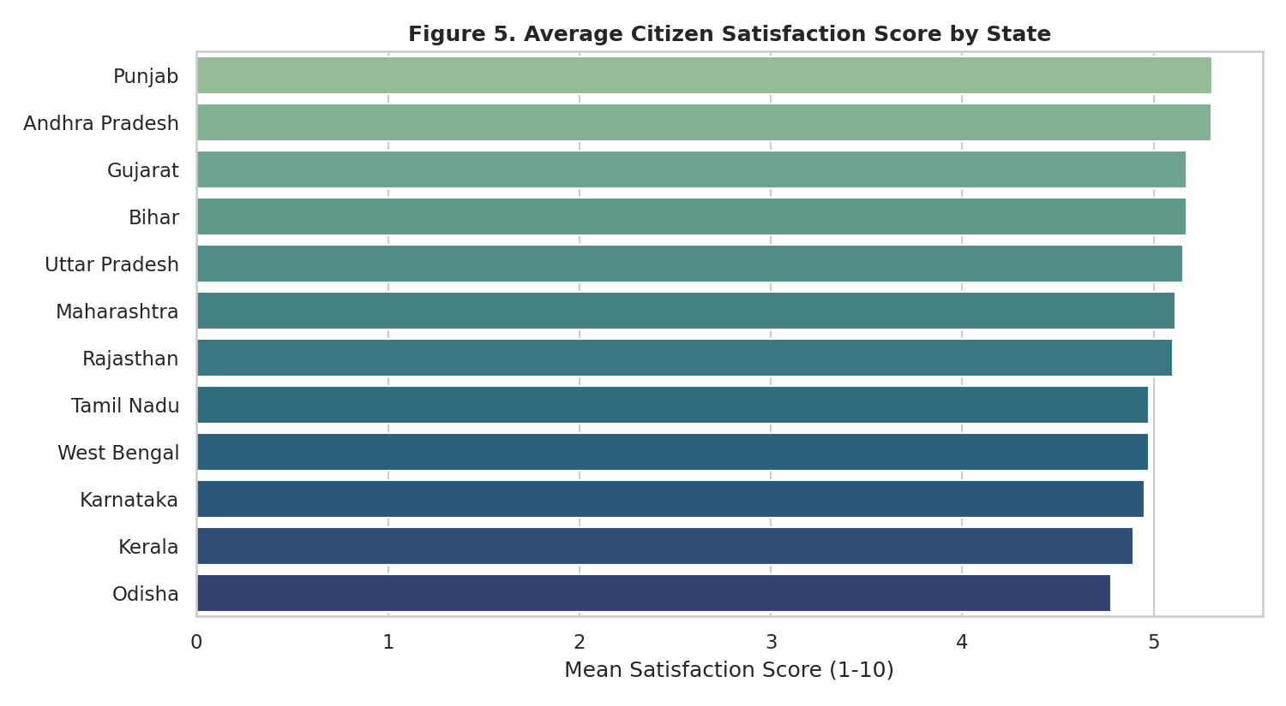
Figure 5. Average citizen satisfaction score by state, ranked highest to lowest.
The state ranking shows a meaningful spread rather than a tight cluster, confirming that state-level administrative and policy differences — not just district-level digital infrastructure — matter for citizen experience. States at the lower end of the ranking are natural candidates for a deeper root-cause review, ideally cross-referenced with their grievance redressal and service-delivery figures from Figures 2 and 3.

5. Insight Discussion and Policy Implications

5.1 Key Patterns
- Responsiveness beats raw digitization: grievance redressal rate is the single strongest correlate of citizen satisfaction — stronger than internet penetration or transaction volume. Digitizing a service matters less to citizens than whether their complaints actually get resolved.
- A persistent urban-rural gap: rural districts show longer and more variable service delivery times and a longer tail of low satisfaction scores, indicating the digital divide is not just about access but about the quality of service once accessed.
- Budget alone is not a lever: per-capita e-governance spending shows negligible correlation with every performance and satisfaction outcome measured. This suggests implementation quality, staff capacity, and process design matter more than funding levels — spending more without fixing delivery processes is unlikely to move citizen satisfaction.
- Digital literacy and connectivity move together: their high mutual correlation means initiatives that expand internet access should be paired with digital-literacy training to realize the full benefit — access alone is only half the equation.
- State-level variation is real and actionable: satisfaction differences across states are large enough to imply that administrative practices and governance culture, not just infrastructure, differentiate high- and low-performing states.

5.2 Policy Implications
- Prioritize grievance-redressal system upgrades (SLA tracking, escalation workflows, transparent status updates) as a high-leverage, comparatively low-cost intervention, given its outsized correlation with satisfaction.
- Target rural districts specifically for service-delivery-time reduction programs (e.g., mobile service camps, offline-to-online bridging) rather than applying a uniform national approach.
- Redirect e-governance budgets from broad allocation toward process-improvement and staff training in underperforming districts, informed by the weak budget-outcome correlation found here.
- Bundle connectivity expansion with digital-literacy campaigns rather than funding either in isolation, to convert access into actual usage and outcomes.
- Use the state-level ranking (Figure 5) to trigger structured peer-learning exchanges, pairing lower-ranked states with higher-ranked neighbors of similar population profile.

5.3 Limitations
This EDA is descriptive and correlational, not causal — the relationships identified (e.g., grievance redressal and satisfaction) may share confounding drivers such as overall administrative capacity. The dataset also reflects a single time snapshot; trend analysis across multiple years would be needed to confirm whether these patterns are stable or improving. These findings should be treated as hypotheses to prioritize for deeper causal or longitudinal study, not as final conclusions.

6. Conclusion
This exploratory analysis moved from raw distributions to cross-variable relationships using a deliberately varied visualization toolkit — histograms for shape, box plots for group comparison, scatter plots for bivariate relationships, a heatmap for the full correlation structure, and a bar chart for ranked state comparison. The consistent thread across all five is that citizen-facing responsiveness (grievance redressal, service delivery speed) matters more to satisfaction than raw digital infrastructure or budget alone, and that rural districts remain a clear priority area. These insights set a concrete, evidence-based agenda for the policy recommendations and, in later weeks, for predictive modeling of citizen satisfaction.

