Objection FrameWork

INTRODUCTION
Objection is runtime mobile exploration toolkit built on top of frida which is used in Android and iOS pentesting. We can use Objection to perform numerous functions like SSLPinning bypass, root detection bypass, performing memory tasks, heap tasks and more without even being root/ jailbroken. However, it is to be noted that to take full advantage of all the functions it is recommended for the device to be root. In this article, some of the functions demonstrated will require root and some may not. It is recommended to test the application on a root device. Let’s begin.

TABLE OF CONTENTs
- Settingup objection
- Attaching Agent and Help Menu
- SSLPinning Bypass
- Android Hooking
- Shell Execution
- FLAG_SECURE Bypass
- Launching Activity Using Objection
- Root Detection Bypass
- Memory Related Tasks
- Conclusion
SETTINGUP OBJECTION
Frida is a dynamic instrumentation toolkit that is used to deploy scripts into the testing process of apk. Frida provides APIs for developers to make tools on top of it. One such tool is objection. Before setting up objection, we’ll have to deploy Frida server in the android system.

python3 -m pip uninstall frida-tools -y
python3 -m pip uninstall frida -y
python3 -m pip uninstall objection -y
python3 -m pip install frida==15.0.7 --force-reinstall --no-cache-dir --force
python3 -m pip install objection==1.11.0 --force-reinstall --no-cache-dir --no-deps
python3 -m pip install --no-cache-dir frida-tools==10.2.1 --force-reinstall

Get frida-server from here:
frida-server-15.0.7-android-arm.xz
frida-server-15.0.7-android-arm64.xz
frida-server-15.0.7-android-x86.xz
frida-server-15.0.7-android-x86_64.xz

unxz frida-server.xz
Now, let’s get it running on your device:
$ adb root # might be required
$ adb push frida-server /data/local/tmp/
$ adb shell "chmod 755 /data/local/tmp/frida-server"
$ adb shell "/data/local/tmp/frida-server &
And now we are good to go. Now, the packages (apps) installed in an android device are referred to as gadget in objection and to interact with an application to test, we’ll have to inject our objection agent in the app. To do so:
objection –gadget jakhar.aseem.diva explore
ping
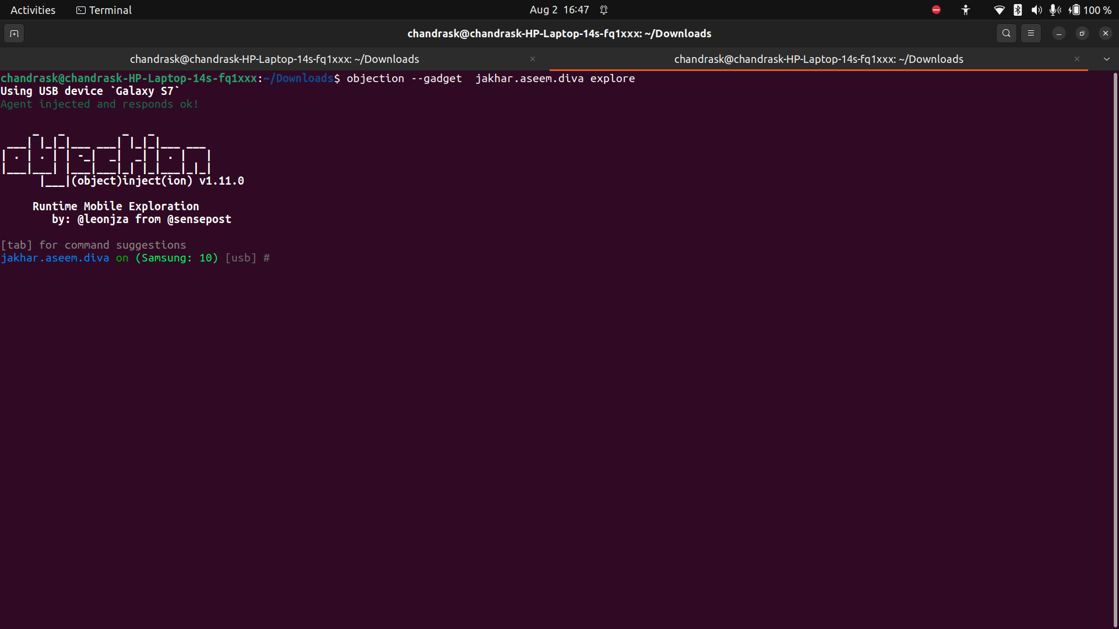
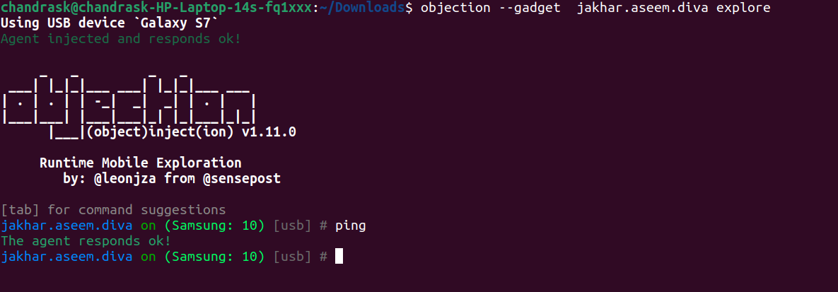
Help Menu

To open the help menu in objection:
objection –help
FLAG_SECURE Bypass
Often times android developers set a check-in their code known as “FLAG_SECURE” that prevents users to watch contents of an application while it is minimized. This is a critical function as a lot of apps don’t allow users to view materials while the app is minimized. Switching this flag would toggle that security. Objection has the ability to toggle this flag in run time. First, let’s set the flag to true and see what happens:
android ui FLAG_SECURE
android ui FLAG_SECURE true

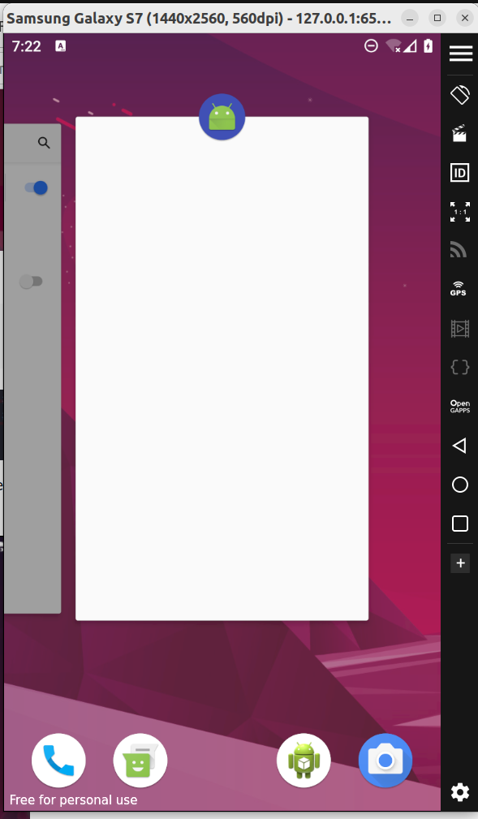

Now let’s turn the flag off
android ui FLAG_SECURE false
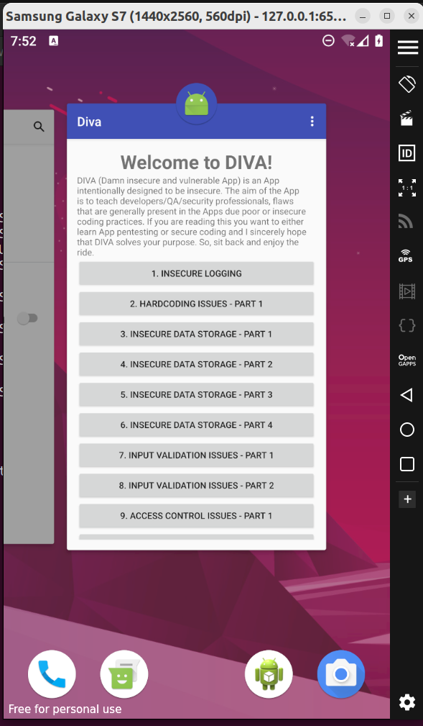

Launching Activity using Objection

Objection can also be used to launch an activity from within its interface. This is the same as gdb’s am tool with -n option as we saw in the previous article. To start an activity, we type:
android intent launch_activity
android intent launch_activity jakhar.aseem.diva.APICredsActivity
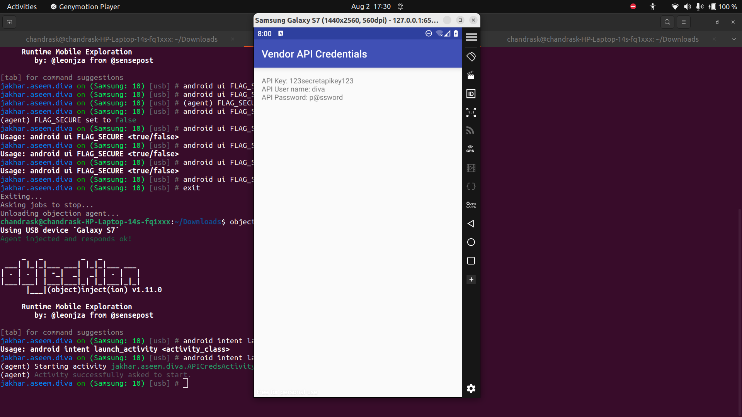
Root Detection Bypass

Root detection is a feature that developers code in their application to restrict their apps from running on rooted devices for security purposes. There are again two methods to bypass root detection, one is through reverse-engineering the application and the other is to use a tool like objection.
To do this in objection, I’ll be using the following commands:
android root disable
To simulate root detection again:
android root simulate

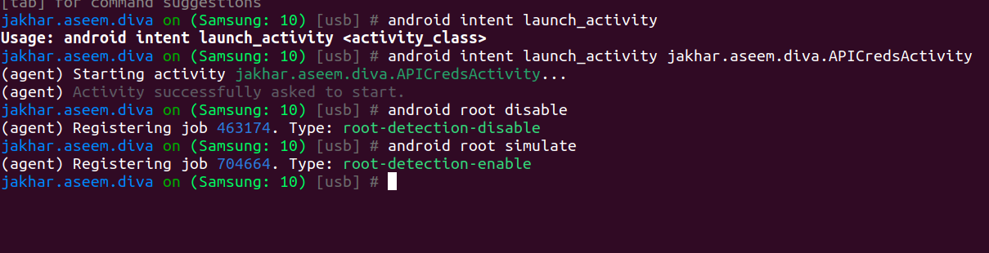
Memory Related Tasks

To play with low-level memory, objection has a handy tool called memory module that allows a person to see what a process is exporting to memory, where it is writing and more!
Here, let’s see what all modules are loaded into the memory while the gadget is attached
memory list modules
memory list exports Frida-agent-32.so

