echo "# IntelliJ23_FrameworkWebAutomation" >> README.md

git init

git add README.md

git commit -m "first commit"

git branch -M main

git remote add origin https://github.com/chandrasureshbabu/IntelliJ23_FrameworkWebAutomation.git

git push -u origin main

**…or push an existing repository from the command line**

git remote add origin https://github.com/chandrasureshbabu/IntelliJ23_FrameworkWebAutomation.git

git branch -M main

git push -u origin main

### …or push an existing repository from the command line

git remote add origin https://github.com/chandrasureshbabu/IntelliJ23_FrameworkWebAutomation.git

git branch -M main

git push -u origin main

To Ignore the unwanted folders and .extension file names are below(for that .gitignore file in respective path and mention the details and save it)

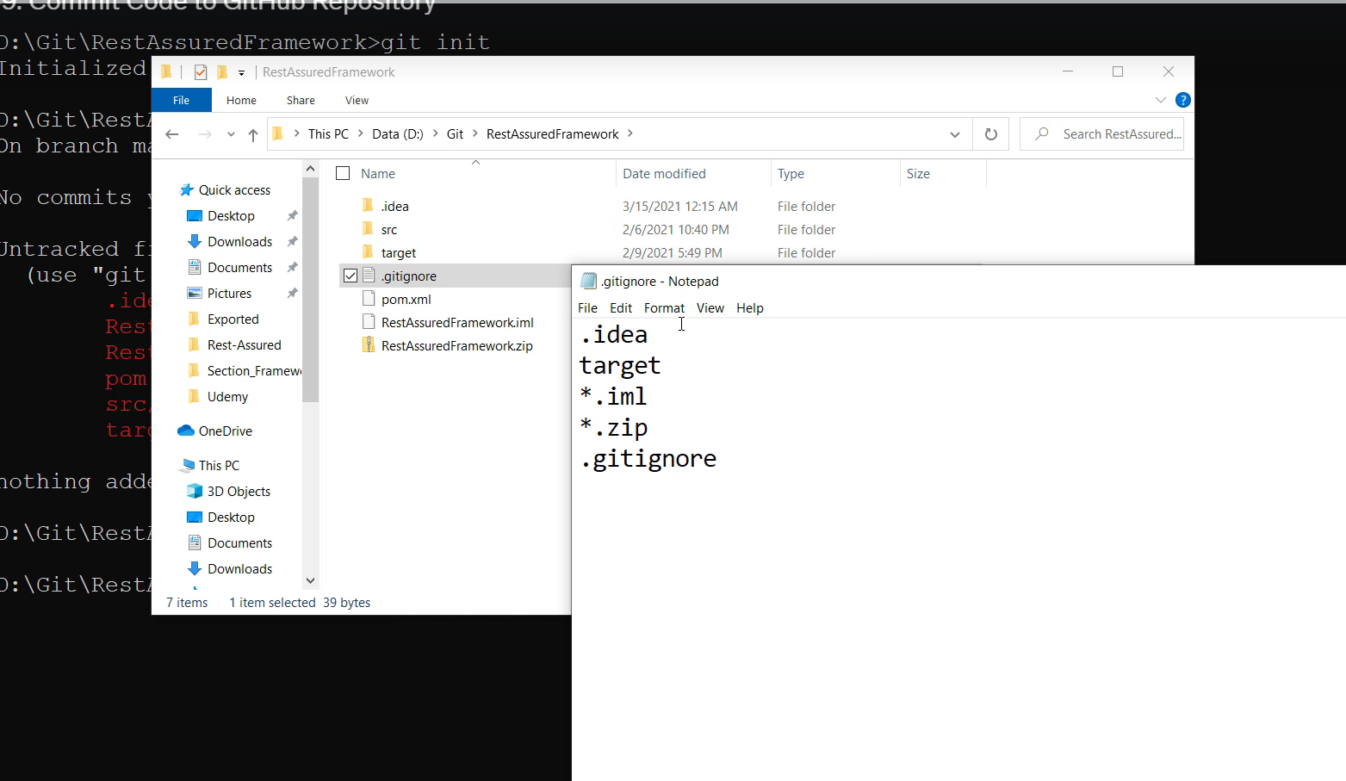

git init

git add --all

git status

git remote add origin <https://github.com/chandrasureshbabu/IntelliJ23_FrameworkWebAutomation.git>

git remote -v

git commit -m “Init Commit”

git push -u origin master (-u for the firsttime)

After any Changes

git status

This will show what are changes untracked files(changed / added files in the project)

Git add –all

git commit -m "cnge brwsr"

if accessing different system u need to do before push

git remote add origin <git remote path>

changes to remote

git push origin master

if accessing different system u need to do before push

git remote add origin <git remote path>

**git branches**

**new Branch creation**

git checkout -b devbranch1

**To know which branch you are on is.**

git branch

**To add all changes to current branch and push repo**

git add*

git commit -m “Message”.

**Push to Specific branch**

git push origin devbranch1

**To pull code from git repo**

Git pull origindevbranch1.

**If your current branch is pointing to master, want to switch to devbranch1.**

Git checkout devbranch1.

**If you want to delete branch**

Git branch -d branchname

**Merge**

**Switch to master branch**

Git checkout master

**Then merge your current branch (Master) with another branch.**

Git merge devbranch1

**Pull updated to master branch.**

Git pull origin master.