A Project Report on:

**“Smart Prepaid Energy Meter with GSM and Theft Detection”**

Submitted by:

**N Janavi (181EC127)**

**Chandravaran K (181EC156)**

**Shashank Holla (18EC243)**

**Shruti Masand(181EC245)**

IV SEM BTECH (ECE)

*Under the guidance of*

**Dr. Sandeep Kumar**

**Department of ECE, NITK Surathkal**

*in partial fulfilment for the award of the degree*

of

**Bachelor of Technology**

in

**Electronics and Communications**

At



**Department of in Electronics and Communications National Institute of Technology Karnataka, Surathkal**

***June 2020***

|  |  |  |
| --- | --- | --- |
|  |  |  |
|  |  |  |
|  |  |  |
|  |  |  |
|  |  |  |
|  |  |  |
|  |  |  |
|  |  |  |

INDEX

Introduction

A large portion of meter reading for electricity consumption is done by human operators who move from building to building to collect data for generating the bill. Disconnection of power supply in the case of consumers who do not pay their bills also requires the human operator to visit the premises. This requires a large number of operators and long working hours to cover the required area of interest. This system of meter reading for billing is highly susceptible to human errors and is time consuming. The operation can be restricted or slowed down by bad weather conditions. This billing system is inaccurate, inefficient and increases the energy provider operation cost for meter reading. Recently, the prepaid electronic energy meter was introduced which partially solved the problem of the need to visit the site in order to take meter readings. However, some problems still exist as the prepaid card can be easily damaged or lost, the inability to provide real-time monitoring and the inability to avoid theft are also disadvantages.

As the number of electricity consumers as well as the commercial activities in the electrical industry increases to a great extent coupled with the fast paced advancement in wireless communication technology and microelectronics, it became increasingly important to develop automatic electric energy meters to replace the traditional manual energy meters in order to achieve efficient meter reading, reduce billing error and operational cost. The Automatic meter reading is an effective means for data collection that ensures greater data accuracy, allows frequent reading, improved billing and customer service, timely energy profiles and consumption

trend updates and better use of human resources. Several solutions based on various technologies such as Wi-Fi, Bluetooth, internet, embedded Radio frequency module and power line communication have been suggested and developed to provide the efficiency, reliability and effectiveness of Smart Energy Meter system. However, these methods either require a complex setup of infrastructure, are too expensive to implement and operate, or have short operating distance and still require field intervention of human operators [2][3]. The GSM based Automatic Energy Meter described in this project takes advantage of the available nationwide coverage of the GSM infrastructure in the country and the Short Message Service (SMS) feature to achieve the purpose of an efficient, reliable and effective meter reading system

Problem Statement

 Even though the digital meters having some advantages, but always there are chances of innovation or modification in different instruments for ease of consumer and supplier. Following some problems are observed in those energy meters which should be rectified:

1. Meter reading and other related tasks like bill payment are performed by a large number of staff i.e., large number of employees are required.
2. An expansive number of staff is utilized for meter reading and other related assignments like bill payment.
3. Billing errors due to the carelessness of meter readers during meter reading and sometimes billing estimation.
4. Careless usage of electricity by the consumer who is unaware of its cost.

Objective

1. To make consumers to keep the track of energy usage
2. To design a power supply circuit for current and voltage measurement/sensing

Circuit

1. To design and implement GSM based power theft control system to notify the power theft for electricity utility power supplier via SMS message.
2. To check, verify and simulate the system in proteus software
3. To reduce man power required
4. To save wastage of time

WORK

Before the outbreak of the current pandemic, we decided to stick to hardware for our project. But due to the lockdown and unavailability of resources we have taken to simulations for the completion of our project. Our work has been designed and simulated on Proteus 8 software.

The hardware of Prepaid Energy Meter includes several modules such as current sensor, voltage sensor, zero crossing detector, microcontroller, Liquid Crystal Display (LCD), buzzer, and a GSM modem. These modules are integrated as a system block diagram as shown in fig1.1

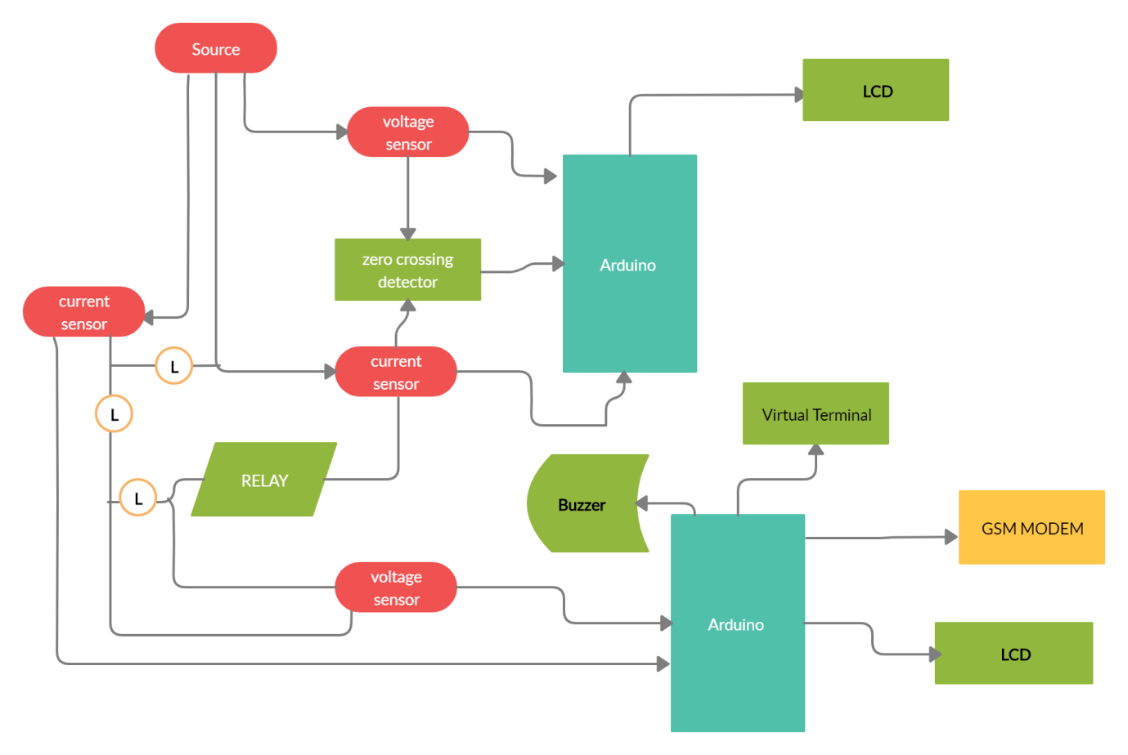

**Fig1.1**

Design of each of these modules is done on proteus 8 software. This software widely used to simulate a system related to the electricity.

1. Design of current sensor

Current sensor was used to measure how much electric current flows on the grid in the household. This project uses current sensor that is widely available in the market namely the type ACS71(Hall effect current sensor). Fig1.2 shows the design of current sensor.

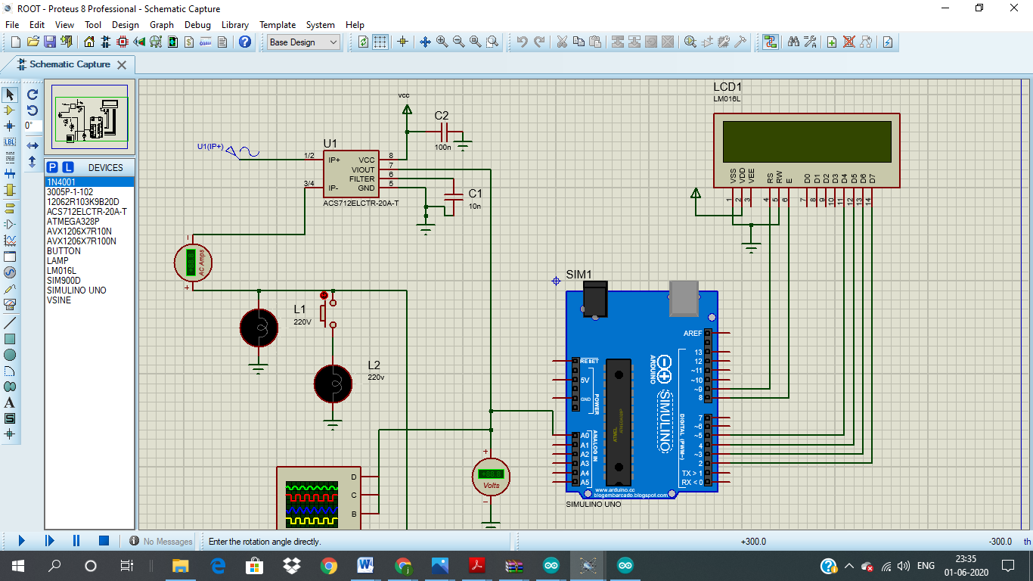

**Fig1.2**

B. Design of Voltage sensor

For the measurement of voltage the following voltage sensor with a voltage regulator is designed as shown in fig1.3. The voltage is calculated by the software and displayed on LCD.

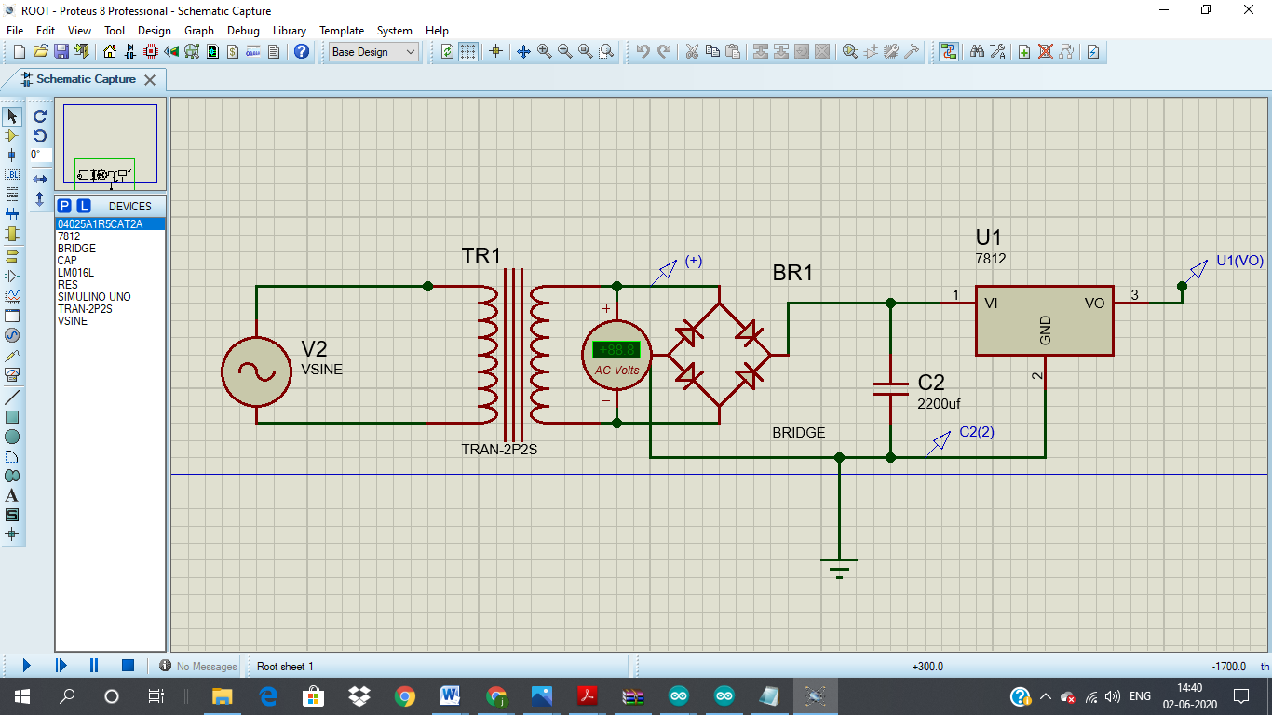

**Fig1.3**

C. Design of Zero crossing detector circuit

Zero Crossing Detector is a technique to detect the power factor. Power factor that is obtained from the phase angle difference between current and voltage. This is given out by the output of Logic gate which is then given as input to Arduino.

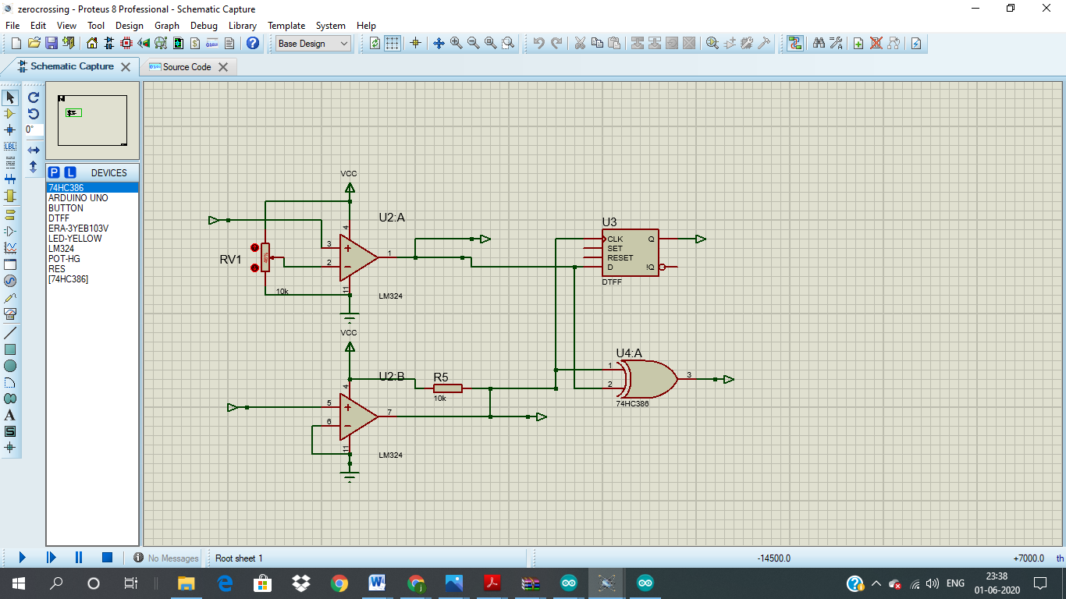

**Fig1.4**

D. Design of Relay (circuit-breaker)

Based on the calculation results by power prepaid meter, if it is deemed to exceed the specified load, and also in the case of theft detection, the system will disconnect the electrical current. In order to disconnect automatically, it is necessary to install the circuit breaker (relay) module. The transistor Q1 acts as a switch here and breaks the circuit when

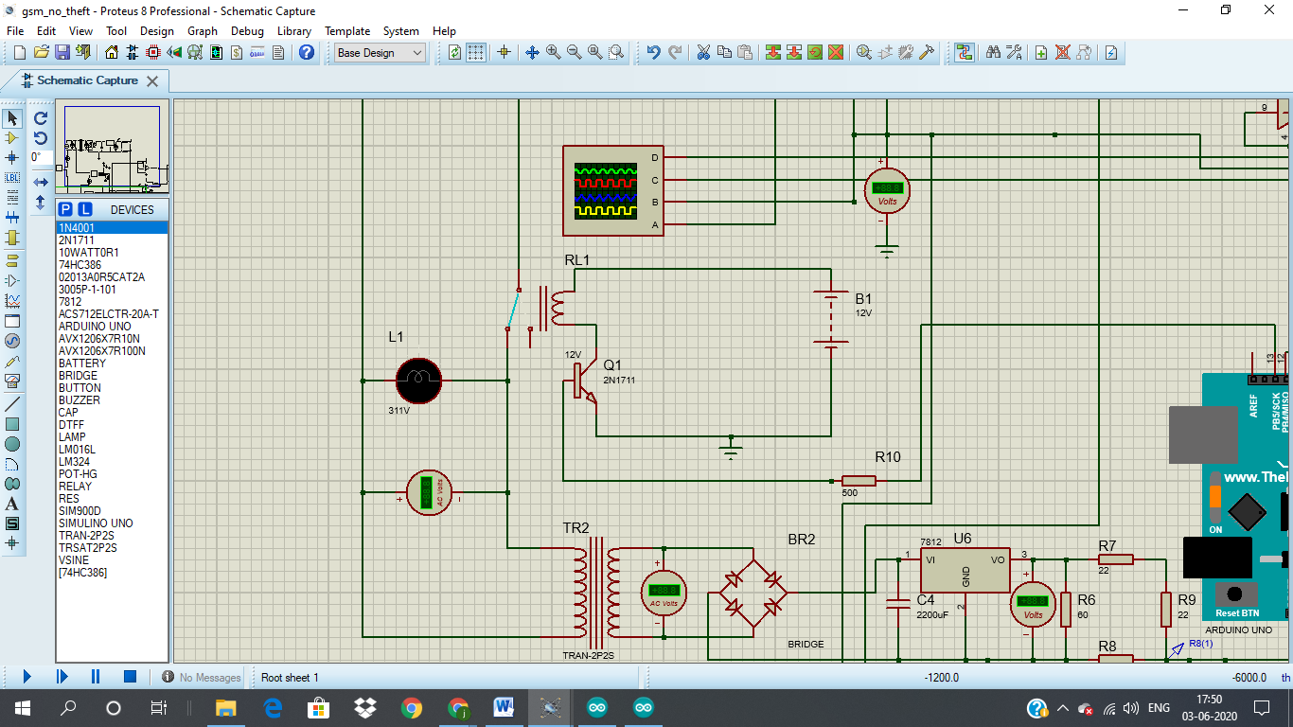

**Fig1.5**

E. Design of LCD

The important information such as voltage and current need to be displayed, it will appear on the display screen. LCD (Liquid Crystal Display) size 20x4 is used to display the information.

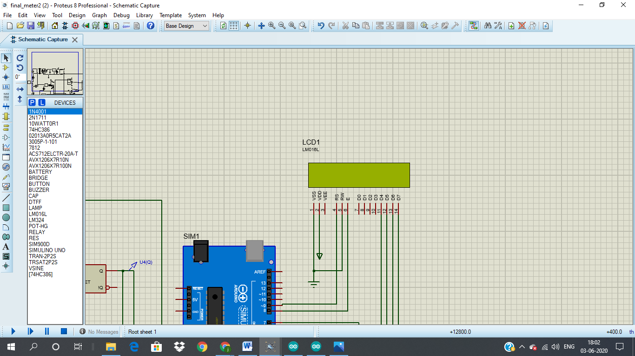

**Fig1.6**

F. Microcontroller (Arduino uno)

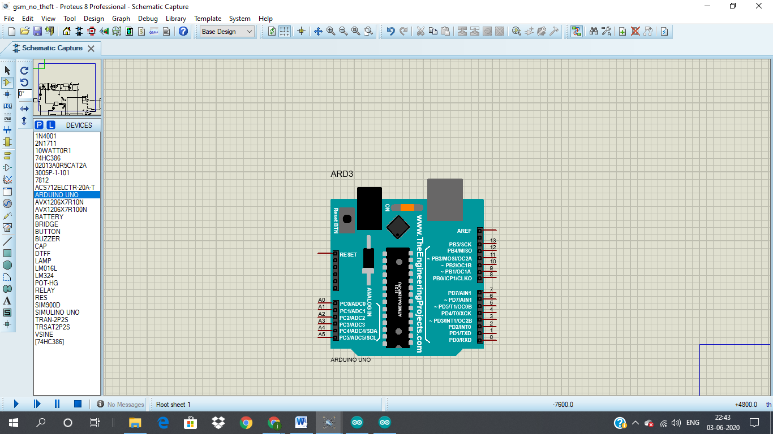

**Fig1.7**

The main component of this project is Arduino Uno. It takes more power consumption for the operation due to the more and sensitive devices connected to it. As per the circuit, the Arduino board takes the connection of current and voltage measurement pins through the current sensor (ACS712) and voltage sensor circuit and gives measured values through code and displays it on LCD

G. Design of buzzer

The circuit shown in figure 13 is designed to control the buzzer. The buzzer ON and OFF is controlled by the pair of switching transistors (BC 547). The buzzer is connected to the Q2 transistor collector terminal.

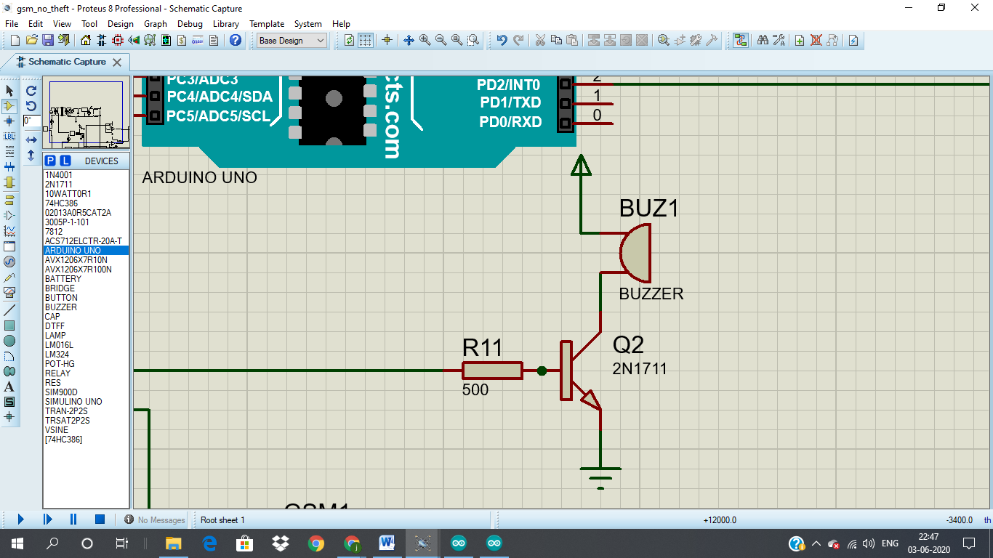

**Fig1.8**

GSM modem used

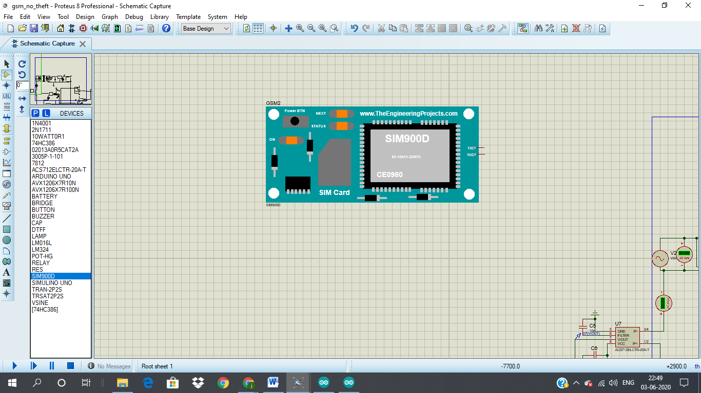

**Fig1.9**

Explanation of project

We have simulated the project in PROTEUS 8.7. The simulated view of the project is shown. Two arduino boards are used. One is to find the current, voltage and power readings of the circuit, the other one is interfaced with GSM module for recharge, balance deduction and units consumption. We have also used 'Virtual Terminal' of proteus to see the data exchanging between the GSM modem and Arduino. The virtual terminal shows everything that occurring or exchanging in the GSM modem and Arduino. We have to set all BAUD rate of virtual terminal to 9600 kbps because of the GSM modem will communicate at this BAUD rate. Otherwise garbage value will show in the virtual terminal. Before RUN the software, the '.hex' file of the associated project i.e. the program should give to the Arduino otherwise it will show error. We have connected buzzer and relay for detection(alert system). We used bulb as load. The program is written in Arduino IDE software will generate a hex code when verified. This hex code should load to the Arduino before compiling.

Our proposed project has designed for energy consumption as well as a billing system based on load and time using Arduino – GSM technology with the current sensor and DC voltage circuit. There is no rotating part in the energy meter system. The Microcontroller (ATmega328) based system continuously records the readings and the live meter reading can be sent to the user after the authenticated card. A GSM modem with a SIM card is required for each energy meter to send the meter reading to a user via SMS. The SMS has extended its service to content providers to deliver a wide variety of services to mobile phone users. The cost savings may be from better utilization of manpower, no data tampering and time saving both for the customers as well as for the energy providers.

Simulations/Results

First we simulated the current and voltage sensors to check their effective performance and accuracy.

**Current sensor silumation:-**

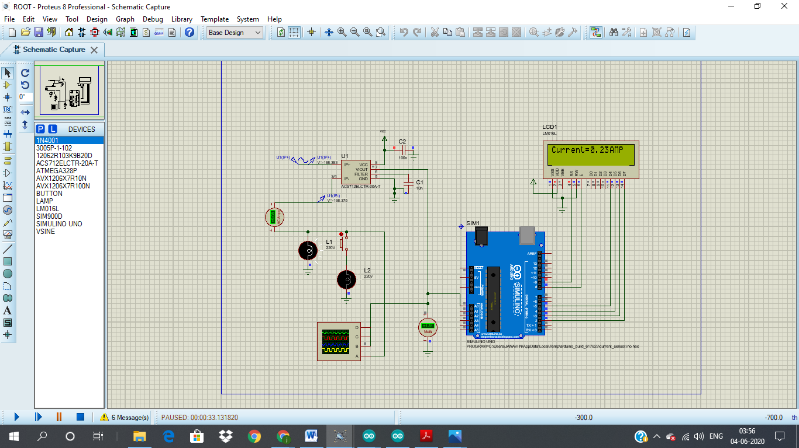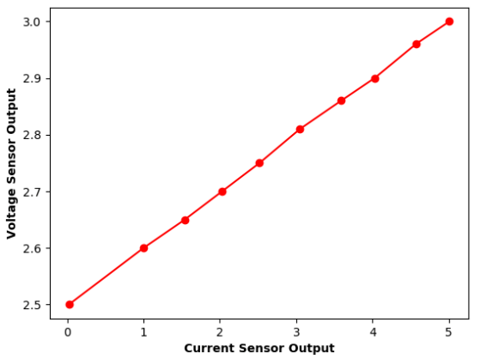

**Fig1.10 Fig1.11**

The current sensor uses hall effect to determine the current that is passing threw it.

**Voltage sensor simulation:-**

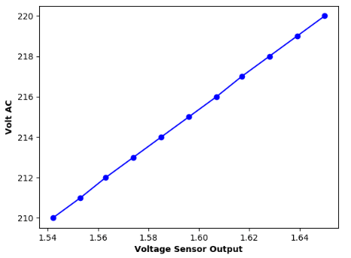

Fig1.12 Fig1.13

From the above circuit you can see that the voltage sensor is made up of a stepdown transformer a full wave rectifier followed by filter and voltage regulator, after which we have a set of resistors so that the final mapping voltage can be within the range of 0-5V so that this can be input into the Arduino uno.

To determine the accuracy and also the scaling factor required we plotted the input AC voltage against the output of the voltage sensor, in this case is showing 2.77 and the scaling factor we got is 90.9.

# Simulation of the entire circuitry: -

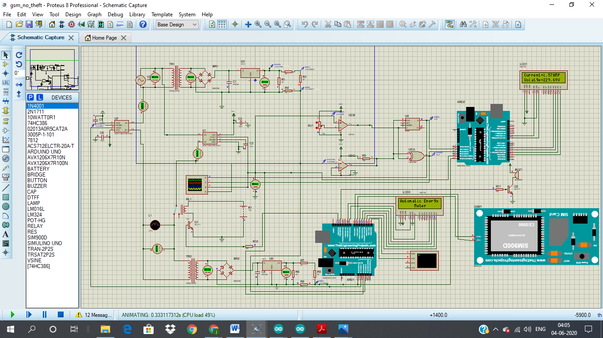

**Fig1.14**

**Fig1.15**

For the final simulation there are 2 circuits that we need to look at, one where no theft occurs and one where theft occurs, let us look at the no theft occurring circuit.

In fig 1.14 there are 2 voltage sensors one at the top and one at the bottom, the one at the top is near the electric pole the bottom one is for the house meter, and there are 2 current sensors which are also placed in the similar locations as that of voltage sensor.

Explanation of result….

Future Scope

The present project can be further extended to measuring the load power factor. This reading can be interfaced to the web page for easy understanding.

Conclusion

Various electronic meters have been developed and are still being developed. However the use of GSM in this particular system provides numerous advantages over methods that have been previously used. The developed system is highly effective in the sense it is able to eliminate the draw backs of serial communication. The system also poses much less risk since human interaction has been minimized. This type of reading system is easy to install and beneficial for both energy provider and consumer. This system provide additional features such as power disconnect due to large outstanding dues, power reconnect, power cut alert, low voltage and power factor lagging alert. Any modification can be made to the code in less time. The changes in tariff or unit calculation can be done very effectively.

References

*Journals:*

[1] J. R. C. Orillaza, L. B. Orillaza and J. Arnulfo L. Barra, "Consumer Acceptance of Prepaid Metering and Consumer Preferences," in IEEE PES Asia-Pacific Power and Energy Engineering Conference (APPEEC), 2014.

[2] Aswatht D. R., C. Shabthi , “An Automated Energy Metering System Home Based Approach” International journal of Advance Research in Electrical, Electronics and Instruments Engineering-2017

[3] K. Ramadan, E. Zakaria and D. M. Eltigani, "Prepaid Energy Meters Network via Power System Communication," in International Conference on Computing, Electrical and Electronic Engineering, 2013.

[4] M. M. Haque, M. K. Hossain, M. M. Ali and M. R. I. Sheikh, "Microcontroller Based Single Phase Digital Prepaid Energy Meter for Improved Metering and Billing System," International Journal of Power Electronics and Drive System, vol. 1, no. 2, p. 139–147, 2011.

[5] H. Hindersah, A. Purwadi, F. Y. Ali and N. Heryana, "Prototype Development of Single Phase Prepaid kWh Meter," in International Conference on Electrical Engineering and Informatics, Bandung, Indonesia, 2011.

*Web Sources:*

[www.researchgate.com](http://www.researchgate.com)

[www.microcontrollerlabs.com](http://www.microcontrollerlabs.com)

[www.circuitdigest.com](http://www.circuitdigest.com)