**Date :-27/06/2025**

**Tram id :-** LTVIP2025TMID32325

**Project name:- Traffictelligence : Advanced traffic volume estimation with machine learning**

**Traffictelligence: Advanced traffic volume estimation with machine learning**

**Project overview:-**

This project uses machine learning to estimate traffic volume based on weather and time-based features. The model is trained using synthetic data generated for January 6, 2025. Random Forest is used for regression to predict trafficvolume.

**Problem statement:-**

Traditional traffic counting is manual,time-consuming,and error prone.this project aims to automatic and improve accuracy in traffic volume Prediction using machine learning models based on multiple environmental and time-related features.

**Technical architecture :-**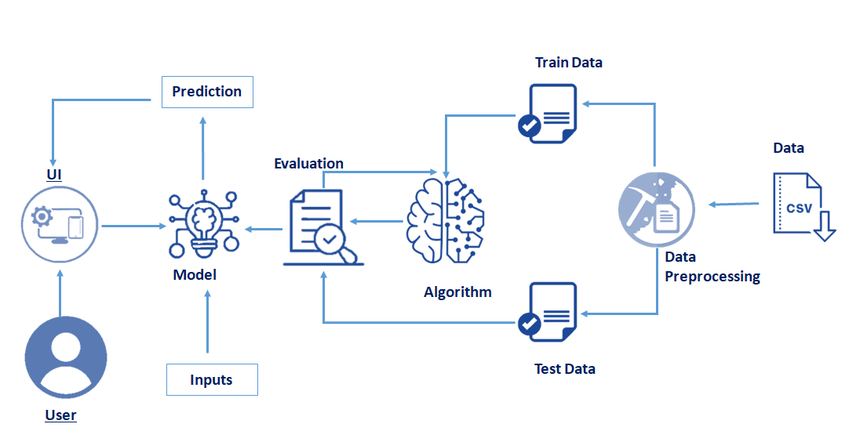

**Dataset Features:**

**-** datetime (hourly)

- temperature (°C)

- rain (mm)

- snowfall (cm)

- clouds (percent)

- visibility (meters)

- traffic_volume (target variable),Etracted: hour and day

**Machine Learning Model:**

Random Forest Regressor was trained on the dataset. The model was evaluated using Mean Absolute Error (MAE) and R2 score metrics. This is suitable for capturing nonlinear relationships and handling multiple weather-related features.

**Output actual vs Predicted :-**

📊 Model Evaluation:

Mean Absolute Error (MAE): 492.92

R² Score: -0.77

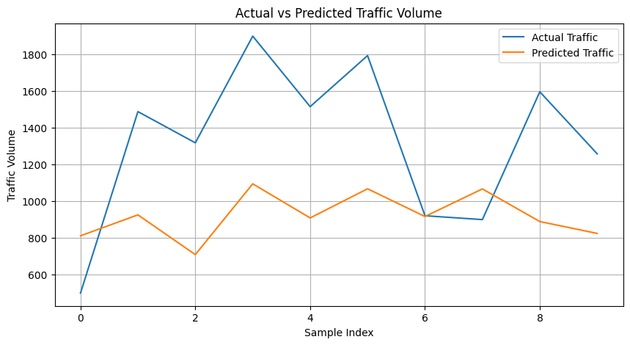

**Results:-**

**📊 Model Evaluation:**

**Mean Absolute Error (MAE): 492.92**

**R² Score: -0.77**