1. Mandatory Fields Implementation (SIS Application)
Summary:
Worked on enhancing data validation by converting optional fields into mandatory based on business requirements. Implemented both frontend and backend validations, ensuring users cannot submit incomplete data. This improved data quality and reduced inconsistencies in the system.

✅ 2. Root Cause Analysis (RCA) – Data Issue
Summary:
Investigated a production issue by analyzing logs, database records, and application flow. Identified the root cause as incorrect data mapping/handling and fixed the issue by updating the logic. Ensured proper validation and tested multiple scenarios to avoid regression.

✅ 3. Database Integration & Data Handling (ADO.NET)
Summary:
Worked on integrating application logic with SQL Server using ADO.NET. Developed and executed SQL queries, handled data retrieval and updates, and ensured efficient database connectivity. Improved reliability and performance of data operations.

✅ 4. Query Optimization & Bug Fixing
Summary:
Analyzed existing queries and resolved performance issues. Optimized joins and conditions, fixed null handling issues, and ensured accurate data retrieval. This improved application performance and reduced data-related bugs.

✅ 5. Blazor UI Enhancement – Adhoc Document Generator
Summary:
Contributed to UI development using Blazor components for dynamic document generation. Handled user inputs, validations, and improved UI responsiveness. Helped enhance user experience and streamline document creation.

✅ 6. Dynamic Document Generation Logic
Summary:
Worked on backend logic to generate documents dynamically based on user inputs. Integrated UI with backend services and resolved rendering/formatting issues, enabling efficient document generation.

🔷 UFG Project – Story Cards (MuleSoft → .NET 8)
✅ 7. API Migration from MuleSoft to .NET 8
Summary:
Participated in migrating MuleSoft APIs to ASP.NET Web APIs. Recreated endpoints while maintaining the same request/response structure, improving performance and reducing dependency on MuleSoft.

✅ 8. Request/Response Data Transformation
Summary:
Handled transformation of incoming and outgoing data between systems. Implemented proper field mapping and ensured data consistency across APIs, enabling smooth integration.

✅ 9. API Development & Integration
Summary:
Developed REST APIs using .NET 8 to support integration workflows. Ensured proper routing, validation, and response handling aligned with business requirements.

✅ 10. API Testing & Debugging (Postman)
Summary:
Tested APIs using Postman by validating request/response, status codes, and edge cases. Identified and fixed issues, ensuring APIs were stable and production-ready.

✅ 11. Performance Monitoring & Issue Fixing
Summary:
Assisted in identifying performance bottlenecks and resolving issues during migration. Contributed to improving API response time and system stability.
UFG Tasks:
status endpoint:
1️⃣ Purpose of the Endpoint
- The endpoint /sapi/asknicely/v2/status is designed as a health check.
- Its main function is to verify that the connection to AskNicely’s API is working properly.
- If the connection succeeds, it returns a "pass" status along with some system information.
- If it fails, it returns an error or "fail" status.

2️⃣ How the Connection is Made
From your StatusProvider code and discussions:
- The call to AskNicely happens internally from your service code (StatusProvider) to the AskNicely API.
- Based on your notes, it’s using HTTPS, not SOAP. So it’s a REST API call over HTTPS.
- Typical flow:
  - StatusProvider creates a request with test parameters.
  - It calls the AskNicely endpoint via HTTP client (GET or POST depending on implementation).
  - Processes the response and returns "pass" or "fail" to your internal /status endpoint.
✅ So yes — this is an internal HTTP REST call, not a SOAP call.

3️⃣ Your StatusProvider File
- You don’t need to change AskNicelyController.
- The logic for establishing the connection and returning the health check result lives in StatusProvider.
- Controller just calls this provider and returns the response to the client.

4️⃣ Key Notes
- If the API call inside StatusProvider fails, your /status endpoint will also show a fail.
- You may want to log errors to troubleshoot API connectivity issues.
- You could include latency or timeout metrics if needed for monitoring
1️⃣ Purpose of the Endpoint
- The endpoint /sapi/asknicely/v2/status is designed as a health check.
- Its main function is to verify that the connection to AskNicely’s API is working properly.
- If the connection succeeds, it returns a "pass" status along with some system information.
- If it fails, it returns an error or "fail" status.

2️⃣ How the Connection is Made
From your StatusProvider code and discussions:
- The call to AskNicely happens internally from your service code (StatusProvider) to the AskNicely API.
- Based on your notes, it’s using HTTPS, not SOAP. So it’s a REST API call over HTTPS.
- Typical flow:
  - StatusProvider creates a request with test parameters.
  - It calls the AskNicely endpoint via HTTP client (GET or POST depending on implementation).
  - Processes the response and returns "pass" or "fail" to your internal /status endpoint.
✅ So yes — this is an internal HTTP REST call, not a SOAP call.

3️⃣ Your StatusProvider File
- You don’t need to change AskNicelyController.
- The logic for establishing the connection and returning the health check result lives in StatusProvider.
- Controller just calls this provider and returns the response to the client.

4️⃣ Key Notes
- If the API call inside StatusProvider fails, your /status endpoint will also show a fail.
- You may want to log errors to troubleshoot API connectivity issues.
- You could include latency or timeout metrics if needed for monitoring
Logic inside StatusProvider:
Checks if the config is valid.
- Makes an HTTPS GET request to AskNicely API /contacts?limit=1 with Bearer token.
- Returns StatusResponse with system status and details.
Testcases:
• Mock ApiConfigWrapper → controls configuration for testing.
• Mock HttpClient → simulate API success or failure.
• Test all scenarios → pass, fail due to missing config, fail due to API error.
• No real API call → safe for CI/CD.
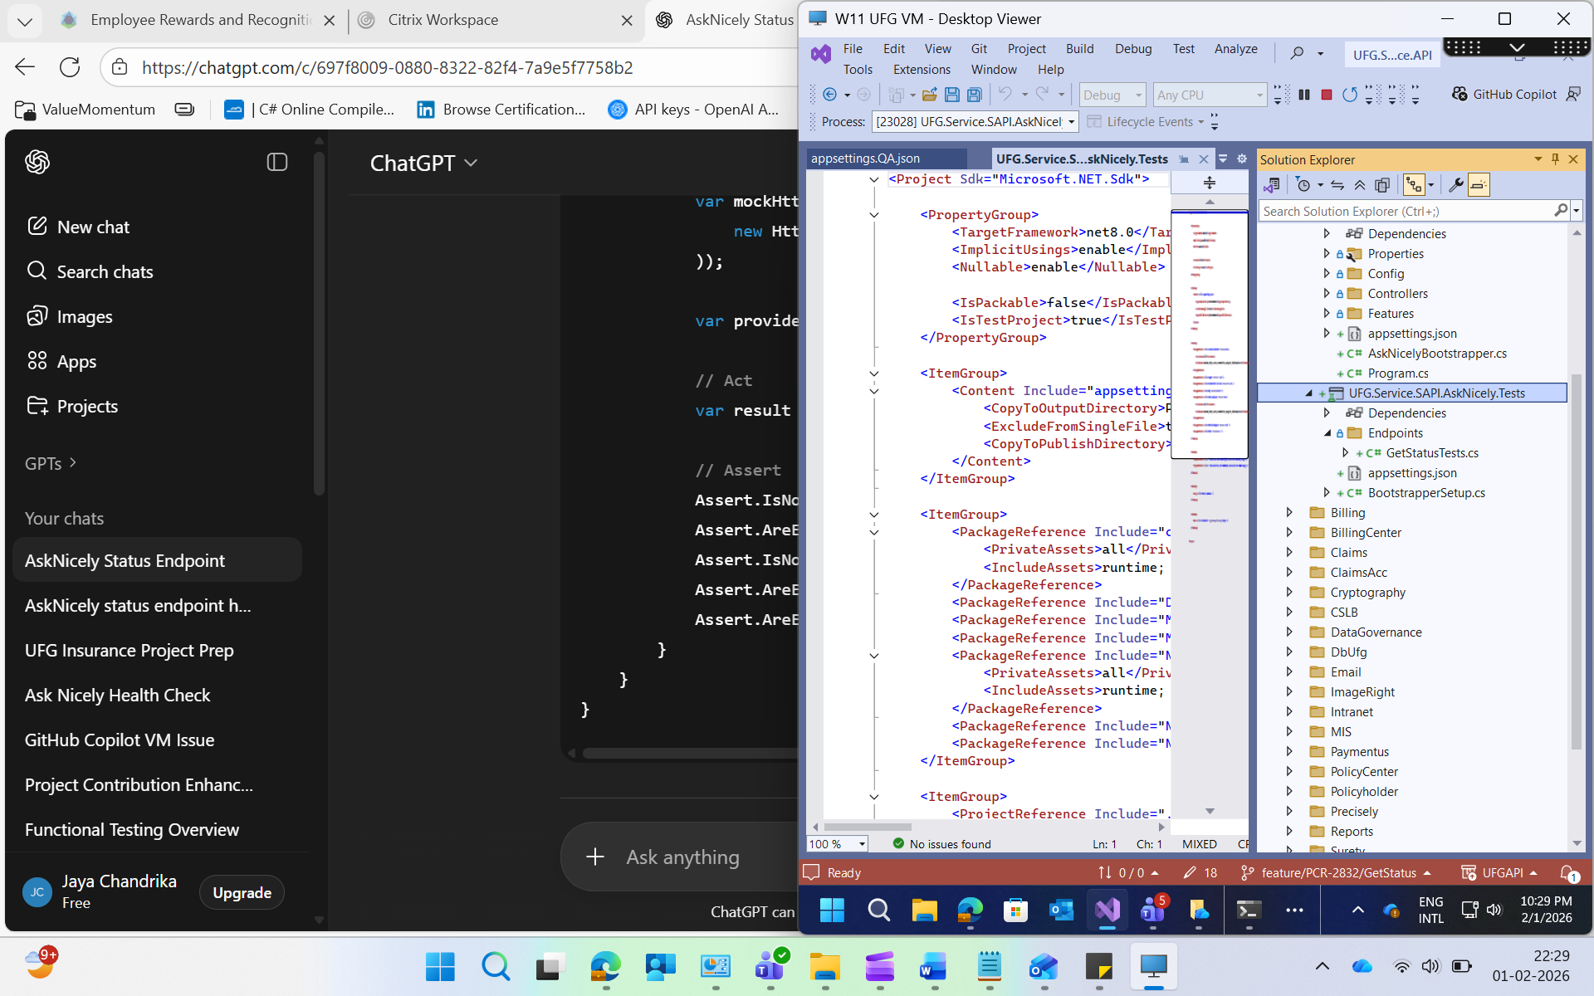
1️⃣ Current state of GetStatusTests.cs
The file exists under Endpoints.
The [Test] methods currently do not call StatusProvider.GetStatus().
They just have a / b divide-by-zero examples, which are placeholders.
Setup uses BootstrapperSetup.SetupServiceCollection() and a mock ApiConfigWrapper, but this isn’t being used in tests meaningfully yet.

✅ So right now, the file exists and will compile/run, but it does not actually test your /status logic.
2️⃣ What it should contain
Your GetStatusTests.cs should:
- Mock ApiConfigWrapper to provide valid or invalid configuration.
- Mock HttpClient responses (success, failure, exception) to simulate AskNicely API.
- Call StatusProvider.GetStatus() in your tests.
- Assert that StatusResponse has the correct Status, Details, and Message.
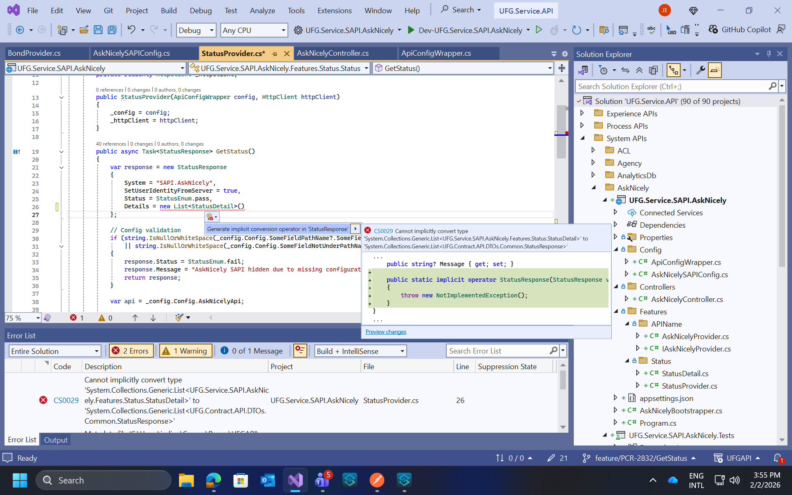
• Features layer → internal logic models
• Contract / DTO layer → API response models
• Controller response MUST use DTOs only
Hi, currently the /status endpoint is returning a 500 error due to a Vault authentication issue — specifically “invalid role or secret ID.”
From the application side, the endpoint logic and connectivity are working as expected, but the failure is happening during secret retrieval from Vault, which indicates a configuration or access issue rather than a code defect.
I am actively coordinating to verify the correct role ID/secret ID and permissions.
Once the valid credentials are provided or access is corrected, the endpoint should return a successful health response.
Since my sprint closes next Tuesday, my plan is:
• Continue troubleshooting with the Vault/infra team
• Validate the fix immediately after correct secrets are shared
• Ensure the status endpoint passes before sprint closure, or provide a clear update if external dependency delays occur.
Please let me know if there’s a preferred contact for Vault access verification to help close this faster.
Short Summary (for JIRA)
Developed a /status endpoint to monitor the health of the AskNicely SAPI service and its dependent systems.

Detailed Description
Implemented a status endpoint to provide real-time health information of the AskNicely SAPI.
This endpoint validates the availability and response of dependent services and returns structured status results.
Key updates include:
- Created /status endpoint in controller
- Integrated StatusProvider for health check logic
- Validates external dependency (AskNicely API)
- Returns structured response with system status and details
- Handles success and failure scenarios
Currently verifying endpoint behavior and resolving dependency-related issues (Vault authentication).

Acceptance Criteria
- /status endpoint returns 200 OK when all services are healthy
- Returns failure status when dependent service is down
- Response includes system name, status, and detailed messages
- Proper error handling implemented
- Unit tests added for success and failure scenarios

Removed LaunchDarkly dependency from the AskNicely SAPI as it is no longer required. Updated configuration and related code to ensure smooth execution without feature flags.

Detailed Description
As part of the update, the LaunchDarkly integration has been removed from the AskNicely SAPI service based on the latest requirement.
Changes include:
- Removal of LaunchDarkly-related configurations and dependencies
- Code cleanup where feature flags were previously used
- Ensured application runs independently without LaunchDarkly
- Verified implementation with the team (Vickey)
Currently validating the application behavior post-removal and checking dependent configurations (like Vault access).

Acceptance Criteria
- Application runs successfully without LaunchDarkly
- No feature flag dependency exists in code
- Configuration is updated and cleaned
- Status endpoint works as expected
NJM:
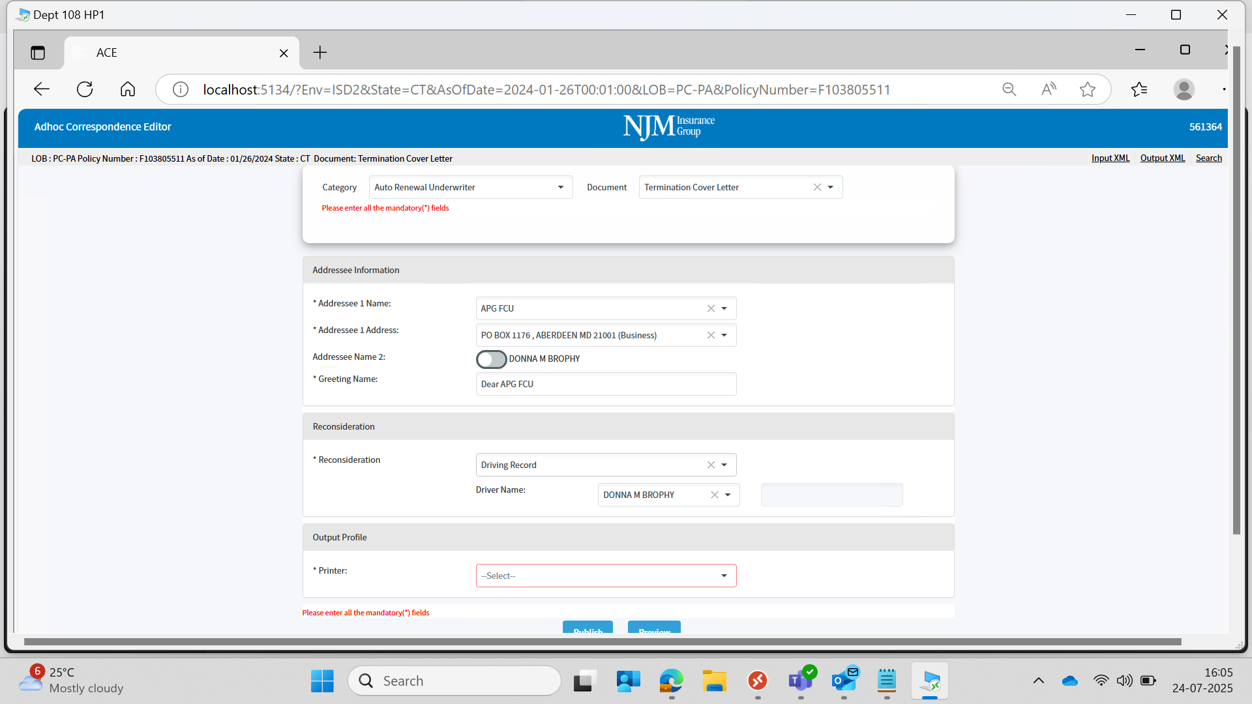
While working on the Reconsideration section of the form, I noticed that there's a blank space beside the Driver Name field in the UI (screenshot attached).
It appears that this space might be reserved for an additional field or component, but currently nothing is rendered there. Could you please confirm if a field is missing or if the layout needs to be adjusted?
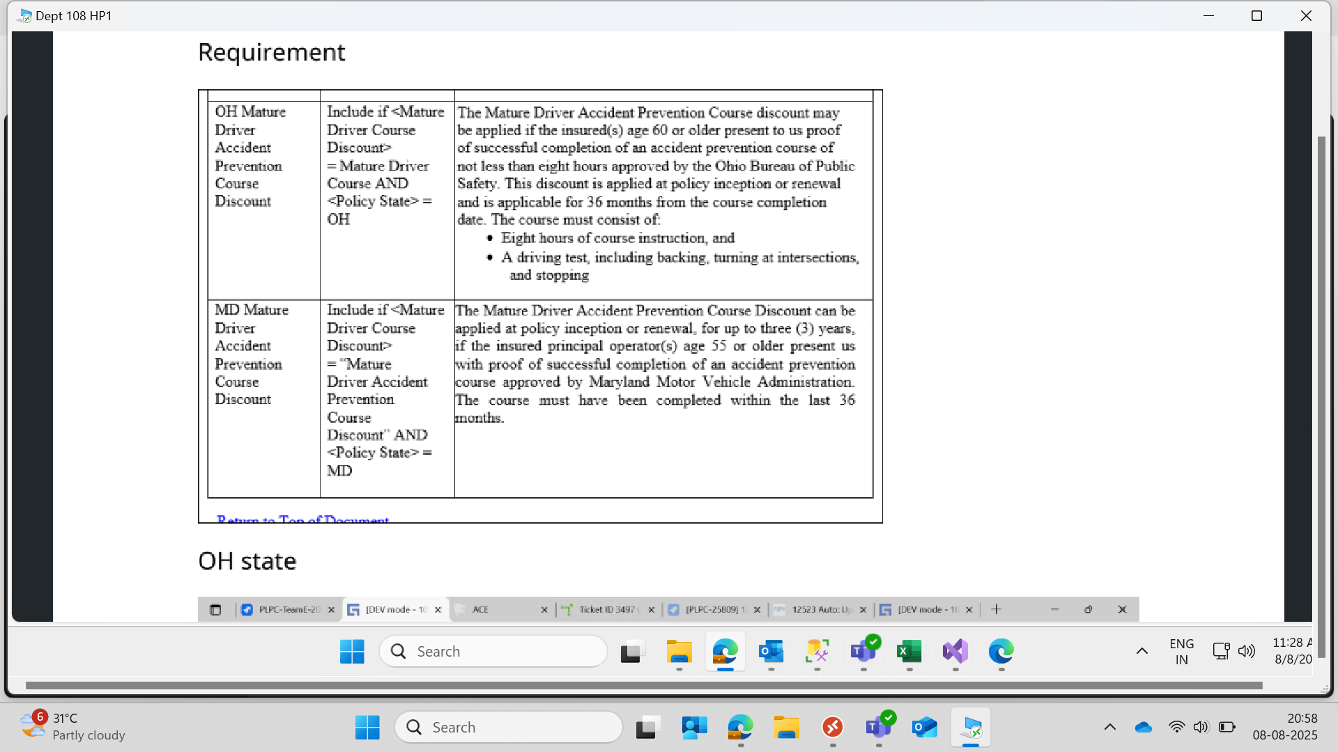
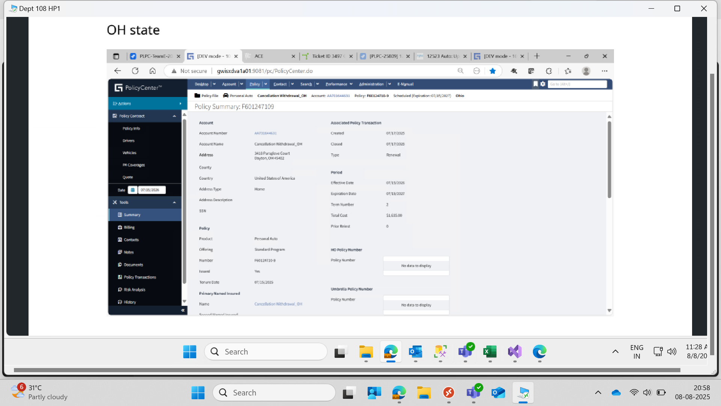
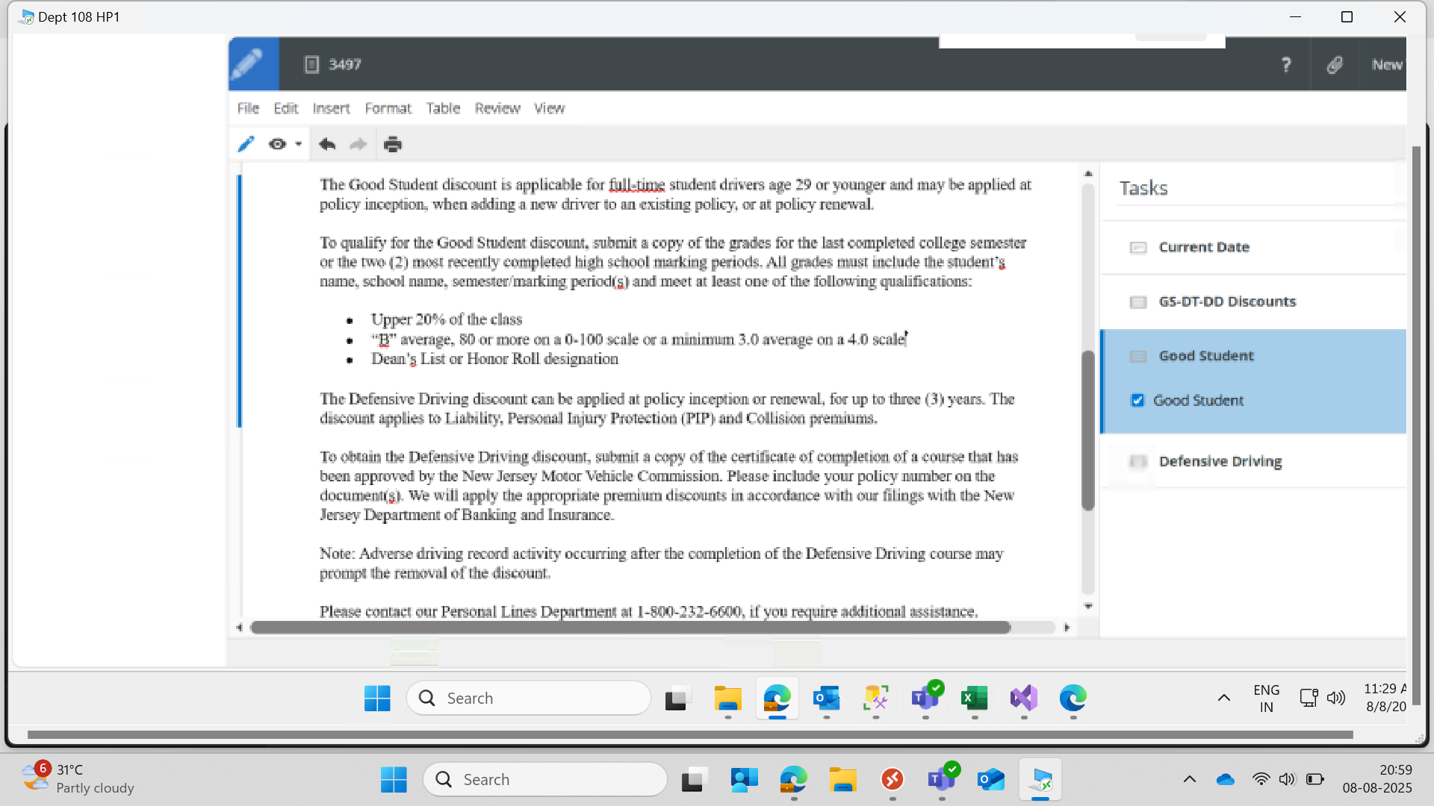
✅ Context Summary
You are working on Mature Driver Accident Prevention Course Discount logic validation in PolicyCenter, checking how it applies for:
- OH (Ohio) State
- MD (Maryland) State
And comparing whether:
- The discounts are applied correctly based on policy state and customer eligibility (age, course completion, etc.)
- There is a mismatch or missing condition
- Rohita raised a concern from the .NET (backend) side

🧾 Breakdown of What Each Screenshot Shows
📌 Screenshot 1 – Discount Rules (Requirement)
- OH: Requires age ≥ 60, 8-hour course + driving test, valid for 36 months
- MD: Requires age ≥ 55, valid for 36 months, course approved by Maryland MVA
Trigger Condition in system:
Include if:
<Mature Driver Course Discount> = “Mature Driver Course”
AND <Policy State> = OH (or MD respectively)

📌 Screenshot 2 – Policy for OH State
- Policy summary shows:
  - Policy State: Ohio
  - Effective Date: 07/15/2026
  - Tenure Date: 07/15/2025
- But no information or field showing Mature Driver Discount applied or not.

📌 Screenshot 3 – Good Student Discount Conditions
- This is unrelated to your issue.
- Likely used as a reference format for how discount qualifications are written.

📌 Screenshot 4 – Policy for MD State
- Policy summary shows:
  - Policy State: Maryland
  - Effective Date: 06/07/2025
  - Total Cost: $5,777.00
- Again, no visible indication of Mature Driver Discount being applied.

❗ Issue Likely Raised by Rohita (from .NET side)
Since your system does not seem to apply or validate the Mature Driver Discount, Rohita might be pointing out:
- The backend may not be sending the required flags (like <Mature Driver Course Discount> = true)
- Or the validation logic is failing to include the discount even when criteria are met.

🧩 Your Comment (Assumption Based on Screenshot)
Your comment likely mentioned that the front-end/UI side has no issues, or that the field is correctly configured for the policy state.

✅ How You Can Resolve / Investigate
- Verify Age and Discount Field in DB:
  - Is the insured aged 60+ (OH) or 55+ (MD)?
  - Has the discount been selected/applied in the system DB or UI?
- Check if Eligibility Logic Is Triggered:
  - Make sure backend triggers Mature Driver Course Discount flag when:
    - Policy State is OH or MD
    - Age condition is met
    - Course completion is validated (you may need to check document upload if any)
- Inspect UI Configuration (if your part):
  - Ensure discount is displayed only when eligibility is met
  - Cross-verify against other working discounts like “Good Student”
- Coordinate with Rohita:
  - Ask her if the discount field is not getting triggered due to backend condition check failing
  - Share with her your policy screen (like the ones you attached) and ask:
“I confirmed that the policy state is correct (OH/MD), but the Mature Driver Discount isn't showing. Can you check if the backend condition is evaluating to false or if the discount field is not being set?"

💡 Suggested Teams Message to Rohita
"Hi Rohita, I checked the policy for OH/MD state, and from the UI side the policy state and effective dates are correct. But the Mature Driver Discount doesn’t seem to be applying. Can you help check if the condition in the backend is evaluating to false or if the discount flag isn't being passed?"
Your Responsibility (.NET side)
- Ensure correct evaluation of eligibility:
  - Policy state = OH/MD
  - Age criteria is met (60+ for OH, 55+ for MD)
  - Course completion date within 36 months
- Set and pass the discount flag/response (like: IsMatureDriverDiscountApplicable = true)
- Include that in the policy details sent to Inspire/UI

❗ What Rohitha Might Be Saying (Inspire Side)
- Discount is not visible in UI or not getting triggered
- She suspects that backend is not passing the right flag/data, or the discount condition is not being met in the backend
What is ISDX1 vs ISD2?
- These are environment codes (like Dev, QA, UAT, Prod, etc.).
- In your case:
  - You have access to ISD2 (maybe used for backend or integration testing).
  - Rohitha is referring to ISDX1, which could be:
    - Her UI/Front-end test environment
    - Used by Inspire team for UI validation
Discount issue story card :
Got it — you want a Root Cause Analysis (RCA) for a discount issue story card. Here’s a clean and professional way you can write it (use this in stand-up, documentation, or your resume):

🧾 Story Card: Discount Calculation Issue
🔍 Issue Summary
Discount was not applied correctly for certain policies, resulting in incorrect premium amounts displayed to users.

🧠 Root Cause
The discount logic was not validating all required conditions before applying the discount.
Specifically:
- Missing/null values in input data were not handled properly
- Incorrect condition check in business logic (e.g., eligibility criteria mismatch)
- Discount calculation executed even when prerequisites were not met

⚠️ Impact
- Incorrect premium calculation
- User confusion due to inconsistent pricing
- Potential business impact on policy accuracy

🛠️ Fix Implemented
- Added proper validation checks before applying discount
- Updated business logic conditions for eligibility
- Handled null/edge cases to prevent incorrect calculations
- Tested with multiple scenarios to ensure accuracy

✅ Outcome
- Discount applied correctly based on eligibility
- Improved accuracy in premium calculation
- Reduced risk of similar issues in future
✅ Reconsideration – Story Cards Summary & Analysis

🔹 Story Card 1: Reconsideration Dropdown Implementation
Summary:
Added a Reconsideration dropdown in the UI to allow users to select reasons for reconsideration.
Analysis:
- Identified requirement to capture reconsideration reason dynamically.
- Integrated dropdown using Radzen component.
- Bound data source from backend lookup API.
- Ensured proper rendering and user interaction handling (OnChange event).
- Verified data flow from UI → API → database.

🔹 Story Card 2: Make Reconsideration Field Mandatory
Summary:
Enhanced validation by making the Reconsideration dropdown a required field before submission.
Analysis:
- Compared existing mandatory fields (like Printer) for consistency.
- Implemented validation using @bind-Value and null/empty checks.
- Displayed error message when no selection is made.
- Ensured form submission is blocked until valid input is provided.
- Improved data integrity and avoided incomplete submissions.

🔹 Story Card 3: UI Alignment & Layout Fix (Driver Name Section)
Summary:
Fixed UI issue where blank space appeared beside Driver Name field.
Analysis:
- Investigated layout structure (grid/columns/div alignment).
- Identified unused or empty container causing spacing issue.
- Adjusted CSS/layout to properly align fields.
- Ensured responsive design consistency across screen sizes.
- Validated fix with UI testing.

🔹 Story Card 4: Backend Integration for Reconsideration Data
Summary:
Connected frontend dropdown selection with backend services for storing and retrieving reconsideration data.
Analysis:
- Verified API endpoints for lookup and submission.
- Ensured correct payload mapping for selected value.
- Handled null/edge cases in API request.
- Tested end-to-end flow (UI → API → DB → response).
- Coordinated with backend team if required.

🔹 Story Card 5: Bug Fix – Missing/Incorrect Reconsideration Handling
Summary:
Resolved issue where reconsideration value was not properly captured or displayed.
Analysis:
- Performed root cause analysis (binding issue / missing state update).
- Fixed data binding and event handling logic.
- Retested scenarios (create, edit, submit).
- Ensured no regression in related fields.

✅ Overall Contribution
- Improved form validation and user experience
- Ensured data accuracy and completeness
- Performed UI fixes + backend integration
- Strengthened end-to-end functionality of Reconsideration feature

