DATE: 04-09-2025.

K. CHANDRIKAA

2403A51227

AIAC ASSIGNMENT 6.4

## TASK 1:

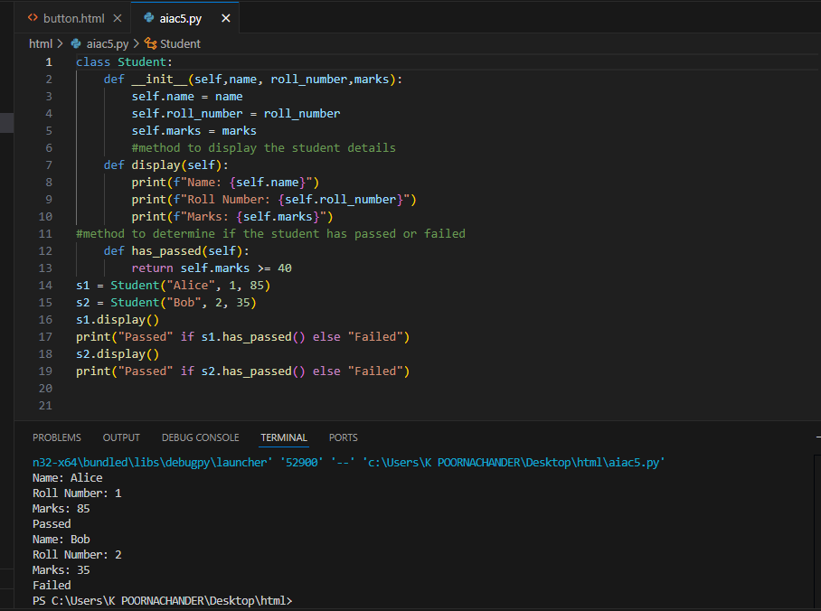

## TASK 2:

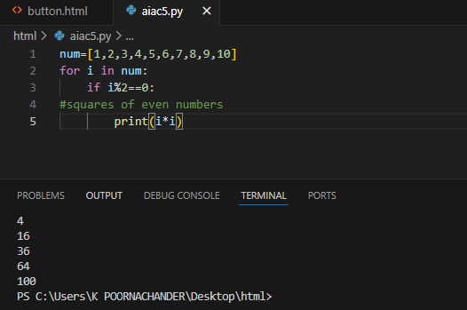

## TASK 3:

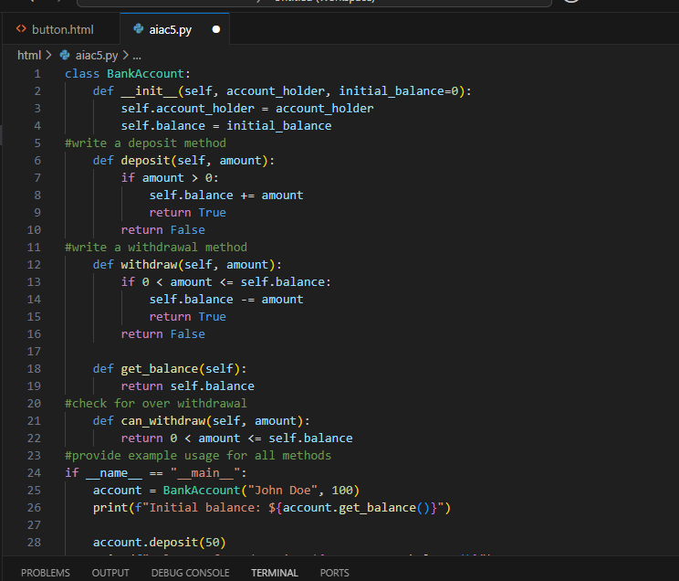

## 

## TASK 4:

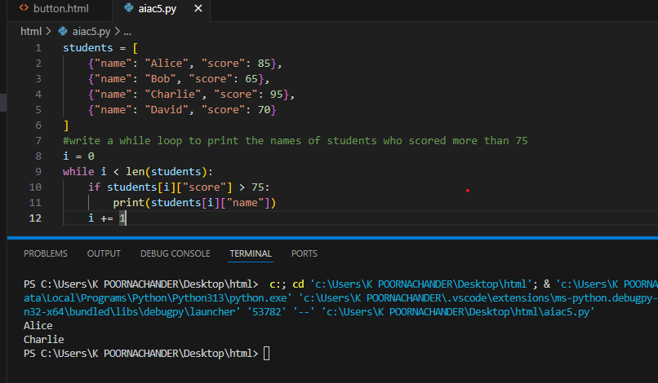

## TASK 5:

