LAB EXPERIMENT RECORD
Set 11: Product Category Analysis
Department | AIML
Course Code / Course Name | DSA0601 / Data Handling and Visualization
Experiment | Data Visualization using R
Name | G. GANGA CHANDRIKA
Register Number | 1925260144
Date | 6 October 2026
Day | Tuesday
Aim
To analyze product category sales by creating a funnel chart, a data table, a pie chart, and an interactive dashboard that combines all of them using R and Shiny.
Dataset: Product Categories
Category | Sales ($)
Electronics | 50000
Clothing | 35000
Appliances | 40000
PROGRAM 1: Funnel Chart of Sales by Product Category
Generate a funnel chart to analyze the sales conversion process for each product category. Label the stages and title the chart.
# Dataset
product_data <- data.frame(
Category = c("Electronics", "Clothing", "Appliances"),
Sales = c(50000, 35000, 40000)
)

product_data

# Sort sales from highest to lowest
funnel_data <- product_data[order(product_data$Sales, decreasing = TRUE), ]

# Create funnel-style chart
barplot(
funnel_data$Sales,
names.arg = funnel_data$Category,
horiz = TRUE,
col = "skyblue",
main = "Sales Funnel by Product Category",
xlab = "Sales ($)",
las = 1
)
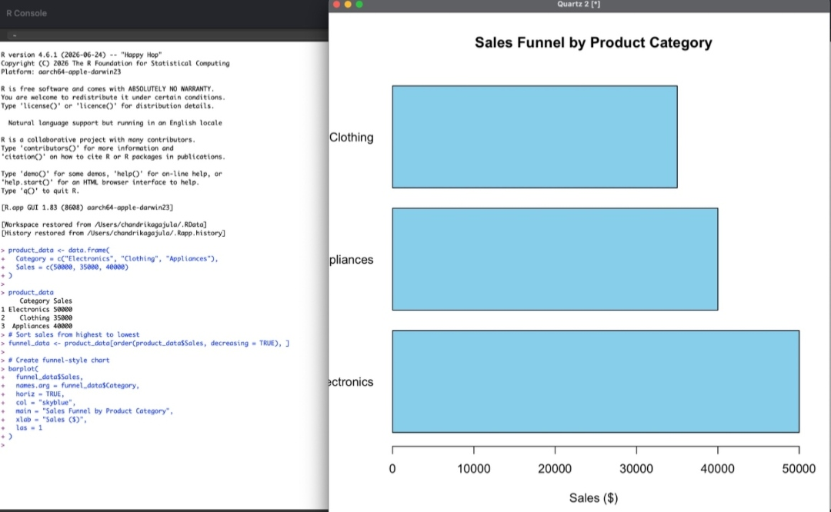
Output 1: Sales Funnel by Product Category
Observation: The funnel chart ranks the categories by sales. Electronics has the largest bar ($50,000), followed by Appliances ($40,000) and Clothing ($35,000).
PROGRAM 2: Table of Sales Data
Build a table to display the sales data for each product category. Label the table elements.
# Display the sales table
product_data
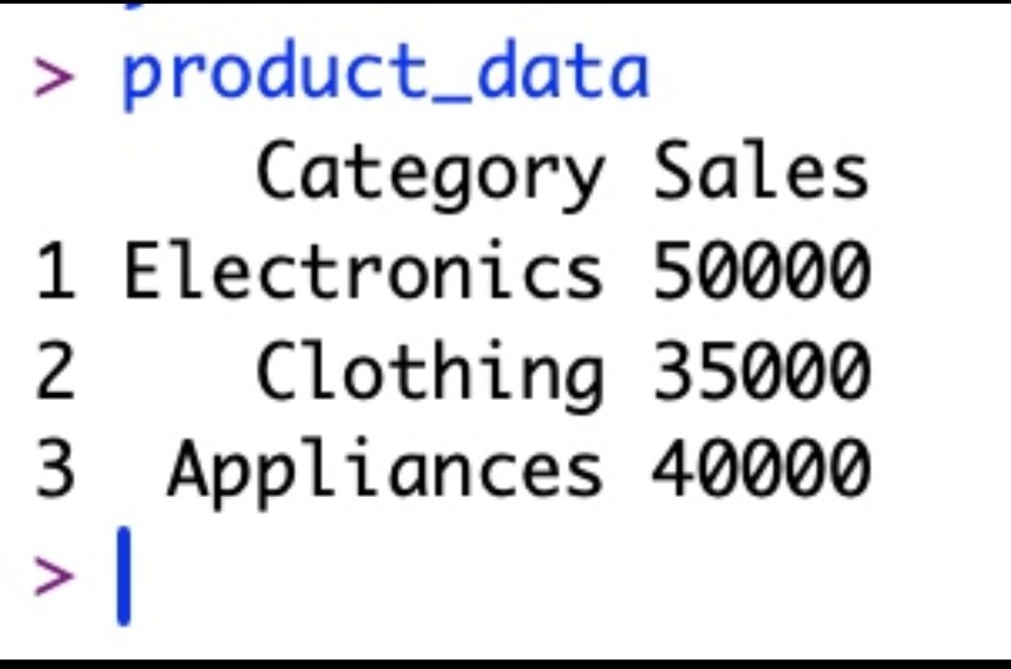
Output 2a: Product Data Frame in the R Console
Category | Sales ($)
Electronics | 50000.00
Clothing | 35000.00
Appliances | 40000.00

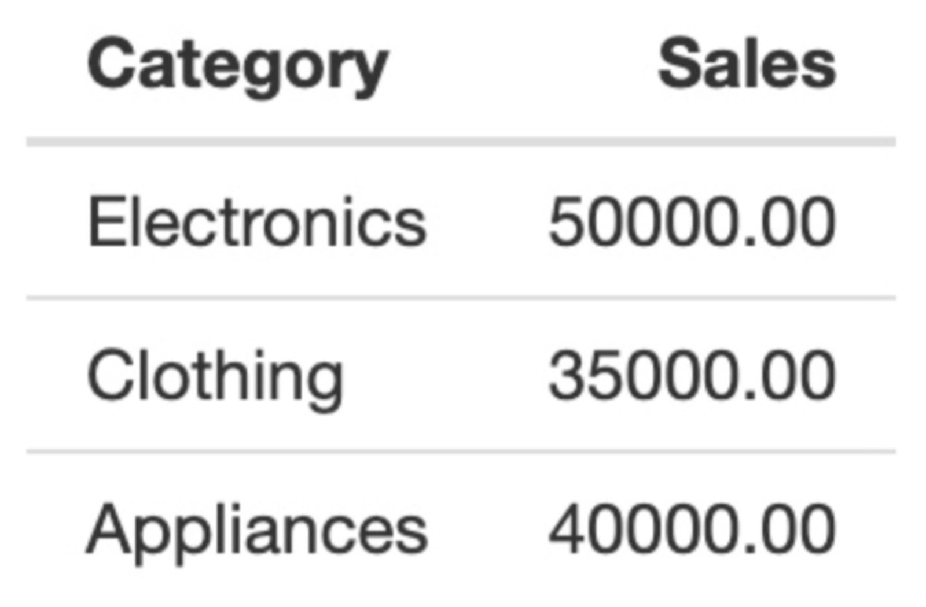
Output 2b: Sales Table with Labelled Columns (Category, Sales)
Observation: The table lists each product category with its sales value. The total sales across all three categories is $125,000.
PROGRAM 3: Pie Chart of Sales Distribution
Create a pie chart to represent the distribution of sales across product categories. Include labels.
# Labels with category name and sales value
labels <- paste(product_data$Category, "\n$", product_data$Sales)

# Pie Chart
pie(
product_data$Sales,
labels = labels,
main = "Sales Distribution by Product Category"
)
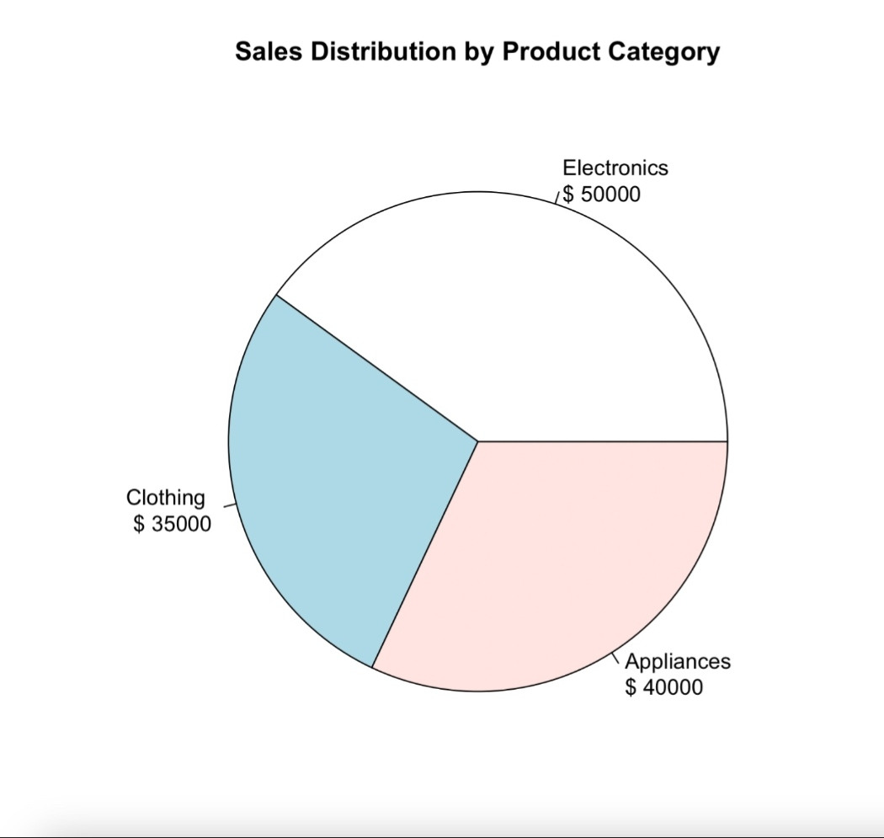
Output 3: Sales Distribution by Product Category
Observation: Electronics contributes 40% of total sales, Appliances 32% and Clothing 28%. Electronics is the largest share.
PROGRAM 4: Interactive Product Category Dashboard
Develop an interactive dashboard combining the pie chart, funnel chart, and the table for exploration of product category data (built with R Shiny).
library(shiny)

product_data <- data.frame(
Category = c("Electronics", "Clothing", "Appliances"),
Sales = c(50000, 35000, 40000)
)

ui <- fluidPage(
titlePanel("Product Category Sales Dashboard"),
sidebarLayout(
sidebarPanel(
selectInput("category", "Select Category:",
choices = c("All", product_data$Category))
),
mainPanel(
plotOutput("piePlot"),
plotOutput("funnelPlot"),
tableOutput("salesTable")
)
)
)

server <- function(input, output) {

filtered <- reactive({
if (input$category == "All") product_data
else product_data[product_data$Category == input$category, ]
})

output$piePlot <- renderPlot({
d <- filtered()
pie(d$Sales,
labels = paste(d$Category, "\n$", d$Sales),
main = "Sales Distribution by Product Category")
})

output$funnelPlot <- renderPlot({
d <- filtered()
d <- d[order(d$Sales, decreasing = TRUE), ]
barplot(d$Sales, names.arg = d$Category, horiz = TRUE,
col = "skyblue", main = "Sales Funnel by Product Category",
xlab = "Sales ($)", las = 1)
})

output$salesTable <- renderTable({
filtered()
}, digits = 2)
}

shinyApp(ui = ui, server = server)
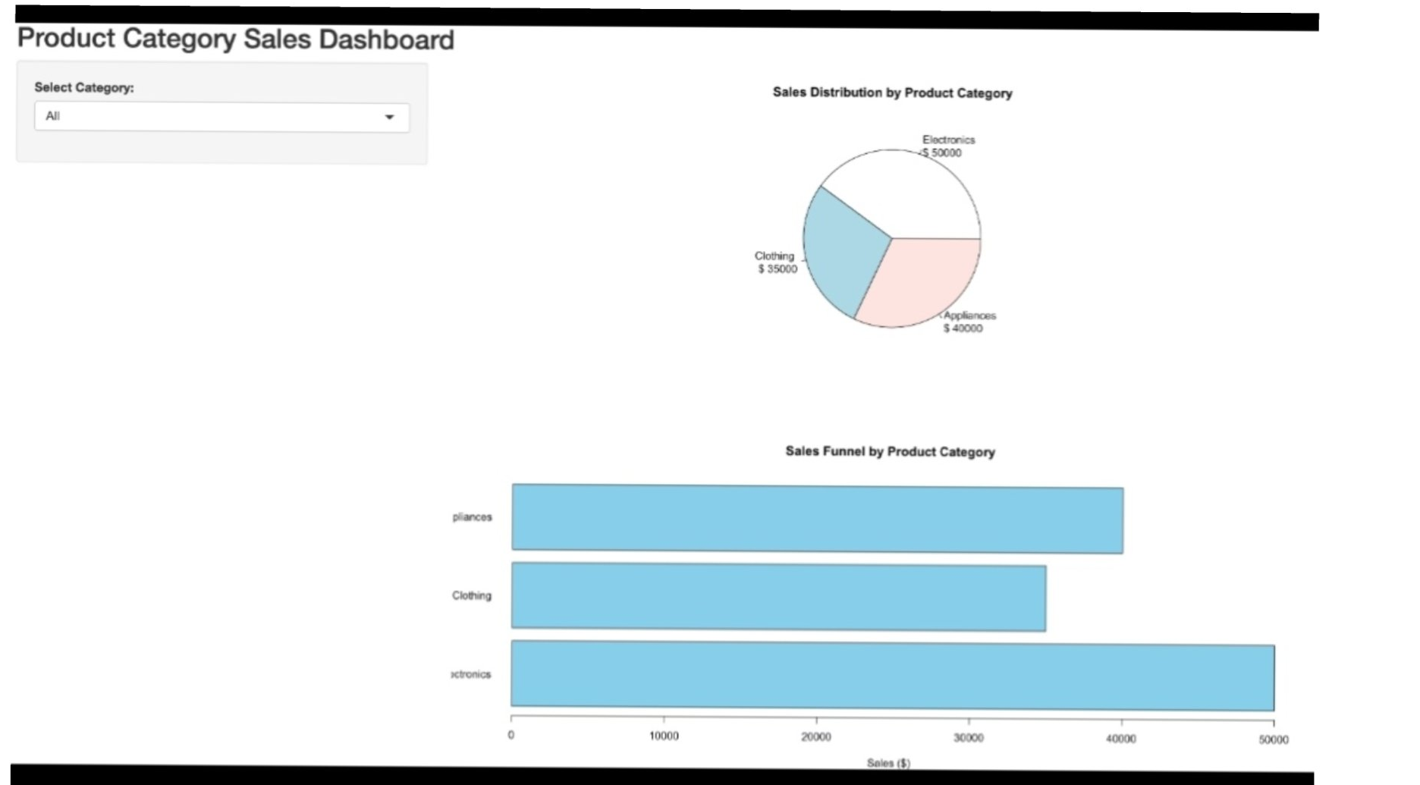
Output 4: Product Category Sales Dashboard (Pie Chart, Funnel Chart and Table)
Observation: The "Select Category" drop-down defaults to All, which shows all three categories together. Choosing a single category updates the pie chart, funnel chart and table to show only that category.
Procedure
1. Create a data frame with the Category and Sales columns.
2. Sort the sales in descending order and use barplot() with horiz = TRUE to draw the funnel-style chart with a title and labels.
3. Display the data frame as a table with labelled Category and Sales columns.
4. Use pie() with paste() labels to draw the sales distribution.
5. Use Shiny (selectInput, reactive, renderPlot, renderTable) to combine the pie chart, funnel chart and table into one interactive dashboard.
Result
The product category sales data was successfully analyzed using a funnel chart, a data table, a pie chart, and an interactive dashboard in R.

