LAB EXPERIMENT RECORD
Experiment 5: Website Traffic Data
Department | AIML
Course Code / Course Name | DSA0601 / Data Handling and Visualization
Experiment | Data Visualization using R and Tableau
Name | G. GANGA CHANDRIKA
Register Number | 1925260144
Date | 1 October 2026
Day | Thursday
Aim
To visualize website traffic data using a line chart, bar chart and stacked area chart in R, and to build an interactive Tableau dashboard combining the line chart and bar chart.
Dataset: Website Traffic
Date | Page Views | CTR (%)
2023-01-01 | 1500 | 2.3
2023-01-02 | 1600 | 2.7
2023-01-03 | 1400 | 2.0
2023-01-04 | 1650 | 2.4
2023-01-05 | 1800 | 2.6

PROGRAM 1: Line Chart of Daily Page Views
Create a line chart to visualize the trend in daily page views over time. Label the axes and title the chart.
# Dataset
website <- data.frame(
Date = as.Date(c("2023-01-01","2023-01-02","2023-01-03",
"2023-01-04","2023-01-05")),
PageViews = c(1500, 1600, 1400, 1650, 1800)
)

# Line Chart
plot(website$Date,
website$PageViews,
type = "o",
main = "Daily Page Views Trend",
xlab = "Date",
ylab = "Page Views",
pch = 19)
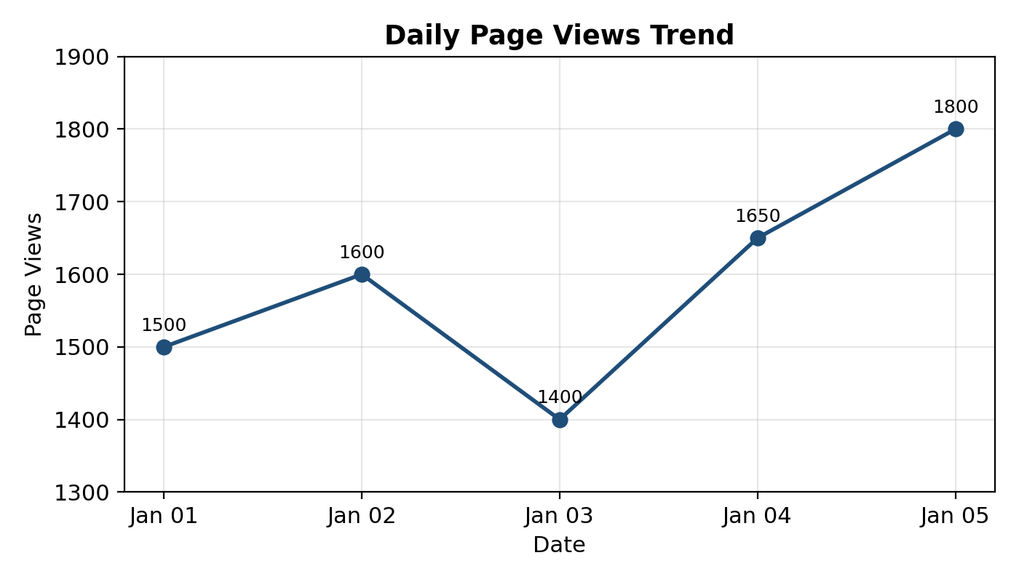
Output 1: Daily Page Views Trend
Observation: Page views rise from 1500 to 1600, fall to the lowest value of 1400 on 3 January, and then increase steadily to the highest value of 1800 on 5 January.

PROGRAM 2: Bar Chart of Top 3 Days by Click-Through Rate
Generate a bar chart showing the top N days (N = 3) with the highest click-through rates. Label the chart elements.
# Add CTR column
website$CTR <- c(2.3, 2.7, 2.0, 2.4, 2.6)

# Select top 3 days by CTR
top3 <- website[order(-website$CTR), ][1:3, ]

# Bar Chart
barplot(top3$CTR,
names.arg = format(top3$Date, "%Y-%m-%d"),
main = "Top 3 Days by Click-Through Rate",
xlab = "Date",
ylab = "Click-Through Rate (%)",
col = "lightblue")
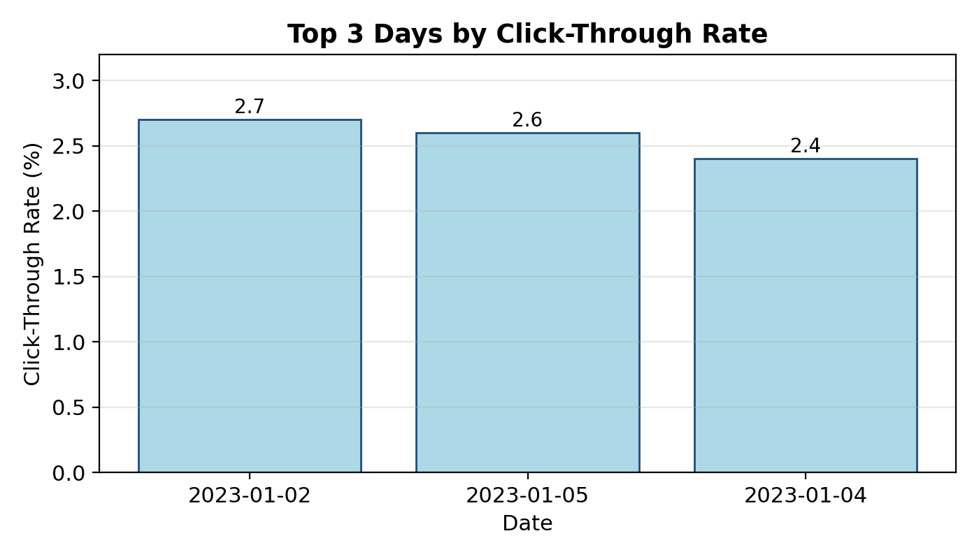
Output 2: Top 3 Days by Click-Through Rate
Observation: The three highest click-through rates occurred on 2023-01-02 (2.7%), 2023-01-05 (2.6%) and 2023-01-04 (2.4%).

PROGRAM 3: Stacked Area Chart of User Interactions
Develop a stacked area chart to display the distribution of user interactions (likes, shares, comments) on a website.
library(ggplot2)

# interaction_long has columns: Date, Interaction, Count
# (Likes, Shares, Comments for each date)

ggplot(interaction_long,
aes(x = Date,
y = Count,
fill = Interaction)) +
geom_area() +
labs(
title = "Website User Interactions",
x = "Date",
y = "Number of Interactions"
)
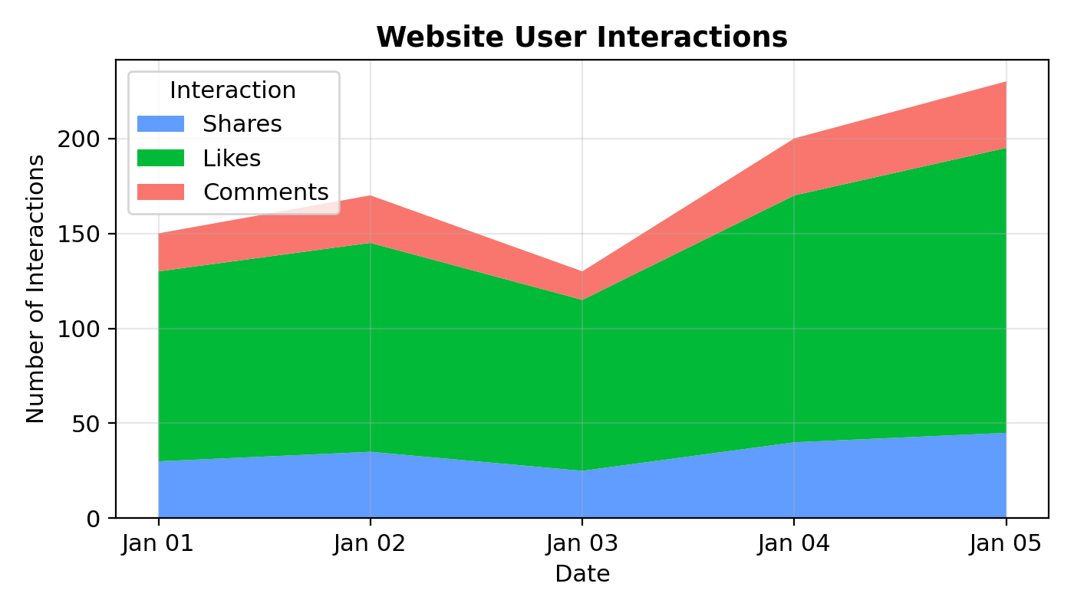
Output 3: Website User Interactions (Stacked Area Chart)
Observation: Likes form the largest share of interactions on every day, followed by shares and comments. Total interactions dip on 3 January and reach their peak on 5 January.

PROGRAM 4: Tableau Dashboard
Build a Tableau dashboard with the line chart and bar chart for interactive exploration of website traffic data.
Steps in Tableau:
- Save the dataset (Date, PageViews, CTR) as an Excel/CSV file and connect to it using Connect > Microsoft Excel / Text file.
- Open a new worksheet named Line Chart: drag Date to Columns, Page Views to Rows, and set the mark type to Line.
- Open a second worksheet named Top Days CTR: drag Date to Columns and CTR to Rows, change the mark type to Bar, sort in descending order and apply a Top 3 filter on CTR.
- Add axis titles and chart titles by editing the axes and titles in each worksheet.
- Create a new Dashboard, drag both worksheets onto the canvas and arrange them side by side.
- Use each chart as a filter (Use as Filter) and add a Date filter so that the dashboard can be explored interactively.
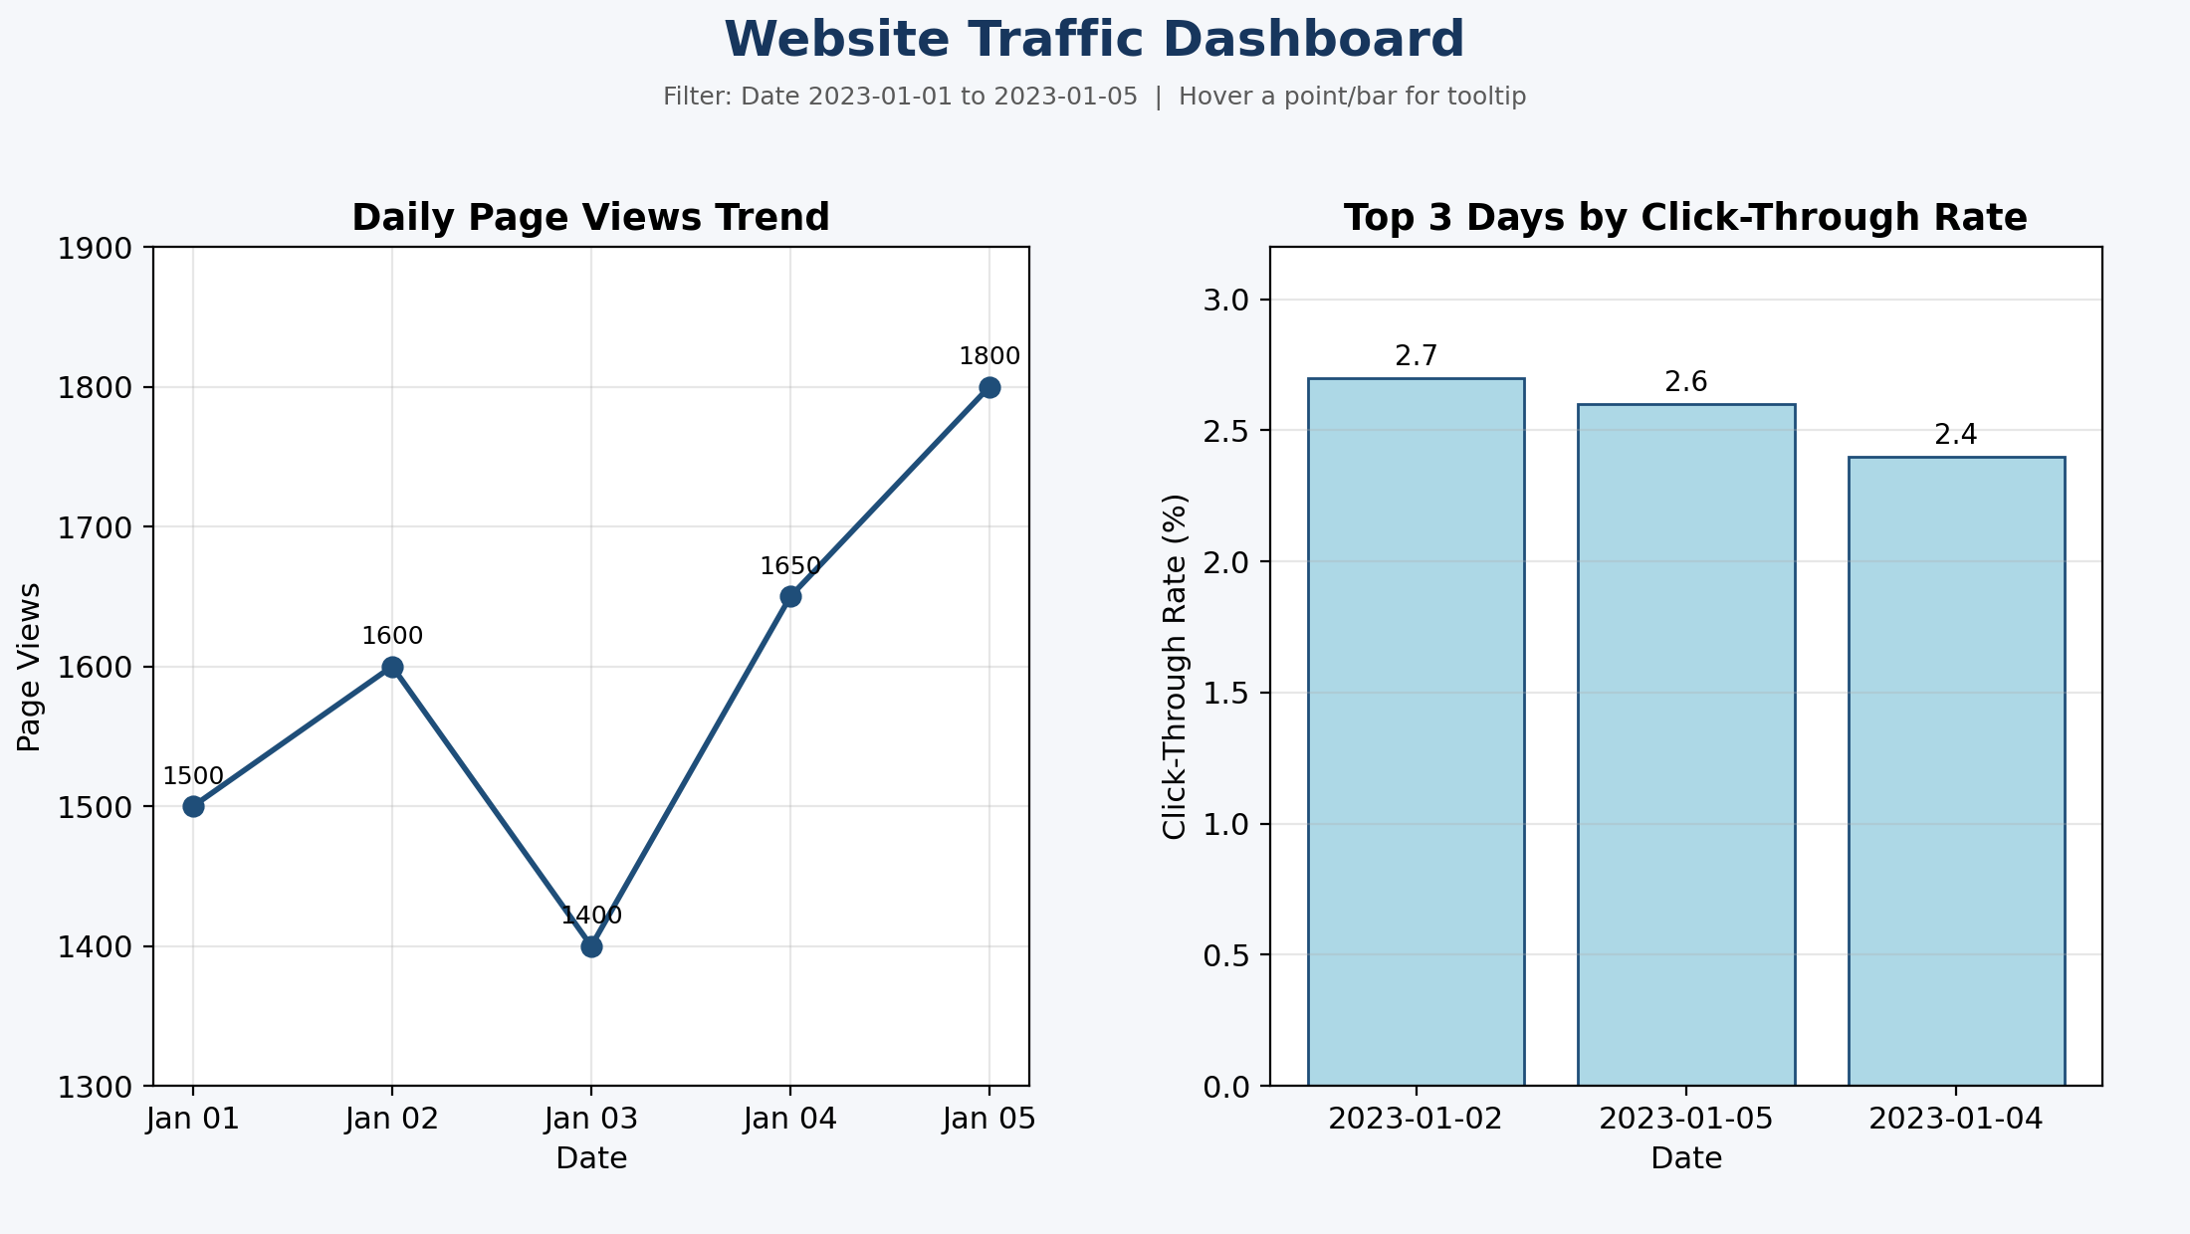
Output 4: Website Traffic Dashboard (Line Chart and Bar Chart)
Observation: The dashboard places the page-view trend next to the top click-through-rate days, so selecting a date in one chart helps to explore the same period in the other.
Procedure
1. Create a data frame with Date and PageViews and add the CTR column in R.
2. Use plot() with type = "o" to create the line chart with axis labels and a title.
3. Use order() to select the top 3 days by CTR and draw them with barplot().
4. Prepare the interaction data in long format and use ggplot() with geom_area() for the stacked area chart.
5. Load the data in Tableau, build the line chart and bar chart worksheets, and combine them in a dashboard with filters.
Result
The website traffic data was successfully visualized using a line chart, bar chart and stacked area chart in R, and an interactive dashboard combining the line chart and bar chart was built in Tableau.
Key R Functions Used
Function | Purpose
plot() | Creates the line chart.
order() | Sorts the data to find the top days by CTR.
barplot() | Creates the bar chart.
ggplot() | Creates the base of a ggplot2 chart.
geom_area() | Draws the stacked area chart.
labs() | Adds the title and axis labels.

