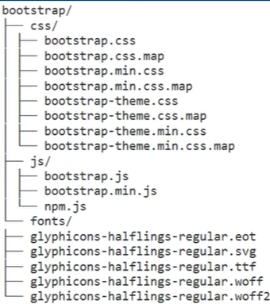**Bootstrap CSS**

* The downloaded bootstrap folder structure is:

-> .map files are the source map files

-> .min files are the minified versions(file content without spaces or linebreaks) of the css files

-> .theme files are for efficiently enhanced experience like 3D effects, gradients, shadows etc.

-> fonts folder provide 5 different files of glyphicons that supports different browsers with diff fonts.

-> js files can be used for bootstrap widgets like picture carousel, dropdown menus etc.

-> bootstrap JS has dependency upon jQuery.

* 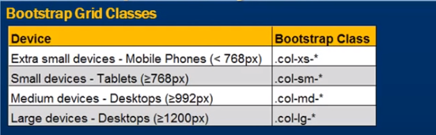Bootstrap Grid System:
* 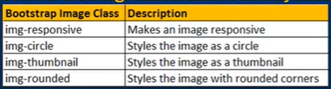Bootstrap Image gallery:
* Bootstrap responsive utility classes:

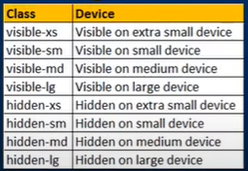

* 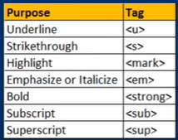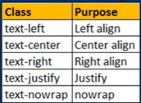Bootstarp paragraphs: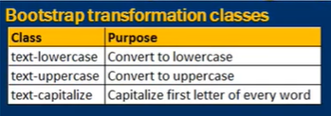

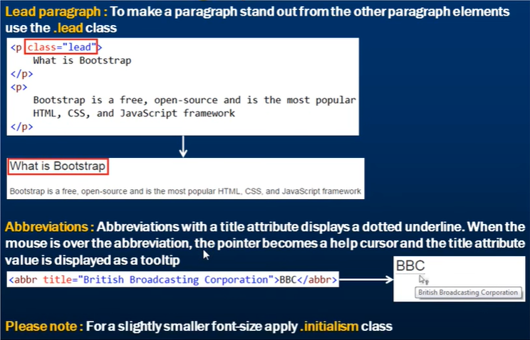

* Bootstrap blockquotes:

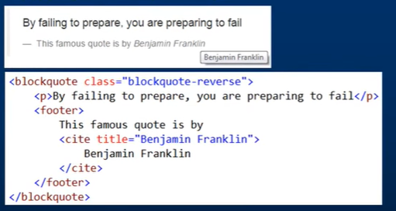

* Bootstrap Lists:

