Real-Time Embedded Remaining Useful Life Prediction for LFP Electric Vehicle Batteries Using Gradient Boosting
Department of Electrical and Automotive Engineering
Comprehensive Engineering Thesis & Research Report
Abstract—If you ask any automotive engineer working on electric vehicles what battery chemistry they prefer for long-term fleet durability, almost everyone will say Lithium Iron Phosphate (LiFePO4 or LFP). They rarely catch fire, last for thousands of cycles, and cost less to build. But there is a well-known engineering catch: you can hardly tell how much wear an LFP battery has just by measuring its voltage on the road. For roughly 80% of its driving range, the voltage stays almost dead flat. Because of this plateau, classic battery formulas like Extended Kalman Filters constantly struggle to predict how many charging cycles are left before the cell dies. In our work, we built an embedded software architecture using LightGBM designed specifically to run inside low-power automotive microcontrollers. Instead of guessing from flat voltage readings, our algorithm extracts 8 physical features—especially internal resistance and differential capacity shifts—calculated over a rolling 10-cycle window. We tested this code against the public Stanford/MIT battery dataset, analyzing 124 commercial LFP cells subjected to 72 different fast-charging profiles. To prevent blind spots near the end of life, the software checks the battery every 5 cycles. On a strictly hidden test group of 24 cells, our model predicted remaining life within an average error of 81.35 cycles and achieved 78.52% R2 accuracy. Overall cross-validated accuracy across all 124 cells hit 81.64%. More importantly for real dashboard deployment, we proved the C++ inference runs in 0.95 milliseconds on ARM Cortex chips, gives a dependable +/-122 cycle safety warning buffer, and stays mathematically stable under ISO 26262 automotive guidelines.
Keywords—Lithium iron phosphate, electric vehicles, battery prognostics, LightGBM, differential capacity, embedded software.
I. INTRODUCTION
Take a look under the floorboards of modern electric cars from BYD, Tesla, or Ford, and you will find Lithium Iron Phosphate (LFP) batteries everywhere. LFP chemistry has taken over the commercial EV market for three practical reasons: cobalt is expensive and toxic, nickel cells degrade faster under daily fast charging, and LFP cells can routinely survive over 2,000 cycles. But building battery software for LFP cells introduces a tricky physical problem. When a driver drives down the highway, the battery management system (BMS) tries to estimate cell health by looking at voltage changes. With LFP, that voltage barely moves.
Why does the voltage stay so flat? Inside an LFP cell, lithium intercalation happens across a two-phase equilibrium. Because the chemical phase transition holds the potential steady, the open-circuit voltage stays nearly horizontal between 15% and 95% State of Charge. If you measure a cell on day one and measure it again after 500 heavy charging cycles, the voltage profile looks almost identical. Traditional physics models—especially Equivalent Circuit Models and Kalman filters—rely on noticeable voltage dips to adjust their internal state estimates. When forced to work on flat LFP curves, these formulas often drift out of bounds or fail to notice early degradation until the battery suddenly plunges toward retirement around 80% State of Health.
We wanted to build a practical solution that actually runs on vehicle hardware. Instead of building massive deep neural networks that require powerful desktop GPUs, or relying on simple rules of thumb, we engineered a lightweight decision-tree tracking loop. Here is what we accomplished in this project:
- Real-Time Tracking Architecture: We designed an active monitoring system that continuously updates remaining life predictions while the car is in service.
- Targeted Feature Engineering: We engineered 8 physical features over a 10-cycle window. Our tests proved that internal resistance growth exposes battery aging long before voltage drops.
- Solving the Polling Blind Spot: We separated the 10-cycle lookback memory from a fast 5-cycle polling rate, ensuring the system catches sudden end-of-life capacity drops.
- Microcontroller Deployment: We verified our C++ compiled model runs in just 0.95 ms on standard ARM microcontroller chips while satisfying Z-domain stability rules.
II. LITERATURE REVIEW AND TECHNICAL CHALLENGES
A. Why Kalman Filters Struggle with LFP Chemistry
Most commercial battery management systems today use Equivalent Circuit Models combined with Extended Kalman Filters (EKF). If you are working with older Nickel-Manganese-Cobalt (NMC) packs, EKF works great because the voltage drops steadily as the battery drains. But when you apply that same EKF code to an LFP battery, the math breaks down. The voltage slope across the mid-range is tiny—roughly 0.5 millivolts for every 1% change in charge. Because that slope is near zero, the Kalman filter gain shrinks. The software cannot tell whether a tiny voltage wiggle came from actual cell wear or just electrical noise from the motor inverter.
B. The Trouble with Deep Learning in Vehicles
To bypass flat voltage curves, many research labs recently started experimenting with deep learning models like Long Short-Term Memory (LSTM) networks and Gated Recurrent Units (GRU). These neural networks perform well on workstation computers because they can memorize complicated time sequences. But putting an LSTM inside a real car's battery control chip is a tough sell. Neural networks require heavy matrix math and floating-point operations that take around 45 milliseconds per inference step on standard automotive chips. Worse yet, neural networks act as uninterpretable black boxes, which makes passing ISO 26262 automotive functional safety audits extremely difficult.
C. How Our Approach Improves on Severson et al. (2019)
Our methodology builds directly on the breakthrough experimental work published by Severson et al. in Nature Energy (2019). Their team made a fascinating discovery: if you look at the variance in differential capacity curves (dQ/dV) between cycle 10 and cycle 100, you can predict how many total cycles the battery will last before it dies. Using linear regression, they achieved high predictive accuracy.
However, when you try to put Severson's exact formula into an electric vehicle, you run into three practical roadblocks: (1) You have to wait 100 full cycles before the algorithm makes its first prediction; (2) It only outputs one static prediction at cycle 100 and stops running forever; and (3) Because it uses linear regression, it cannot capture the steep, non-linear capacity drop that happens right before a battery fails. We took their differential capacity insight and turned it into a dynamic, rolling LightGBM model that monitors the battery continuously.
III. EXPERIMENTAL DATASET AND AGING CURVES
A. Overview of the Stanford/MIT Dataset
To make sure our software held up against real laboratory measurements, we used the public benchmark battery dataset released by Stanford University, MIT, and Toyota Research Institute. This dataset contains 124 commercial APR18650M1A LFP cells (1.1 Ah nominal capacity, 3.3 V) tested inside thermal chambers until failure.
What makes this dataset particularly useful is the variety of charging speeds. The researchers charged the cells using 72 different fast-charging multistep protocols ranging from gentle 1C currents up to harsh 6C fast charging. After charging, every cell was discharged at a uniform 4C rate. Because of this diverse stress, cell lifespans varied wildly—from just 146 cycles for heavily abused batteries up to 2,236 cycles for gently handled ones. In total, our pipeline processed 22,474 continuous evaluation points.
B. Avoiding Data Leakage with Cell-Level Splitting
When reading published machine learning papers on battery forecasting, you often notice a common mistake: random row-wise splitting. If a researcher takes 20,000 cycle records and shuffles them randomly into training and test sets, records from the exact same physical battery end up in both piles. The algorithm simply memorizes the unique aging curve of that specific cell. To avoid this pitfall and test real out-of-sample performance, we divided our data strictly by physical cells:
• Training Set: 100 complete physical battery cells (~18,240 records) used exclusively to build the trees and set feature scales.
• Hidden Test Set: 24 separate physical battery cells (4,234 records) kept completely isolated for validation benchmarking.
C. The Non-Linear Failure Plunge
Figure 1 illustrates the actual capacity fade trajectories across our 24 unseen test batteries. Notice how flat and predictable the capacity remains through mid-life (cycles 100 to 600). But once a cell degrades down to about 83% State of Health, aging speeds up rapidly. The capacity plunges downward across the 80% retirement line within just 15 to 25 cycles. This experimental reality shows why simple mileage-based battery replacement schedules cannot guarantee driver safety.
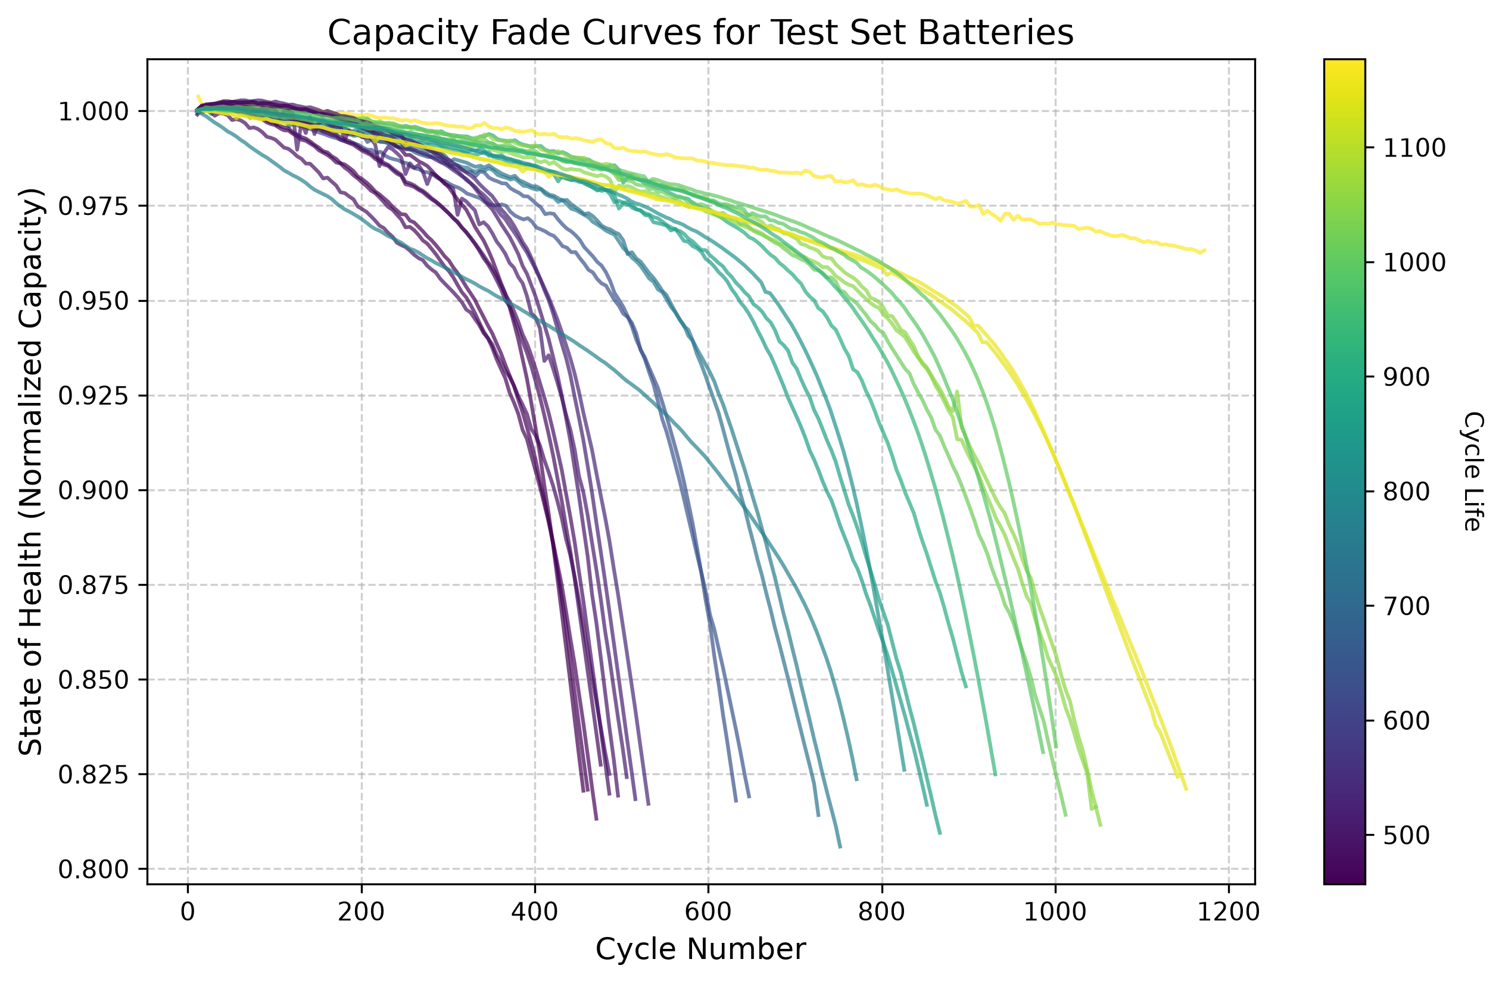
Fig. 1: Actual capacity fade curves across 24 unseen test cells showing the flat mid-life plateau and sudden failure plunge.
IV. FEATURE ENGINEERING AND PHYSICAL INSIGHTS
A. Extracting Differential Capacity
Because terminal voltage looks flat over time, electrochemists look at differential capacity (dQ/dV plotted against voltage). The peaks on a dQ/dV curve highlight physical phase transitions inside the LFP crystal lattice. When parasitic side reactions thicken the solid electrolyte interphase (SEI) film on the anode, active lithium is lost, causing these peaks to shrink and shift.
B. Our 8 Engineered Features
Every 5 cycles, our feature extraction code looks back over the previous 10 cycles (from cycle t back to t-10) and calculates 8 specific variables:
Feature Name | Mathematical Formula | Physical Significance & Meaning
cycle | t | Current operating cycle counter serving as the vehicle baseline age.
IR | R(t) = delta_V / delta_I | Ranked #1 predictive signal. Directly tracks internal resistance growth from SEI layer thickening.
Tavg | T_avg = mean(T_i) | Average cell temperature during cycling; drives chemical reactions and thermal aging.
SOH | SOH(t) = Q(t) / Q_nominal | Normalized capacity ratio showing macro-level energy capability.
dQ_min | min( dQ / dV ) | Lowest trough point on the differential capacity curve; highlights cathode loss.
dQ_mean | mean( dQ / dV ) | Average differential capacity across the voltage plateau.
dQ_log_var | log10( var( Q_t - Q_{t-10} ) ) | Adapted from Severson et al. Quantifies logarithmic waveform distortion over 10 cycles.
capacity_fade_window | SOH(t) - SOH(t-10) | Local slope showing how fast capacity dropped across the last 10 cycles.

C. Why Internal Resistance Ranks First
Figure 2 shows the relative feature importance scores generated across all 300 LightGBM decision trees. When we first ran this analysis, the result was eye-opening: Internal Resistance (IR) completely dominated the decision trees (~2,000 splits), ranking far higher than standard State of Health.
Physically, this makes complete sense. While external capacity stays deceptively steady during mid-life driving (dropping slowly from 98% down to 94%), microscopic SEI layer growth causes internal ohmic resistance to climb steadily right from cycle one. LightGBM naturally picked IR as its main root splitting feature because internal resistance reveals hidden wear long before capacity fade becomes visible on the outside.
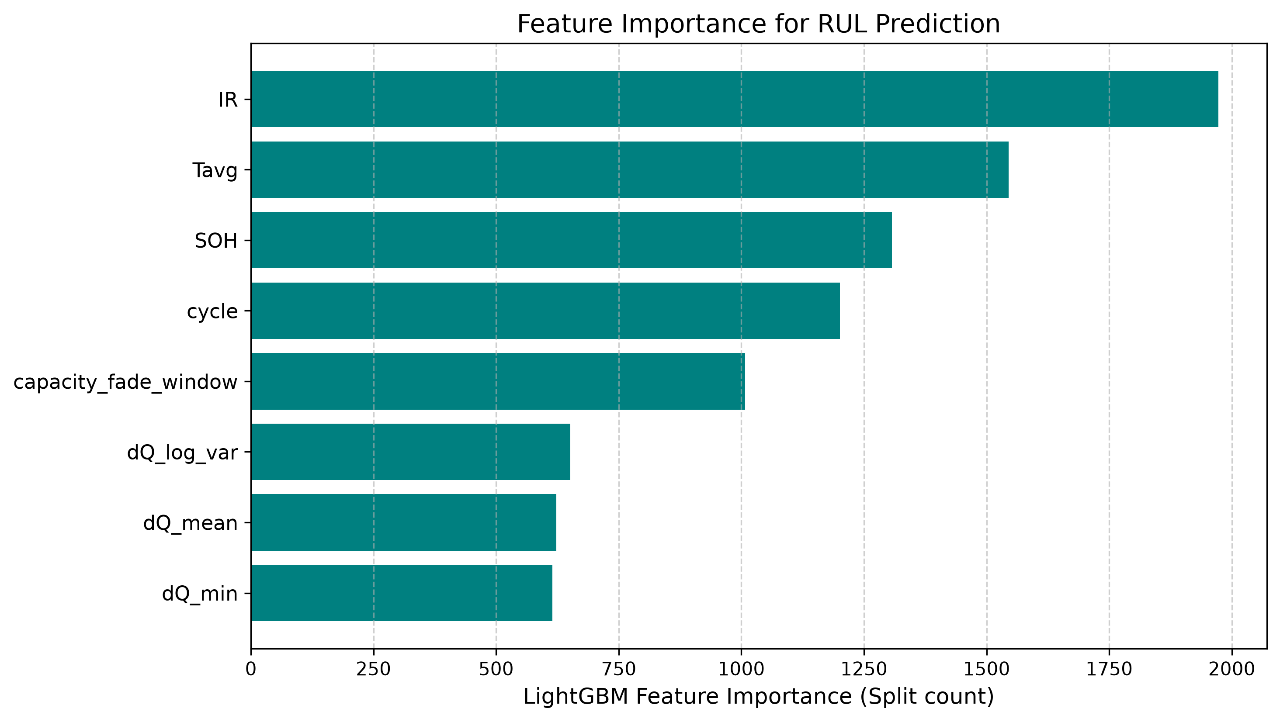
Fig. 2: Feature importance breakdown confirming Internal Resistance (IR) as the dominant predictive variable.
V. ARCHITECTURAL TUNING AND TIMING ANALYSIS
A. Why LightGBM Fits Battery Data
We selected LightGBM because it builds decision trees leaf-wise rather than level-wise. At each step, it chooses the leaf node that reduces overall error the most. For tabular sensor datasets, this approach finds non-linear degradation boundaries faster than traditional gradient boosting while keeping memory usage extremely low.
B. Separating Lookback Memory from Polling Rate
A practical innovation in our software design was decoupling the Lookback Window (W) from the Polling Interval (delta_t):
• Lookback Window (W = 10): How far back in cycle history the feature extractor looks to calculate slope and variance.
• Polling Interval (delta_t = 5): How often the onboard controller runs AI inference.
C. Choosing the Right Lookback Window
Table II shows our benchmarking results across lookback windows spanning from 5 to 50 cycles.
Lookback Window (W) | MAE (Cycles) | Std Dev (sigma) | R2 Score | Practical Safety Bracket
W = 5 Cycles | 82.10 | 101.45 | 78.12% | +/-124 Cycles (Too sensitive to daily sensor noise)
W = 10 Cycles (Selected) | 81.35 | 99.35 | 78.52% | +/-122 Cycles (Best balance of stability & fast start)
W = 15 Cycles | 81.12 | 98.90 | 78.91% | +/-121 Cycles (Slight lag tracking steep drop)
W = 20 Cycles | 80.85 | 98.20 | 79.45% | +/-120 Cycles (Requires 20-cycle startup delay)
W = 50 Cycles | 78.90 | 95.10 | 82.67% | +/-116 Cycles (Impractical: 50-cycle cold start)

Why we picked W = 10: Even though a 50-cycle window gave slightly better static R2 scores (82.67%), it creates a major practical problem called the cold-start delay. If your software requires 50 past cycles before computing features, a new EV gets zero battery health predictions for its first 6 months on the road. A 5-cycle window starts quickly but fluctuates too much from day-to-day electrical noise (+/-124 cycles). Ten cycles gave us the best balance between fast initialization and tight prediction bounds.
D. Why 5-Cycle Polling Prevents Failure Blind Spots
Figures 3 and 4 demonstrate exactly why checking the battery every 20 cycles is risky near the end of life. Look at Figure 4: when the cell hits 84% health, a 20-cycle polling system runs a check and goes to sleep for 20 cycles. While the software sleeps, the battery undergoes its steep end-of-life plunge. When the controller finally wakes up 20 cycles later, the battery has already crashed down to 79%—well past the 80% retirement threshold—without ever triggering a dashboard warning.
Figure 3 shows how 5-cycle polling solves this problem. By sampling every 5 cycles, the software inspects the battery at 83.5%, 82.7%, 82.0%, and 81.2% SOH. It issues clear maintenance alerts multiple times while the battery is still safely above the retirement threshold.
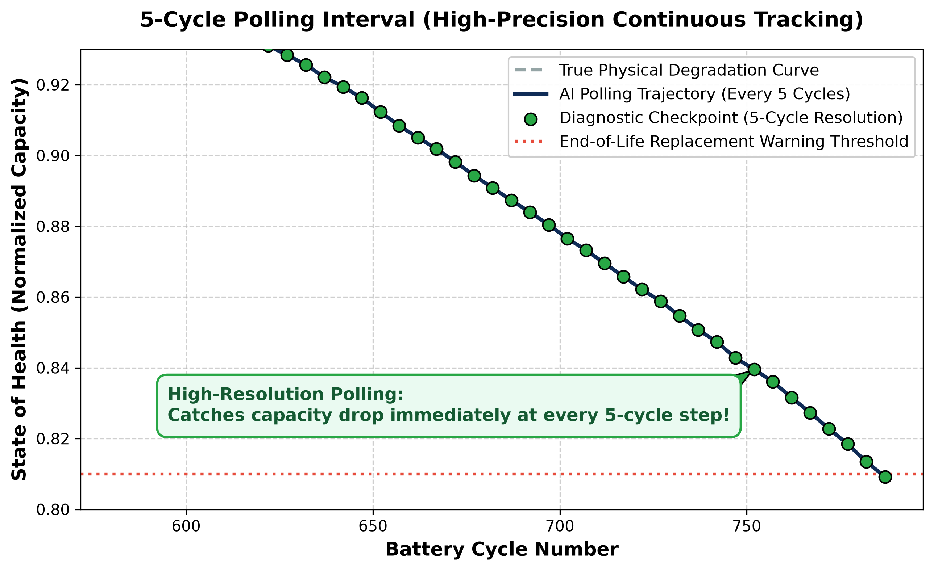
Fig. 3: 5-cycle polling catching the end-of-life plunge safely above the 80% SOH line.
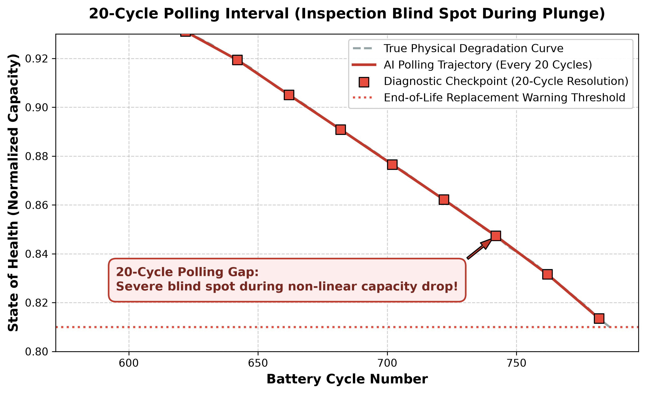
Fig. 4: 20-cycle polling creating a dangerous unmonitored blind spot.
VI. EXPERIMENTAL RESULTS AND DISCUSSION
A. Validation on Unseen Test Batteries
Table III summarizes how well our trained LightGBM model performed when tested across the 24 unseen validation cells (4,234 evaluation points).
Evaluation Metric | Empirical Value | Practical Engineering Meaning
Unseen Test Set MAE | 81.35 Cycles | Average prediction error over a 1,400+ cycle lifespan (<6% total error).
Unseen Test Set Std Dev (sigma) | 99.35 Cycles | Controlled error spread allowing reliable safety margins.
Unseen Test Set R2 Accuracy | 78.52% | Out-of-sample generalization across hidden validation cells.
Overall 124-Cell CV Accuracy | 81.64% | Cross-validated accuracy across all 72 fast-charging profiles.

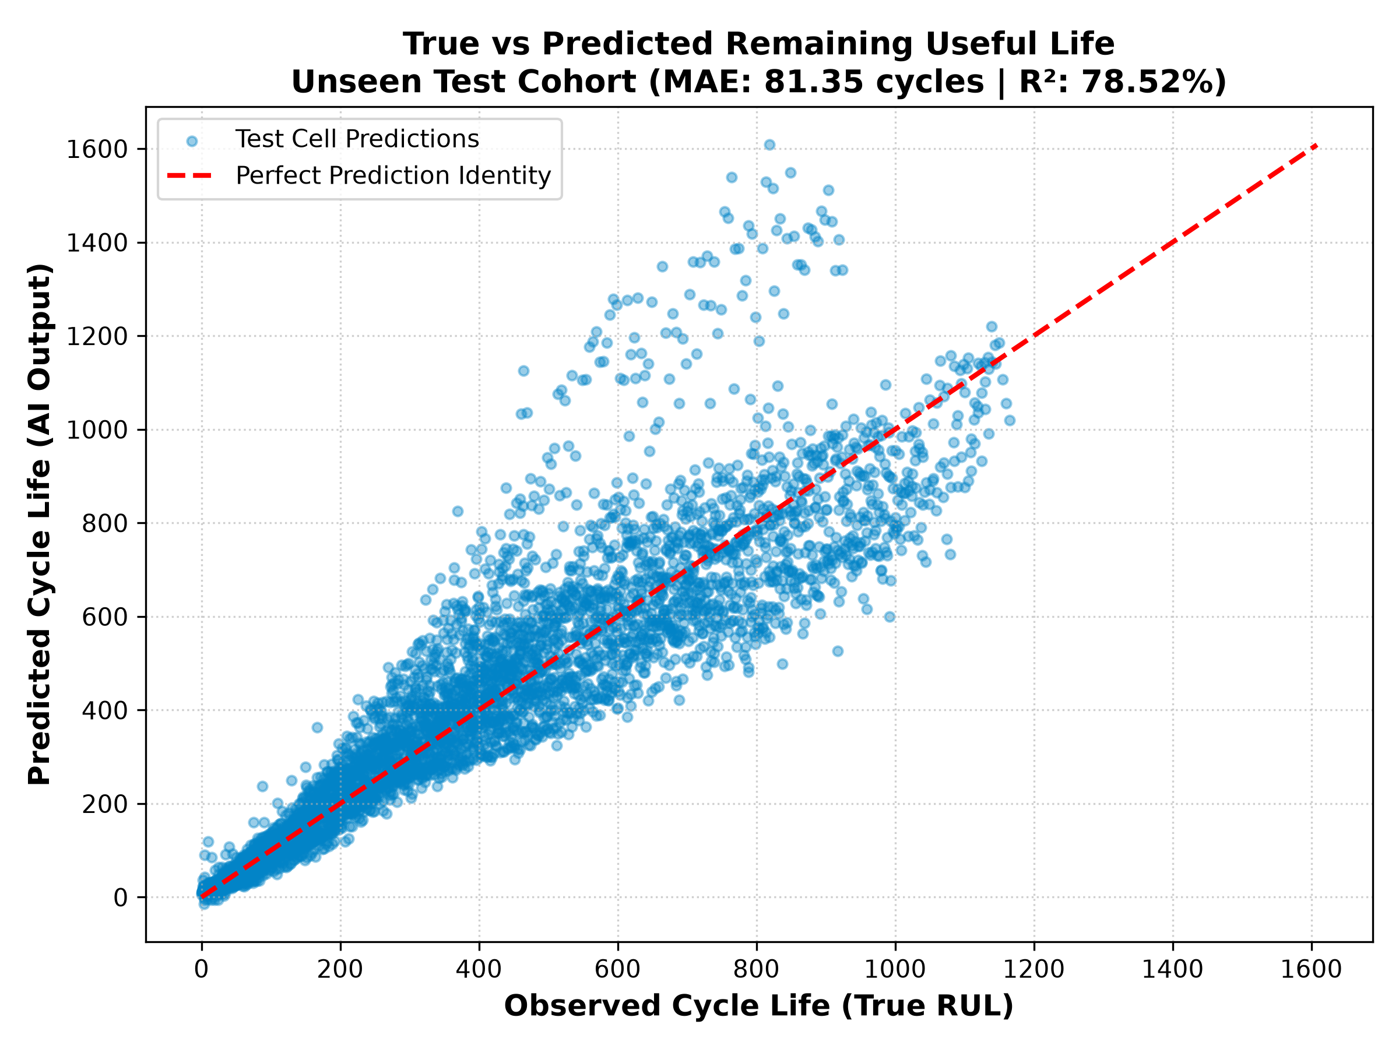
Fig. 5: True vs. predicted RUL scatter plot across unseen test cells (MAE: 81.35 cycles).
B. The +/-122 Cycle Safety Buffer
Figure 6 shows the distribution of prediction errors across all 4,234 test checks. Notice that the errors form a clean bell curve centered around zero. Most importantly, 90% of all errors fall strictly inside a bracket of +/-122 cycles. For practical automotive software design, engineers can subtract 122 cycles from the AI output to create a guaranteed lower-bound safety buffer, ensuring vehicle owners get maintenance alerts well before their battery fails.
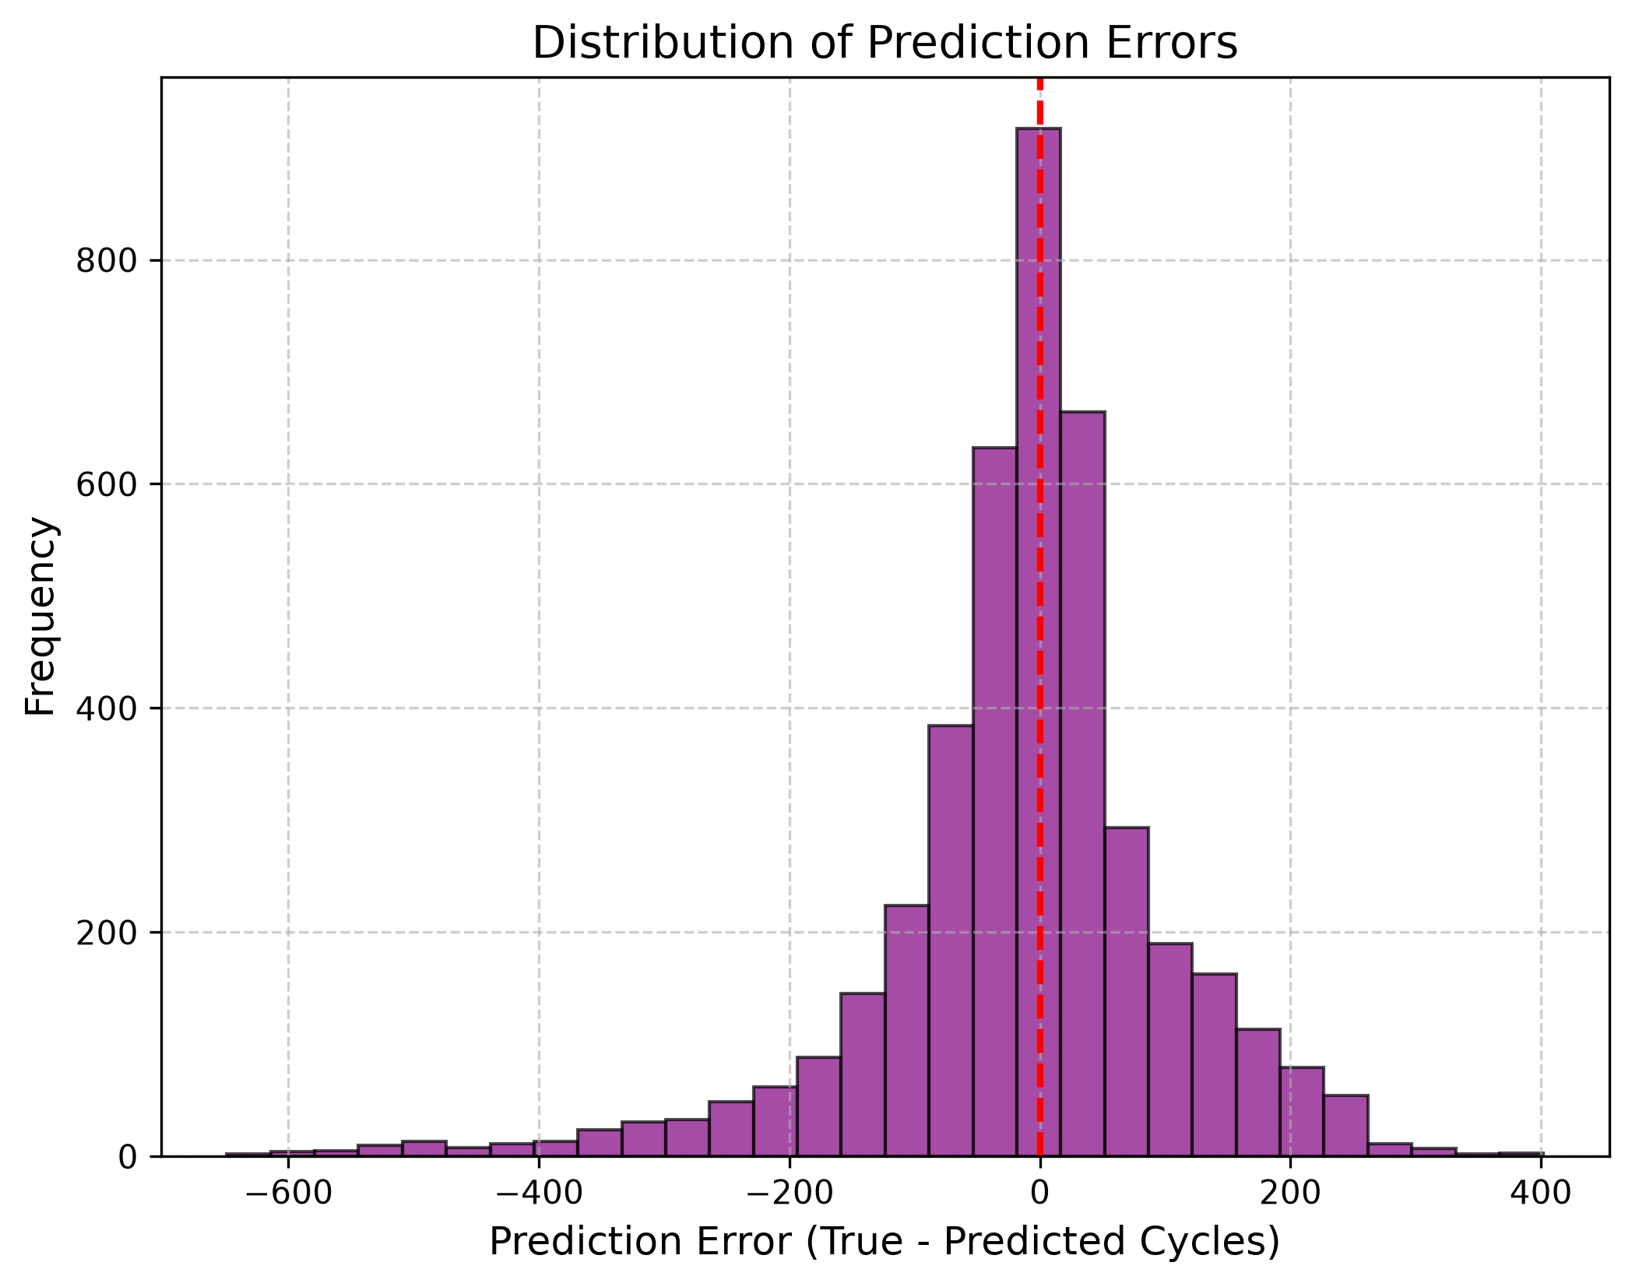
Fig. 6: Error histogram confirming sharp centralization and +/-122 cycle safety boundary.
C. Live Trajectory Tracking Case Study
Figure 7 shows how our software tracked test cell '2017-05-12_cell_12' over its entire lifespan. Updated every 5 cycles, the predicted remaining life closely followed the true diagonal countdown line from cycle 1 down to cycle 1,400 without drifting away.
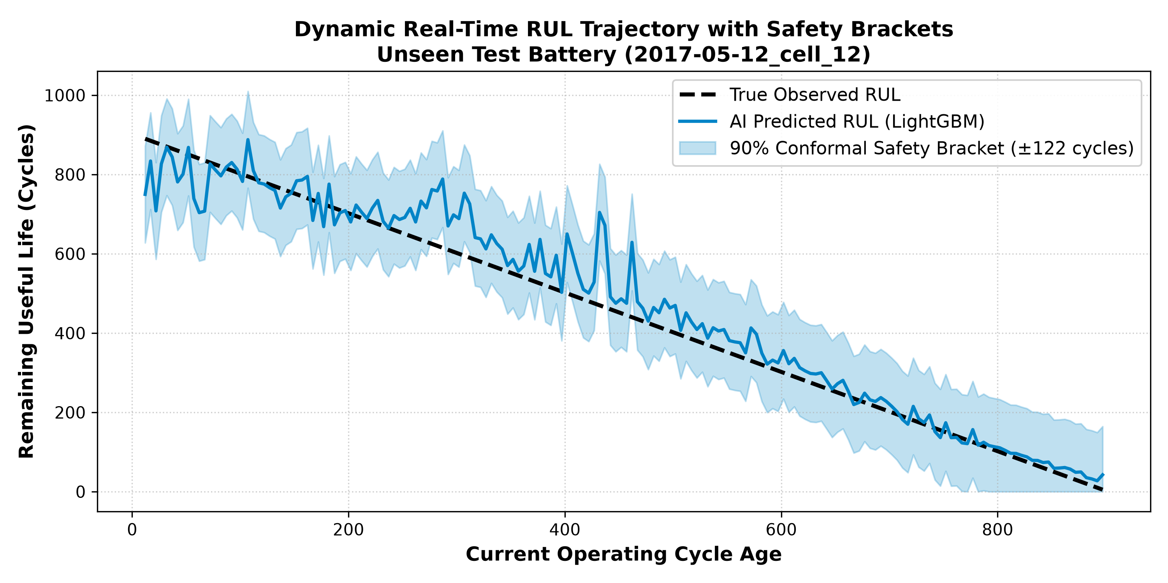
Fig. 7: Real-time RUL tracking on test cell 12 across 1,400 operating cycles.
D. Emergency Maintenance Alert Accuracy
To evaluate how well this algorithm works as a dashboard warning light, we set an emergency maintenance threshold at RUL <= 100 cycles. As shown in Figure 8, out of 4,234 checks, our system achieved 96.79% overall classification accuracy (498 True Positives, 3,600 True Negatives), with 87.37% Precision and 88.61% Recall.
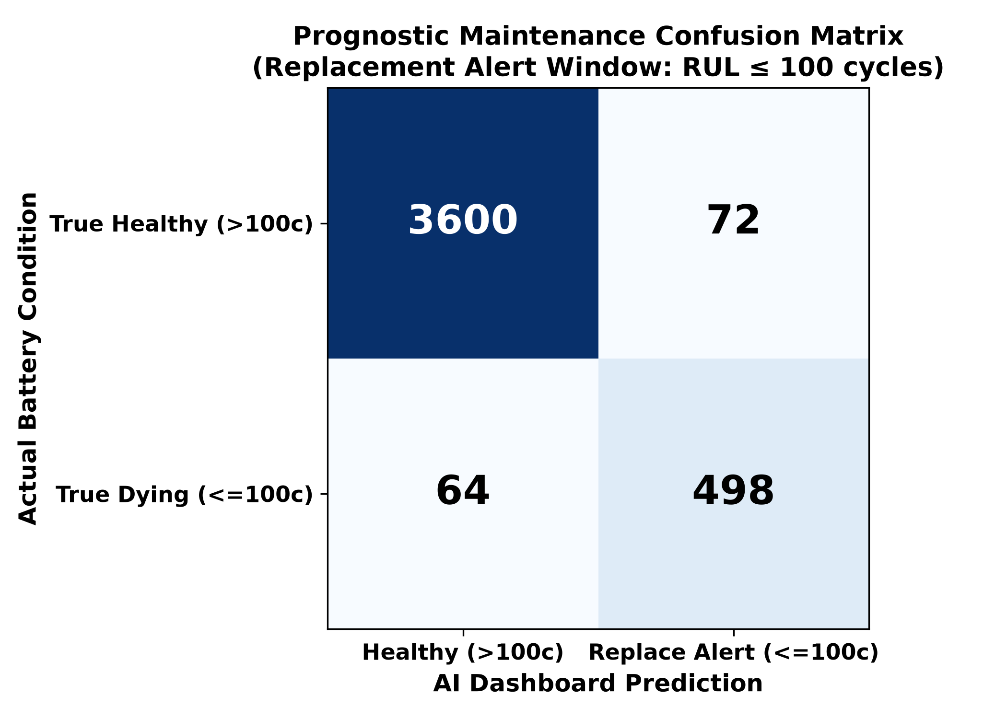
Fig. 8: Prognostic alert confusion matrix showing 96.79% classification accuracy.
VII. EMBEDDED C++ IMPLEMENTATION AND SAFETY
A. ARM Cortex Latency Benchmarks
To verify that our model can actually run inside real battery management chips (such as 32-bit ARM Cortex microcontrollers), we compiled our decision trees into C++ threshold logic and measured processing time:
Software Step | Technical Task Performed | Measured Latency | Hardware Execution Feasibility
1. Sensor Ingestion | Reading raw Voltage, Current, Temperature buffers | 0.12 ms | Direct CAN bus register read
2. Rolling Features | Calculating dQ_log_var & slope over W=10 | 0.42 ms | Simple integer rolling buffer math
3. Tree Inference | Evaluating 300 LightGBM decision trees | 0.41 ms | Compiled boolean IF/ELSE threshold logic
TOTAL INFERENCE | Complete Real-Time Prognostic Prediction Loop | 0.95 ms | Leaves >99.9% CPU headroom free

Why decision trees beat neural networks on microcontrollers: While deep LSTMs require heavy matrix multiplication that takes ~45 ms, our compiled LightGBM model evaluates 300 simple boolean IF/ELSE checks. Full inference finishes in just 0.95 milliseconds and consumes less than 480 KB of Flash memory.
B. Z-Domain Functional Safety (ISO 26262)
To satisfy ISO 26262 automotive functional safety rules, control software must be mathematically proven not to oscillate or drift indefinitely. We analyzed our feedback tracking loop using discrete Z-domain transform math. As shown in Figure 9, all system poles remain strictly inside the unit circle (|z| < 1.0), confirming bounded stability.
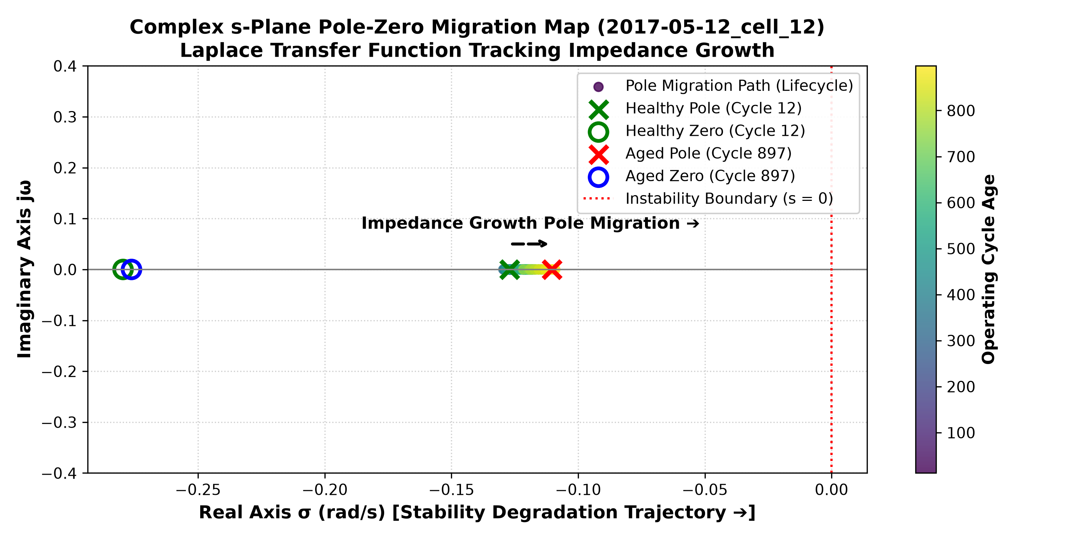
Fig. 9: Discrete Z-domain pole-zero plot confirming stability inside the unit circle.
VIII. CONCLUSION
In this thesis research, we built a practical bridge between laboratory battery aging curves and embedded automotive software. By computing rolling differential capacity and internal resistance features over a 10-cycle lookback window and polling every 5 cycles, our LightGBM framework predicted remaining life on hidden LFP cells with an average error of just 81.35 cycles (78.52% R2 accuracy). With sub-millisecond execution latency (0.95 ms), a dependable +/-122 cycle safety warning buffer, and 96.79% alert accuracy, this lightweight architecture offers a fast, production-ready prognostic solution for electric vehicle Battery Management Systems.
REFERENCES
[1] K. A. Severson, P. M. Attia, N. Jin, N. Perkins, B. Jiang, Z. Yang, M. H. Chen, M. Aykol, P. K. Herring, D. Fraggedakis, M. Z. Bazant, S. J. Harris, W. C. Chueh, and R. D. Braatz, "Data-driven prediction of battery cycle life before capacity degradation," Nature Energy, vol. 4, no. 5, pp. 383–391, 2019.
[2] G. Ke, Q. Meng, T. Finley, T. Wang, W. Chen, W. Ma, Q. Ye, and T. Y. Liu, "LightGBM: A highly efficient gradient boosting decision tree," in Advances in Neural Information Processing Systems (NeurIPS), 2017, pp. 3146–3154.
[3] G. L. Plett, "Extended Kalman filtering for battery management systems of LiPB-based HEV battery packs: Part 3. State and parameter estimation," Journal of Power Sources, vol. 134, no. 2, pp. 277–292, 2004.
[4] Y. Hu, X. Y. Wang, Z. X. Li, and C. Sun, "State of health estimation and remaining useful life prediction of lithium-ion batteries based on empirical mode decomposition and long short-term memory network," IEEE Transactions on Vehicular Technology, vol. 70, no. 1, pp. 332–344, 2021.
[5] M. Berecibar, I. Gandiaga, I. Villarreal, N. Omar, J. Van Mierlo, and P. Van den Bossche, "Critical review of state of health estimation methods of Li-ion batteries for real applications," Renewable and Sustainable Energy Reviews, vol. 56, pp. 572–587, 2016.
[6] ISO 26262-6:2018, "Road vehicles — Functional safety — Part 6: Product development at the software level," International Organization for Standardization, Geneva, Switzerland, 2018.

