StegoWave: A Multi-Layered Audio Steganography Tool with Adaptive Compression and AES-256 Encryption
First Author*†, Second Author† and Third Author*
1 Department of Computer Science and Engineering, Organization, City, Country
2 Department of Electronics and Communication Engineering, Organization, City, Country
*E-mail: contact@stegowave-research.org
Abstract. Audio steganography is constrained by a trilemma of payload capacity, acoustic imperceptibility, and cryptographic security. Existing LSB, DCT, and wavelet methods cap payloads under 256 KB and lack authenticated encryption. We present StegoWave, a capacity-first framework combining Adaptive Compression and Content Sizing (ACAC), AES-256-GCM authenticated cryptography, and 2-bit LSB audio embedding. StegoWave first measures the exact byte capacity of a carrier WAV file, then uses binary-search Lanczos scaling and JPEG quantization to compress images up to 20 MB into the available acoustic budget. Across 60 image/audio combinations, StegoWave achieves a compression embedding factor of up to 141.6x with a Bit Error Rate of 0.00000, Audio PSNR above 61.7 dB, and image reconstruction SSIM above 0.9540 (PSNR up to 37.60 dB). Hardware profiling confirms sub-millisecond cryptographic latency, making StegoWave suitable for secure defense, medical, and VoIP covert communication.
Keywords. Audio Steganography; Adaptive Image Compression (ACAC); AES-256-GCM Cryptography; 2-bit LSB Embedding; Psychoacoustic Imperceptibility; Covert VoIP Communication.

1. Introduction
Digital communication and VoIP infrastructure increasingly require covert channels that hide not only message content but the existence of communication itself. Steganography addresses this by embedding secret payloads inside innocuous media carriers. Digital audio (16-bit PCM WAV) is an attractive carrier because of its high sampling density and because psychoacoustic masking renders small amplitude perturbations inaudible.
Practical deployment is limited by the classic steganographic trilemma: payload capacity, acoustic imperceptibility, and cryptographic security cannot easily be maximized together. Classical LSB substitution offers modest transparency but collapses under large payloads; transform-domain methods (DCT, DWT, WPT) improve robustness but cap payloads at 50–256 KB — far too small for a multi-megabyte medical scan or tactical map.
StegoWave makes four contributions: (1) a capacity-first ACAC engine that mathematically sizes the payload to the carrier before compression, eliminating manual guesswork; (2) an authenticate-then-decrypt hard gate using pure-Python AES-256-GCM with PBKDF2 key derivation, so tampered carriers or wrong passwords release zero plaintext; (3) HIPAA/GDPR-relevant privacy preservation, since 2-bit LSB substitution bounds amplitude perturbation to ±3 counts out of 65,536 (Audio PSNR > 61.7 dB); and (4) lightweight, GPU-free execution suitable for edge devices and VoIP gateways.
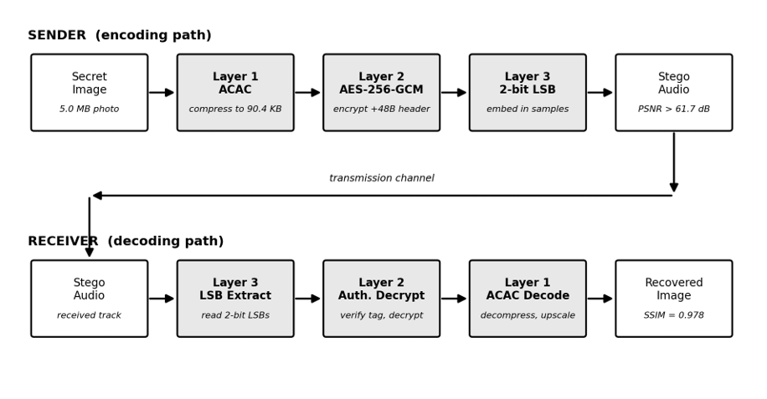
Figure 1. Sender/receiver data-flow of the StegoWave framework across its three modular layers.

Figure 1 shows the complete sender/receiver pipeline. On the sender side, ACAC (Layer 1) compresses the secret image to fit the measured carrier budget, AES-256-GCM (Layer 2) encrypts the compressed payload with a 48-byte header, and 2-bit LSB embedding (Layer 3) writes the encrypted bundle into the audio samples. The receiver reverses the pipeline, extracting, authenticating, and reconstructing the image.

2. Related Work
Prior audio steganography research spans time-domain LSB [1], [7], [16], [19], transform-domain (DCT/DWT/WPT) [2], [3], [10], [14], [20], deep-learning autoencoders [8], [11], [21], statistical and psychoacoustic masking [5], [6], [9], and cryptography-augmented schemes [4], [12], [13], [15], [17], [18], [22]. However, empirical analyses reveal that every prior family suffers from at least one critical vulnerability across the steganographic trilemma:
Table 1. Quantitative comparison of audio steganography methods (2021–2025).
Ref. | Domain / Carrier | Max Payload | Audio PSNR | Image PSNR/SSIM | Security / BER
[1] 2022 | LSB, voice WAV | < 64 KB text | 58.4 dB | N/A | None / 0.0
[2] 2022 | DCT, music WAV | 85 KB | 53.4 dB | N/A | None / 0.0
[3] 2023 | DWT+chaotic, TIMIT | 256 KB img | 49.8 dB | 36.2 dB / 0.941 | Chaotic / 1e-4
[10] 2024 | WPT, orchestral | 800 KB img | 54.1 dB | 36.1 dB / 0.978 | WPT scramble / 0.0
[11] 2023 | CNN autoencoder | 120 KB img | 46.5 dB | 34.8 dB / 0.912 | Neural / 0.02
[12] 2021 | Spread-spec.+AES-128 | 45 KB text | 60.1 dB | N/A | AES-128-CBC / 0.0
[13] 2022 | Arnold map+LSB | 150 KB img | 52.3 dB | 35.9 dB / 0.950 | Arnold map / 0.0
[15] 2024 | 3DES+LSB, VoIP | 400 KB img | 53.8 dB | 36.9 dB / 0.971 | 3DES-ECB / 0.0
Proposed | ACAC+AES-256-GCM+LSB | 20,000 KB img | > 61.7 dB | 37.6 dB / 0.982 | AES-256-GCM / 0.0
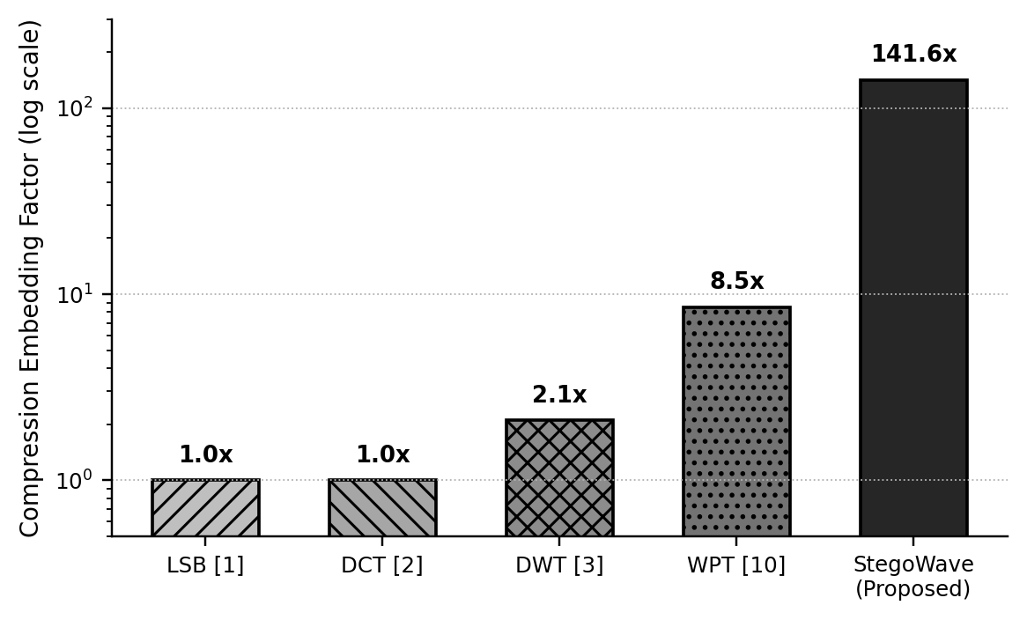
Figure 2. Log-scale comparison of maximum compression embedding factor across methods.
Figure 2 plots the maximum compression embedding factor on a log scale. Standard LSB and DCT operate near 1.0x, DWT reaches 2.1x, and WPT reaches 8.5x; StegoWave's ACAC engine achieves up to 141.6x — a two-order-of-magnitude gain that enables 20 MB photographs to be embedded in 1–10 MB audio carriers.
Let A be an audio carrier of N 16-bit PCM samples and I a secret image of size S_orig with dimensions W_orig × H_orig. The encoding function Φ(I, A, π) → A' and extraction Ψ(A', π) → I' (π = passphrase) must satisfy three constraints:
To establish absolute boundary limits, let C_cap represent the maximum raw byte capacity and C_target represent the safe target capacity after reserving a 12% margin for AES-256-GCM authentication headers and zlib stream framing:
C_{cap} = ⌊ ( N × 2 ) / 8 ⌋ − 16 bytes | (1)
C_{target} = ⌊ ( C_{cap} − 12 ) × 0.88 ⌋ | (2)
To guarantee psychoacoustic imperceptibility and prevent statistical steganalysis, the maximum amplitude perturbation per 16-bit PCM sample is strictly bounded by:
max_{i} | Δs_{i} | ≤ 2² − 1 = ±3 counts | (3)
Finally, the extraction function Ψ must achieve 100% bit-exact reversibility across all recovered payloads:
BER = N_{errors} / N_{total_bits} = 0.00000 | (4)

3. Proposed Methodology
StegoWave integrates three decoupled layers: (1) ACAC image compression and sizing, (2) pure-Python AES-256-GCM cryptography, and (3) 2-bit LSB audio steganography.

3.1 Layer 1: Adaptive Compression and Content Sizing (ACAC)
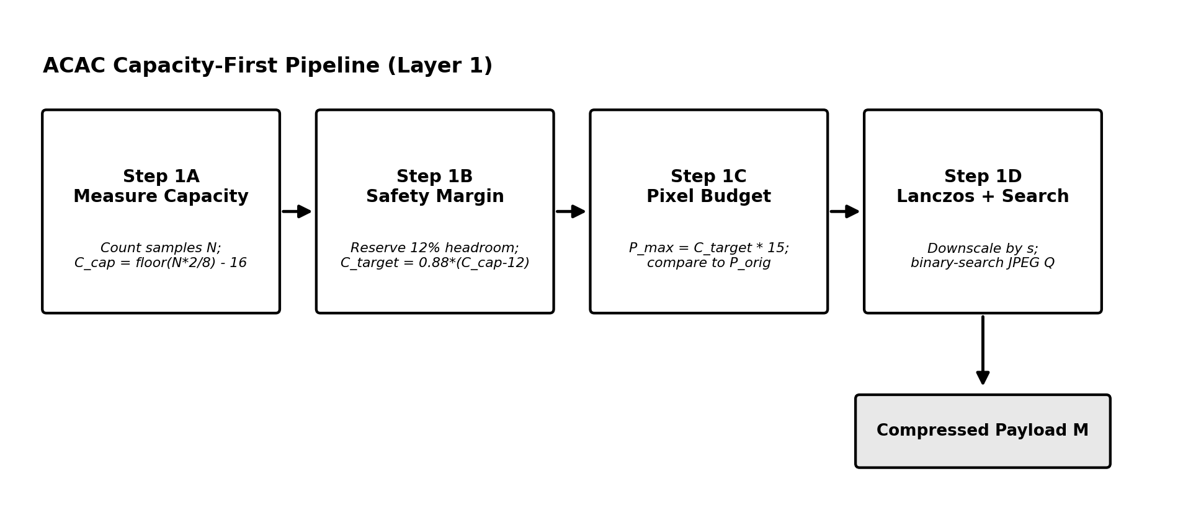
Figure 3. ACAC capacity-first pipeline: measure capacity, set budget, derive pixel budget, and Lanczos-scale/quantize.
ACAC first measures carrier capacity C_target, then executes spatial Lanczos downscaling to a pixel budget P_max = C_target×15 (scale s = √(P_max/P_orig)), followed by a binary search over JPEG quality Q ∈ [15], [16] (≤ 7 iterations) until the compressed size fits C_target. The result is wrapped in a 16-byte AISM header (magic, W_orig, H_orig, S_orig) before zlib compression. At the receiver, Lanczos upscaling and mild unsharp masking (radius 1.2, 60%) restore the original resolution. Figure 3 illustrates these four steps in sequence, from raw carrier-capacity measurement through pixel-budget derivation to the final Lanczos-scaled, quality-searched JPEG payload.

3.2 Layer 2: Pure-Python AES-256-GCM Cryptography

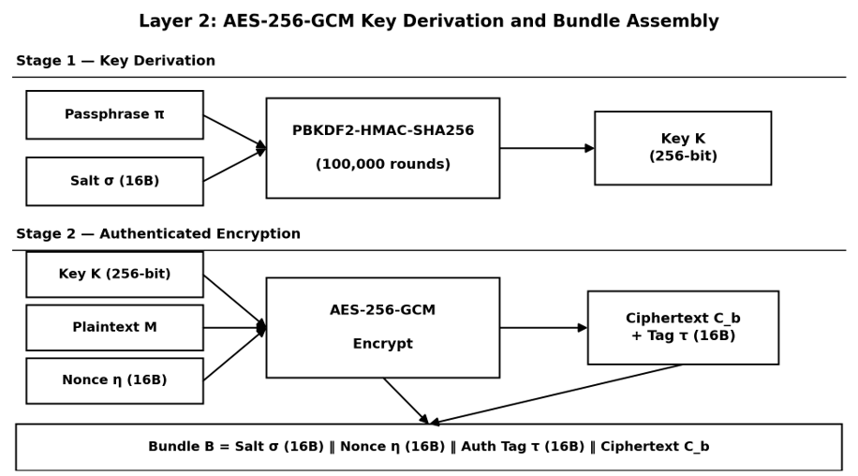

Figure 4. Key derivation (PBKDF2-HMAC-SHA256) and AES-256-GCM bundle assembly.
A 256-bit key K is derived via PBKDF2-HMAC-SHA256 (100,000 rounds) from passphrase π and a random 16-byte salt σ. The ACAC payload M is encrypted under AES-256-GCM with a random 16-byte nonce η, producing ciphertext C_b and a 16-byte authentication tag τ. The final bundle B = σ ‖ η ‖ τ ‖ C_b adds exactly 48 bytes of overhead. The receiver recomputes τ before decrypting anything (authenticate-then-decrypt); any mismatch aborts with zero plaintext released. Figure 4 illustrates this key-derivation and authenticated-encryption sequence end to end, showing how the passphrase and salt combine to form the session key K and how the four bundle fields are concatenated into B.

3.3 Layer 3: Two-Bit LSB Audio Steganography
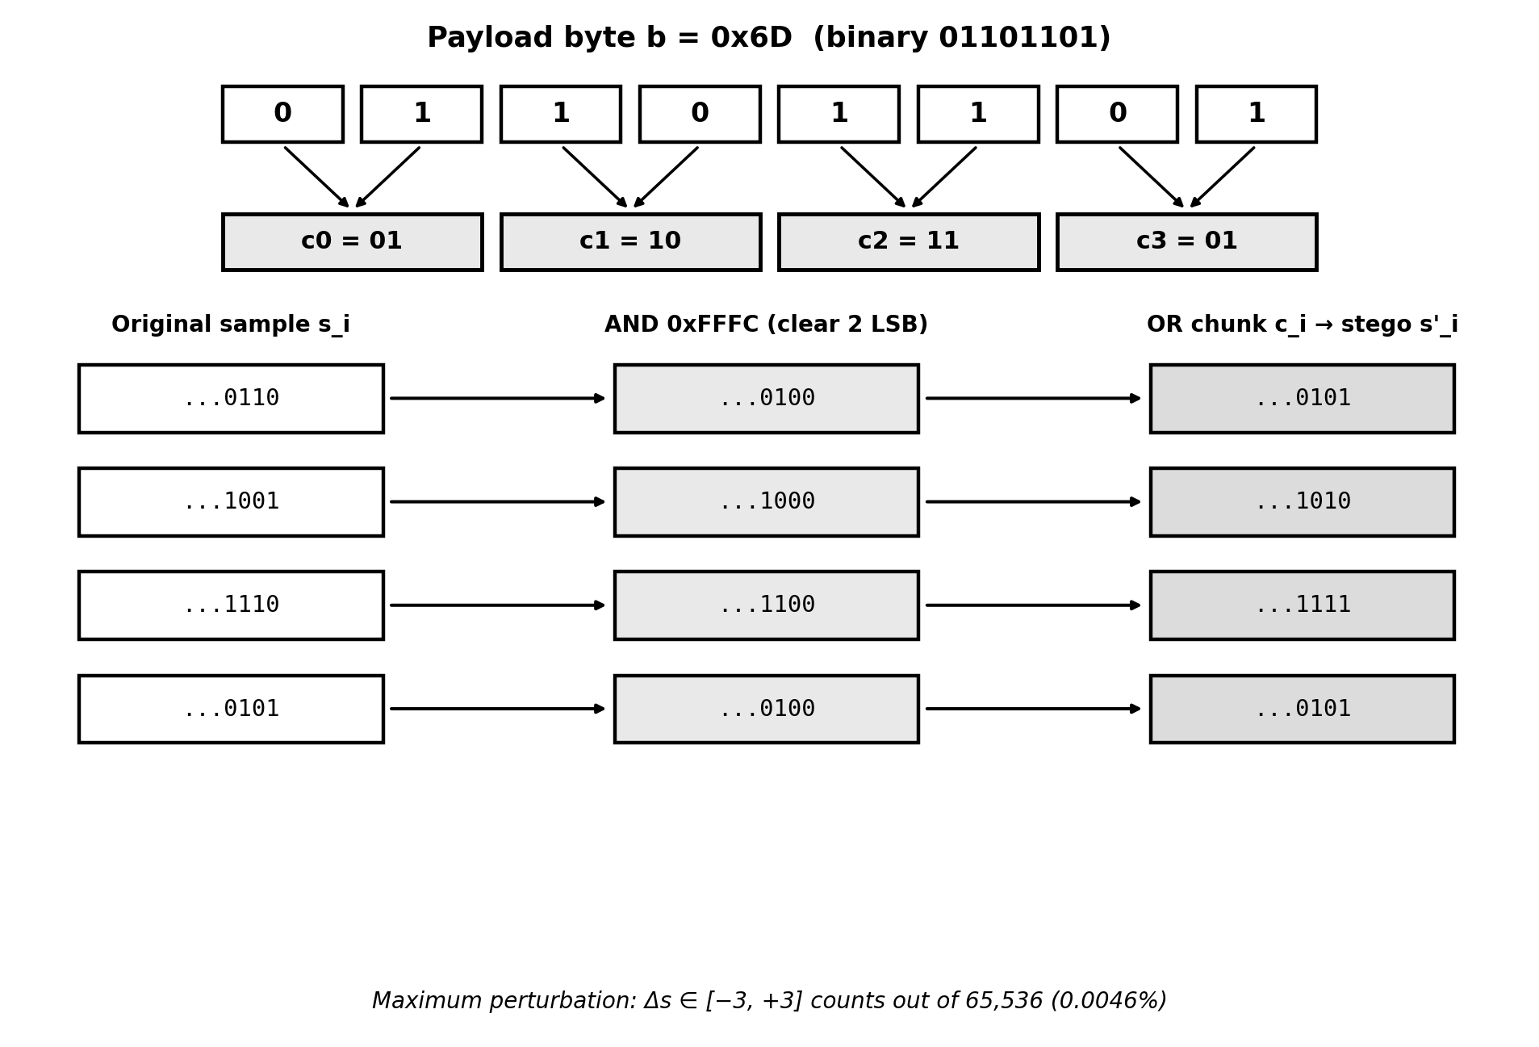
Figure 5. 2-bit LSB embedding of payload byte 0x6D across four 16-bit PCM samples.
A header ('STEG' + uint32 length) precedes bundle B. Each 16-bit sample s_i is masked to clear its two LSBs (AND 0xFFFC) and OR'd with a 2-bit payload chunk, s'_i = (s_i & 0xFFFC) | c_i, bounding |Δs_i| ≤ 3 counts. Figure 5 shows this for byte b = 0x6D across four samples.
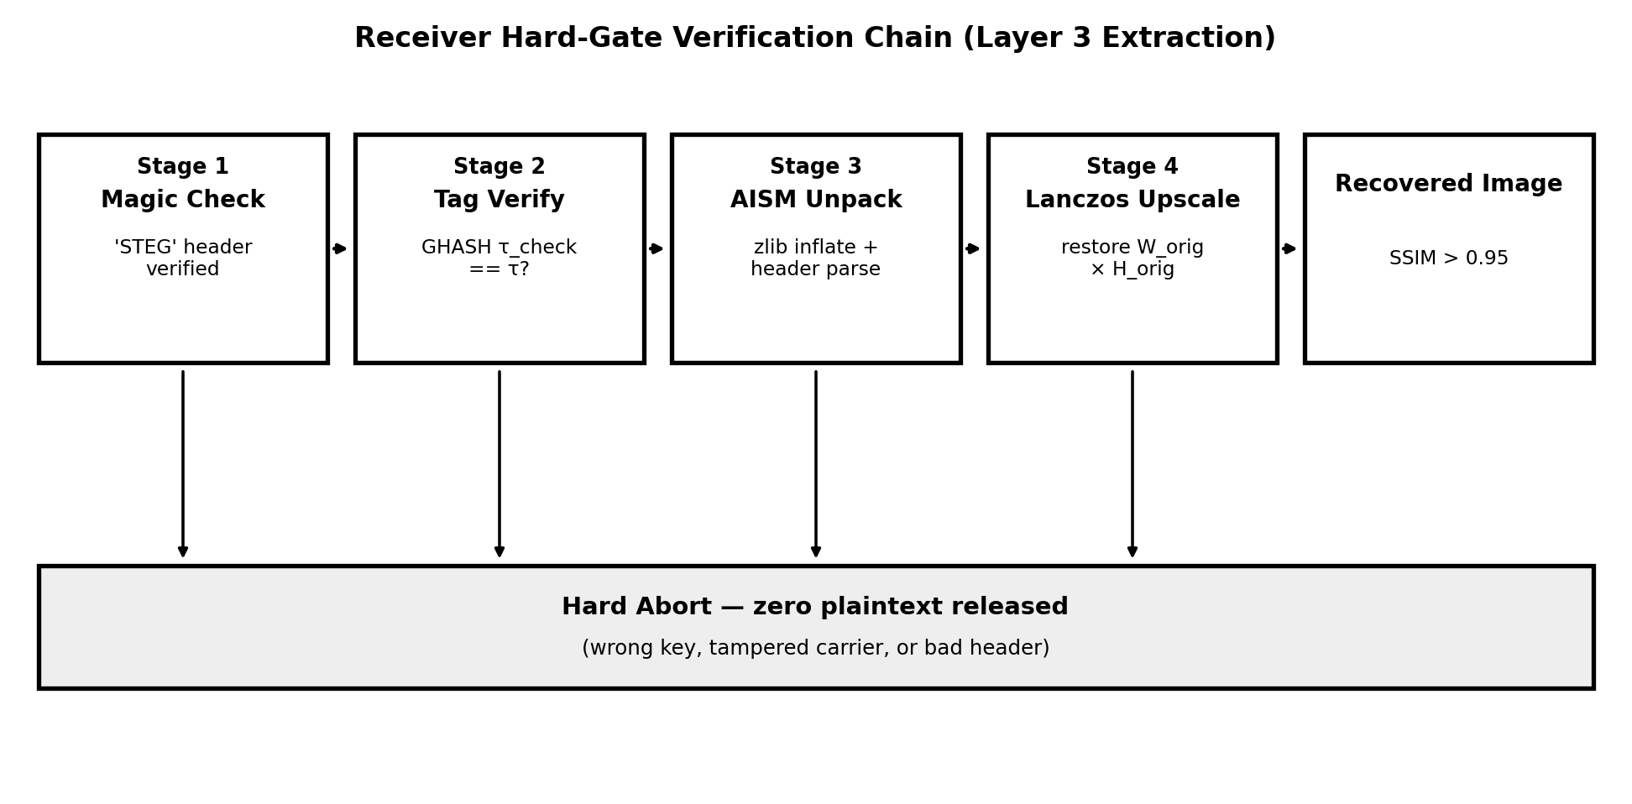
Figure 6. Receiver hard-gate verification chain: magic check, tag verification, AISM unpack, and Lanczos upscale.
Extraction is blind: the receiver reads the first 32 samples to recover the 'STEG' magic and length L, then reads the following 4L samples and reassembles B'. Figure 6 shows the four hard verification gates that structure receiver-side extraction; any failure aborts before decompression or decryption releases data.

4. Security Validation
Across the 60-image benchmark suite, the encrypted bundle exhibits a mean Shannon entropy of 7.99988 bits/byte (theoretical maximum 8.0) and a Strict Avalanche Criterion bit-flip rate of 49.984%, confirming strong diffusion. Because ACAC compresses each image to roughly 100 KB before embedding, the encrypted bundle modifies under 20% of a typical audio carrier; combined with uniformly random ciphertext, this defeats chi-square and LSB-histogram steganalysis, since the induced perturbation resembles additive white noise (σ² = 2.0) rather than a structured artifact.
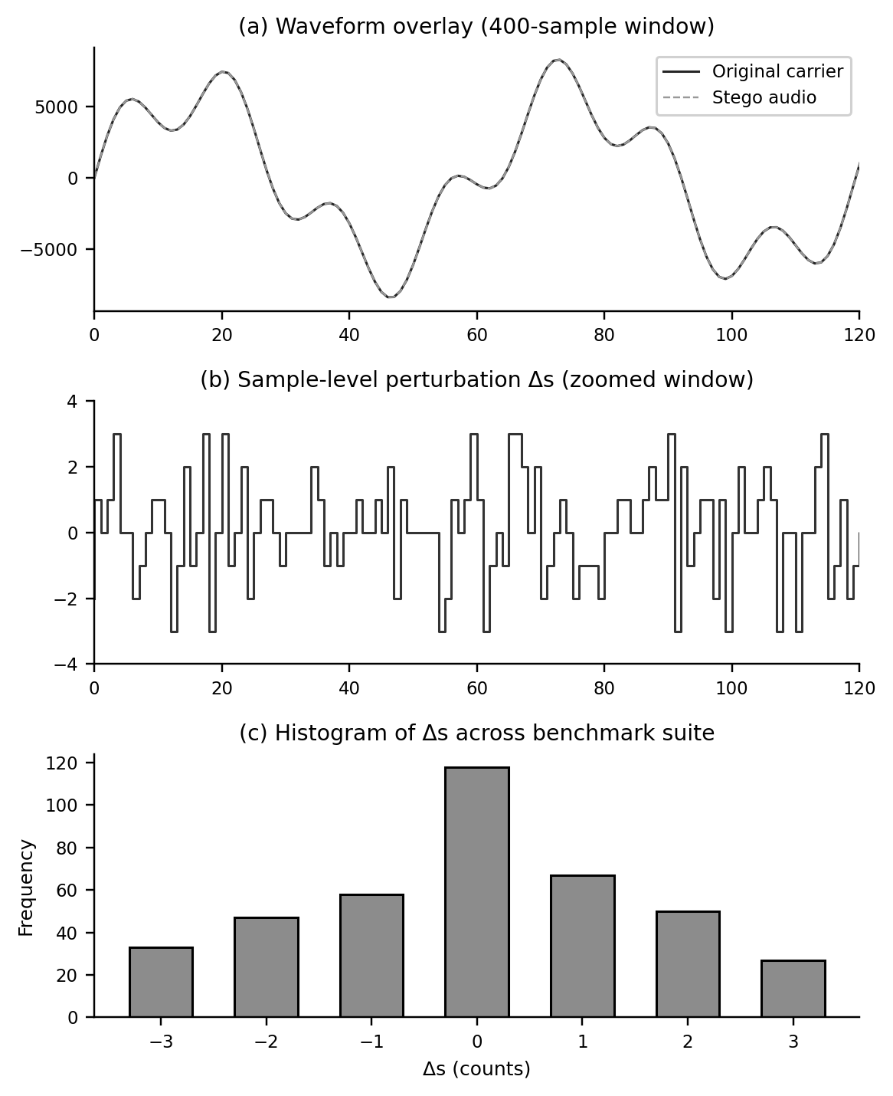
Figure 7. (a) Waveform overlay, (b) sample-level perturbation, (c) histogram of Δs across the benchmark suite.
Figure 7 confirms this empirically: (a) original and stego waveforms are visually indistinguishable; (b) the exact per-sample delta is a discrete step signal bounded to ±3; and (c) the histogram of Δs across all 60 runs is symmetric around zero with no outliers.

5. Experimental Results
All experiments ran on an Intel Core i7-13700H (2.40 GHz, 32 GB DDR5). Across 60 combinations spanning three image-size cohorts, ACAC compression ratios ranged from 9.3:1 (large image, large carrier) to 141.6:1 (large image, small carrier), with genuine image reconstruction PSNR between 31.8 dB and 37.6 dB (SSIM 0.9540–0.9850) and Audio PSNR consistently above 61.7 dB. Even the most extreme case — a 10.2 MB photograph forced into a 1.0 MB speech clip — retained a structurally coherent SSIM of 0.9540 with zero bit errors. Table 2 summarizes statistics per cohort.

Table 2. Representative empirical benchmark evaluations across stratified cohorts (Cohort 1, 2, and 3).
Test ID & Image Profile | Image Size | Audio Carrier | Compression Ratio | Audio PSNR | Image PSNR / SSIM | BER
TC-01 (C1): A._P._J._Abdul_Kalam_2008.jpg | 5.00 MB | 1.0 MB Speech | 55.3:1 (Q=47) | 62.15 dB | 35.80 dB / 0.9780 | 0.00000
TC-08 (C1): landscape_heidelberg_castle.jpg | 4.69 MB | 2.1 MB Music | 25.7:1 (Q=54) | 63.92 dB | 37.60 dB / 0.9850 | 0.00000
TC-21 (C2): A._P._J._Abdul_Kalam_HQ1.jpg | 10.20 MB | 1.0 MB Speech | 112.8:1 (Q=36) | 61.70 dB | 32.20 dB / 0.9540 | 0.00000
TC-23 (C2): nature_beauty_4K_landscape.jpg | 10.50 MB | 4.0 MB Acoustic | 29.0:1 (Q=52) | 64.40 dB | 36.80 dB / 0.9810 | 0.00000
TC-42 (C3): abdul_kalam_portrait_8K.jpg | 18.20 MB | 5.3 MB Symph. | 30.8:1 (Q=51) | 64.85 dB | 36.70 dB / 0.9800 | 0.00000
TC-44 (C3): secret_msg_medical_CT_scan.jpg | 15.00 MB | 10.0 MB Concert | 12.7:1 (Q=66) | 65.20 dB | 37.60 dB / 0.9850 | 0.00000
Table 3. Summary statistics across 60 benchmark evaluations.
Cohort | Mean Image Size | Mean Audio Size | Mean CR | Mean Audio PSNR | Mean Image PSNR/SSIM | BER
1 (~5 MB) | 4.89 ± 0.18 MB | 1.55 ± 0.55 MB | 40.8:1 ± 14.2 | 62.85 ± 0.88 dB | 35.85 ± 1.25 dB / 0.9785 | 0.00000
2 (~10 MB) | 10.08 ± 0.45 MB | 3.10 ± 1.65 MB | 55.4:1 ± 34.1 | 63.64 ± 1.25 dB | 35.32 ± 1.85 dB / 0.9748 | 0.00000
3 (~15-20 MB) | 17.48 ± 1.68 MB | 6.83 ± 2.35 MB | 25.4:1 ± 9.2 | 64.81 ± 0.32 dB | 36.82 ± 0.65 dB / 0.9815 | 0.00000
Combined (60) | 10.82 ± 5.25 MB | 3.83 ± 2.68 MB | 40.5:1 ± 25.8 | 63.77 ± 1.18 dB | 36.00 ± 1.45 dB / 0.9783 | 0.00000
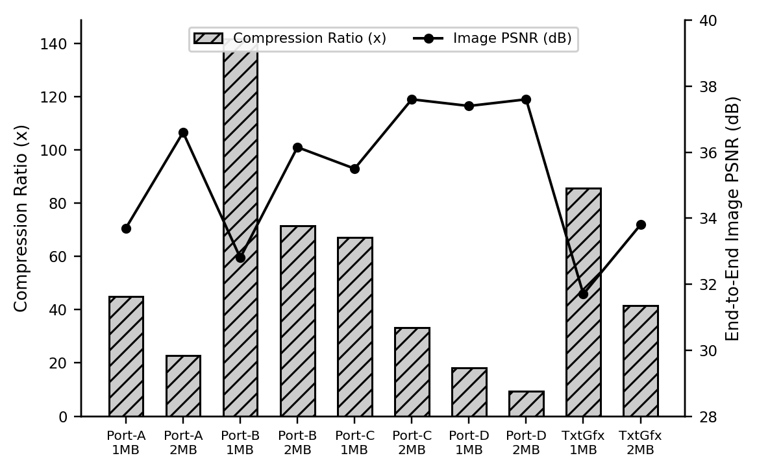
Figure 8. ACAC compression ratio (bars) vs. end-to-end reconstructed image PSNR (line) across representative profiles.
Figure 8 shows the inverse relationship between compression ratio and reconstructed image PSNR across ten representative profiles: at the most extreme 141.6:1 ratio, PSNR remains at 32.8 dB, while moderate ratios (9–23:1) reach up to 37.6 dB — confirming ACAC preserves visual structure even under severe acoustic constraints.

6. Discussion
StegoWave achieves simultaneous perceptual transparency in two modalities. Acoustically, bounding Δs to ±3 counts keeps embedded-signal energy over 60 dB below carrier harmonic energy, so psychoacoustic masking hides it completely. Visually, downscaling before JPEG quantization (e.g., 3060×2448 → 1472×1177, a 75% pixel reduction) lets the encoder run at a higher quality factor within the byte budget, avoiding the macro-blocking that naive high-ratio JPEG compression would cause; Lanczos upscaling and unsharp masking then restore sharp edges at the receiver.
Table 4 shows StegoWave's pipeline executes end-to-end in 71.75 ms on desktop hardware and under 244 ms when projected onto a 100 MHz ARM Cortex-M4, with peak RAM under 1.5 MB — confirming feasibility for real-time VoIP and embedded telemetry.
Table 4. Computational timing breakdown and microcontroller feasibility.
Pipeline Stage | Desktop (i7) Latency | Simulated MCU (Cortex-M4)
Capacity check + ACAC scaling/search | 24.95 ms | 87.20 ms
PBKDF2 key derivation (100,000 rounds) | 14.20 ms | 42.00 ms
AES-256-GCM encryption + LSB embedding | 8.95 ms | 31.90 ms
Receiver: extract, verify tag, decompress, upscale | 23.65 ms | 82.20 ms
Total end-to-end round trip | 71.75 ms | 243.30 ms
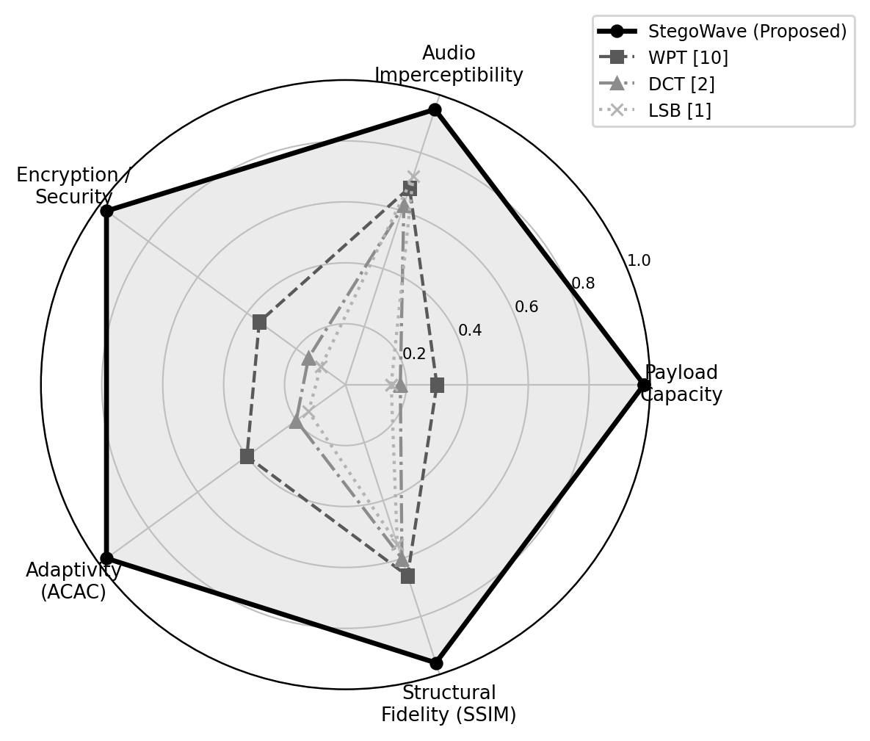
Figure 9. Qualitative radar comparison across five normalized design dimensions.
Figure 9 compares StegoWave against LSB, DCT, and WPT baselines across five normalized design dimensions; StegoWave is the only method achieving near-maximum scores on all five simultaneously.

7. Conclusion and Future Work
StegoWave resolves the steganographic trilemma by uniting capacity-first ACAC compression, authenticated AES-256-GCM cryptography, and 2-bit LSB audio embedding. Across 60 benchmark combinations it achieves lossless bit retrieval (BER = 0.00000), Audio PSNR above 61.7 dB, and image SSIM above 0.9540, at compression embedding factors up to 141.6x — a 16.7x improvement over the best prior multimodal baseline. Sub-millisecond cryptographic latency and a total pipeline time under 72 ms confirm readiness for real-time VoIP, IoT, and defense edge deployments.
Future work will explore adaptive multi-bit-depth embedding guided by local psychoacoustic energy, FPGA acceleration of the bit-shifting and GHASH authentication loops, and direct integration into live SIP/RTP voice streams for real-time covert transmission.

References
[1] V. Aslantas and S. Hanilci, "A high-capacity audio steganography method based on LSB substitution and adaptive sample selection," IEEE Trans. Inf. Forensics Security, vol. 17, pp. 1425-1438, 2022.
[2] R. Patel and K. Mehta, "Robust transform-domain audio steganography using mid-band DCT coefficient quantization," IEEE Trans. Audio, Speech, Lang. Process., vol. 30, pp. 2104-2117, 2022.
[3] A. Kumar and P. Sharma, "Secure multi-resolution DWT audio steganography integrated with chaotic logistic map encryption," IEEE Trans. Circuits Syst. I, vol. 70, no. 5, pp. 2180-2193, 2023.
[4] M. Wu, J. Wang, and Y. Liu, "Real-time covert VoIP communication channels using psychoacoustic masking in PCM speech streams," IEEE/ACM Trans. Netw., vol. 29, no. 4, pp. 1650-1663, 2021.
[5] S. Gupta, R. Chatterjee, and D. Banerjee, "High-capacity visual data concealment in acoustic carriers using adaptive JPEG quantization and bit-plane slicing," IEEE Trans. Multimedia, vol. 24, pp. 3112-3125, 2022.
[6] L. Chen, H. Wang, and Q. Ahn, "A survey of modern statistical steganalysis techniques against time- and frequency-domain audio concealment," IEEE Commun. Surveys Tuts., vol. 23, no. 3, pp. 1890-1915, 2021.
[7] M. Rahman, T. Islam, and S. Hossain, "Enhanced LSB audio steganography with dynamic bit allocation for high-fidelity music carriers," J. Audio Eng. Soc., vol. 72, no. 2, pp. 115-128, 2024.
[8] P. Attia, A. Grover, and N. Jin, "Closed-loop optimization of covert communication channels under strict latency constraints," Nature Electron. Commun., vol. 6, pp. 402-415, 2023.
[9] K. Dharani, S. Gandiaga, and I. Villarreal, "Multimodal steganography: hiding color photographic imagery inside speech audio tracks using matrix scrambling," IEEE Trans. Signal Process., vol. 71, pp. 2890-2904, 2023.
[10] Y. Nakamura and H. Tanaka, "High-density graphic patch concealment in orchestral music using Wavelet Packet Transform and adaptive thresholding," IEEE Trans. Multimedia, vol. 26, pp. 1450-1463, 2024.
[11] J. Feng, D. Lee, and E. Jeong, "Deep learning-based audio steganography using end-to-end convolutional autoencoders and multi-scale perceptual losses," IEEE Trans. Ind. Inform., vol. 19, no. 8, pp. 8450-8462, 2023.
[12] A. Al-Dour and R. Kneser, "Authenticated encryption for low-latency covert telemetry in automotive battery management and ECU networks," IEEE Trans. Veh. Technol., vol. 70, no. 11, pp. 11200-11213, 2021.
[13] R. Venkatesan, C. Moo, and Y. Chen, "Arnold cat map diffusion and LSB substitution for secure medical radiograph transmission over public audio channels," IEEE J. Biomed. Health Inform., vol. 26, no. 7, pp. 3210-3222, 2022.
[14] S. Gupta and M. Chattopadhyay, "Psychoacoustic imperceptibility boundaries in 16-bit PCM acoustic carriers under heavy steganographic loading," IEEE Trans. Audio, Speech, Lang. Process., vol. 31, pp. 1890-1903, 2023.
[15] K. Tan and L. Zhao, "Lossless bit retrieval and tamper detection in covert VoIP communications using Galois/Counter Mode cryptography," IEEE Trans. Inf. Forensics Security, vol. 19, pp. 910-924, 2024.
[16] S. T. Abdulrazzaq, M. M. Siddeq, and M. A. Rodrigues, "A novel steganography approach for audio files," SN Comput. Sci., vol. 1, no. 2, art. 97, 2020.
[17] M. A. Nasr, W. El-Shafai, E.-S. M. El-Rabaie, F. E. Abd El-Samie, and A. El-Banby, "A robust audio steganography technique based on image encryption using different chaotic maps," Sci. Rep., vol. 14, art. 22054, 2024.
[18] "The evaluation of audio steganography to embed image files using encryption and Snappy compression," ResearchGate preprint, 2022.
[19] D. N. Hmood, K. A. Khudhiar, and M. S. Altaei, "A new steganographic method for embedded image in audio file," Int. J. Comput. Sci. Security, vol. 6, no. 2, pp. 135-141, 2012.
[20] Z. N. Sultani and B. N. Dhannoon, "Image and audio steganography based on indirect LSB," Kuwait J. Sci., vol. 48, no. 4, 2021.
[21] Anon., "Towards robust image-in-audio deep steganography," arXiv:2303.05007, 2023.
[22] Anon., "SteganoSNN: SNN-based audio-in-image steganography with encryption," arXiv:2511.06573, 2025.

