Mongo Db Queries

Name : Chandru.V

1.How to insert a single document in Mongo DB Collection ?

Query :

* db.studentdetails.insertOne({"name":"Tamilharazan","programe":"M.Sc","age":20,"acadamic fees":"250000","State":"karnadaka"})

Output :

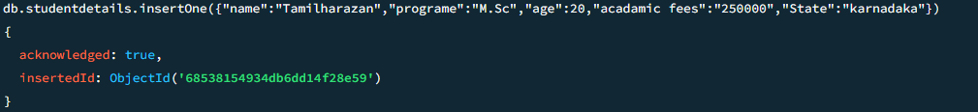

2.How to inset a multiple document in Mongo DB Collection ?

Query :

* db.studentdetails.insertMany([{"name":"Chandru","programe":"B.Tech","age":18,"acadamicfees":"200000","State":"TamilNadu"},

{"name":"Vishwa","programe":"B.Tech","age":20,"acadamicfees":"100000","State":"Karnadaka"},

{"name":"Lokesh","programe":"B.Tech","age":19,"acadamic fees":"150000","State":"Andra Pradesh"},

{"name":"Akash","programe":"B.Sc","age":19,"acadamic fees":"50000","State":"Andra Pradesh"},

{"name":"Ravishanker","programe":"B.Sc","age":18,"acadamic fees":"20000","State":"Tamil Nadu"},

{"name":"Prabhakaran","programe":"B.Sc","age":19,"acadamicfees":"30000","State":"Karnadaka"},

{"name":"Rakesh","programe":"M.Sc","age":20,"acadamic fees":"205000","State":"Tamil Nadu"},

{"name":"Jeeve","programe":"M.Sc","age":21,"acadamicfees":"300000","State":"Karnadaka"},

{"name":"Giri","programe":"M.Sc","age":21,"acadamic fees":"450000","State":"Andra Pradesh"}])

Output :

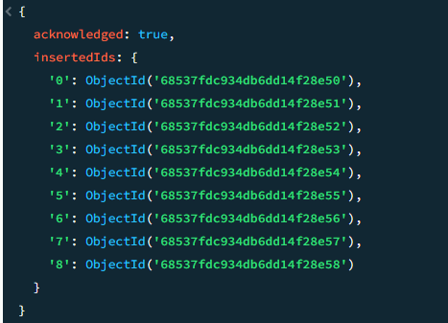

3.How do you find all documents in a Collections ?

Query :

* db.studentdetails.find();

Output :

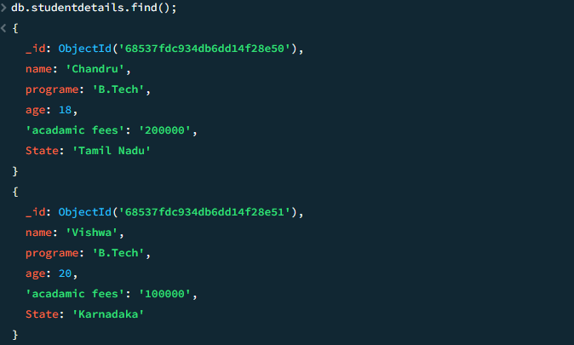

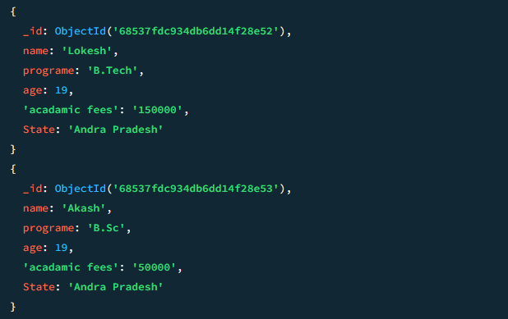

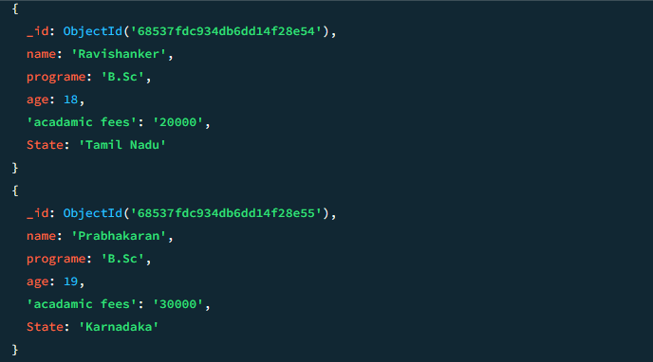

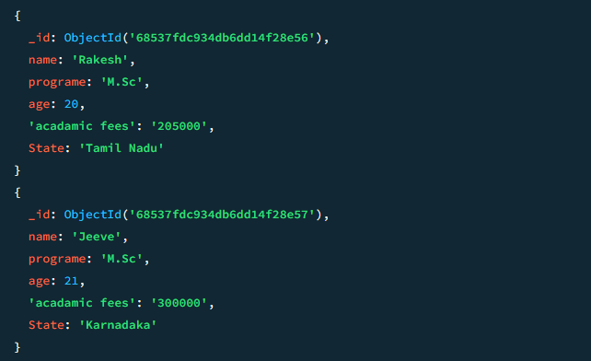

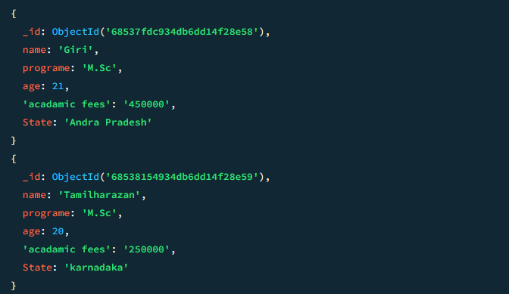

4.How do you find a documents where field equals to numeric value?

Query :

* db.studentdetails.find({"programe":"B.Tech"})

Output :

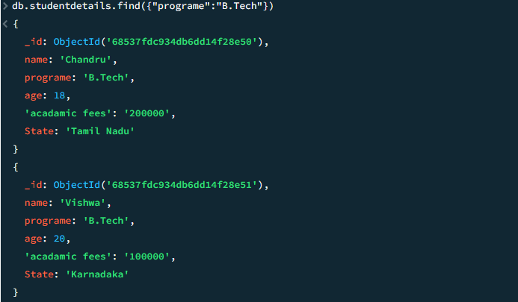



5.How to you find the documents were numeric field graterthan value ?

Query :

* db.studentdetails.find({age :{$gt :20}});

Output :

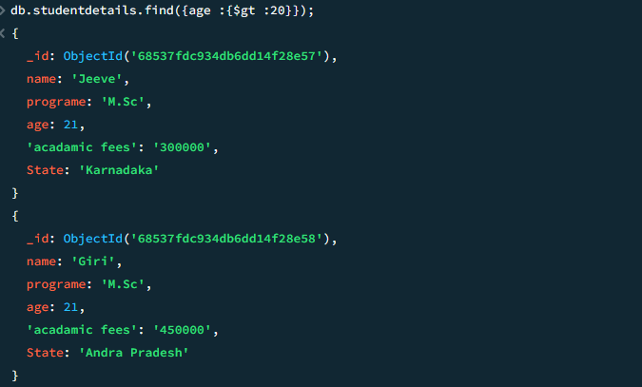

6.How to you find the documents numeric value is less than the field ?

Query :

* db.studentdetails.find({age :{$lt :19}})

Output :

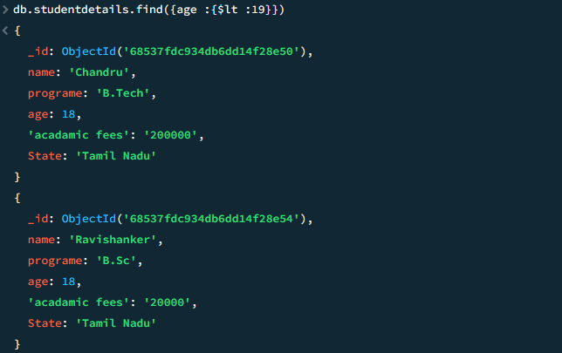

7.How do you find multiple documents using AND logical operator ?

Query :

* db.studentdetails.find({$and: [{ age: { $gt: 18 } },{ State: "Tamil Nadu" }]});

Output :

