Name  :R Thirulogachander  
Reg no:713921106056  
NM Id  :au713921106056

***Smart Public Restroom***

***India is a country with a rich linguistic and cultural diversity population. Many people in our country still do not have access to a healthy sanitation system. To maintain health and hygiene, developing a smart latrine system is a great challenge. This has motivated us to provide a proper solution for our people by designing an eco-friendly and hygienic sanitation system.The project aims to enhance public restroom management by installing IoT sensors to monitor occupancy and maintenance needs. The goal is to provide real-time data on restroom availability and cleanliness to the public through a platform or mobile app. This project includes defining objectives, designing the IoT sensor system, developing the restroom information platform, and integrating them using IoT technology and Python.Our project objectives such as real-time restroom availability information, cleanliness monitoring, improved user experience, and efficient restroom.We are plan the deployment of IoT sensors such as occupancy sensors, cleanliness sensors in public restrooms and design a web-based platform and mobile app to display real-time restroom availability and cleanliness data.After the integration of all the subsystems , the entire system will be tested and put into practice physically. It is necessary to mobilize and engage money, resources, people, equipment, and information to implement.***

***HARDWARE REQUIREMENTS:***

***1.Microcontroller***

***2.Power supply***

***3.LCD display***

***4.Buzzer***

***5.Infrared sensor***

***6.Sonicsensor***

***7.Gassensor***

***8.RFID***

***9.GSM modem***

***SOFTWARE REQUIREMENTS***

***1.Embedded C***

***BLOCK DIAGRAM:***

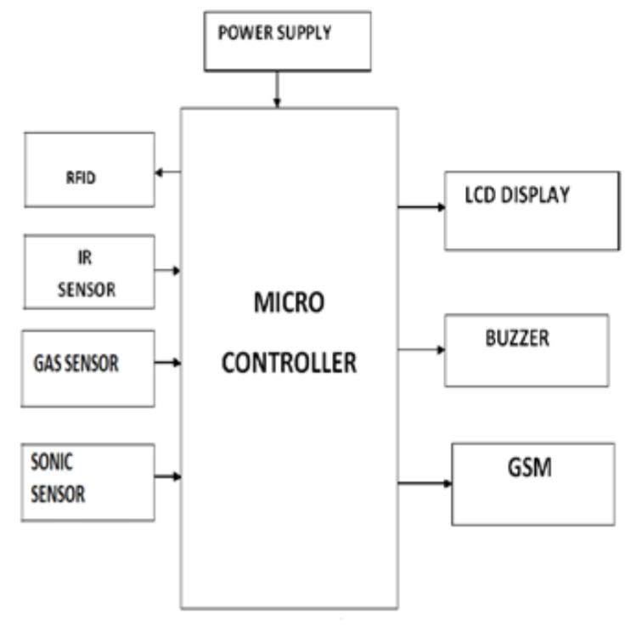

***WORKING PRINCIPLE:***

***• In the first phase, IR sensor is used to discover the dirt present in the toilet.***  
***• Here the set of sample images are given as input.***  
***• After using the toilet, the sensor senses the basin of the toilet.***  
***• Then it relates the sensed image with the input image.***  
***• If the dirt present, it increases the alarm.***  
***• Then the user wants to be clean the waste. Through this activity, people can get theawareness about the toilet management.***  
***• In the second phase, Figaro sensor is used to  perceive the unwanted gases present in the toilet.***  
***• In the Figaro sensor, a particular range is to be stableearlier manner. If the range gets extended, it can send the alert message to the sweeper. Then they cleaned it by using proper fragrant.***  
***• In the third phase, RFID reader (Radio Frequency Identification) is used to observe the sweeper’s activities (absence and presence inthe toilet cleaning).***  
***• Initially, the sweeper wants to show his/her individuality tag in front of RFID reader. It can be shown before and after cleaning the toilet.***  
***• Then the first phase gets initiated and senses for the dirt presence in the toilet.***  
***• If the dirt gets noticed, it raises the alarm.***  
***• Through this monitoring activity, the sweeper can realize their roles and responsibilities.Then they protect the people by disposing all the unwanted materials (dirt, unwanted gases) present in the toilet.***  
***• In the final phase, the sonic sensor is used to detect the depth of the septic tank.***  
***• Here, the range of septic tank is fixed prior manner.***  
***• If the sewage reached with the range, then it directs message to an organization.***  
***• All the message transfer can be done by the GSM (Global System for Communication).***

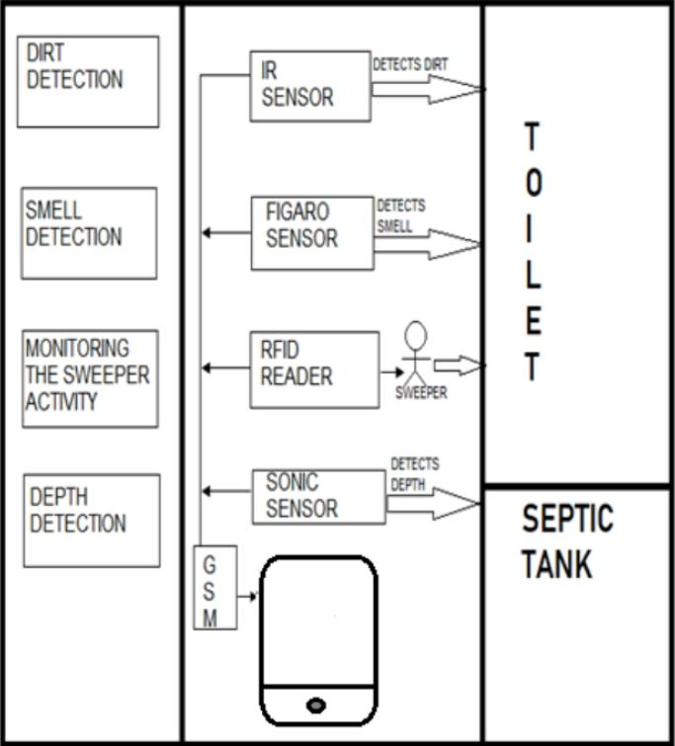 ***ARCHITECTURE OF THE PROPOSED SYSTEM:***