1. For the object "myContact" of type ABContact, what is the dot notation for the object's:
Preferred currency?
Notes?
Level of experience of myContact's assigned user?
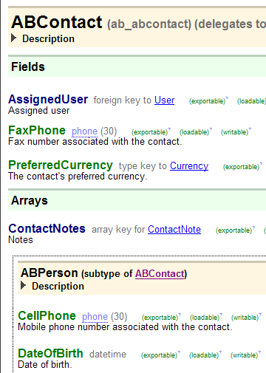

2.Does the base application have ETI files? Can developers create new ETI files? Where and how?

3. Which typecode attribute determines the order in which typecodes are listed in the user interface?
Explain the purpose of retired attribute.

4.If you create a widget and specify only the ID, name, and label, is the widget visible? Editable? Required?

5.The def property of a panel ref usually has a value in the format of "x(y)". What information comes before the parenthesis? (What is the x?) What information is defined within the parenthesis? (What is the y?)

6.A screen contains a card view that contains a detail view. The detail view contains an input. To allow the end user to change the value of the input, what must be set to editable?

7.What is the difference between the "input set" widget and the "input set ref" widget?

8.Assume you have a list view with "anABContact" as the root object. The list view displays the contact's addresses.
What would the row iterator's "value" property be set to?
What would the row iterator's "element name" be set to?
What other widgets would make use of the element name?
9.What happens if a reference identifies a mode, but there is no PCF with that mode in the set?

10.For what reasons might you decide to put logic in a Gosu class method (as opposed to a PCF method or entity enhancement)?

11.When is it appropriate to use a script parameter?
Where are the values of script parameters updated?

12.What kind of entities are initially put into read-only bundles? Under what circumstance would you need to copy one of those entities to a writeable bundle? How is this done?

13.What triggers a rule set?What must be added to a Gosu class in order to make it a Guidewire web service?

14.What plugin is required for every destination? What does this plugin do?

15.When you add a new batch process typecode to BatchProcessType, why must you add one or more categories to the typecode?

