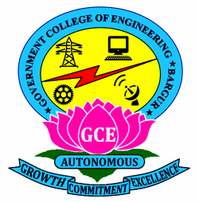

**GOVERNMENT COLLEGE OF ENGINEERING BARGUR**

**( AUTONOMOUS)**

**PROJECT TITLE: CHATBOT DEPLOYMENT WITH IBM CLOUD WATSON ASSISTANT**

**TEAM MEMBERS:**

**CHANDRU D**

**NAVINKUMAR N**

**MANIKANDAN V**

**BHARATH P**

**JAISURYA G**

Introduction:

Chatbots have become an essential tool for businesses to enhance customer interaction and streamline processes. With the advancement of technology, integrating Natural Language Understanding (NLU) into chatbots has become crucial for accurate user intent recognition and providing a seamless user experience. This document explores the implementation of NLU in IBM Cloud Watson Assistant, focusing on improving user interaction and problem-solving capabilities.

**ASSISTIVEBOT**



1.Understanding Natural Language Understanding (NLU):

NLU is a branch of artificial intelligence that focuses on the interaction between humans and computers using natural language. It enables chatbots to comprehend user inputs, extract meaningful information, and respond contextually. In the context of IBM Cloud Watson Assistant, NLU enhances the chatbot’s ability to interpret user queries accurately.

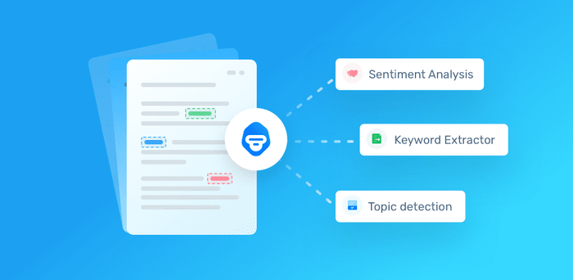

2.Benefits of Implementing NLU in Chatbots:

Improved User Intent Recognition: NLU helps the chatbot understand user intents with higher accuracy, leading to precise responses. Enhanced Context Awareness: NLU enables the chatbot to understand the context of the conversation, making interactions more personalized. 3 Efficient Problem-Solving: With accurate intent recognition, chatbots equipped with NLU can efficiently address user queries and solve problems.

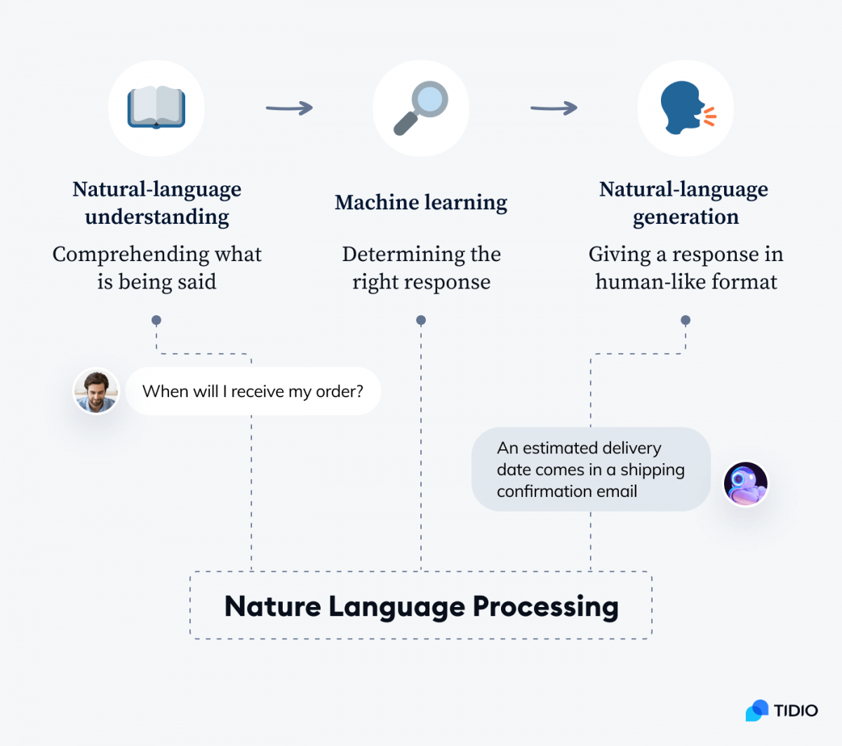

3. Steps to Implement NLU in IBM Cloud Watson Assistant:

a. Configure Language Models: Set up language models to recognize various languages and dialects used by your target audience. b. Train NLU Models: Train the NLU models using relevant datasets to improve the accuracy of intent recognition. c. Integrate with Watson Assistant: Integrate the trained NLU models seamlessly with IBM Cloud Watson Assistant. d. Test and Iterate: Conduct rigorous testing to ensure the chatbot accurately interprets user intents. Iterate on the training data and models as needed to enhance accuracy

Conclusion:

As technology continues to advance, the integration of Natural Language Understanding (NLU) in chatbots represents a pivotal development in enhancing user experiences and customer interactions. By implementing NLU in IBM Cloud Watson Assistant and staying updated with emerging trends, businesses can create intelligent, empathetic, and efficient chatbot solutions that cater to the diverse needs of users. As you embark on your chatbot deployment journey, embracing the power of NLU will undoubtedly pave the way for innovative and impactful user interactions.