**Solution- Weborders**

Below are the test case that were automated :

- Login

- Logout

- Place a new Order

- Update a new Order

- Delete a selected Order

I have implemented the solution in testng- cucumber framework. The project is of type maven and the programming language used in java.

**Steps to install the Project:**

* Step-1: Copy the repository (ordertestingscenarios) from GITHUB to your local machine
* Step-2: Browser & version required : Chrome - 73.0.3683(as this test will run in chrome browser)
* Step-3: Import the project to eclipse/Intellij. The plugins that are required are maven, testng and cucumber for java. The essential maven dependencies are mentioned in the pom.xml file.

Screenshots of Plugins used:

1. Maven

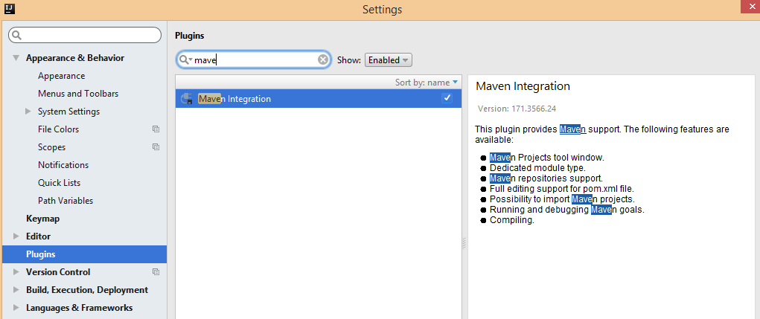

1. TestNG

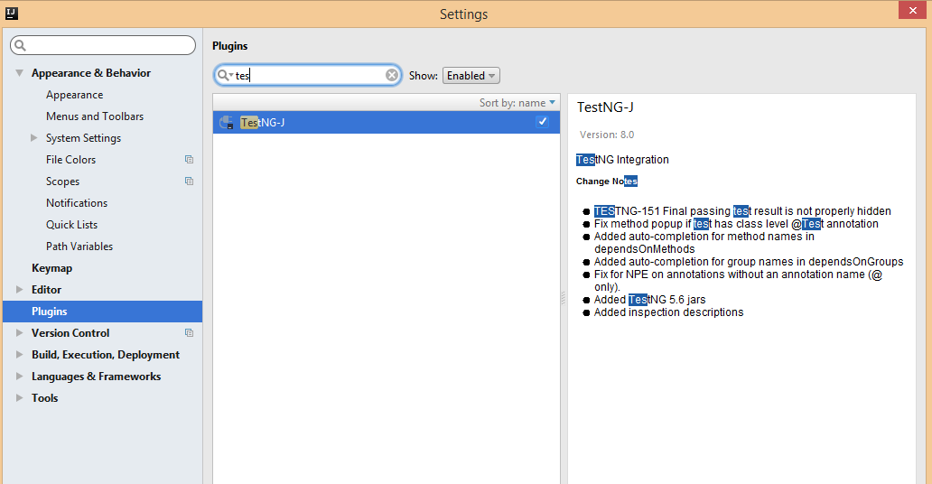

1. Cucumber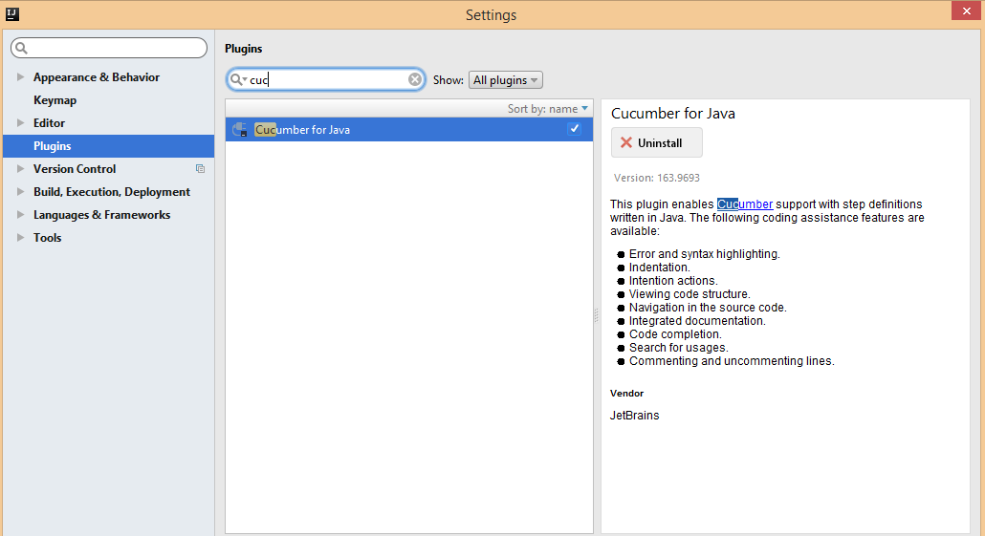

**Steps to run the Project:**

* Under the features folder we have the feature file stored which contains the test scenarios.
* The page factory folder contains all the Web elements in a structured format which we are using in our test.
* Step definitions containing the test steps matching to the scenarios from the feature file.
* The test runner is heart of the project. We can either run the test by running the TestRunner or running the testing.xml file

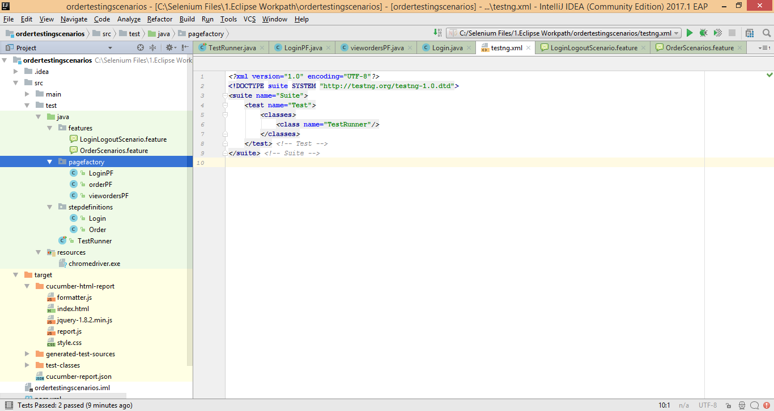

In the intellij, once the test is run, we can see the features and the scenarios that have completed the run with the results.

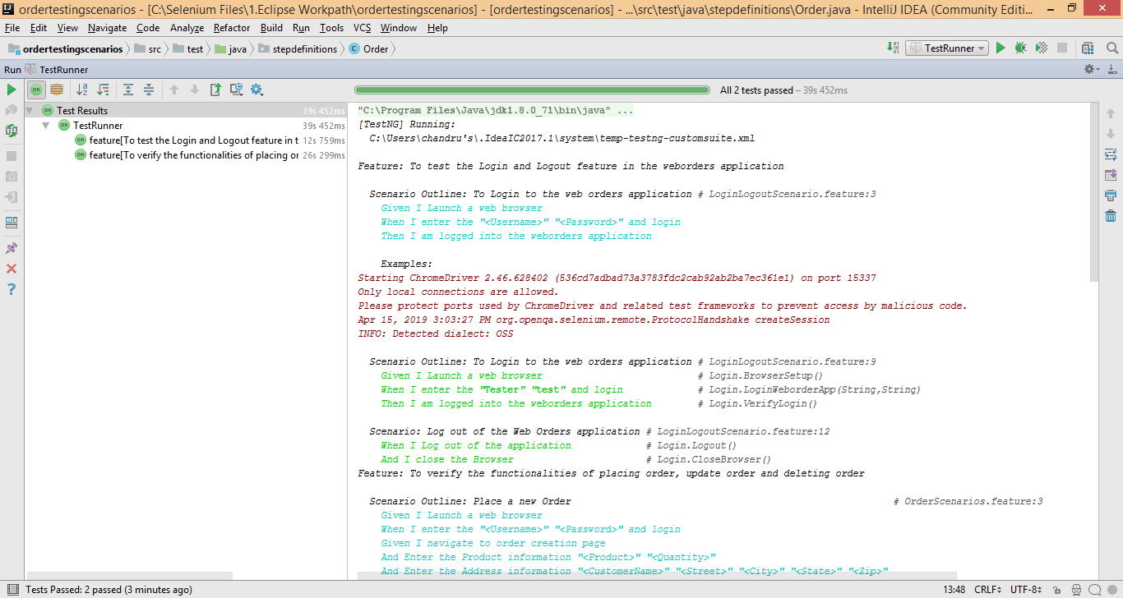

Also, we can see the output in a HTML format.After the test is run, there will be a folder called target in the project structure. Select index.html under target/cucumber-html-report in a web browser.

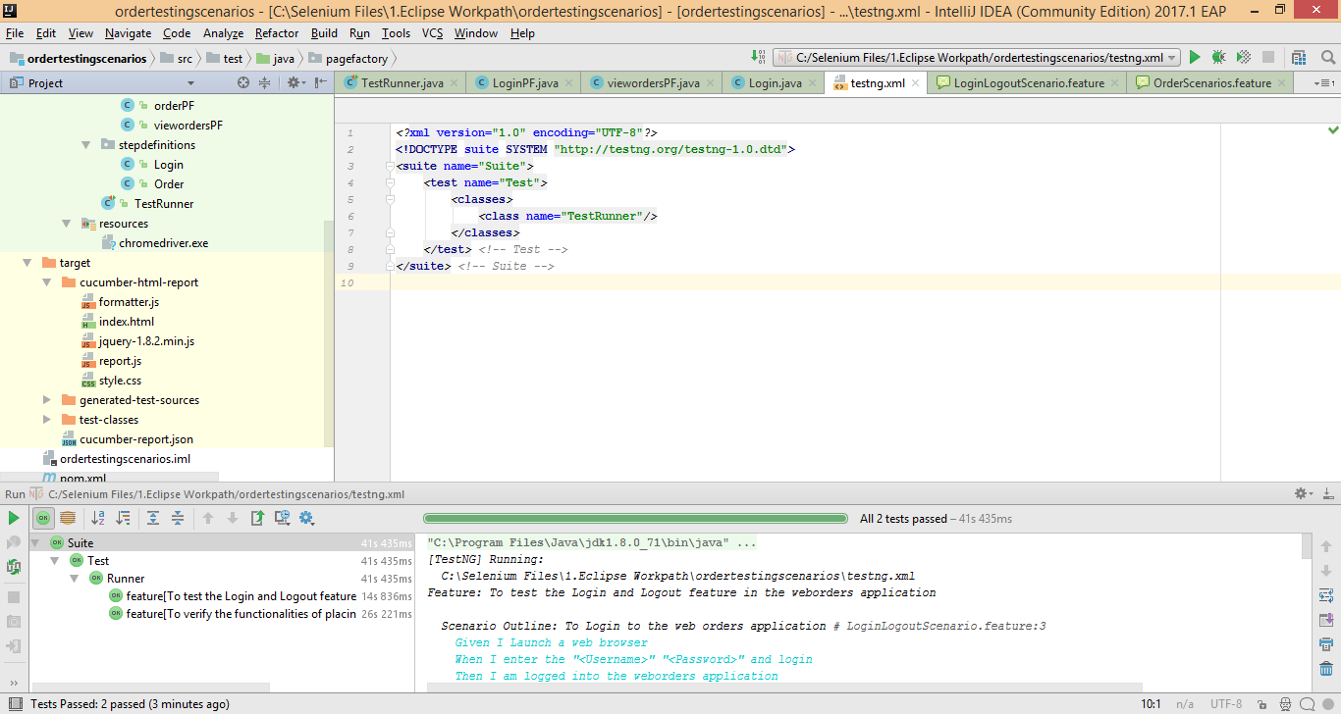

There we can see the report in a html format.

