Computer Networking &
Workload Distribution

problem being solved

In any Local or Wide Area Network users (especially administrators) always find a need to send a file or folder to all or a subset a computers in the network. These are slow because the resource in question usually is from a removable media (a setup/installation file) or has just been obtained from the internet (maybe updates) and therefore is present in only one of the systems.
You need the file (possibly huge) in all systems hard drives and want it done quick.
Sharing won’t do here because typically the number of computers involved are more than hundred while an OS in the computer that contains a resource that we have shared can’t allow more than 5 simultaneous accessors. Which means the goal of getting the file onto all the participating systems hard drives takes a long time and uses lot of network traffic and the upload bandwidth of the computer containing the necessary resource may not be high (what if you have the resource on a computer that isn’t a server) in which case the situation gets considerably worse.

technology and usage issues causing the problem

Typical networking hardware have independent upload and download bandwidths. Meaning we can send and receive data simultaneously across shared media (Ethernet). For achieving the given goal if we can make use of both these bandwidths and speed up the process we must definitely do so. If we have the hardware we ought to try and keep it busy always (mantra for anything computer related). OS technology in typical systems can’t handle bulk requests without rejecting some or total slowdown - motivates the problem.
A usage issue has been discussed above another one is : Say we got the service pack 2 for windows XP and all the two hundred and forty systems in our company/college network has XP SP1 and needs it. That’ll take physical work using temporary medias or a long time to get the downloaded file to all systems via networks (measures ~300 mb). Happens everytime an update is out for any software or you want a new software. Or we want the Visual Web Developer Express Edition on all systems in a lab – there’s only one CD belonging to the seminar – conductor who wants everyone to work on it. He definitely can’t wait till the 700 MB goes to all the 40 systems in the lab and the students install it. A large number of situations can be given all of them concerning resource replication across big networks – which happens surprisingly frequently in all institutions.

research hypothesis

A node in a system of computers that have a common resource requirement can upload whatever part of the resource it has to other computers in the system even if it has not got the entire resource itself. This policy if followed by all systems will distribute network load over all the connections available instead of concentrating load on client-server connection in addition to improving the performance with respect to time.
The answer to why we need to distribute the load is obvious considering the fact that concentrating network traffic on specific connections lead to congestion and slowdown.

how do we verify the hypothesis

A practical experiment will convince the average user. Let a program send a 4 GB file out to all 10 systems sequentially. Let another program divide up the file into 10 400 MB parts and send each part to each system sequentially , letting the client systems to exchange the parts among themselves. In both cases we have the resource on all the client systems, but with a time reduction of upto 80% when using the second case. How this reduction comes and why the number 80% are theory – looked at in detail in the following sections.

impact on industry

If the logic behind the hypothesis is feasible we might have extra chips on the standard network card where the concepts of workload distribution are implemented on a CHIP-PROTOCOL pair. Or the software implementation can find itself present in the kernel DLL routines in all commercial and server operating systems. The former is cheaper and faster but the fact remains that only those computers on big networks find use for the hardware. Home or Small Office networks can do without the hardware since number of computers involved are usually in the 5 or 10 range.
Still the functionality of the hardware can be made use of in the VPNs over internet where workload distribution can mean all the difference. Also the difference in the cost of network cards before and after using the logic is fairly negligible which allows the manufacturers to implement it as a service to end users , or to gain an edge over competition.

research on the proposal

Implications of this hypothesis on grid and cluster computing is fairly straightforward. Getting data files to individual processing elements is as important as the actual processing itself. A collective of usage issues and situations where the hypothesis improves performance has been organized. Practical File Transfer utilities have been tested against this, all of which facing all the same constraints and environmental restrictions the implementation of this concept faces. Meaning the available utilities and the implementation were tested in the same place in the same hardware and interconnects.

THE DRAWING BOARD

“A node in a system of computers that have a common resource requirement can upload whatever part of the resource it has to other computers in the system even if it has not got the entire resource itself. This policy if followed by all systems will distribute network load over all the connections available instead of concentrating load on client-server connection in addition to improving the performance with respect to time.”
First part forms the required premises :
- We have many computers in our system having a common resource requirement (data).
- The requirement is to be satisfied as fast as possible.
- The nodes can upload whatever data it has got to other systems even if it has not got its requirement fully satisfied.
Second part states what happens then :
- If all the premises are true, then, instead of the server (node(s) possessing the required data) having to send all data to all clients (nodes having the requirement), the clients can exchange data among themselves, thus distributing the workload over the entire network topology.
- Client communications can occur in parallel between different clients across independent interconnects. Such parallal work decreases the total time taken for the accomplishment of the goal.
Let’s convert all that generalization into a particular instance… that will get the point across…

Instantiation (Particularisation)

Consider the problem of getting a <requiredresource> huge update and an antivirus database </requiredresource> file across to the seven systems on your network which you have just downloaded from the internet browsing center outside. You have the resources in your laptop fitted only with a common commercial network card. And we know normal daily computers are no great shakes in being an efficient server.
Let the time taken to transfer the file from your computer to another be 1 ResTT (say around 30 mins). ResTT stands for Resource Transfer Time. RTT is not used as it represents round trip time.

- Doing it the hard way, we move around system to system uploading our data, it takes a minimum of 7 ResTTs. ( 3.5 hours )

- Optimally, We can do it as follows to save time :

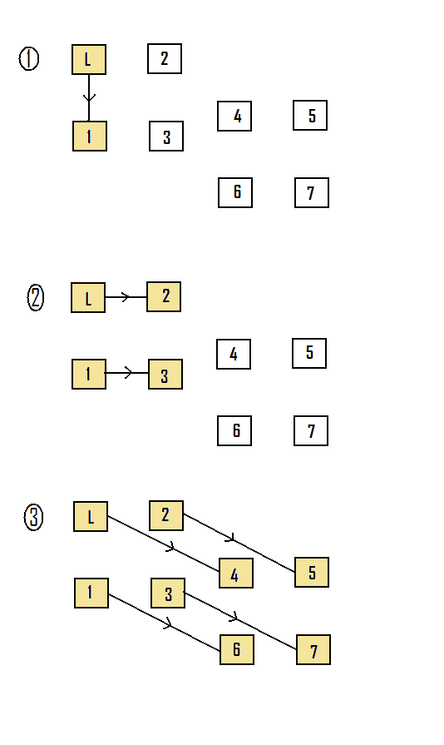

Upload onto one of the networked systems. (1 ResTT)
+

Use your laptop and that system to upload onto two systems. (1 ResTT)
+

Use all four systems that now contain the data to upload to the remaining four systems. (1 ResTT)

Now we seem to have completed the job in 3 ResTTs.
(1.5 hours)
Obviously more parallelization increases performance. But how the parallalization should actually be done?

- The third method which uses the research hypothesis stated above can be implemented as follows :
Let’s have an engine that splits up whatever data we have into as many pieces as there are nodes that need the data. Why we choose this number is explained later. In our case the number is Seven so our engine splits up net data into seven segments of approximately equal size. The engine can also reassemble the original resource when it is given the seven segments. Let such an engine exist on all systems under consideration.
We’ll number the seven segments from 1 to 7. The computers in the network are also numbered likewise. A communication is represented by an arrow mark pointing from uploader to downloader, the content of the communication i.e., the segment that’s being transferred is shown on top of the arrow in the middle.
Since each segment is only 1/7 th size of the original data the time taken to transfer one segment is 1/7 ResTT. Each step in the next diagram represents a stage of inter-client-communication that takes exactly one-seventh of ResTT (1/7 ResTT). As you will see each stage may contain one or more independent client to client communications.
If we orchestrate the inter-client-communication as follows we end up with a pleasing resultant time. Why and how this orchestration is done this way will be evident in the later sections.
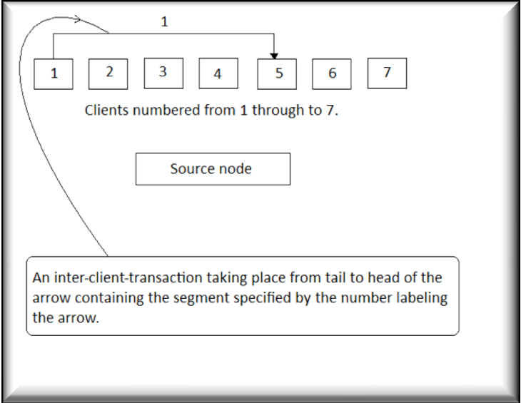
Thus we ended up with the figure 1.85 ResTT total time about 55 minutes, a 73.80% improvement over the first case. How we got such an improvement can be explained as follows :
In an eight-node system maximum parallalization is 4 simultaneous communications. As we can see the number of independent communications between separate pairs of nodes, starts with one keeps increasing as the system progresses through time reaches a maximum and then decreases back to one.
For handling 4 simultaneous inter-client-communications it is enough if we have 8 independent segments, 2 segments per communication. More segments won’t make sense because 4 is the upper limit on the number of maximum simultaneous inter-client-communications. We can argue that 4 distinct segments is enough, but that would mean two systems should seed the same segment which will give rise to synchronisation problems. To avoid those problems we might then have to rigidify the algorithm, saying this seeder must provide for this section of systems and the other for the rest. Such sacrifice in flexibility will decrease performance and fault tolerance. So our optimised number 8 is the correct number with which we have to split into segments. But since the source node itself does not need the resource since it is the provider, we can do with splitting into seven pieces.
Consider we have split into 14 pieces instead of 7. Let’s see what happens :
In the first 13 stages , the first 7 pieces get stored in all nodes following the same stages in the diagram before but take only ½ the time i.e., 1.85/2 ResTT because each segmet takes 1/14 ResTT to transfer and therefore the 13 steps take 13/14 ResTT which is equal to (13/7)/2 = 1.85/2 ResTT. Since we divided into 14 pieces this same procedure must take place between the next 7 pieces which takes another 1.85/2 ResTT thus total process will again end up taking 1.85 ResTT. If we proceed to do this step in a diagramatic manner , we can obviously intersperse (or) intersect these two 7-packet steps and thus get a slight increase in performance but that would complexify the algorithm leading to more packets waiting in queue over the network , which is undesirable. Such waiting could very well overcome the obtained small benefit and therefore the effort put in would be rendered useless.
Suppose we send two pieces per communication transfer, to finish the process in a single cycle, we would end up in using the same logic as in using a single big piece. These are the reasons we choose to divide up the resource into as many pieces or segments as there are client systems.
Now that we know such an orchestration greatly reduces time, we will look at another orchestration method which provides similar functionality in terms of time. If we are using a ring topology with seven pieces and follow the steps given below again we would have 1.85 ResTT but this is not a good choice for many reasons. If one of the computers in the system breaks down or stops responding or gets congested the process would break down. In the previous orchestration however if a computer stops responding we can simply use a timeout mechanism to skip over to other computers thus causing little or perfomance degradation. The ring format is easier to implement but we can afford complex algorithms because speed comparison between the processor and network is like comparing plane and walking.

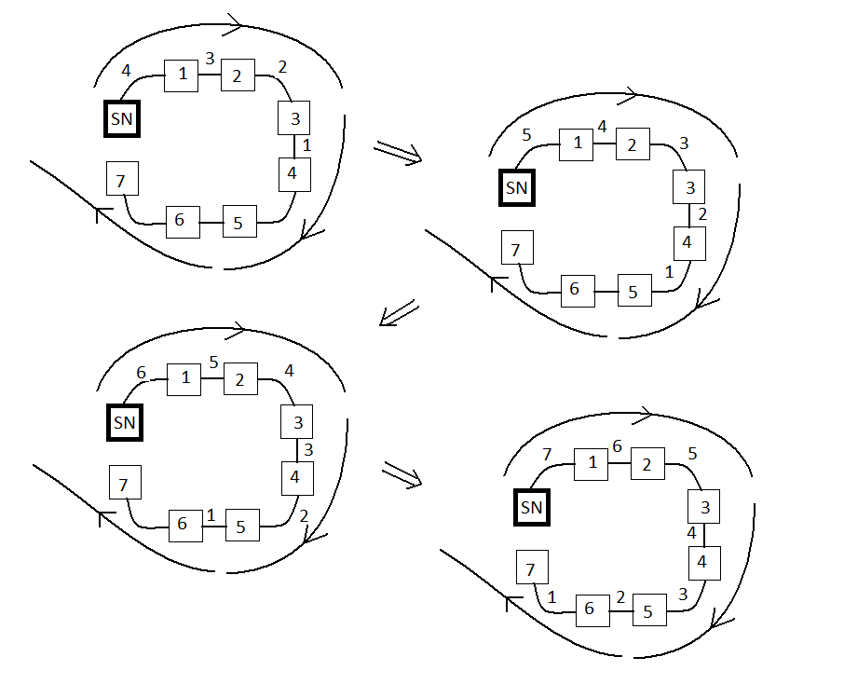

How do we implement the first orchestration as an algorithm ?
Simple every node on receiving the piece from server must flag it as seedpiece and start sending it sequentially to all nodes starting from the last node to the last-but-one th node, Assume 1st node comes after last. If the turn to send comes to itself it must skip. Eg. The third node sends sequentially like 7,1,2,4,5,6 the sixth node 7,1,2,3,4,5 the second node 7,1,3,4,5,6 the seventh node 1,2,3,4,5,6. Note that all sequences start with 7 (last node) and end with 6 (last-but-one). If it encounters itself it skips sending. All clients must follow this algorithm.
Data splitting can be done in the server such that while splitting a one-byte header identifying the position of the segment or piece in the original data block is added. This information is used while ressembling pieces in the clients. The clients must have an engine capable of reassembling the original data block in the correct manner no matter in what order the segments may arrive. This can also be easily done.

Generalisation :

Now onwards, we forget about seven computers and a source laptop. If we have 4 systems we require seven stages, 7 systems means 13 stages and 5 systems take 9 stages.
4 => 7 = (2*4)-1
5 => 9 = (2*5)-1
7 => 13 = (2*7)-1
Thus practical following of the algorithm for various instances give the result as generalized form: For an n-node system the number of stages to complete full transfer is (2*n)-1. Let’s allow 1 extra stage to compensate for any real-life delays and approximate the value to simply (2*n) stages for an n-node system.
Also for an n-node system each stage measures 1/n th of ResTT. Therefore total time taken for process to complete in an n-node system is ( number of stages * time per stage ) which is ( (2*n) * (1/n) ) = 2. Thus we arrive at the value 2 ResTT, which tells us that time taken for process to complete is independent of n, which means whether 2 or 100,000 systems participate the process would be done within 2 ResTT. Isn’t this sort of seeming like an impossibility? Where then is the Catch22?
The answer is we assume that any node can communicate with any other node whenever it wants to. We have taken system2 to system4 transaction and system5 to system7 transaction can take place simultaneously. This is rarely the case in real life because there at maximum three or four shared lines (or media) which all computers share while talking to each other. Supposing if all nodes were connected to all other nodes through dedicated point-to-point links as shown below – the above result of less than 2 ResTT time will hold.
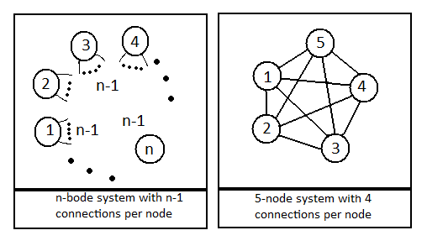

However it does not mean the entire exercise is worthless, though we do not have as many interconnects as we like we still increase performance by using the 3 or 4 shared media as efficiently as possible. Gigabit Ethernet provides upto 16 logically independent shared media. Thus the real life performance decrease is as follows :
Required interconnects / available interconnects ⬄ n(n-1) / x
Eg. Performance decrease if we use 10 systems with only 5 shared media instead of 10(10-1) = 90 required interconnections is 90/5 = 18 times. Performance of 5 connections in percentage as compared to using 90 interconnections is (1/18) * 100 is only 6 percentage. However the 5 shared media can be buffered (9 buffers one inbetween every two adjacent systems) in between every system to give 10*5 = 50 interconnections which would raise the same performance comparison percentage to 56% that is nearly 4 ResTT. The algorithm under ideal hardware should finish up in 2 ResTT, but 4 is better than 10 ResTT.
Terms and concepts are somewhat similar to existing P2P applications like LimeWire and BitTorrent. While those rely on web servers, internet, TCP/IP and client nodes focussed on getting file pieces, this implementation focuses on link level protocols, distributed or de-centralised logic, with client nodes focussing on giving away whatever they have.

Hardware Implementation

A subarea in the chip should contain the logic to detect which packets belong to this implementation. On detection it must be able to retrieve the header area that contains the position into a buffer. Another buffer must contain the pointers to start and length of segment pair, in the same index as the position was placed. For eg. If buffer1[i] has position of a segment X, then buffer2[i] must have the pointer to the place where the actual segment X got placed, along with length of that segment X. A software routine call sorts the buffer2 based on buffer1. Another software routine call must use buffer2 to extract the segments and reconstruct the original data block in the proper order. Hardware buffer must be non-volatile or proper mesures are to be taken not to lose buffer contents if power down occurs. Such an arrangement not only increases fault tolerance but also allows us to pause & resume the process. A array of timers (4 or 5 is enough ) is needed to skip over unresponsive systems.

A Java implementation of the entire proposition is included. The program is not flawless, it has a few semantic errors, but however it clearly shows how multithreading and socket-usage can be employed to implement the whole hypothesis – Also resource data splitting algorithm and reassembling algorithm is shown. Multi-threaded programs allow taking advantage of multi-core systems, and sockets allow easy synchronisation as compared to datagrams – hence Java. The entire program can easily be ported into the .NET platform using C# instead of java, in which case the executable-file size is greatly reduced because most of the routines for multithreading and UI are part of .NET runtime platform library. Any errors, corrections in the program sugested by the reader is welcome.

Authors :
T. Chandirasekar
N.G. Karthikeyan
BE CSE V Semester
TCE, Madurai

