**Name: Chandrasekaran R**

**Practice: Impact Training**

**Designation: Trainee**

**Azure Virtual Machine**

**Step 1:** SigIn into Azure. Open VM (virtual machine). Create resource group and give the VM name in the box column.

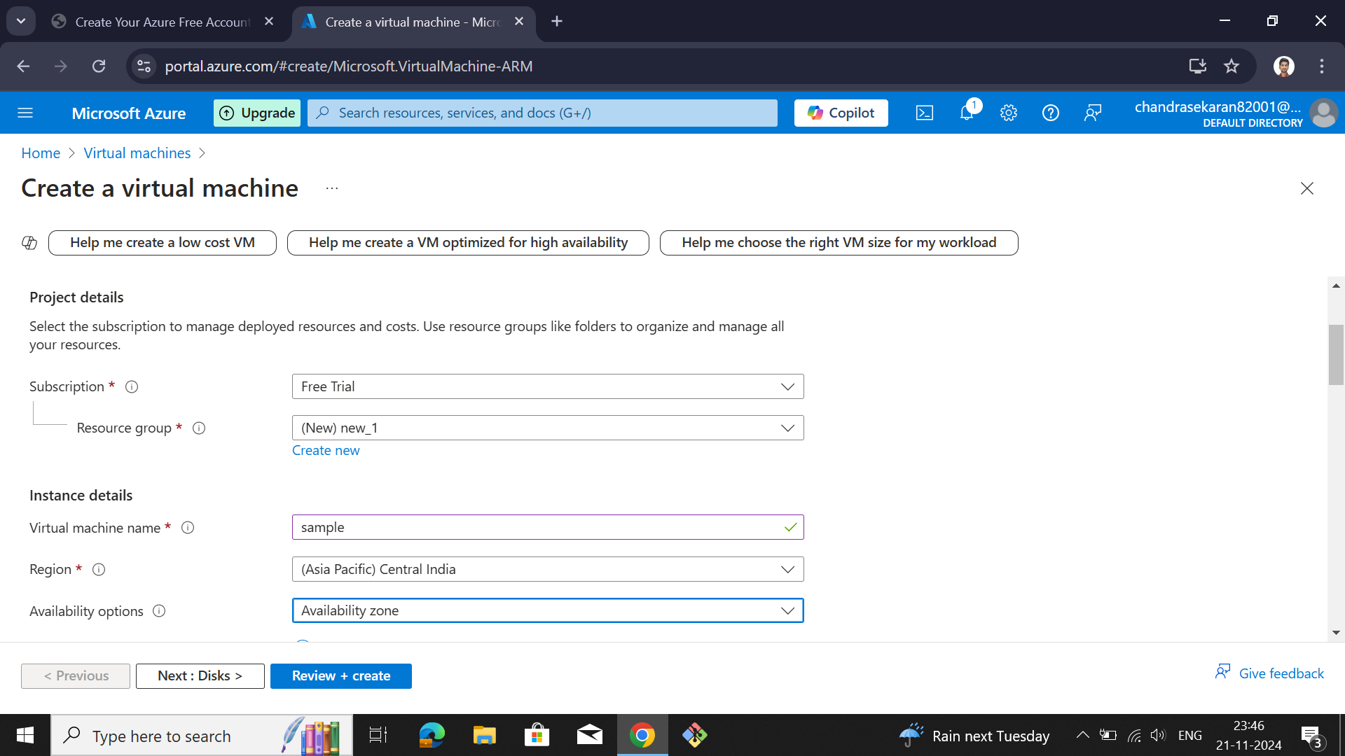

**Step 2:** Next -> Select -> Image and Availability Zone. If any requirements are needed means need to select those as well.

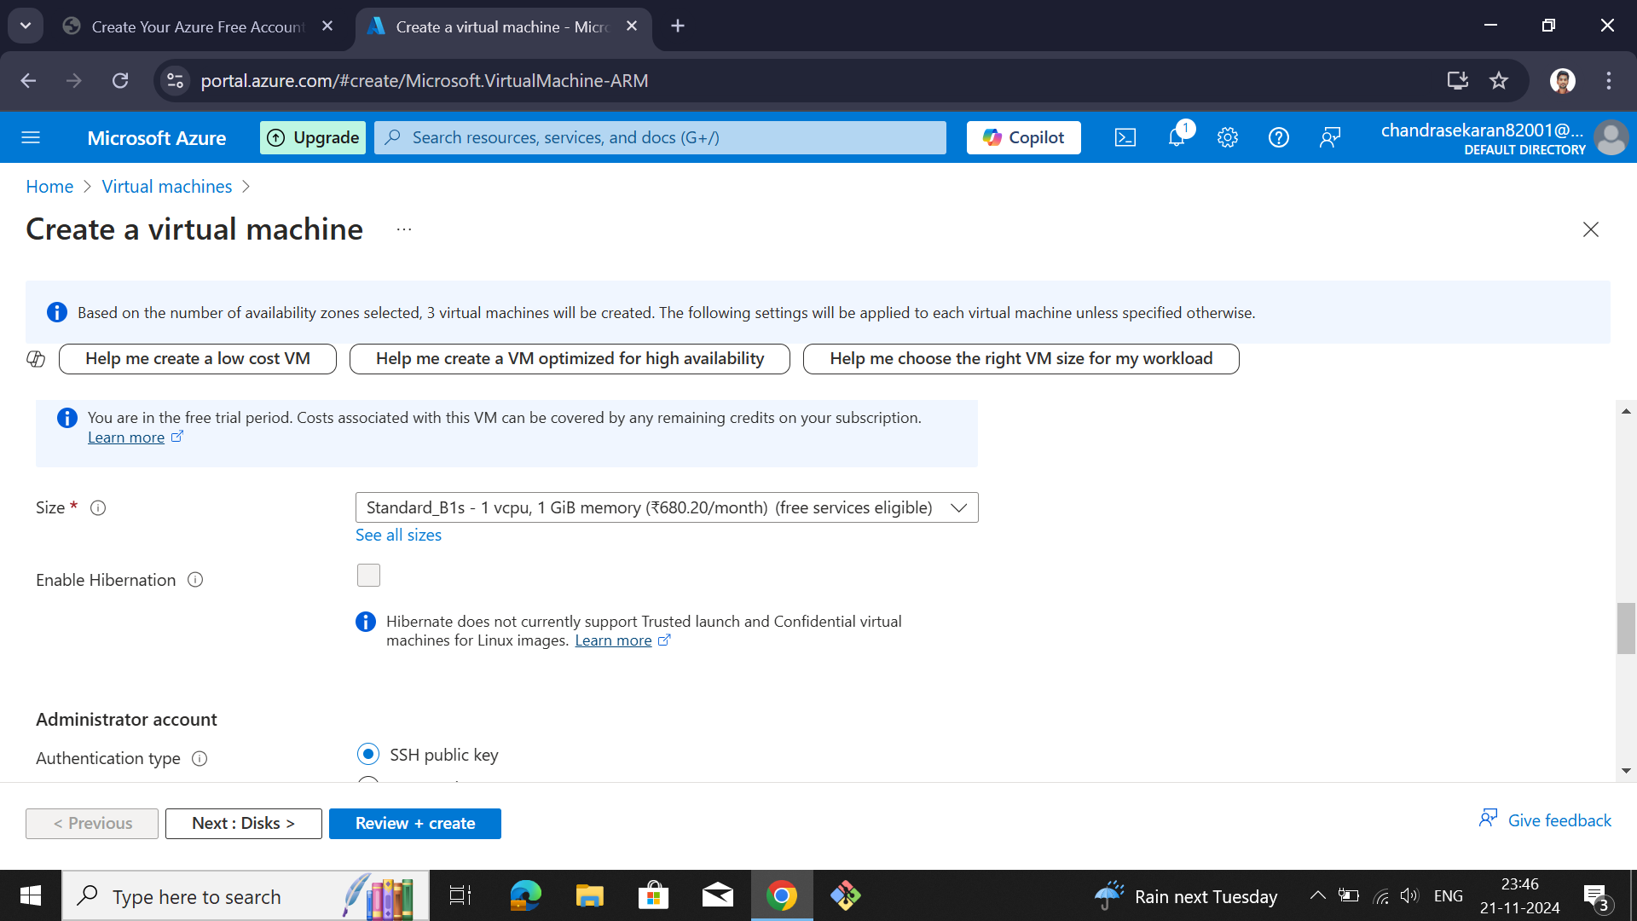

**Step 3:** SSH public key source -> Generate new key pair. Give Key Pair name.

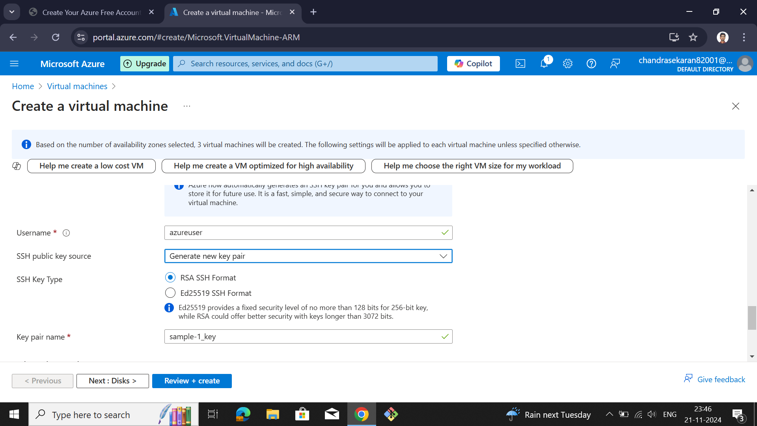

**Step 4:** Select inbound ports for accessing the Server from outside traffic using it.

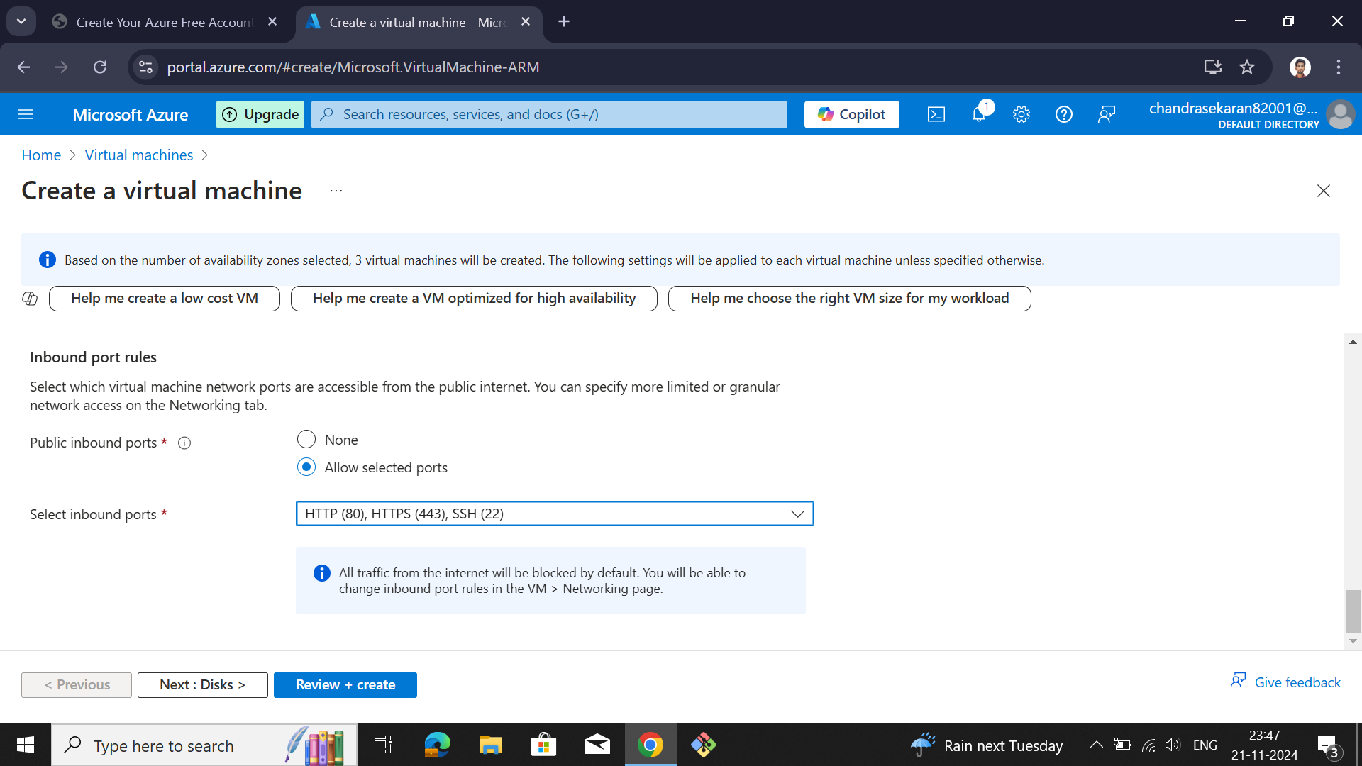

**Step 5:** After all are (Disk, Network, Tag name(optional)) completed with create server then deploy the server.

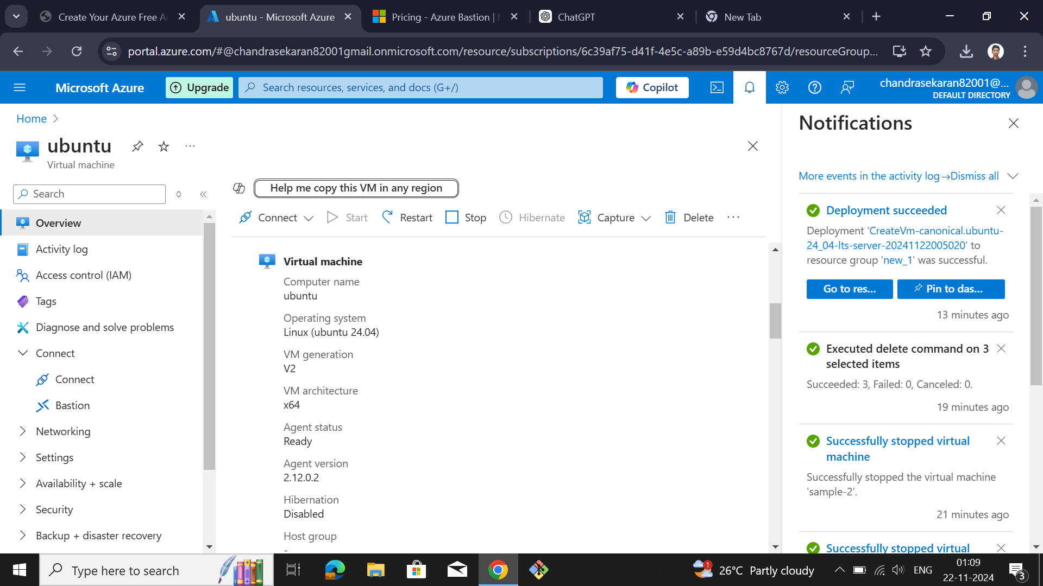

**Step 6:** In the left side of the window. There is Connect->connect->SSH connect.

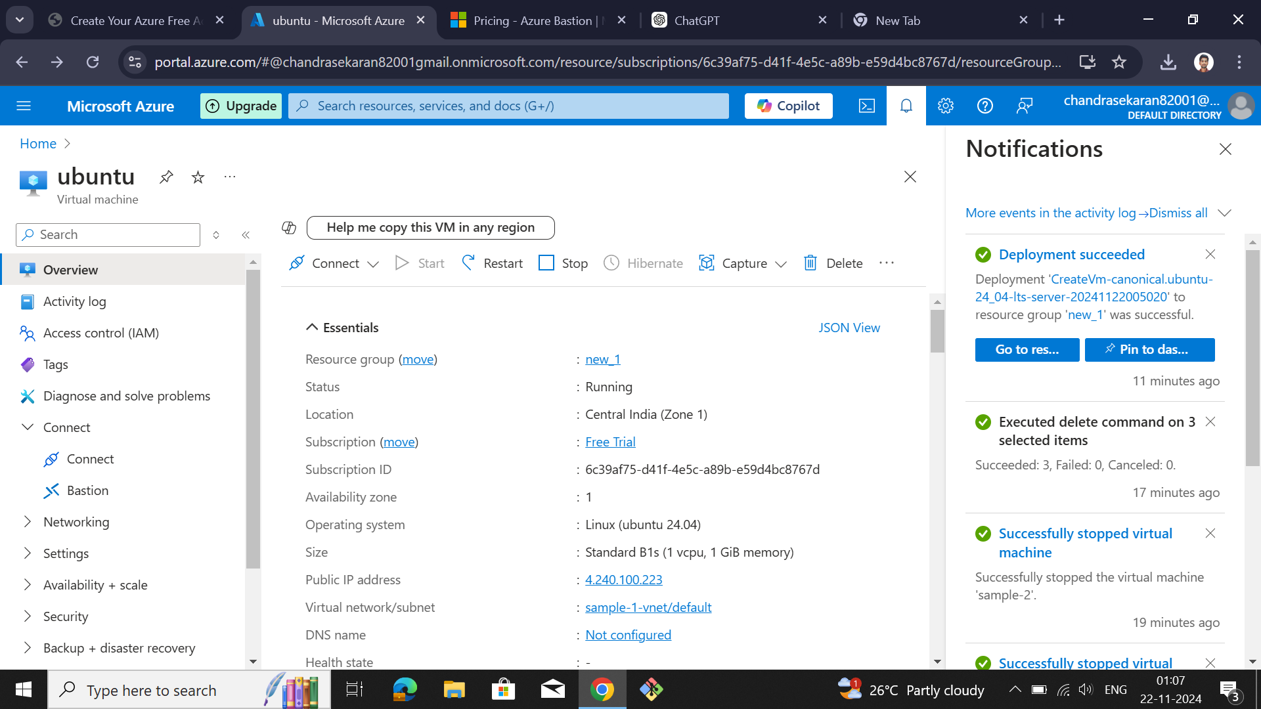

**Step 7:** Azure console is open. After that, based on your requirements, we need to install the software's in it.

