CSE 5524 - Homework #3 8/29/2016
Chandrasekar Swaminathan (swaminathan.42)

1) Generate a 4-level Gaussian pyramid (original image is level-1) and the
corresponding Laplacian pyramid of an image (select one from the web). Use the
formula in the notes to first determine a viable image size, and crop the image (if
needed) to test the pyramid code. Use a=0.4 for the Gaussian mask – use separable
masks! Write/use functions for properly reducing and expanding an image.
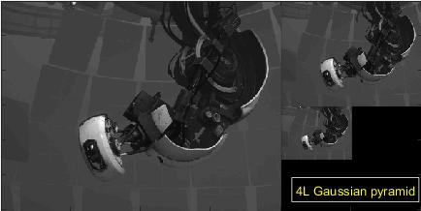
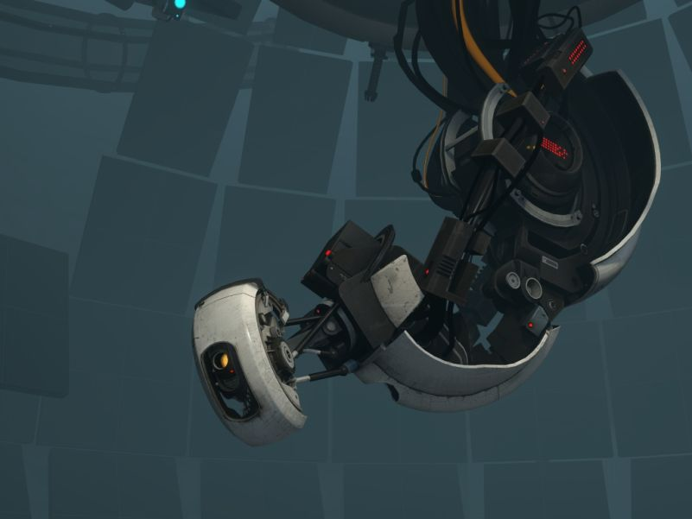
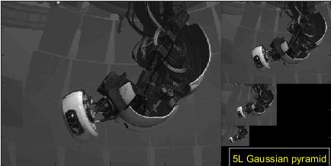
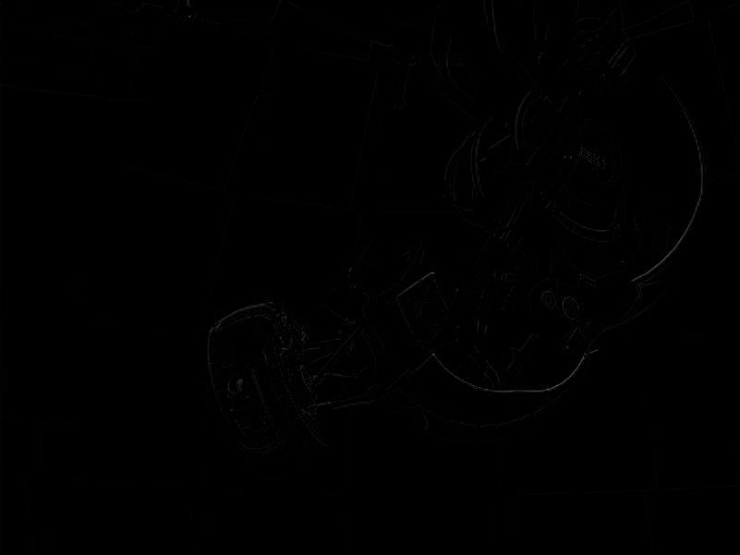
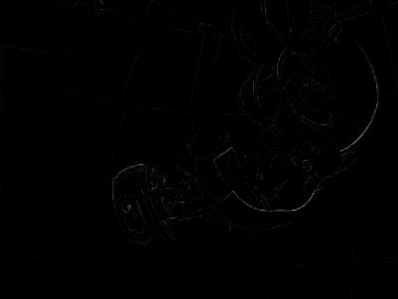
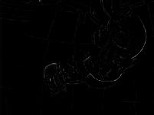
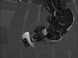
2) Using the grayscale images (walk.bmp, bg000.bmp) provided on the WWW site,
perform background subtraction 1 using simple image subtraction to identify the
object. Experiment with thresholds.

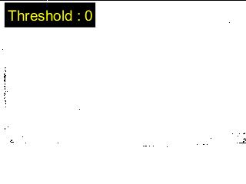
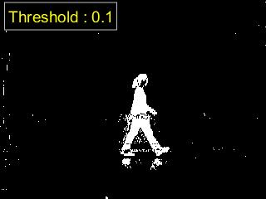
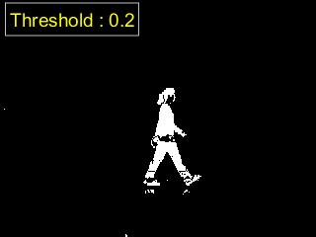
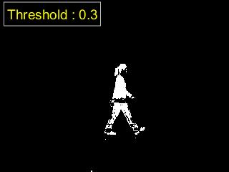
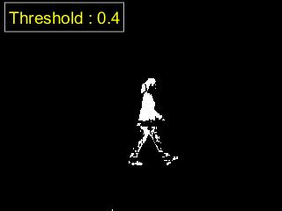
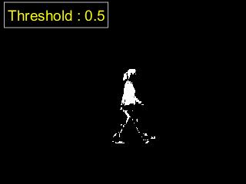
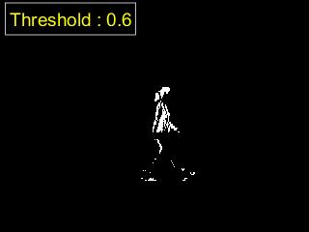
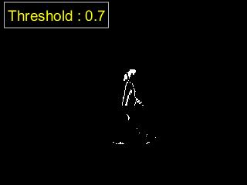
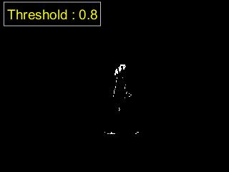
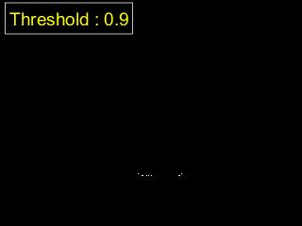

3) Using the grayscale images (walk.bmp, bg[000-029].bmp) provided on the WWW
site, perform background subtraction 2 using statistical distances. Experiment with
thresholds.
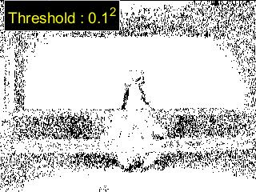
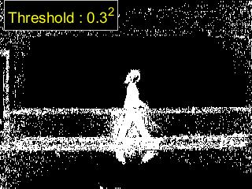
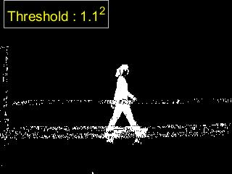
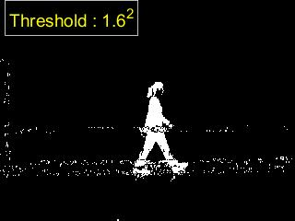
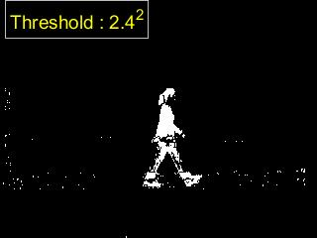
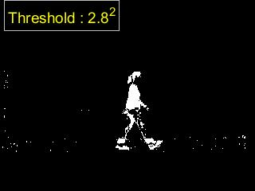
4) Dilate the best binary image resulting from problem 3) using d_bsIm = bwmorph(bsIm, ‘dilate’);
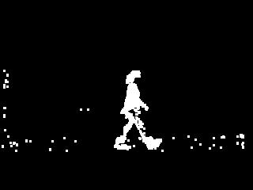
5) Next perform a connected components algorithm, and keep only the largest region in
L (save/display as an image).
[L, num] = bwlabel(d_bsIm, 8);

