CHANDRASEKAR SWAMINATHAN (swaminathan.42)
Computer Vision for HCI
CSE 5524
Homework Assignment #2

1) Perform Gaussian smoothing on face.jpeg. Try with multiple sigma values, starting
with larger values (e.g., from 20 to 0.5). When does the face become recognizable?
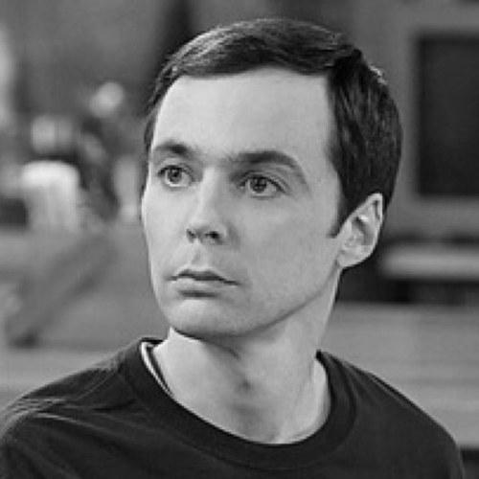
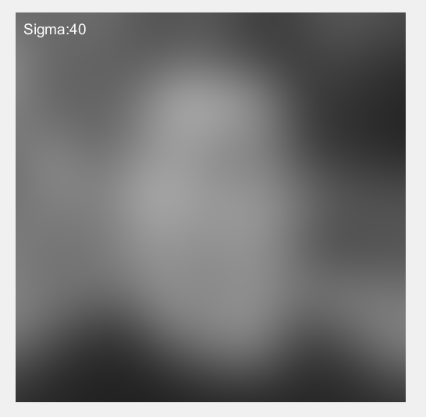
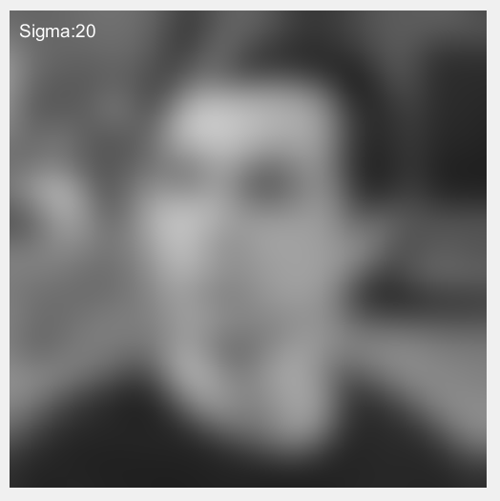
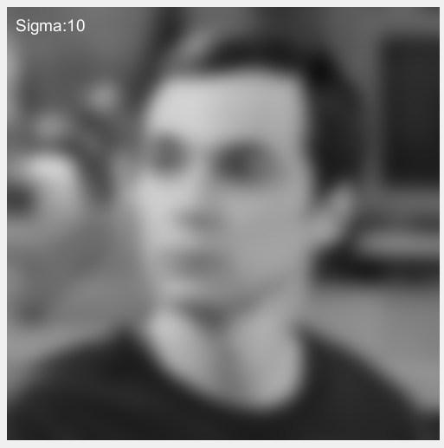
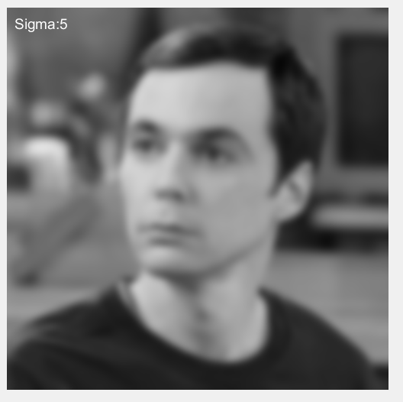
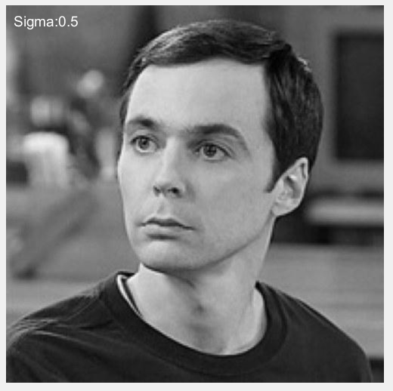

We can see from the above images that as sigma increases the image is blurred to an extent that it is hard to recognize the face in the image. The face became recognizable to one of my friends at the sigma value of 20 and for another friend at the sigma value of 15 (not shown above).

2) Write a MATLAB function to compute and display the 2D Gaussian derivative masks
Gx and Gy for a given sigma (see class notes). Note: each mask is a square 2D
matrix.
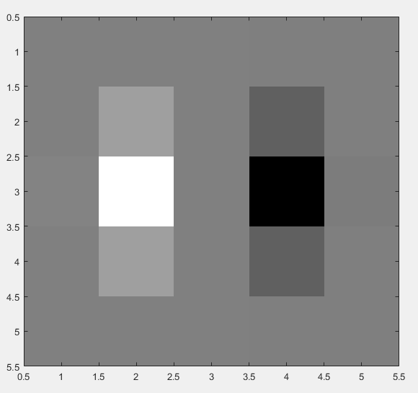
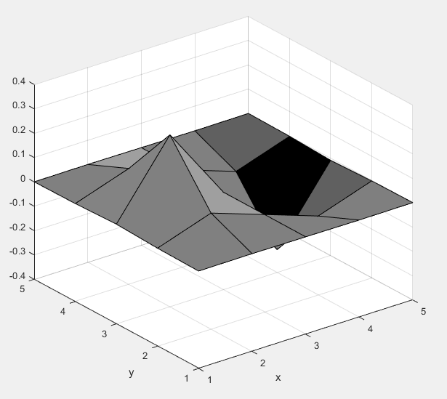
Gx, sigma = 0.6

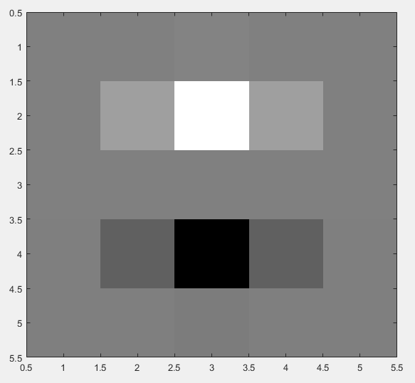
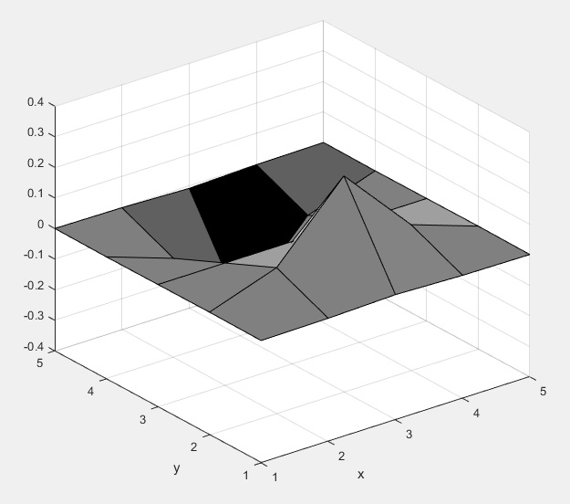
Gy sigma = 0.6

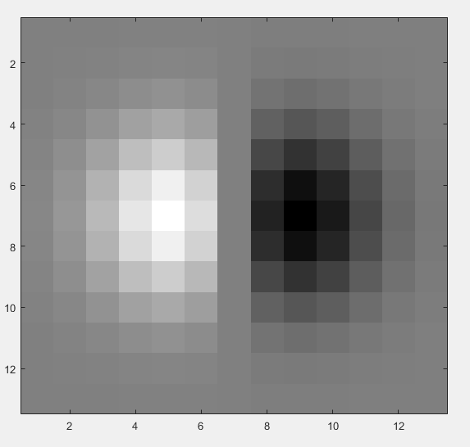
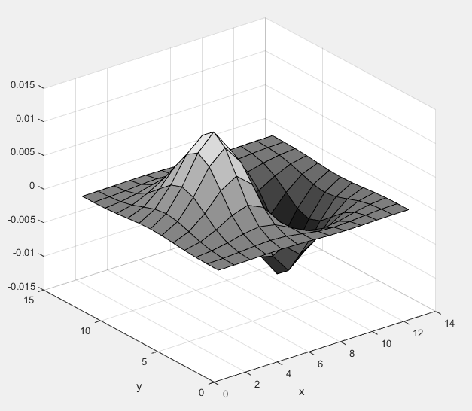
Gx sigma = 2

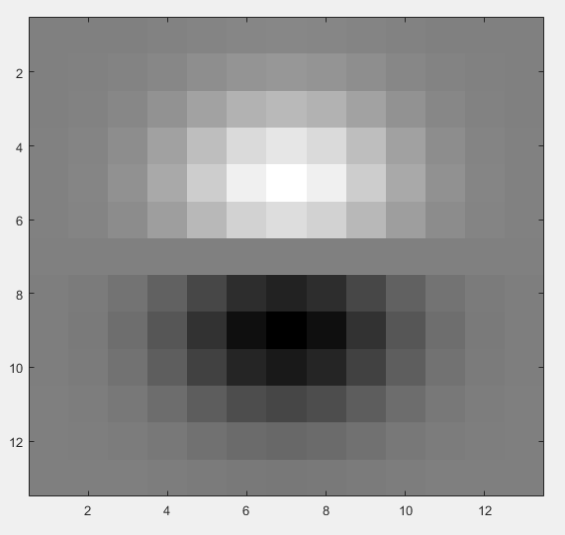
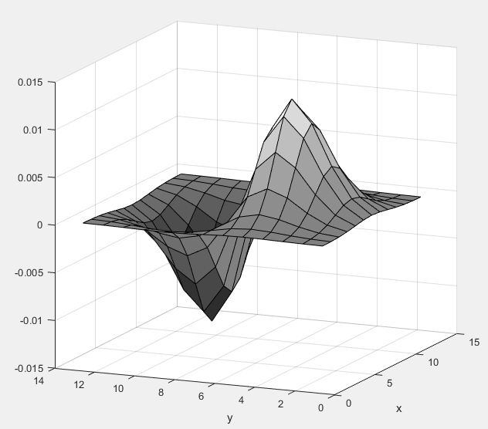
Gy sigma = 2

3) Compute and display the gradient magnitude of an image (search the web for an
interesting image; convert to grayscale if necessary; make sure to upload the image
with code in your submission)

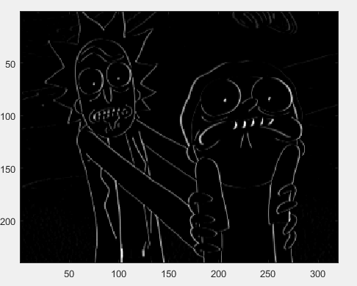
Gx filter, sigma = 0.6, vertical edges are highlighted more than horizontal edges


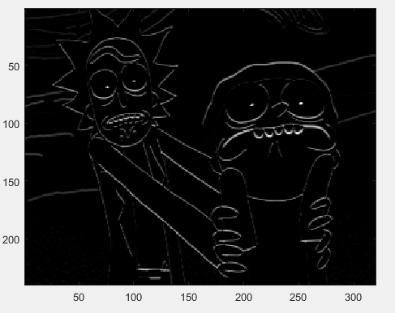
Gy filter, sigma = 0.6 horizontal edges are highlighted more than the vertical edges
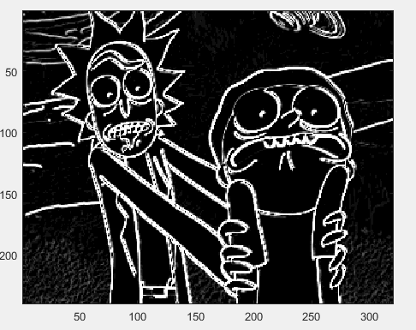
Gradient magnitude combining both the above images

4) Threshold and display the magnitude image with different threshold T levels.
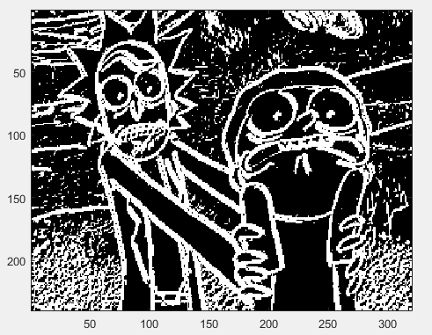
Threshold = 0.5

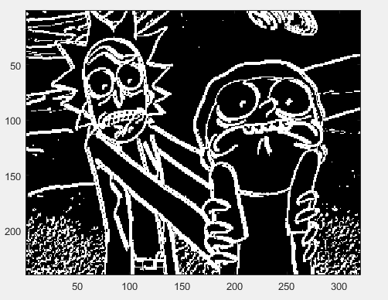
Threshold = 1.5
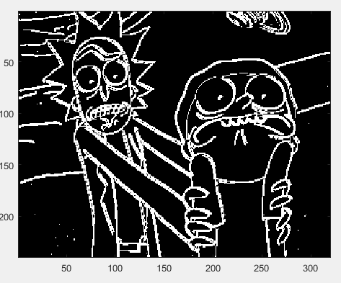
Threshold = 5

5) Compare the above results with the Sobel masks.

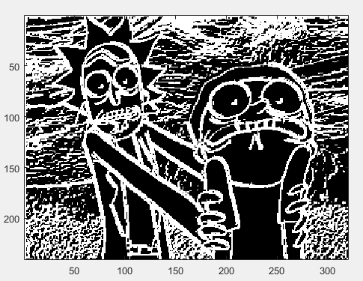
Sobel Threshold = 5

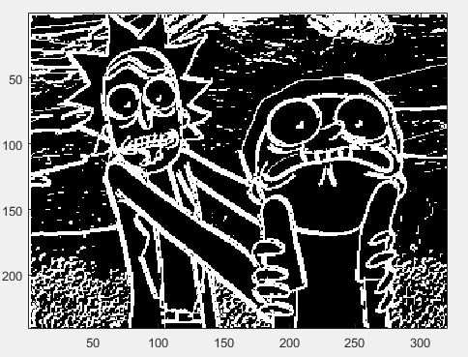
Sobel Threshold = 10

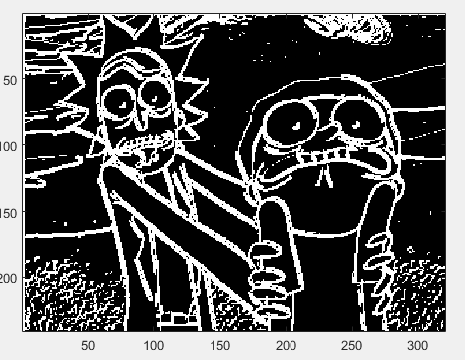
Sobel Threshold = 15

6) Run the MATLAB canny edge detector, edge(Im,'canny'), on your image and display
the default results. How does it compare?

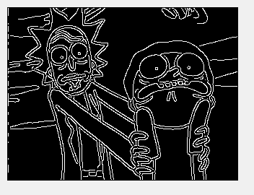
Code
HW2.m
% Chandrasekar Swaminathan
% swaminathan.42@osu.edu
% CSE5524 - HW2
% 9/6/2016

%%%%%%%%%%%%%%%%%%%%%%%%%%%%%%%%%%%%%%%%
% Problem 1
% applies gaussian filter with sigma values from 40 to 0.5
face_gaussian_blur;
pause;

% Problem 2
% create gaussian second derivative mask with sigma as 0.6 and 2
[Gx, Gy] = gaussDeriv2D(0.6);
[Gx2, Gy2] = gaussDeriv2D(2);
surf(Gx);xlabel('x');ylabel('y');
pause;
imagesc(Gx);
colormap('gray');
pause;
surf(Gy);xlabel('x');ylabel('y');
pause;
imagesc(Gy);
colormap('gray');
pause;
surf(Gx2);xlabel('x');ylabel('y');
pause;
imagesc(Gx2);
colormap('gray');
pause;
surf(Gy2);xlabel('x');ylabel('y');
pause;
imagesc(Gy2);
colormap('gray');
pause;

% Problem 3
% Computing gradient magnitude
img = imread('rickandmorty.jpg');
img = rgb2gray(img);
gxIm = imfilter(img, Gx, 'replicate');
gyIm = imfilter(img, Gy, 'replicate');
magIm = sqrt(double(gxIm.^2 + gyIm.^2));
imagesc(gxIm);
colormap('gray');
pause;
imagesc(gyIm);
colormap('gray');
pause;
imagesc(magIm);
colormap('gray');
pause;

% Problem 4
% applying a threshold on the gradient magnitude
T = 0.5;
tIm = magIm > T;
imagesc(tIm);
pause; % very low threshold
T = 1.5;
tIm = magIm > T;
imagesc(tIm); %slightly better
T = 5;
tIm = magIm > T;
imagesc(tIm); %a lot better

% Problem 5
% Using sobel mask to detect edges
sobel_masks(img, 5);
pause;
sobel_masks(img, 10);
pause;
sobel_masks(img, 15.95);
pause;

% Problem 6
cannyImg = edge(img, 'canny');
imshow(cannyImg);

sobel_masks.m
function [] = sobel_masks (Im, T)
Fx = -fspecial('sobel')';
fxIm = imfilter(Im, Fx);
Fy = -fspecial('sobel');
fyIm = imfilter(Im, Fy);
magIm = sqrt(double(fxIm.^2 + fyIm.^2));
tIm = magIm > T;
imagesc(tIm);
colormap('gray');
axis('image');
end

gaussDeriv2D.m

function [Gx, Gy] = gaussDeriv2D (sigma)
maskSize = 2*ceil(3*sigma) +1;
twoSigmaSquared = 2 * sigma^2;
twoPiSigmaQuad = 2 * pi * sigma^4 ;
Gx = zeros (maskSize,maskSize);
Gy = zeros (maskSize,maskSize);
x0 = floor(maskSize/2) + 1;
y0 = floor(maskSize/2) + 1;
for n=1:maskSize
for m=1:maskSize
exponentTerm = exp(-((n-x0)*(n-x0) + (m-y0)*(m-y0))/twoSigmaSquared);
Gx(n,m)= -(m-y0) * exponentTerm/twoPiSigmaQuad;
Gy(n,m)= -(n-x0) * exponentTerm/twoPiSigmaQuad;
end
end
end

face_gaussian_blur.m
function [] = face_gaussian_blur()
sigma = 40;
decrement_step =5;
faceIm = double (imread('face.jpeg'));
gIm = faceIm;
while sigma >= 0.5
G = fspecial ('gaussian', 2 * ceil(3*sigma) + 1, sigma);
gIm = imfilter(faceIm, G, 'replicate');
imshow(gIm/255);
text(10, 20, strcat('Sigma: ', num2str(sigma)), 'Color', 'white', 'FontSize', 14);
pause;
if sigma <= decrement_step
sigma=sigma-0.5;
else
sigma=sigma-decrement_step;
end
end
end

