**CSE 5524 - Homework #1** 8/29/2016

Chandrasekar Swaminathan (swaminathan.42)

**1. Test the MATLAB image functions to read, display, and write images. Use buckeyes_gray.bmp and buckeyes_rgb.bmp from the class webpage**

The image on the left is the converted JPG version of buckeyes_gray.bmp. The size of the JPG file is 13KB, almost 67% smaller in size when compared to the original BMP image (39KB). The reduction in file is more significant with the RGB image (on the right), with the JPG format taking up only 15KB, 86% smaller than the BMP image (111KB). In both cases, the generated JPG image is identical to the original image and loss of visual detail, if any, due to compression is not visible to the human eye.

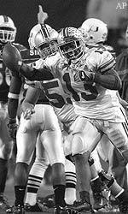  
buckeyes_gray.jpg

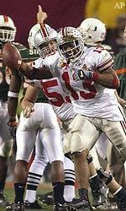  
buckeyes_rgb.jpg

**2. Read and convert buckeyes_rgb.bmp to grayscale using the NTSC conversion formula via the MATLAB fun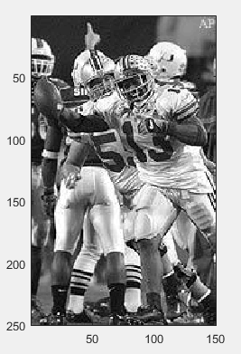ction rgb2gray. Display your image to verify the result.**

We can see that the RGB image has been converted to grayscale using the **rgb2gray** function.

**3. Test MATLAB more fully by creating, writing, and reading a checkerboard image.**

The above 10×10 checkerboard patte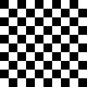rn was generated by repeating a 2×2 pattern five times both horizontally and vertically.

**4. Turn in all code, test images, printouts of images, and discussion of results. Make a**

**HW1.m script to do the above tasks and call needed functions. Upload your code and**

**selected images to Carmen.**

**HW1.m**

**% Chandrasekar Swaminathan**

**% swaminathan.42@osu.edu**

**% CSE5524 - HW1**

**% 8/29/2016**

%%%%%%%%%%%%%%%%%%%%%%%%%%%%%%%%%%%%%%%%

% Problem 1

% converts buckeyes_gray.bmp to buckeyes_gray.jpg

**grayscale_bmp2jpg;**

**pause;**

%%%%%%%%%%%%%%%%%%%%%%%%%%%%%%%%%%%%%%%%

% converts buckeyes_rgb.bmp to buckeyes_rgb.jpg

**rgb_bmp2jpg;**

**pause;**

%%%%%%%%%%%%%%%%%%%%%%%%%%%%%%%%%%%%%%%%

% Problem 2

% converts buckeyes_rgb.bmp to a gray scale image and displays it

**rgb2grayscale;**

**pause;**

%%%%%%%%%%%%%%%%%%%%%%%%%%%%%%%%%%%%%%%%

% Problem 3

% generates a 10x10 checkboard and saves it to checkerIm.bmp

**generate_checker_board;**

**-----------------------------------------------------------------------------------**

**grayscale_bmp2jpg.m**

function [] = grayscale_bmp2jpg()

%bmp2jpg Converts the given grayscale bmp image to jpg

grayIm = imread('buckeyes_gray.bmp');

imagesc(grayIm);

axis('image');

colormap('gray');

imwrite(grayIm, 'buckeyes_gray.jpg');

end

**-----------------------------------------------------------------------------------**

**rgb_bmp2jpg.m**

function [] = rgb_bmp2jpg()

%rgb_bmp2jpb converts the rgb bmp image to a jpg image

rgbIm = imread('buckeyes_rgb.bmp');

imagesc(rgbIm);

axis('image');

imwrite(rgbIm, 'buckeyes_rgb.jpg');

end

**rgb2grayscale.m**

function [] = rgb2grayscale()

rgbIm = imread('buckeyes_rgb.bmp');

grayIm = rgb2gray(rgbIm);

imagesc(grayIm);

axis('image')

colormap('gray');

end

**-----------------------------------------------------------------------------------**

**generate_checker_board.m**

function [] = generate_checker_board()

zBlock = zeros(10, 10);

oBlock = ones(10, 10)*255;

%generate 2x2 checker board image

pattern = [zBlock oBlock; oBlock zBlock];

%repeat the 2x2 checker board five times both horizontally and vertically.

checkerImage = repmat(pattern, 5,5);

imwrite(uint8(checkerImage), 'checkerIm.bmp');

imwrite(uint8(checkerImage), 'checkerIm.jpg');

im = imread('checkerIm.bmp');

imagesc(im);

colormap('gray');

axis('image');

end