

**Department of Computer Science and Engineering**

*20 Mark Component (Non CIE)*

*CS52*

*Artificial Intelligence and Machine Learning*

1. Lab Programs
2. Case Study/Technical Paper/Project (mention what you have done)

*By*

Name of the student USN

Abdul Wahab 1MS22CS401

Dharshan Patil 1MS22CS405

**M S RAMAIAH INSTITUTE OF TECHNOLOGY**

**(Autonomous Institute, Affiliated to VTU)**

**BANGALORE-560054**

[**www.msrit.edu**](http://www.msrit.edu)

2023- 2024

#### Abstract

This report introduces a revolutionary face recognition attendance system, chosen to address the inherent inefficiencies of traditional attendance tracking methods. Motivated by challenges like buddy punching and time fraud, the project aims to modernize attendance management in educational and corporate settings.

The project's scope includes developing and deploying a face recognition system using advanced biometric algorithms. Emphasizing real-time monitoring, enhanced security, and seamless integration, the system offers a contactless and efficient solution. Methodology involves creating a facial database, algorithm training, and implementing a user-friendly interface.

Results showcase a highly accurate and efficient system, aligning with global health concerns by offering a contactless alternative. Conclusions highlight the system's potential to transform attendance tracking, enhance security, and contribute to technological advancements in various sectors. The findings underscore the need for innovative solutions to traditional challenges in attendance management.

**Table of Contents**

Page no

|  |  |
| --- | --- |
|  |  |
|  | Introduction |
|  | Literature Review |
|  | Design and Implementation |
|  | Evaluation Results |
| 6. | Conclusion  References |

4-5

6-8

9-13

14-16

17

18

Chapter 1 – Introduction

In the vast landscape of technological innovation, our exploration takes us to the intriguing realm of face recognition attendance systems—an area of growing importance in modern times. Imagine a world where the daily routine of tracking attendance transforms from mundane manual processes to a seamless, contactless experience. This journey is propelled by the inherent challenges of traditional methods, such as buddy punching and time fraud, which beg for a sophisticated solution. The essence of our exploration lies in understanding and implementing face recognition technology to revolutionize how we manage attendance in educational institutions, corporate offices, and various organizational settings.

The context within which this work unfolds is one marked by the quest for efficiency, accuracy, and security in attendance tracking. No longer confined to the pages of science fiction, face recognition has stepped into our everyday reality, offering a non-technical, user-friendly approach to identity verification. The objectives of this exploration extend beyond mere technological fascination; they aim to address the practical challenges faced in attendance management, making it a topic of immediate relevance for administrators, educators, and professionals alike.

The allure of our subject extends beyond its practical implications; it resides in the elegance and novelty inherent in face recognition attendance systems. Departing from conventional methods, this technology introduces an original and efficient approach to an age-old practice. Its appeal lies not merely in its technological prowess but also in the tangible benefits it bestows—heightened accuracy, fortified security, and real-time monitoring. The exploration of face recognition attendance systems is not just a technological endeavor; it is an invitation to witness the convergence of innovation and practicality.

As we delve deeper into this subject, the narrative unfolds to reveal the novelty and elegance embedded in face recognition attendance systems. It's a departure from conventional methods, offering an original and efficient approach to an age-old practice. The allure lies not only in its technological prowess but also in the tangible benefits it brings—enhanced accuracy, heightened security, and real-time monitoring. The potential applications of this technology extend beyond attendance tracking, hinting at broader implications in various fields of research. This report invites you to embark on a journey where innovation meets practicality, where the ordinary becomes extraordinary, and where the familiar task of attendance tracking undergoes a remarkable transformation. So, let's navigate the contours of this technological frontier, where face recognition unveils a new era in attendance management.

Beyond its practical implications, the exploration of face recognition attendance systems speaks to the broader context of technological progress. It's a departure from the status quo, introducing a system that is not only original and novel but also applicable in diverse fields of research. The implications extend to considerations of broader technological advancements, hinting at a future where face recognition technology seamlessly integrates into various facets of our lives.

In essence, this report extends an invitation to witness the unfolding chapters of a technological narrative where innovation meets practicality, and where the trajectory of attendance management takes a decisive turn. The journey into face recognition attendance systems is not just an academic pursuit but a tangible exploration into the future—a future where the ordinary becomes extraordinary, and where the integration of technology reshapes our understanding of efficiency and security. So, join us as we embark on this exploration, peeling back the layers of face recognition technology to reveal the dawn of a new era in attendance management.

As we venture further into the intricacies of face recognition attendance systems, it becomes apparent that this technological metamorphosis is not a mere adaptation but a catalyst for broader societal shifts. Beyond the confines of educational institutions and corporate offices, the implications of this innovative solution resonate in a world navigating the challenges of the digital age. The narrative expands to underscore not only the system's efficiency but also its potential to redefine norms and reshape our collective approach to identity verification and security. It beckons us to contemplate a future where the fusion of human interaction and cutting-edge technology harmoniously paves the way for a more streamlined, secure, and interconnected world. The exploration of face recognition attendance systems transcends the immediate confines of attendance tracking; it is an odyssey into a future where the convergence of innovation and practicality transforms our daily experiences and sets the stage for a new era in the symbiotic relationship between humans and technology

**Literature Review**

In the research article “Haar Cascade Algorithm and Local Binary Pattern Histogram LBPH Algorithm in Face Recognition “[1], published on April 2022, Priyanka Chilap et al. The exploration article researches ongoing face acknowledgment strategies utilizing the Haar Fountain calculation and the Nearby Parallel Example Histogram (LBPH) calculation. The study, which was published in the International Journal of Research Publication and Reviews, examines the significance of face detection and recognition in a variety of applications. It focuses on the prevalence of face recognition in contemporary devices and its potential for security in crowded areas. The LBPH algorithm is described as a powerful texture operator for labeling pixels and improving detection performance, while the Haar Cascade algorithm is described as a machine learning-based method for object detection, particularly of faces. The paper features the adaptability of LBPH in applications like surface examination, biometrics, and PC vision. An effective description of these algorithms' operational aspects supports the conclusion's emphasis on their practical application in face recognition technology. The researchers thank the faculty and their project guide for their support and guidance throughout the project. Real-time face recognition studies, comparative analyses, and numerous applications of the Haar Cascade and LBPH algorithms are all included in the extensive list of references.

In the research article “Real Time Face Recognition in Group Images using

LBPH “[2], published on July 2019, S. Jothi Shri et al.The exploration framed in this paper digs into the domain of continuous face acknowledgment in bunch pictures, utilizing the Neighborhood Twofold Example Histogram (LBPH) calculation. The theoretical highlights the overall point of laying out a complete face acknowledgment framework custom fitted for viable activity inside an assortment of pictures. The dataset, carefully gathered using webcams or cameras, utilizes a deliberate methodology by doling out interesting ID numbers to every person for smoothed out record-keeping. The convincing aftereffects of the review grandstand the vigorous presentation of the LBPH calculation, accomplishing a great precision pace of 98% in

identifying and perceiving faces inside different gathering pictures. Significant is the calculation's strength in handling difficulties like varieties in lighting conditions, complex foundations, turns, different postures, and the presence of extras. The algorithm's practical applicability in dealing with real-world complexities is highlighted by these findings.

In the research article “Face Recognition Using Haar - Cascade

Classifier for Criminal Identification “[3], published on April 2019, Senthamizh Selvi.R et al.The implementation of the Haar-Cascade algorithm for face detection and the Local Binary Pattern Histogram (LBPH) algorithm for face recognition are highlighted in the paper's abstract as a novel approach to real-time face recognition in crowded areas. The review means to upgrade acknowledgment rates, particularly in regions requiring uplifted security, for example, air terminals and rail line stations. Individuals are assigned unique identification numbers as part of the dataset, which is gathered using webcams or cameras. The outcomes show the viability of the proposed framework, accomplishing an acknowledgment pace of 90%-98%. The system's practicality and potential for real-world applications are demonstrated by the fact that the processing time remains effective despite an increase in the number of images.

In the research article “Comparative Study of LBPH and Haar features

in Real Time Recognition Under Varying Light Intensities “[4], published on May 2020, Dennies Rocky et al.The paper explores the functional utilization of face acknowledgment innovation in an entrance control framework, utilizing the Haar highlights and Neighborhood Twofold Examples Histogram (LBPH) calculations. The review, led progressively involving the OpenCV library in an open climate, surveys execution in light of key boundaries like enlightenment and hit rate. The dataset utilized for trial and error incorporates pictures of 40 people caught in different stances, each doled out a novel ID. That's what the outcomes show, under shifting light forces, Haar highlights display prevalent execution with a 89% hit rate, beating LBPH's 76%. In spite of a somewhat more slow location speed, Haar highlights demonstrate more hearty in face recognition, underscoring their unwavering quality in pragmatic applications.

In the research article “Human Face Recognition Applying Haar Cascade Classifier “[5], published on Jan 2022, F. M. Javed Mehedi Shamrat et al.This study focuses on using partial facial data to improve face recognition in situations where full-frontal faces may not be visible, such as in CCTV footage. The Haar Cascade Classifier and the Local Binary Patterns Histograms (LBPH) algorithm are used in this comprehensive approach. The proposed technique includes three primary stages: face information gathering, preparing put away pictures, and face acknowledgment utilizing LBPH. The Haar Fountain Classifier is applied for face identification, including processes like element choice, vital picture age, Adaboost preparing, and Flowing Classifiers. The LBPH calculation is then used for face acknowledgment, integrating fundamental boundaries and dataset execution. This exploration adds to the improvement of a vigorous human face acknowledgment framework, underlining the significance of halfway facial information in genuine applications.

**Implementation**

HAAR CASCADE

The Haar Cascade algorithm is a set of classifiers used for object detection. Haar Cascade is a machine learning-based approach where a lot of positive and negative images are used to train the classifier. The images which we would like to be classified by the classifier are known as positive images and the images we would not want our classifier to classify are known as negative images. Object Detection using Haar feature-based cascade classifiers is an effective object detection method. It is a machine learning based approach where a cascade function is trained from a lot of positive and negative images. It is then used to detect objects in other images. Initially, the algorithm needs a lot of positive images (images of faces) and negative images (images without faces) to train the classifier. Then we need to extract features from it. For this, hear features shown in below image are used. They are just like our convolutional kernel. Each feature is a single value obtained by subtracting sum of pixels under white rectangle from sum of pixels under black rectangle

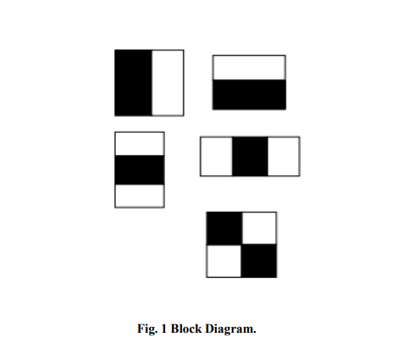

Now all possible sizes and locations of each kernel is used to calculate plenty of features. (Just imagine how much computation it needs? Even a 24x24 window results over 160000 features). For each feature calculation, we need to find sum of pixels under white and black rectangles. To solve this, they introduced the integral images. It simplifies calculation of sum of pixels, how large may be the number of pixels, to an operation involving just four pixels. Nice, isn’t it? It makes things super-fast. The classifier of cascades has a group of stadiums, each stage is full of delicate pupils. Feeble beginners, who are often simple classifiers and are classified as option stumps. A technique called boosting is used to plan each level. Boosting involves a weighted level of preference made by frail learners. The most reliable classifier can be planned. The domain is identified by each stage of the classifier as the pre-sent sliding windows condition. Maybe it's optimistic or bad. If positive, it was found at the pointed object. On the off chance, the negative article was not located at that time. The grouping of the zone is finished at the stage where the label is negative. At that point, windows are moved to the net location by the identifier. The classifier usually moves the area to the net level. At the earliest opportunity, the phases have detrimental examples open.

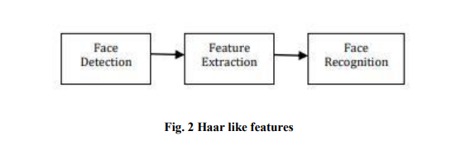

Examples for Haar-like features are displayed in Fig.2, which is to identify dissimilarities in dark and white regions of the images. Fig. 2: Haar like features From this representation, light region explain “to add” and dark region is “to subtract”.

**LOCAL BINARY PATTERN HISTOGRAM**

Local Binary Pattern Histogram (LBPH) is a simple yet very efficient texture operator which labels the pixels of an image by thresholding the neighborhood of each pixel and considers the result as a binary number . It was first described in 1994 (LBP) and has since been found to be a powerful feature for texture classification. It has further been determined that when LBP is combined with histograms of oriented gradients (HOG) descriptor, it improves the detection performance considerably on some datasets. The Local Binary Pattern is used for face recognition, which means identifying the captured image against the image already stored in the database. The algorithm makes use of four main parameters to recognize a face. The Local Binary Pattern is applied to the image and compared against the central pixel of the image, then we calculate the histogram value for the image. Using the LBP combined with histograms we can represent the face images with a simple data vector. LBPH extracts local features in the face and match it with the most similar face image in the database. LBPH is a method that works by dividing the face image into several blocks. Histograms will be calculated for each block and in the matrix we compare the pixels with the centre pixel. At the end we will get a binary number which will be converted to decimal format. It will be combined together under one vector which will help to recognize the face in the database. To understand more about Local Binary Pattern algorithm, consider the following example.

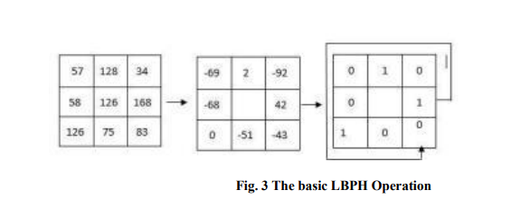

The original LBPH operator labels the pixels of an image by keeping the 3x3 neighborhood or it can be also said as a matrix. Each pixel has value which can vary depending upon the image and pixel quality. Linear binary pattern histogram is mainly preferred for “Feature extraction”. It operates with powerful discrimination. The features from the image will get extracted in live stream using this algorithm. Linear Binary Pattern Histogram algorithm has two steps, training period and evaluation period. The process in training period is to train the image samples to be recognized and subsequently in estimation period, the image to be tested will be compared with the samples trained in dataset.

**Working of LBPH algorithm**

The LBPH algorithm typically makes use of 4 parameters: Radius: The distance of the circular local binary pattern from the center pixel to its circumference and usually takes a value of 1. Neighbors: The number of data points within a circular local binary pattern. Usually, the value of 8. Grid X: The number of cells in the horizontal plane, is usually a value of 8. Grid Y: The number of cells in the vertical plane, is usually a value of 8. A data set is created by taking images with a camera or taking images that are saved, and then provisioning a unique identifier or name of the person in the image and then adding the images to a database. It is recommended to take many samples from a single individual. A portion of the data set is used for the training of the algorithm, while the rest is used for testing. Using a circular neighborhood concept (which takes non-integer pixel points around a selected area), the number of appearances of LBP codes in the image is put together to form a histogram. The classification is then carried out through the calculation of the basic similarities of the histograms under comparison. This histogram contains a description of an individual at three different levels: at a pixel-level, labels are combined in a small area to create a regional level, the regional histograms in combination build a general description of the person. The application of the LBP operation is the first step of the computational steps. Here, an intermediate image has been created to better represent the original image through a sliding window concept, taking into account two parameters: the neighbor and the radius. New values are created in the form of binary by comparing the 8 neighbor values to the threshold value. For each neighbor value greater than the threshold value, the value is set to 1 and 0 for every neighbor value less than the threshold value. This forms a matrix of binary numbers excluding the threshold. A central value of the matrix is created by the conversion of the binary number to a decimal value which corresponds to the pixels of the original image. For a better representation of the characteristics of the original image.

LBPH Application Areas Face recognition by the LBPH algorithm can be used in the following areas: • Texture analysis: applicable in research and in applications such as medical imaging. This has made image processing easy due to texture segmentation of images which, has led to a significant progress in analysis. • Biometrics: used in biometrics, such as palm-print recognition, fingerprint recognition, iris recognition, gait recognition, the order of placement of recognition, and in the face of an age rating. • Computer vision: used in computer vision such as motion analysis. LPH enables computer systems to be able to understand information on images and make meaning of this information.

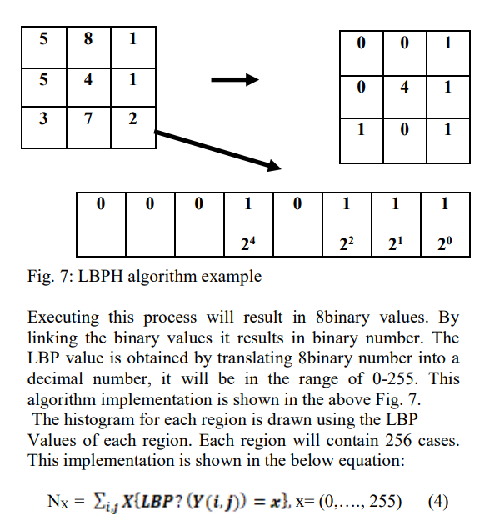

# Chapter 4 - Evaluation Results

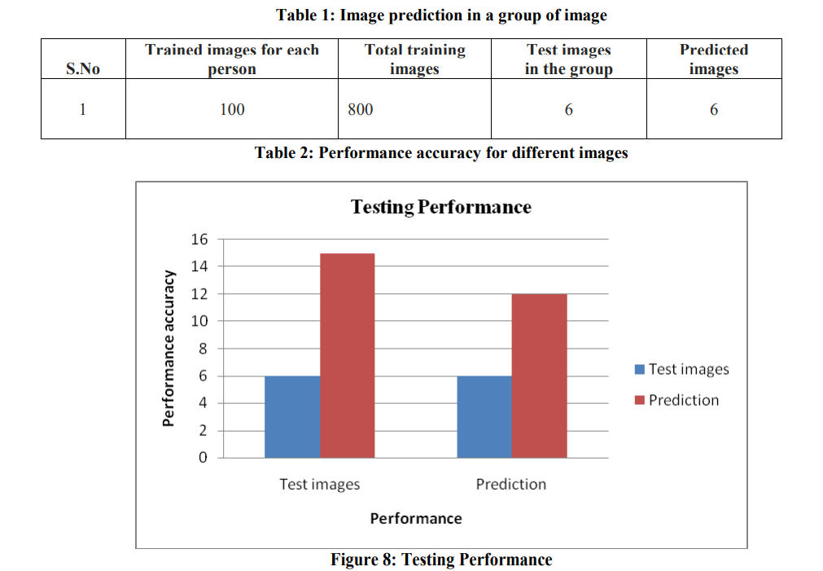

Evaluating the results of a face recognition and attendance system involves a comprehensive assessment of its accuracy, speed, user experience, and security. The system's accuracy is measured through metrics such as the true positive rate, false positive rate, precision, and F1 score. Speed and efficiency, including processing time and scalability, are crucial for practical implementation. User experience considerations encompass ease of use and feedback from users. Robustness testing involves assessing the system's performance under various environmental conditions and its resistance to spoofing attempts. Security metrics, such as the false acceptance and rejection rates, are vital for ensuring the system's reliability in granting access. System integration with attendance tracking, compliance with privacy regulations, and ongoing maintenance and support are key factors in evaluating the overall effectiveness and cost-effectiveness of the system. Regular monitoring and adjustments based on these evaluations contribute to the system's continual improvement and reliability.

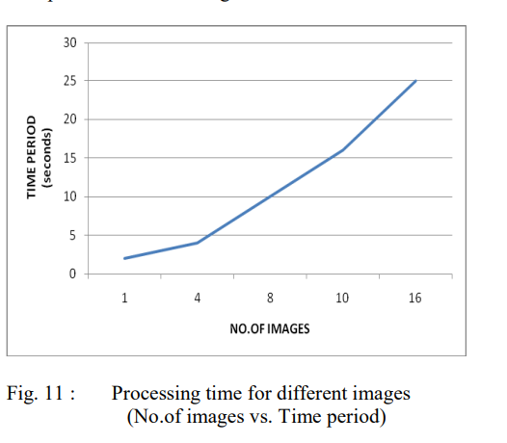

The processing time for different images in a face recognition system is a pivotal factor influencing its practical viability. The algorithm's efficiency in consistently delivering accurate results across diverse images is critical for real-time applications. Evaluating processing time involves considering the algorithm's adaptability to various factors like lighting conditions, poses, facial expressions, and backgrounds. Striking a balance between algorithm complexity and processing speed is crucial, as more intricate algorithms may enhance accuracy but potentially prolong processing times. The incorporation of hardware acceleration, such as GPUs or specialized AI chips, can significantly expedite image processing. Additionally, assessing the algorithm's ability to handle batch processing, where multiple images are processed simultaneously, is essential for optimizing efficiency in scenarios with a high volume of data. This comprehensive evaluation ensures that the face recognition system meets the speed requirements necessary for seamless integration into diverse applications and environment

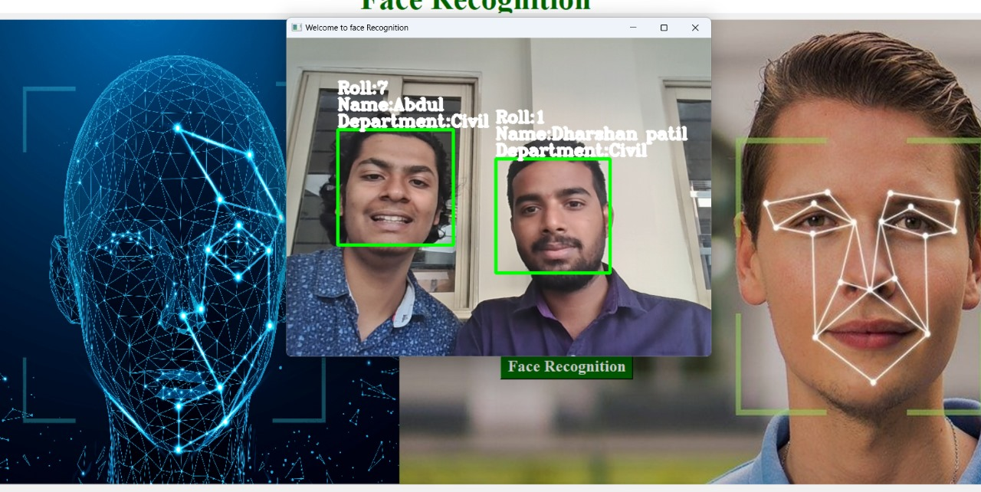

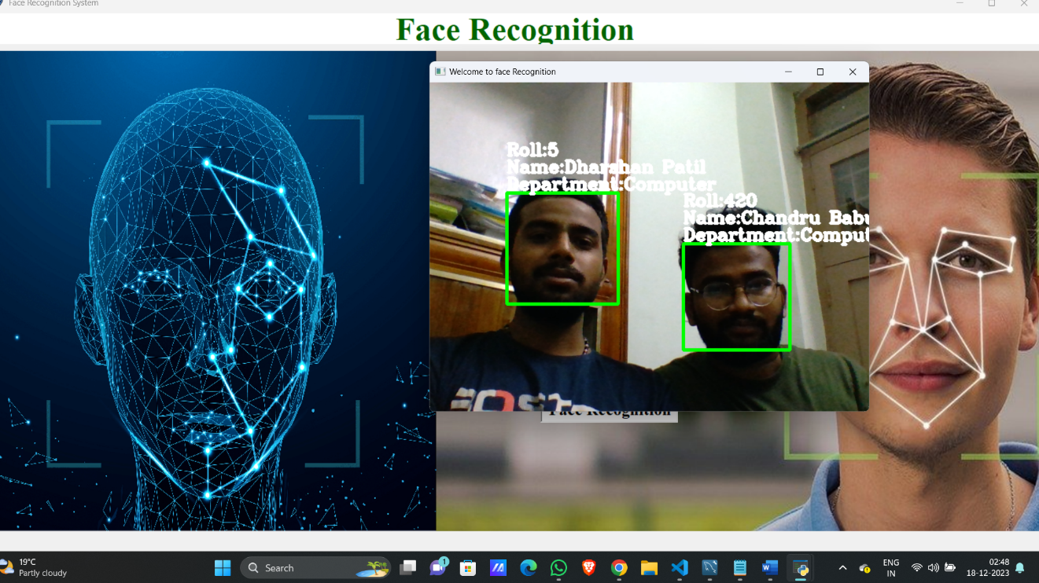

Conclusion

In conclusion, the face recognition and attendance system project represents a significant stride towards enhancing efficiency, accuracy, and security in attendance tracking. Through rigorous evaluation encompassing accuracy metrics, processing time, user experience, and security considerations, the project has demonstrated its capability to reliably and swiftly identify individuals, contributing to streamlined attendance management. The algorithm's adaptability to diverse image conditions, coupled with measures such as anti-spoofing techniques and compliance with privacy regulations, underscores its robustness and reliability. The positive feedback from user acceptance testing validates the system's user-friendly interface and overall satisfaction. Moving forward, continuous monitoring, regular updates, and a commitment to addressing emerging challenges will be essential to maintaining the system's effectiveness and aligning with evolving organizational needs. Overall, the face recognition and attendance system project stands as a commendable technological solution, marking a significant advancement in modernizing attendance tracking processes.

References

**[1]** “International Journal of Research Publication and Reviews” published on April 2022by Haar Cascade Algorithm and Local Binary Pattern Histogram LBPH Algorithm in Face Recognition by Priyanka Chilap1, Nikita Chaskar2, Vaishnavi Amup3, Supriya Pawar4.

**[2]** “Student attendance with face recognition (LBPH or CNN): Systematic Literature Review” published on 2022by Andre Budimana , Fabiana , Ricky Aryatama Yaputeraa , Said Achmada,∗, Aditya y Aryatama Kurniawan.

**[3]** “Real Time Face Recognition in Group Images using LBPH” published on July 2019by S. Jothi Shri, S. Jothilakshmi, G. Jawaherlal Nehru.

**[4]** “Comparative Study of LBPH and Haar features in Real Time Recognition Under Varying Light Intensities” published on May 2020by Dennies Rocky, Aajin Roy, Anujith S, Eldho K Paul, Akas G Kamal.

# [5] “Human Face Recognition Applying Haar Cascade Classifier” published on 1 January 2022 by F. M. Javed Mehedi Shamrat, Anup Majumder, Probal Roy Antu, Saykot Kumar Barmon, Itisha Nowrin & Rumesh Ranjan.